- Supplemental Digital Content (SDC)
- Complement deposition on the surface of RBC after trauma serves a biomarker of moderate trauma severity: A prospective study
- Abhigyan Satyam¹, Kostas Andreo², Peter H. Lapchak¹, Jurandir J. Dalle Lucca³, Roger B. Davis¹, Maria G. Tsokos¹, Nathan I. Shapiro^{2*}, George C. Tsokos^{1*}
¹Department of Medicine, Beth Israel Deaconess Medical Center, Harvard Medical School, Boston, MA, USA.
²Department of Emergency Medicine, Beth Israel Deaconess Medical Center, Harvard Medical School, Boston, MA, USA.
³Translational Medical Division, Department of Chemical and Biological Technologies, Defense Threat Reduction Agency, Fort Belvoir, VA, USA.
* Equally contributed as senior authors

Correspondence:
George C. Tsokos, M.D.
Address: Center for Life Sciences, CLS 937, 3 Blackfan Circle, Boston, MA, 02215, USA
Phone: +1-617-735-4161, Fax: +1-617-735-4170
Email: gtsokos@bidmc.harvard.edu

- Nathan I. Shapiro, M.D.
Address: 1 Deaconess Road, CC2-W, Boston, MA, 02215, USA
Phone: +1-617- 667-5398, Fax: +1-617- 264-6848
Email: nshapiro@bidmc.harvard.edu

Running title: Complement deposition on surface of RBC after trauma

Supplementary figure 1: Deposition of C4d on the surface of RBCs from trauma patients according to the injury severity score. Injury severity scores are grouped in 8 subgroups (ISS 3 – 6, 7 – 10, 11 – 14, 15 – 18, 19 – 22, 23 – 26, 27 – 30 and 31 - 34). Blood samples were collected from trauma patients at 0, 6, 24 and 72 hours.
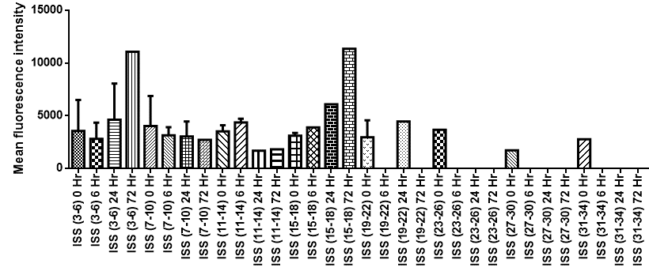
Supplementary figure 2: Deposition of C4d on the surface of healthy control RBCs (type O, Rh negative) incubated with sera from trauma patients according to the injury severity score. Injury severity scores are grouped in 8 subgroups (ISS 3 – 6, 7 – 10, 11 – 14, 15 – 18, 19 – 22, 23 – 26, 27 – 30 and 31 - 34). Blood samples were collected from trauma patients at 0, 6, 24 and 72 hours.
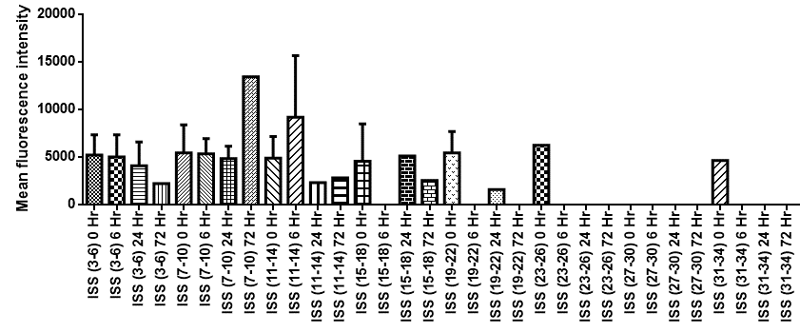
Supplementary figure 3: Deposition of C3d on the surface of healthy control RBCs (type O, Rh negative) incubated with sera from trauma patients according to the injury severity score. Injury severity scores are grouped in 8 subgroups (ISS 3 – 6, 7 – 10, 11 – 14, 15 – 18, 19 – 22, 23 – 26, 27 – 30 and 31 - 34). Blood samples were collected from trauma patients at 0, 6, 24 and 72 hours.
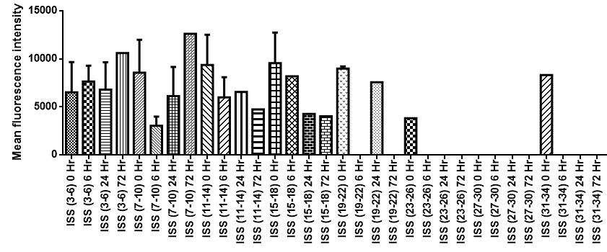
Supplementary figure 4: Deposition of C5b-9 on the surface of healthy control RBCs (type O, Rh negative) incubated with sera from trauma patients according to the injury severity score. Injury severity scores are grouped in 8 subgroups (ISS 3 – 6, 7 – 10, 11 – 14, 15 – 18, 19 – 22, 23 – 26, 27 – 30 and 31 - 34). Blood samples were collected from trauma patients at 0, 6, 24 and 72 hours.
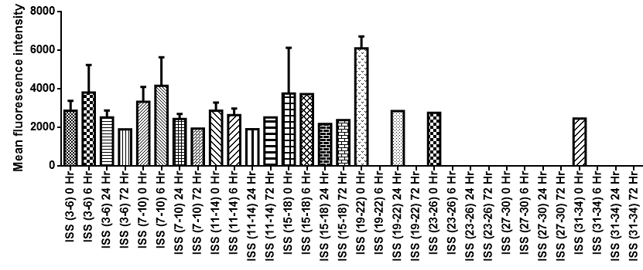
Supplementary figure 5: Phosphorylation status of band 3 in RBCs incubated with trauma sera according to the injury severity score. Injury severity scores are grouped in 8 subgroups (ISS 3 – 6, 7 – 10, 11 – 14, 15 – 18, 19 – 22, 23 – 26, 27 – 30 and 31 - 34). Blood samples were collected from trauma patients at 0, 6, 24 and 72 hours.
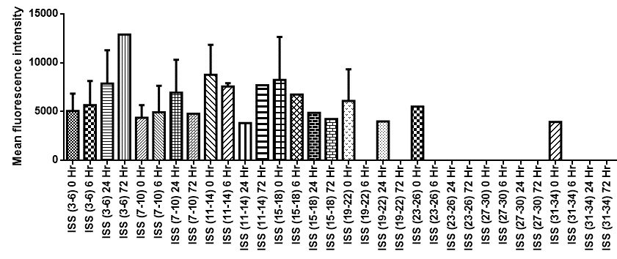

Supplementary figure 6: NO production in RBCs incubated with trauma sera according to the injury severity score. Injury severity scores are grouped in 8 subgroups (ISS 3 – 6, 7 – 10, 11 – 14, 15 – 18, 19 – 22, 23 – 26, 27 – 30 and 31 - 34). Blood samples were collected from trauma patients at 0, 6, 24 and 72 hours.
