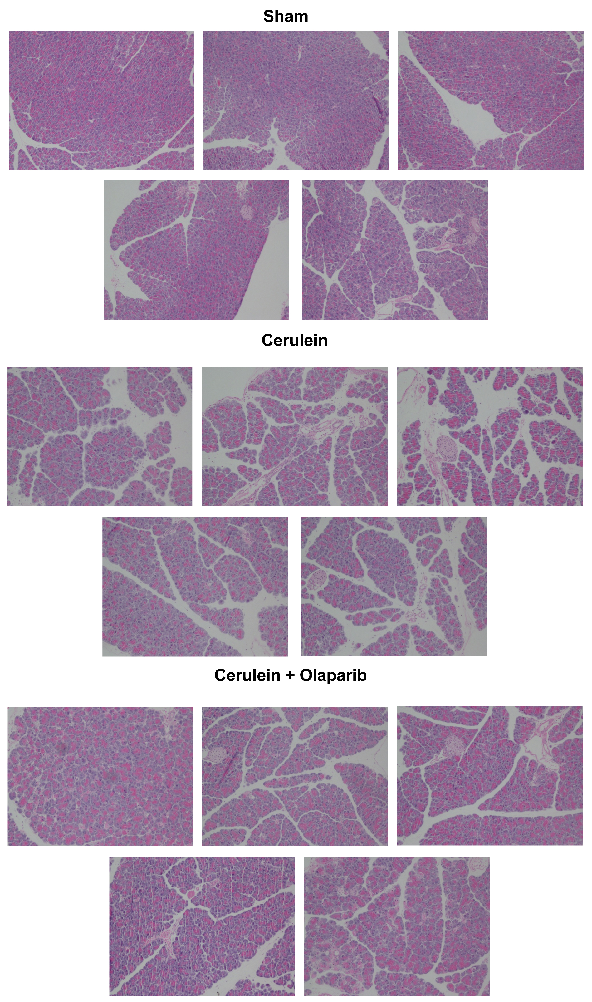

Supplemental Figure 1. Effect of olaparib on histological alterations injury in the pancreas of male Balb/c mice subjected to cerulein-induced pancreatitis. H&E histological pictures from 5 sham mice (not subjected to CLP) ("Sham"), 5 vehicle-treated mice subjected to cerulein at 6 hours ("Cerulein") and 5 mice subjected to cerulein in the presence of olaparib (2x 3 mg/kg) (Cerulein+Olaparib).

