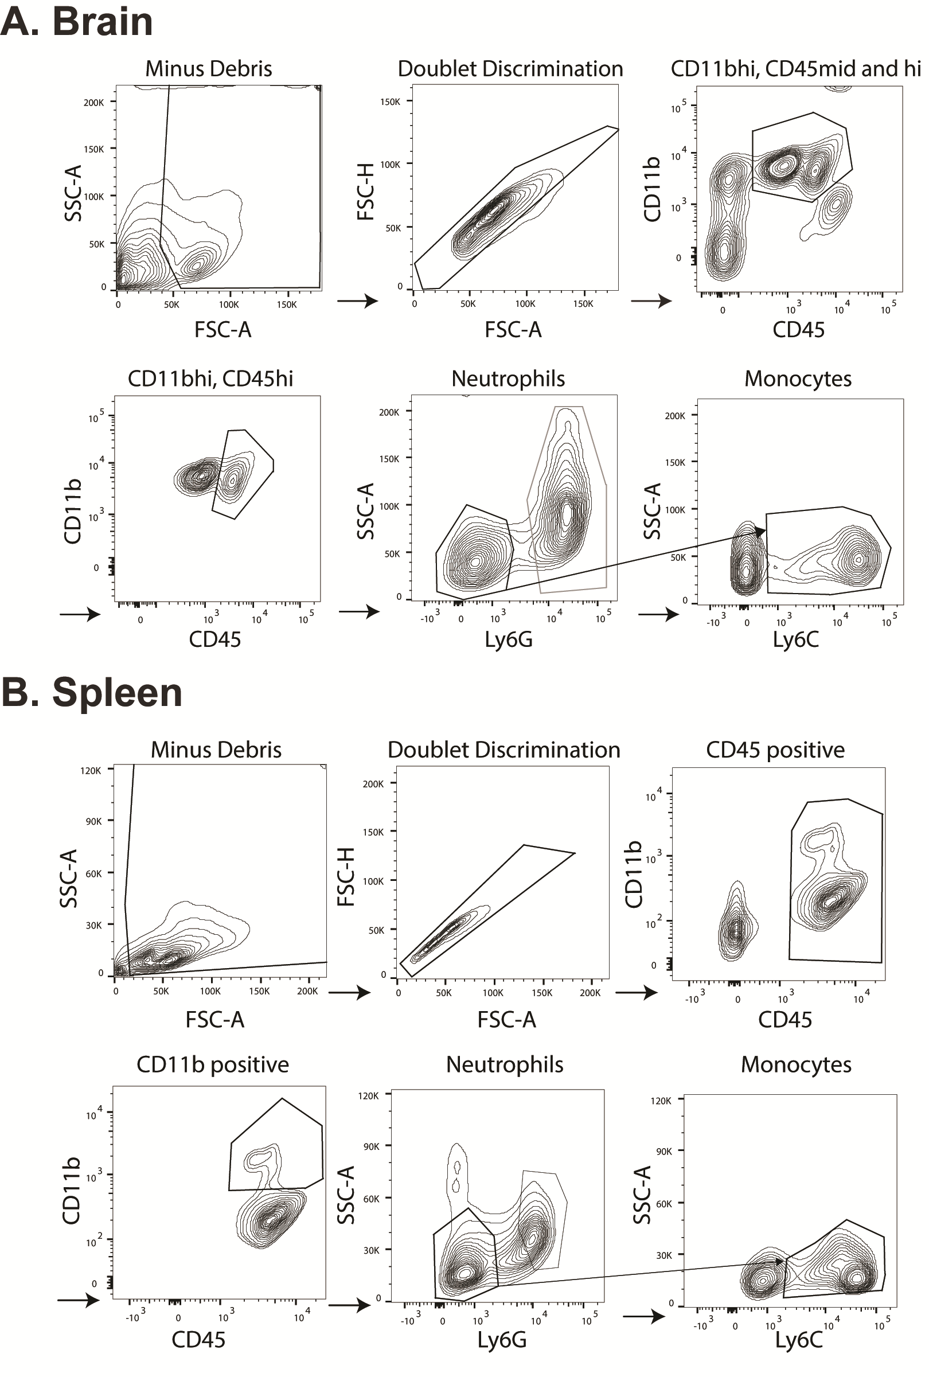

Figure S1. Flow cytometry gating strategies for brain (A) and splenic (B) myeloid cells.

