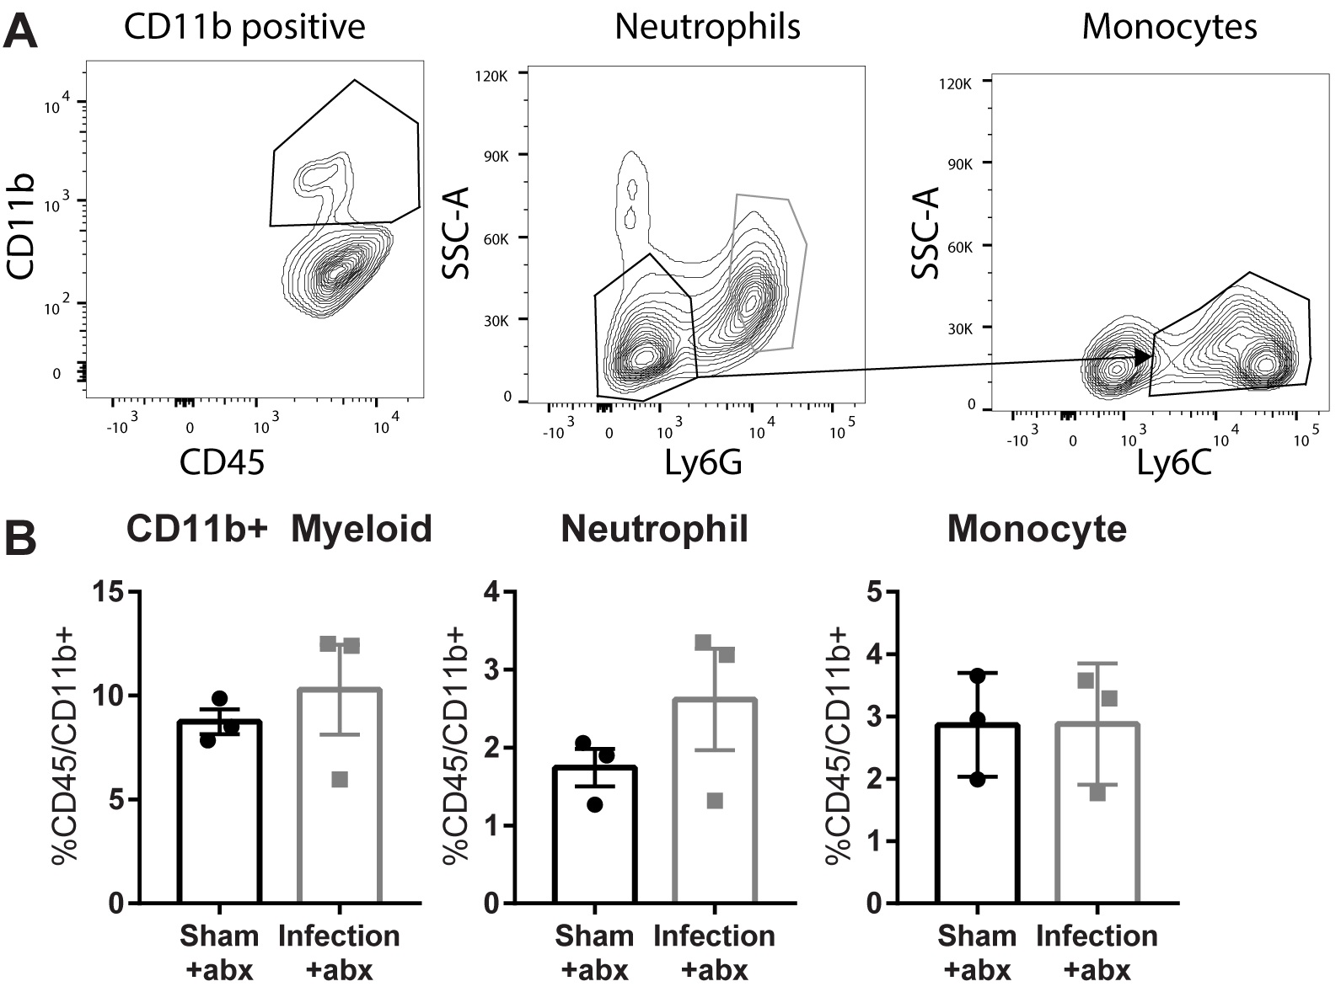

Figure S2. There is no significant difference in myeloid cell populations in the spleen after pneumosepsis. myeloid CD45⁺/CD11b⁺, neutrophils (middle panel, gray box) CD45⁺/CD11b⁺/Ly6G⁺ cells, monocytes (right panel, black box) as CD45⁺/CD11b⁺/Ly6G⁻/Ly6C⁺ (A). Neutrophil or monocytes are not systemically expanded in the spleen in pneumosepsis mice as compared to control (B).

