SUPPLEMENTAL FIGURES
Shock severity and hospital mortality in out of hospital cardiac arrest patients treated with targeted temperature management
Tabi Meir, M.D. Department of Cardiovascular Medicine, Mayo Clinic, 200 First Street SW, Rochester, MN 55905, Electronic address: Tabi.Meir@mayo.edu
Burstein Barry J., M.D. Division of Pulmonary and Critical Care Medicine, Mayo Clinic, Rochester, MN 55905, United States. Burstein.Barry@mayo.edu
Ahmed Abdelrahman M., M.B.B.S. Division of Pulmonary and Critical Care Medicine, Mayo Clinic, Rochester, MN 55905, United States Ahmed.Abdelrahman@mayo.edu
Kashani, Kianoush B., M.D., M.S. Division of Nephrology and Hypertension, Division of Pulmonary and Critical Care Medicine, Department of Medicine, Mayo Clinic, 200 First Street Southwest, Rochester, MN 55905, USA. Electronic address: kashani.kianoush@mayo.edu.
Corresponding author:
Jacob C. Jentzer, MD FACC FAHA, Director of Cardiac Intensive Care Unit Research, Assistant Professor of Medicine, Department of Cardiovascular Diseases and Division of Pulmonary and Critical Care Medicine, Department of Internal Medicine, Mayo Clinic, Rochester MN, Office phone (507) 255-2502, Office fax (507) 255-2550, Cell phone (585) 313-9764 | Mayo pager 4-6254 | Email jentzer.jacob@mayo.edu

Page 2: Supplemental Figure 1
Page 3: Supplemental Figure 2
Page 4: Supplemental Figure 3
Page 5: Supplemental Figure 4A
Page 6: Supplemental Figure 4B

Supplemental Figure 1: Use of vasopressors (A) and maximum 24-hour VIS (B) as a function of mean 24-hour MAP.
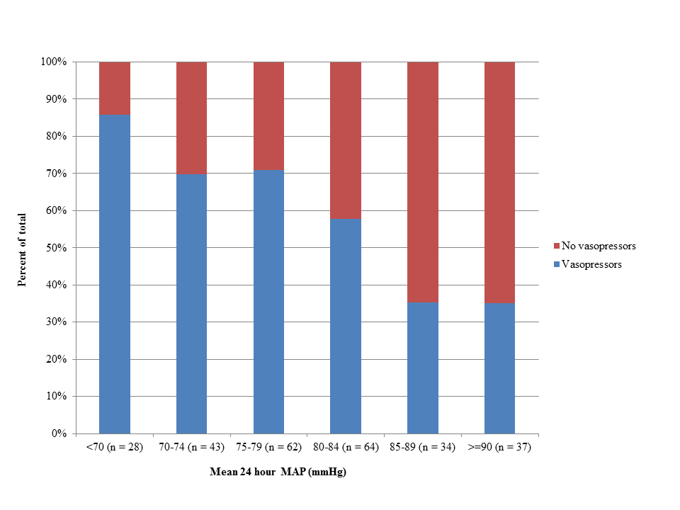
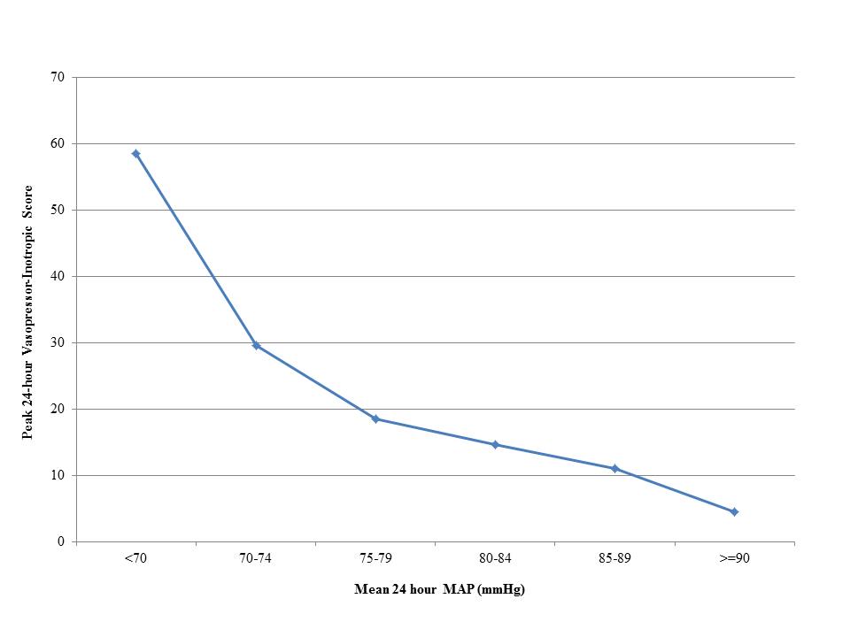

Supplemental Figure 2: Initial and peak lactate levels as a function of mean 24-hour MAP.
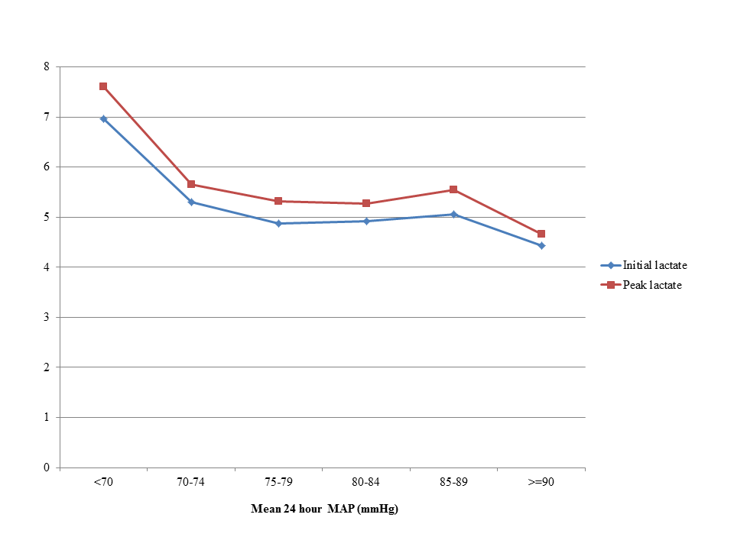

Supplemental Figure 3: Hospital mortality as a function of initial lactate and maximum 24-hour VIS. Inpatient deaths are marked by a red +, and hospital survivors are marked by a blue O.
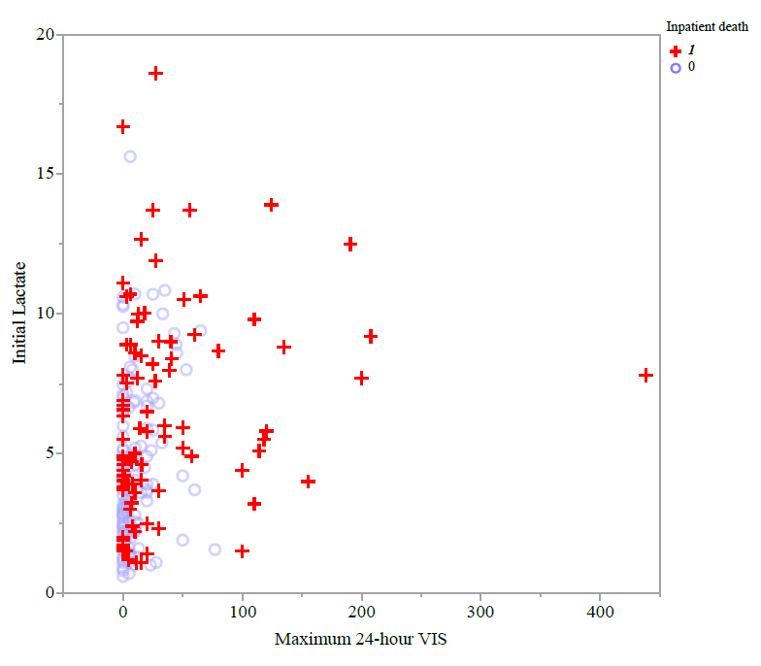

Supplemental Figure 4A: Hospital mortality as a function of maximum 24-hour VIS and mean 24-hour MAP. Inpatient deaths are marked by a red +, and hospital survivors are marked by a blue O.
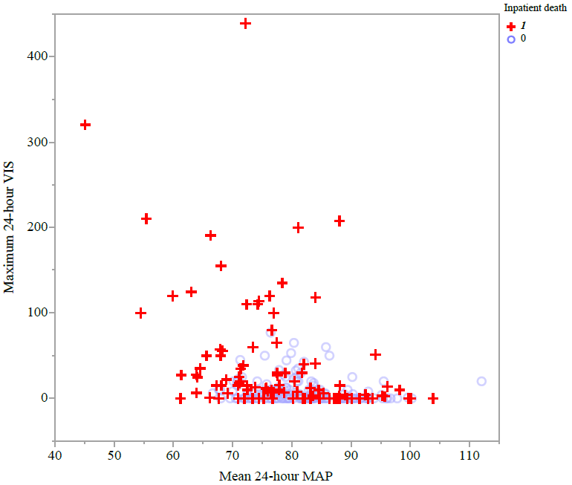

Supplemental Figure 4B: Hospital mortality as a function of initial lactate and mean 24-hour MAP. Inpatient deaths are marked by a red +, and hospital survivors are marked by a blue O.
