Supplemental Digital Content 2. Serious games published by year and genre
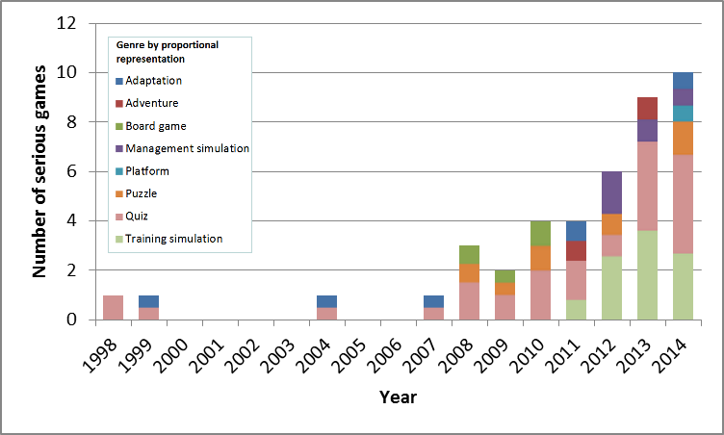
Note: Because some serious games belong to more than one genre, the height of each individual genre bar is not meant to convey the absolute number of games of that genre published. The height of each genre bar should be interpreted as the proportion of that year’s serious games which engage the genre.

