The Supplementary Appendix I
INCA (Inguinal Hernia: Conservative or Operative Approach) Trialists' Collaboration:
Barry de Goede, Pieter J. Klitsie, Bob J.H. van Kempen, Myriam G.M. Hunink, Wim C. Hop, Jens A. Halm, Pim J.W.A. Burger, Alexandra Brandt, Gaston J.H. Franssen, Jan Oomen, Gert-Jan Kleinrensink, Johannes Jeekel, Johan F. Lange (Erasmus University Medical Center, Rotterdam, The Netherlands.); Arthur R. Wijsmuller (VU Medical Center, Amsterdam, The Netherlands.); Hiltjo J. Rath, Harold E. Lont, Guido H. Mannaerts (Sint Franciscus Vlietland Groep, Rotterdam, The Netherlands.); Gabrielle H. van Ramshorst (VU Medical Center, Amsterdam, The Netherlands.); Marc R.M. Scheltinga, Rudi M. H. Roumen, Oliver Boelens, Denis Susa, Tim Verhagen (Maxima Medisch Centrum, Veldhoven, The Netherlands.); Jeroen de Haan, Diederik H. de Lange, Jesse van Buijtenen (Westfriesgasthuis, Hoorn, The Netherlands.); Walter Mastboom (Medisch Spectrum Twente, Twente, The Netherlands.); Dingeman J. Swank, Roderick F. Schmitz, Bonnie Zijsling (Groene Hart Ziekenhuis, Gouda, The Netherlands.); Nicole D. Bouvy, Marc H.F. Schreinemacher, Kevin van Barneveld (Maastricht University Medical Center, Maastricht, The Netherlands); Henk Stigter, Arianne J. Ploeg (Alrijne Ziekenhuis Leiden, Leiden, The Netherlands.); Erwin van der Harst, Peter D. de Rooij, Tara Deelman, Naomi van Hout (Maasstad Ziekenhuis, Rotterdam, The Netherlands.); Wibo F. Weidema (Ikazia ziekenhuis, Rotterdam, The Netherlands.); Laurents P.S. Stasssen (Renier de Graaf Gasthuis, Delft, The Netherlands.); Peter M.N.Y.H. Go (St. Antonius Ziekenhuis, Nieuwegein, The Netherlands.); Willem F.M. van Erp (Maxima Medisch Centrum, Eindhoven, The Netherlands.); Maarten P. Simons (Onze Lieve Vrouwe Gasthuis, Amsterdam, The Netherlands.); Hermien W.H. Schreurs, Claudia M.G. Keyzer-Dekker (Medisch Centrum Alkmaar, Alkmaar, The Netherlands.); Franz Ugahary, Paul F. Liqui Lung, Marnix A.J. de Roos, Paul K.H. Ong, (Ziekenhuis Rivierenland, Tiel, The Netherlands.); Rob T.M. Wijffels, Bas P. Vierhout, Irene F. Donse (Wilhelmina Ziekenhuis Assen, Assen, The Netherlands.); Richard J. de Muynck, Marguerite F. Bouwmeester (Isala Diaconessenhuis, Meppel, The Netherlands.); Imro Dawson (IJsselland Ziekenhuis, Capelle a/d IJssel, The Netherlands.); Rob W.F.R. van den Broek (Ziekenhuis Bethesda, Hoogeveen, The Netherlands.); Harry van Goor, Erik Staal (Radboud University Medical Center, Nijmegen, The Netherlands.); Jan-Willem Juttmann (Tergooiziekenhuizen, Hilversum, The Netherlands.); Roelf R. Postema (Spijkenisse Medisch Centrum, Spijkenisse, The Netherlands.); Serdjan Rakic, Ernst J.P. Schoenmaeckers (Ziekenhuisgroep Twente, Almelo, The Netherlands.); Paul C.M. Verbeek (Flevoziekenhuis, Almere, The Netherlands.); Pieter Heres (Waterlandziekenhuis, Purmerend, The Netherlands.); Thomas Berendes, Rob J. Oostenbroek, Peter W. Plaisier, Paul P.C. Poyck (Albert Schweitzer ziekenhuis, Dordrecht, The Netherlands.); Erwin H.J.A.A. van Geffen, Jelle Ruurda (Jeroen Bosch Ziekenhuis, ’s-Hertogenbosch, The Netherlands.); Frans J.F. Smulders (Catharina Ziekenhuis, Eindhoven, The Netherlands.); Robert E.G.J.M. Pierik, Dick van Geldere (Isala Klinieken, Zwolle, The Netherlands.); Paul Haers, Karel Mulier (Heilig Hartziekenhuis, Leuven, Belgium.); Marc Miserez, Daphne Hompes, Ellen Peeters (Catholic University of Leuven, Leuven, Belgium.)

The Supplementary Appendix II
Randomization procedure
Patients were registered in an online database (Trial Online Process (TOP), designed and managed by HOVON data center, Rotterdam, The Netherlands) in which each patient received a unique trial code. The randomization process was performed during the first visit at the outpatient clinic of each participating center by telephone (block randomization) and later on by a computer-based randomization service in TOP. Patients were randomly assigned to watchful waiting or elective repair. Randomization was stratified for participating centers, age (men aged 50 to 65 years or 65 years and older) and for the duration the inguinal hernia was present at baseline (3 months or less and more than 3 months).

Data collected during follow-up
A) Patient’s characteristics at baseline: body mass index (BMI), smoking status, health status, ASA classification, education level, and type of employment.
B) Comorbidities at baseline: The cardiovascular system (i.e., history of angina, hypertension requiring medication, history of myocardial infarction, history of cardiac arrhythmia, diabetes mellitus, history of transient ischemic attack (TIA) or stroke, medication usage (i.e., aspirin, anticoagulants), history of other cardiovascular disease (i.e., history of valve insufficiencies, abdominal aortic aneurysm (AAA), coronary artery bypass graft surgery (CABG))); The pulmonary system (i.e., chronic obstructive pulmonary disease (COPD), chronic cough, other pulmonary disease (i.e., history of lung embolism, sarcoidosis)); The digestive system (i.e., constipation, cirrhotic liver disease with ascites) and urinary tract (i.e., prostate cancer, benign prostate hyperplasia (BPH), urinary complaints, history of other diseases of the urinary tract (i.e., cancer of the bladder, history of prostatitis, or nephritic diseases)); musculoskeletal system (back problems: rheumatic diseases, herniated disc, back pain).
C) Hernia details at baseline: inguinal hernia (primary or recurrence), hernia side, hernia enlargement (past 6 weeks), reducibility, referent physician, the duration of inguinal hernia present at baseline (3 months or less and more than 3 months), positive family history of abdominal wall hernia, ultrasonography at baseline (i.e., hernia type, diameter of the defect).
D) Perioperative data: operation time, operation technique (i.e., Lichtenstein repair, total extra-peritoneal (TEP) repair, trans-abdominal pre-peritoneal (TAPP) repair, plug and patch repair, prolene hernia system (PHS), pre-peritoneal mesh repair (Kugel or Ugahary hernia repair)), type of mesh (flat mesh (i.e., polypropylene, polyester, large pore lightweight mesh), three-dimensional mesh (i.e. plug&patch repair, bilayered mesh, memory-ring patch)), surgical experience (less than 10, 10 to 25 and more than 25 procedures), type of anaesthesia, Nyhus classification¹⁹, identification of the nerves (i.e., iliohypogastric nerve, ilioinguinal nerve, and/or the genital branch of the genitofemoral nerve), nerve handling, closure of the subcutis, closure of the skin, difficulty of the procedure, perioperative complications (i.e., damage to the vas deferens, epigastric or testicular vessels, nerve injury, peritoneal/hernia sac defects, cardiovascular or anesthetic complications), perioperative use of antibiotics, post-operative complications (i.e., wound infection, hematoma, seroma, ischemic orchitis, urinary retention requiring catheterization, urinary tract infection requiring antibiotics, epididymitis requiring antibiotics, reoperation, pain during ejaculation), hospitalization.
E) Long-term complications (i.e., hernia complication (incarceration, strangulation), hernia complication requiring intervention, moderate or severe pain (pain/discomfort score of 2 or higher), recurrence, reoperation, crossover rates).

Ethical considerations and monitoring
The study protocol was approved by the institutional review board (IRB) of Erasmus University Medical Center, Rotterdam (MEC-2004-298) and by the IRBs of each study center before local start of inclusion. An independent data and safety monitoring board (DSMB) was constituted before the start of the trial. This DSMB consisted of three independent surgeons and one statistician. All serious adverse events (SAEs), defined as incarceration and/ or strangulation, were to be reported to the IRB of each participating center by the local investigators. The progress of the trial and all serious adverse events were reported to the DSMB and the safety of the trial was examined. The trial was registered at the Dutch Trial Registry, recognized by the World Health Organisation, before enrollment began, and assigned to ID number: NTR629.

SUPPLEMENTARY APPENDIX III
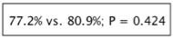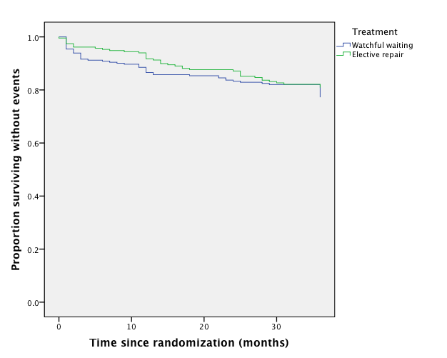Figure 3. The estimated overall 3-year event-free survival among patients aged 50 years and older with mildly symptomatic or asymptomatic inguinal hernia assigned to watchful waiting and elective repair, according to intension-to-treat analysis.

Number at risk
Watchful waiting | 262 |  | 225 | 203 |  | 137
Elective repair | 234 |  | 210 | 180 |  | 133

