Supplementary Figure Legend

Supplementary Figure 1. (A–C) Kaplan-Meier (KM) survival curves of tubular adenocarcinoma (AC) and signet ring cell carcinoma (SRC) are shown for (A) relapse-free survival (RFS) of all stages, (B) RFS of early gastric cancer (EGC), and (C) RFS of advanced gastric cancer (AGC). (D) KM curves comparing the RFS of patients with well differentiated (WD), moderately differentiated (MD), and poorly differentiated (PD) tubular adenocarcinoma and SRC for all stages. (E–I) RFS KM curves comparing those of patients with well-to-moderately differentiated (WMD) and poorly differentiated (PD) tubular adenocarcinoma and SRC at (E) EGC, (F) AGC, (G) American Joint Committee on Cancer, 7th edition (AJCC) stage I, (H) AJCC stage II, and (I) AJCC stage III.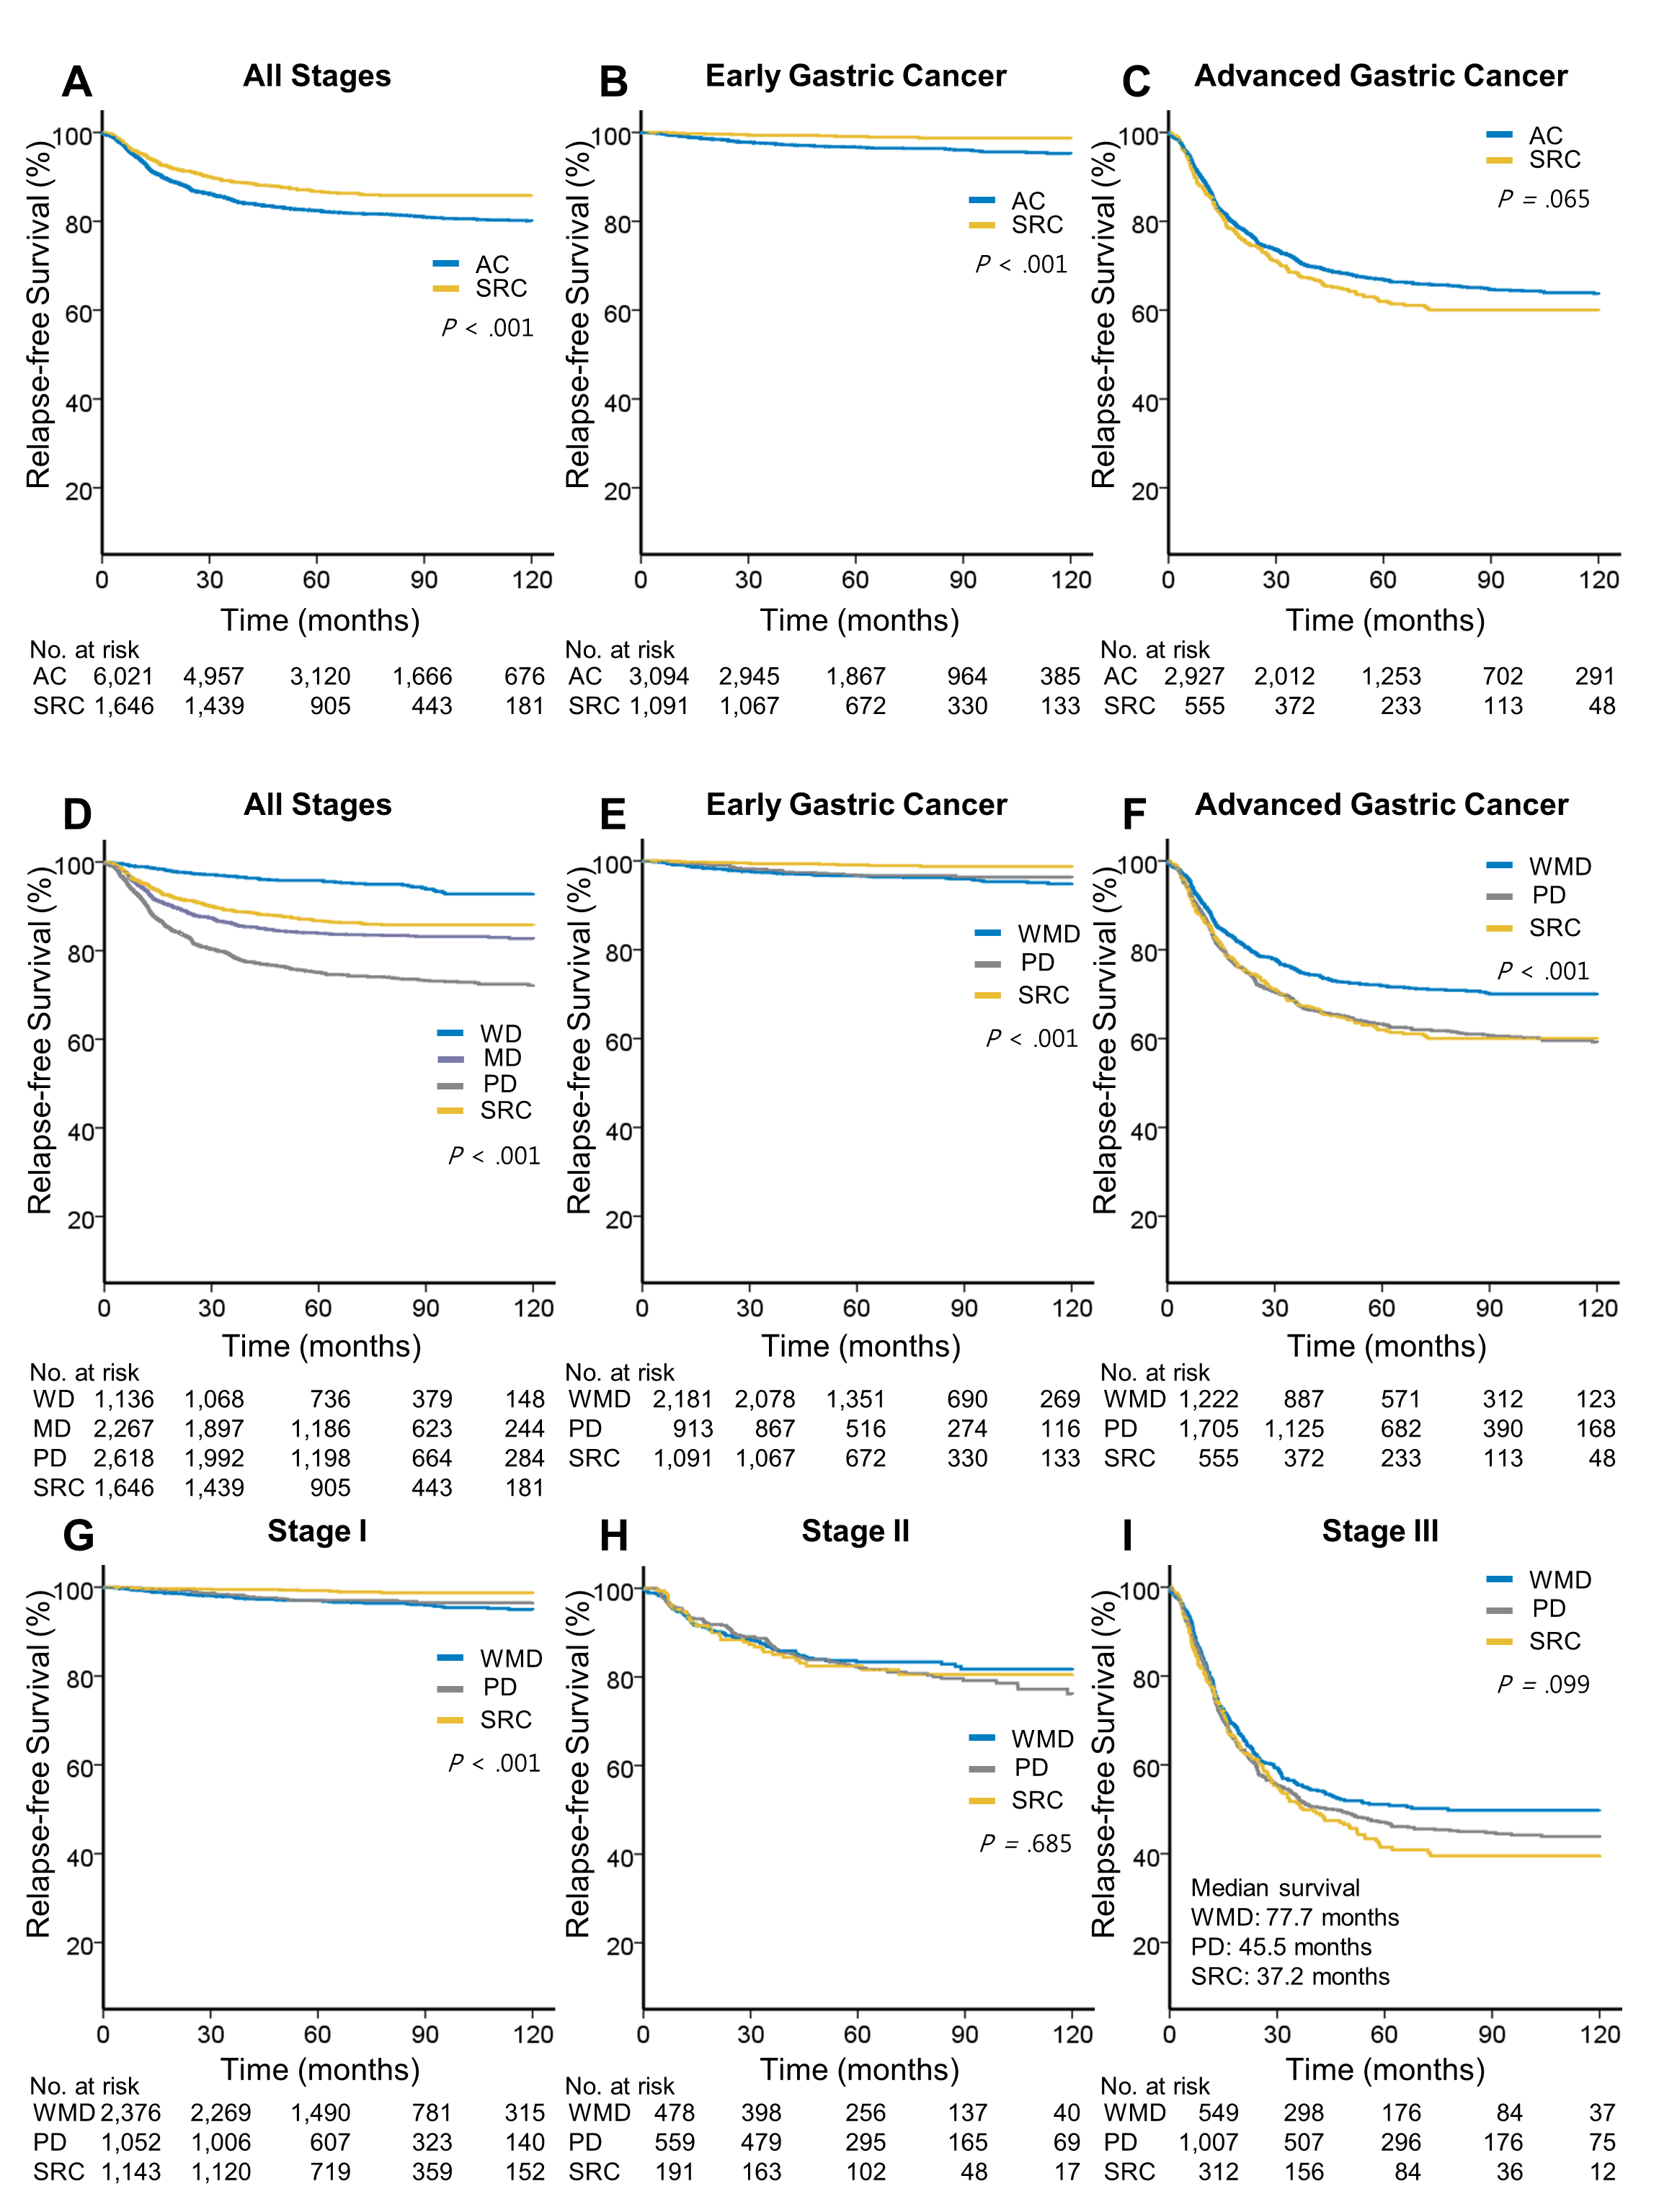

Supplementary Table 1. Unadjusted Factors Associated with Relapse-free Survival and Overall Survival
Variable | RFS |  |  |  | OS
 | HR | 95% CI | P |  | HR | 95% CI | P
WHO Histology & Grade
PD (vs. WMD) | 2.19 | 1.94 to 2.48 | < 0.001 |  | 1.78 | 1.60 to 1.98 | < 0.001
SRC (vs. WMD) | 1.07 | 0.91 to 1.26 | 0.425 |  | 0.91 | 0.79 to 1.06 | 0.218
SRC (vs. non-SRC) | 0.72 | 0.62 to 0.83 | < 0.001 |  | 0.69 | 0.61 to 0.79 | < 0.001
Lauren’s Classification
Diffuse (vs. intestinal) | 1.68 | 1.47 to 1.93 | < 0.001 |  | 1.42 | 1.25 to 1.60 | < 0.001
Mixed (vs. intestinal) | 1.47 | 1.11 to 1.93 | 0.006 |  | 1.17 | 0.91 to 1.51 | 0.218
Age at diagnosis | 1.01 | 1.00 to 1.01 | 0.023 |  | 1.03 | 1.03 to 1.04 | < 0.001
Female sex | 1.00 | 0.89 to 1.12 | 0.991 |  | 0.88 | 0.79 to 0.97 | 0.013
AJCC Stage
1B | 3.24 | 2.27 to 4.62 | < 0.001 |  | 1.87 | 1.47 to 2.39 | < 0.001
2A | 5.30 | 3.77 to 7.46 | < 0.001 |  | 2.59 | 2.02 to 3.33 | < 0.001
2B | 13.70 | 10.42 to 18.01 | < 0.001 |  | 5.06 | 4.16 to 6.16 | < 0.001
3A | 17.79 | 13.51 to 23.44 | < 0.001 |  | 6.44 | 5.27 to 7.86 | < 0.001
3B | 33.08 | 25.62 to 42.70 | < 0.001 |  | 11.15 | 9.36 to 13.29 | < 0.001
3C | 62.94 | 49.42 to 80.16 | < 0.001 |  | 22.40 | 19.19 to 26.14 | < 0.001
Tumor stage
T1b | 2.00 | 1.38 to 2.89 | < 0.001 |  | 1.61 | 1.27 to 2.04 | < 0.001
T2 | 6.02 | 4.24 to 8.55 | < 0.001 |  | 3.24 | 2.55 to 4.12 | < 0.001
T3 | 13.79 | 9.99 to 19.06 | < 0.001 |  | 6.25 | 5.02 to 7.79 | < 0.001
T4a | 34.83 | 25.80 to 47.04 | < 0.001 |  | 13.94 | 11.51 to 16.88 | < 0.001
T4b | 85.20 | 54.32 to 133.63 | < 0.001 |  | 27.98 | 19.19 to 40.81 | < 0.001
Node stage
N1 | 5.19 | 4.25 to 6.35 | < 0.001 |  | 2.83 | 2.40 to 3.35 | < 0.001
N2 | 9.63 | 8.01 to 11.58 | < 0.001 |  | 4.72 | 4.05 to 5.51 | < 0.001
N3a | 19.51 | 16.41 to 23.19 | < 0.001 |  | 10.02 | 8.72 to 11.51 | < 0.001
N3b | 36.83 | 30.71 to 44.16 | < 0.001 |  | 20.53 | 17.75 to 23.75 | < 0.001
Location
Middle | 0.76 | 0.64 to 0.91 | 0.002 |  | 0.78 | 0.67 to 0.91 | 0.002
Lower | 0.79 | 0.67 to 0.93 | 0.004 |  | 0.78 | 0.68 to 0.91 | 0.001
Whole | 4.23 | 2.17 to 8.26 | < 0.001 |  | 6.91 | 4.03 to 11.86 | < 0.001

Abbreviation: WMD, well-to-moderately differentiated; PD, poorly differentiated; SRC, signet ring cell carcinoma; HR, hazard ratio
* 5453 of 7667 patients with available data were analyzed according to Lauren’s classification.

Supplementary Table 2. Multiple Variable Model Predicting Risk of Recurrence and Mortality
Variable | RFS |  |  |  | OS
 | HR | 95% CI | p |  | HR | 95% CI | p
 | EGC
Age | 1.02 | 1.00 to 1.04 | 0.040 |  | 1.08 | 1.07 to 1.09 | < 0.001
Female | 0.63 | 0.41 to 0.96 | 0.033 |  | 0.53 | 0.39 to 0.71 | < 0.001
Submucosal invasion | 1.03 | 0.68 to 1.56 | 0.900 |  | 1.15 | 0.89 to 1.48 | 0.294
LN metastasis | 5.83 | 3.87 to 8.77 | < 0.001 |  | 2.22 | 1.61 to 3.05 | < 0.001
SRC (vs. non-SRC) | 0.40 | 0.21 to 0.76 | 0.005 |  | 0.66 | 0.45 to 0.99 | 0.043
 | AGC
Age | 1.00 | 1.00 to 1.01 | 0.252 |  | 1.02 | 1.02 to 1.03 | < 0.001
Female | 1.11 | 0.98 to 1.25 | 0.103 |  | 1.07 | 0.95 to 1.20 | 0.270
AJCC Stage
Stage II (vs. Stage I) | 3.71 | 2.50 to 5.52 | < 0.001 |  | 2.17 | 1.64 to 2.87 | < 0.001
Stage III (vs. Stage I) | 14.17 | 9.73 to 20.64 | < 0.001 |  | 7.14 | 5.51 to 9.25 | < 0.001
SRC (vs. non-SRC) | 1.11 | 0.96 to 1.30 | 0.170 |  | 1.26 | 1.09 to 1.46 | 0.002
Abbreviation: AGC, advanced gastric cancer; EGC, early gastric cancer; HR, hazard ratio; LN, lymph node; PD, poorly differentiated; SRC, signet ring cell carcinoma; WMD, well-to-moderately differentiated

