Supplemental Digital Content
Manuscript
Gero et al. Defining Global Benchmarks in Bariatric Surgery. A Multicenter Analysis of Minimally Invasive Roux-en-Y Gastric Bypass and Sleeve Gastrectomy. Annals of Surgery. 2019

Table of contents

Supplementary Tables
Supplementary Table 1. Baseline characteristics of patients and procedures.
Supplementary Table 2. Cumulative incidence (%) of the most common reasons for readmission after BS in benchmark patients.
Supplementary Table 3. Surgical outcomes after BS (A. RYGB, B. SG)
Supplementary Table 4. Comparison of outcomes in non-benchmark Roux-en-Y gastric bypass cases with the identified global benchmarks for RYGB.
Supplementary Table 5. Results of a literature review to identify published outcome data from the participating centers on consecutive RYGB cohorts or on non-benchmark RYGB patients.

Supplementary Figures
Supplementary Figure 1. Study flowchart.
Supplementary Figure 2. Rate of “uneventful postoperative course” in benchmark patients per included bariatric center
Supplementary Figure 3. Cumulative hazard of Clavien-Dindo grade > II events in benchmark patients during the first two years after bariatric surgery
Supplementary Figure 4. Cumulative hazard of Clavien-Dindo grade > II events during the first two years after BS, stratified by centers
Supplementary Figure 5. Correlation of center volume and cumulative morbidity (CCI®) at 90-days postoperatively.

Supplementary Table 1. Baseline characteristics of patients and procedures.
 | Roux-en-Y gastric bypass  n = 4120 | Sleeve gastrectomy  n = 1457
Patient characteristics
Age, years | 38.2 ± 11.1 | 37.0 ± 10.8
Sex (female/male) | 3302 (80.1%) / 818 (19.9%) | 1050 (72.1%) / 407 (27.9%)
Height, cm | 168.1 ± 9.0 | 167.4 ± 8.7
Weight, kg | 116.9 ± 17.6 | 109.3 ± 19.1
BMI, kg/m² | 41.3 ± 6.2 | 38.9 ± 5.2
Hypertension, n (%) | 891 (21.6) | 344 (23.6)
Gastro-esophageal reflux disease, n (%) | 905 (22.0) | 170 (11.7)
Hyperuricemia, n (%) | 112 (2.7) | 60 (4.1)
Depression, n (%) | 800 (19.4) | 117 (8.0)
Dyslipidemia, n (%) | 935 (22.7) | 388 (26.6)
Joint disorders, n (%) | 1200 (29.1) | 269 (18.5)
Smoking, n (%) | 733 (17.8) | 224 (15.4)
Operation characteristics
Approach: laparoscopic / robotic | 4112 (99.8%) / 8 (0.2%) | 1455 (99.9%) / 2 (0.1%)
Conversion to open, n (%) | 1 (0.0) | 0 (0.0)
Conversion to laparoscopic, n (%) | 5 (0.1) | 1 (0.1)
Operation duration, min | 91.3 ± 44.7 | 73.7 ± 34.4
Intraoperative drain placement, n (%) | 1481 (35.9) | 377 (25.9)
Anastomotic technique, (%) | circular: 53.5%, linear: 30.5%, hand-sewn: 15.5% | -
Staple line over-sewn (%) | - | 52.6%
Mesenteric defect closure (%) | 86.3% | -

Supplementary Table 2. Cumulative incidence (%) of the most common reasons for readmission in benchmark patients after bariatric surgery.
- Roux-en-Y gastric bypass (n= 4120, median follow-up = 1.9 year, [range: 0.25-6 years])
 | Until 30 days | Until 90 days | Until 1 year | Until last-follow-up
Abdominal pain of unknown origin | 0.51 (n=21) | 1.02 (n=42) | 2.52 (n=104) | 5 (n=206)
Symptomatic cholelithiasis | 0.05 (n=2) | 0.15 (n=6) | 2.45 (n=101) | 4.3 (n=177)
Internal hernia / small bowel obstruction | 0.24 (n=10) | 0.39 (n=16) | 1.43 (n=59) | 3.71 (n=153)
Dysphagia | 0.49 (n=20) | 1 (n=41) | 1.14 (n=47) | 1.26 (n=52)
Weight regain | 0 | 0 | 0 | 0.41 (n=17)
Anastomotic leak / perforation | 0.17 (n=7) | 0.17 (n=7) | 0.24 (n=10) | 0.32 (n=13)
Gastroesophageal reflux disease | 0.05 (n=2) | 0.12 (n=5) | 0.19 (n=8) | 0.27 (n=11)

- Sleeve gastrectomy (n = 1457, median follow-up = 1.6 year, [range: 0.25-6 years])
 | Until 30 days | Until 90 days | Until 1 year | Until last-follow-up
Symptomatic cholelithiasis | 0.07 (n=1) | 0.21 (n=3) | 1.3 (n=19) | 1.99 (n=29)
Abdominal pain of unknown origin | 0.55 (n=8) | 0.69 (n=10) | 1.44 (n=21) | 1.65 (n=24)
Gastroesophageal reflux disease | 0 | 0.07 (n=1) | 0.27 (n=4) | 0.75 (n=11)
Staple line leak | 0.48 (n=7) | 0.62 (n=9) | 0.62 (n=9) | 0.62 (n=9)
Weight regain | 0 | 0 | 0.07 (n=1) | 0.48 (n=7)

Supplementary Table 3. Surgical outcomes after BS (median and range of centers’ medians)
A. Roux-en-Y gastric bypass
1. Perioperative Course | Median (range)
Operation duration | 92 min (46 - 148)
Conversion to open surgery | 0% (0-0)
Intraoperative blood transfusions | 0 % (0 - 1.3)
Postoperative blood transfusions | 0.9 % (0 - 3)
Postoperative ICU admission | 0 % (0 - 1.3)
ICU stay in patients admitted to ICU | 0 day (0 - 1)
Hospital stay | 2 days (1 - 5)
Hospital cost in CH or USA / in the EU | 16204 (16204 - 18361) / 5402 (5402 - 6121)
Hospital cost in patients with complications in CH or USA / in the EU | 25982 (21717 - 31537) / 8662 (7240 - 10513)
 | Median (range) | Median (range) | Median (range)
2. Morbidity and Mortality | Until discharge | Until 30-days | Until 90-days
Uneventful postoperative course | 96 % (88 – 99.8) | 94 % (83 – 99.7) | 93 % (72 – 99.7)
Readmission | - | 2 % (0.09 - 9.5) | 3.7 % (1.5 - 20.5)
Reoperation | 1 % (0 - 5.3) | 1.6 % (0 - 4.2) | 1.7 % (0 - 6.2)
Any complication | 3.3 % (0.1 - 12) | 5.5 % (0.3 - 16.8) | 6.75 % (0.3 - 28.26)
Complication grade ≥ IIIa | 1.6 % (0 - 7) | 2 % (0 - 9.7) | 2.7 % (0 - 21.2)
Mortality | 0% (0-0) | 0% (0-0) | 0% (0-0)
CCI® In patients with at least 1 Clavien-Dindo Grade ≥II complication until 90-days | 20.92 (0 - 36.71) | 21.35 (0 - 36.71) | 33.63 (20.92 - 36.71)
Signature complications
Anastomotic leak | 0 % (0 - 0.017) | 0.1 % (0 - 3.3) | 0.2 % (0 - 3.3)
Stenosis of the anastomosis | 0 % (0 - 0.018) | 0 % (0 - 4) | 0.1 % (0 - 9.2)
Postoperative bleeding | 1.6 % (0 - 5.3) | 1.6 % (0 - 5.3) | 1.6 % (0 - 5.3)
Small bowel obstruction/internal hernia | 0.09 % (0 - 2.2) | 0.27 % (0 - 2.7) | 0.36 % (0 - 3.5)
Wound infection | 0 % (0 - 3.26) | 0 % (0 - 5.4) | 0 % (0 - 5.4)
Marginal ulcer | 0 % (0 - 1.6) | 0% (0 - 2.38) | 0.09 % (0 - 7)
B. Sleeve gastrectomy
A. Perioperative Course | Median (range)
Operation duration | 72 min (35 - 125)
Conversion to open surgery | 0% (0 - 0)
Intraoperative blood transfusions | 0% (0 - 0)
Postoperative blood transfusions | 0.6 % (0 - 1.8)
Postoperative ICU admission | 0 % (0 - 1.7)
ICU stay in patients admitted to ICU | 2 days (1 - 6)
Hospital stay | 2 days (1 - 5)
Hospital cost in CH or USA / in the EU | 16204 CHF (16204 - 16204) / 5402 EUR (5402 - 5402)
Hospital cost in patients with complications in CH or USA / in the EU | 24608 CHF (21717 - 34606) / 8203 EUR (7240 - 11536)
 | Median (range) | Median (range) | Median (range)
B. Morbidity and Mortality | Until discharge | Until 30-days | Until 90-days
Uneventful postoperative course | 98 % (88 - 100) | 96 % (83 - 100) | 95 % (83 - 98)
Readmission | - | 1.8 % (0 - 10.6) | 2.5% (0 - 10.6)
Reoperation | 0.7 % (0 - 3.8) | 1.1 % (0 - 7.1) | 1.4 % (0.5 - 7.1)
Any complication | 2 % (0 - 11.4) | 3.7 % (0 - 16.5) | 4.3 % (1.3 - 16.5)
Complication grade ≥ IIIa | 1.1 % (0 - 5) | 1.2 % (0 - 7.1) | 2.3 % (0.9 - 7.7)
Mortality | 0% (0 - 0) | 0% (0 - 0) | 0% (0 - 0)
CCI® In patients with at least 1 Clavien-Dindo Grade ≥II complication until 90 days | 4.3 (0 - 33.7) | 28.6 (0 - 39.7) | 33.73 (20.9 - 54.2)
Signature complications
Staple line leak | 0% (0 - 0) | 0% (0 - 4.6) | 0 % (0 - 10.8)
Dysphagia/Stenosis of the gastric tube | 0 % (0 - 7.6) | 0 % (0 - 7.6) | 0 % (0 - 7.6)
Postoperative bleeding | 1.17% (0 - 3.8) | 1.17 % (0 - 3.8) | 1.17 % (0 - 3.8)
Small bowel obstruction | 0 % (0 - 1.1) | 0 % (0 - 1.1) | 0 % (0 - 1.1)
Wound infection | 0 % (0-0) | 0 % (0-0) | 0 % (0-0)

Supplementary Table 4. Comparison of outcomes in non-benchmark Roux-en-Y gastric bypass (RYGB) cases operated during the study period in one participating center with the identified global benchmarks for RYGB.
1. Perioperative Course | Global benchmark cutoff (n=4120, 15 centers) | Outcomes in non-benchmark cases (n=468, 1 center)
Operation duration (benchmark cutoff / median, range) | ≤120 min | 117 min (55-450)
Intraoperative blood transfusions | 0% | 0.00%
Postoperative blood transfusions | ≤2% | 4.70%
Postoperative ICU admission | ≤0.14% | 0.43%
ICU stay in patients admitted to ICU (benchmark cutoff / median, range) | ≤1 day | 7 days (4-11)
Hospital stay (benchmark cutoff / median, range) | ≤4 days | 5 days (3-36)
 | Global benchmark cutoff (n=4120, 15 centers) | Outcomes in non-benchmark cases (n=468, 1 center) | Global benchmark cutoff (n=4120, 15 centers) | Outcomes in non-benchmark cases (n=468, 1 center)
2. Morbidity and Mortality | Inpatient stay | Inpatient stay | 90-day postoperative | 90-day postoperative
Uneventful postoperative course | >94% | 86.7% | >90% | 66%
Readmission | - | - | ≤5.5% | 19.6%
Reoperation | ≤2% | 2.80% | ≤4% | 11.5%
Any complication | ≤6% | 13.3% | ≤10% | 34%
Complication grade ≥ IIIa | ≤3.5% | 3.80% | ≤5.5% | 19.6%
Mortality | 0% | 0% | 0% | 0%
CCI® In patients with at least 1 Clavien-Dindo Grade ≥II complication (benchmark cutoff / median, inter-quartile range) | ≤26.2 | 20.9 (20.9 -33.7) | ≤33.7 | 33.7 (20.9 - 42.3)
Signature complications
Anastomotic leak | 0% | 0.21% | ≤1.3% | 0.64%
Stenosis of the anastomosis | 0% | 0% | ≤1.2% | 10.90%
Postoperative bleeding | ≤2.2% | 5.30% | ≤2.2% | 6.40%
Small bowel obstruction/internal hernia | ≤1.4% | 0.21% | ≤2.1% | 0.43%
Wound infection | ≤0.5% | 2.35% | ≤0.5% | 6.20%
Marginal ulcer | 0% | 0% | ≤1.5% | 2.13%

Supplementary Table 5. Results of a literature review to identify published outcome data from the participating centers on consecutive RYGB cohorts or on non-benchmark RYGB patients. The median rate of 30-day complications requiring re-intervention in these 10 studies covering a total of 3993 patients was 10.75%, more than the double of the benchmark cutoff for the same outcome indicator identified by the current study: 5%.
CD: Clavien-Dindo grade of postoperative complications; PMID: Pubmed ID; RYGB: Roux-en-Y gastric bypass
References
1. Peterli R, Borbely Y, Kern B, et al. Early results of the Swiss Multicentre Bypass or Sleeve Study (SM-BOSS): a prospective randomized trial comparing laparoscopic sleeve gastrectomy and Roux-en-Y gastric bypass. Ann Surg 2013; 258(5):690-4; discussion 695.
2. Weiner RA, El-Sayes IA, Theodoridou S, et al. Early post-operative complications: incidence, management, and impact on length of hospital stay. A retrospective comparison between laparoscopic gastric bypass and sleeve gastrectomy. Obes Surg 2013; 23(12):2004-12.
3. Gero D, Tzafos S, Milos G, et al. Predictors of a Healthy Eating Disorder Examination-Questionnaire (EDE-Q) Score 1 Year After Bariatric Surgery. Obes Surg 2019.
4. Pujol Rafols J, Al Abbas AI, Devriendt S, et al. Roux-en-Y gastric bypass, sleeve gastrectomy, or one anastomosis gastric bypass as rescue therapy after failed adjustable gastric banding: a multicenter comparative study. Surg Obes Relat Dis 2018; 14(11):1659-1666.
5. Khan OA, McGlone ER, Maynard W, et al. Single-stage conversions from failed gastric band to sleeve gastrectomy versus Roux-en-Y gastric bypass: results from the United Kingdom National Bariatric Surgical Registry. Surg Obes Relat Dis 2018; 14(10):1516-1520.
6. Debergh I, Defoort B, De Visschere M, et al. A one-step conversion from gastric banding to laparoscopic Roux-en-Y gastric bypass is as safe as a two-step conversion: A comparative analysis of 885 patients. Acta Chir Belg 2016; 116(5):271-277.
7. Langer FB, Bohdjalian A, Shakeri-Leidenmuhler S, et al. Conversion from sleeve gastrectomy to Roux-en-Y gastric bypass--indications and outcome. Obes Surg 2010; 20(7):835-40.
8. Abdemur A, Han SM, Lo Menzo E, et al. Reasons and outcomes of conversion of laparoscopic sleeve gastrectomy to Roux-en-Y gastric bypass for nonresponders. Surg Obes Relat Dis 2016; 12(1):113-8.
9. Homan J, Betzel B, Aarts EO, et al. Secondary surgery after sleeve gastrectomy: Roux-en-Y gastric bypass or biliopancreatic diversion with duodenal switch. Surg Obes Relat Dis 2015; 11(4):771-7.
10. Iannelli A, Debs T, Martini F, et al. Laparoscopic conversion of sleeve gastrectomy to Roux-en-Y gastric bypass: indications and preliminary results. Surg Obes Relat Dis 2016; 12(8):1533-1538.

Center | Cohort  (publication date) | CD>II  at 30-day (%) | N | Title
Basel | Consecutive RYGB (2013) | 4.5 | 110 | Early results of the Swiss Multicentre Bypass or Sleeve Study (SM-BOSS): a prospective randomized trial comparing laparoscopic sleeve gastrectomy and Roux-en-Y gastric bypass.¹
Offenbach | Consecutive RYGB (inpatient complications only) (2013) | 5 | 1345 | Early Post-operative Complications: Incidence, Management, and Impact on Length of Hospital Stay. A Retrospective Comparison Between Laparoscopic Gastric Bypass and Sleeve Gastrectomy²
Zurich | Consecutive RYGB (2019) | 15 | 135 | Predictors of a Healthy Eating Disorder Examination-Questionnaire (EDE-Q) Score 1 Year After Bariatric Surgery³
Brussels | Secondary RYGB after gastric band (2018) | 12.9 | 1219 | Roux-en-Y gastric bypass, sleeve gastrectomy, or one anastomosis gastric bypass as rescue therapy after failed adjustable gastric banding: a multicenter comparative study⁴
Taunton | Secondary RYGB after gastric band (2018) | 14.15 | 113 | Single-stage conversions from failed gastric band to sleeve gastrectomy versus Roux-en-Y gastric bypass: results from the United Kingdom National Bariatric Surgical Registry.⁵
Bruges | Secondary RYGB after gastric band (2016) | 5.1 | 885 | A one-step conversion from gastric banding to laparoscopic Roux-en-Y gastric bypass is as safe as a two-step conversion: A comparative analysis of 885 patients.⁶
Wien | Secondary RYGB after sleeve gastrectomy (2010) | 12.5 | 73 | Conversion from Sleeve Gastrectomy to Roux-en-Y Gastric Bypass—Indications and Outcome⁷
Weston | Secondary RYGB after sleeve gastrectomy (2016) | 3.3 | 30 | Reasons and outcomes of conversion of laparoscopic sleeve gastrectomy to Roux-en-Y gastric bypass for nonresponders⁸
Arnhem | Secondary RYGB or duodenal switch after sleeve gastrectomy (2015) | 9 | 43 | Secondary surgery after sleeve gastrectomy: Roux-en-Y gastric bypass or biliopancreatic diversion with duodenal switch⁹
Nice | Secondary RYGB after sleeve gastrectomy (2016) | 14 | 40 | Laparoscopic conversion of sleeve gastrectomy to Roux-en-Y gastric bypass: indications and preliminary results¹⁰
Overall | Median | 10.75
 | 75th percentile | 13.72

Supplementary Figure 1. Study flowchart.
RYGB: Roux-en-Y gastric bypass, SG: sleeve gastrectomy, FU: follow-up

Supplementary Figure 2. Rate of “uneventful postoperative course” in benchmark patients per included bariatric center (anonymized). Red dashed line: Benchmark cut-off at 90-days
- Roux-en-Y gastric bypass
- Sleeve gastrectomy

Supplementary Figure 3. Cumulative hazard of Clavien-Dindo grade > II events in benchmark patients during the first two years after bariatric surgery (Roux-en-Y gastric bypass and sleeve gastrectomy).

Supplementary Figure 4. Cumulative hazard of Clavien-Dindo grade > II events in benchmark patients during the first two years after, stratified by centers
- Roux-en-Y gastric bypass
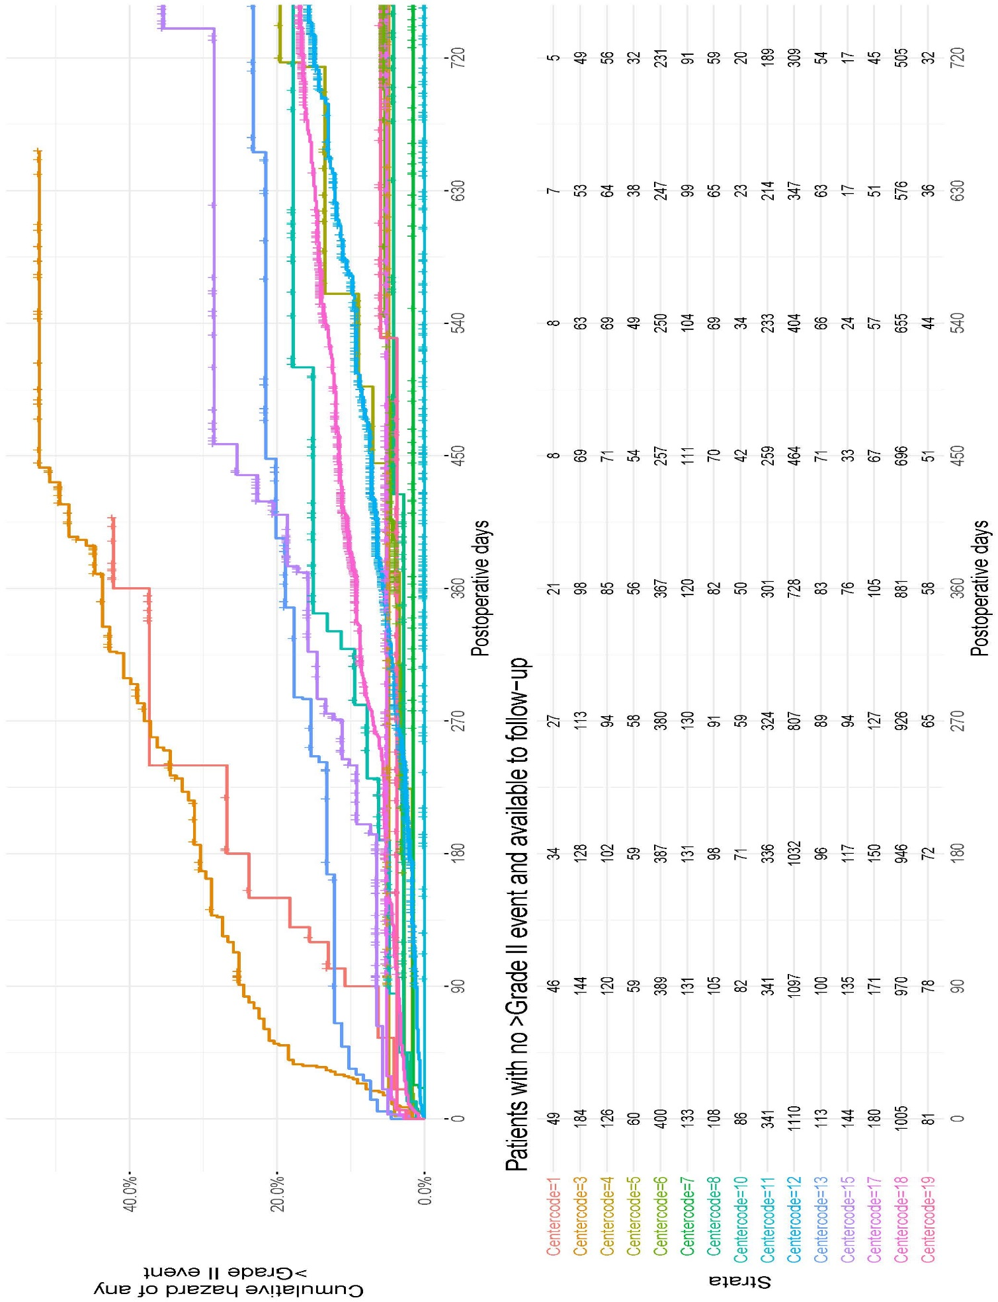
- Sleeve gastrectomy
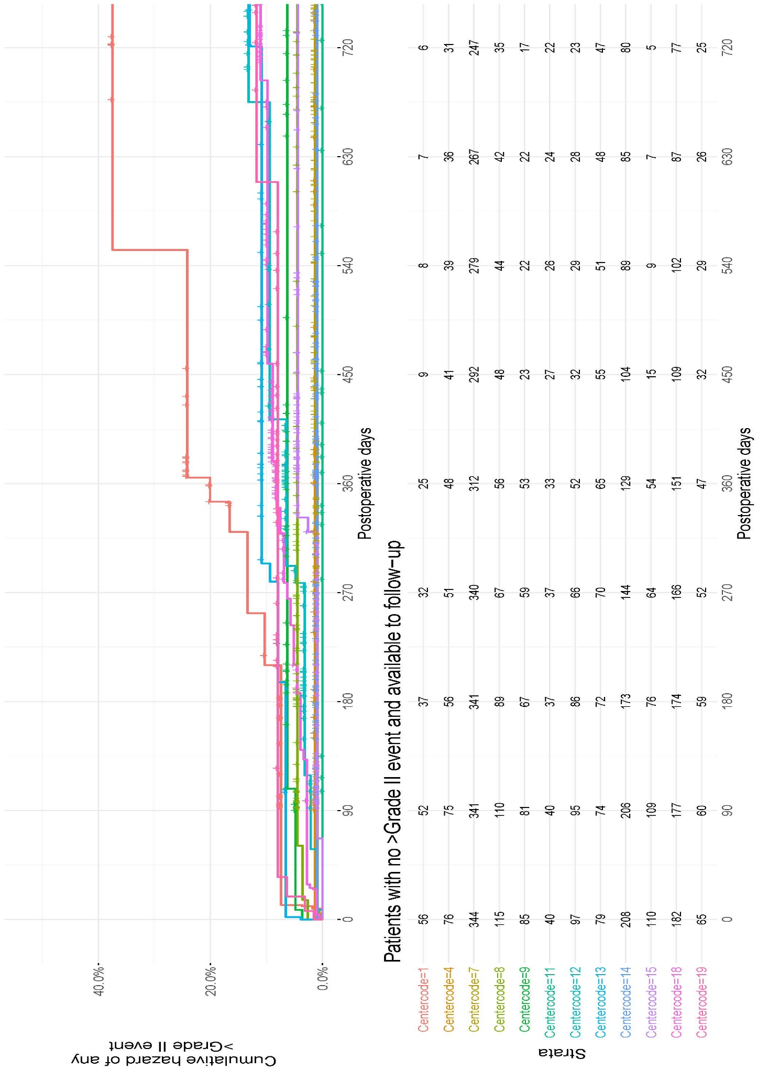

Supplementary Figure 5. Correlation of center volume and cumulative morbidity (CCI®) at 90-days postoperatively.
A. Elective bariatric caseload over 5-years and mean CCI® in benchmark RYGB cases over the first 90-days postoperatively (r = -0.37, P = 0.17).
B. Benchmark RYGB cases over 5-years and mean CCI® in benchmark RYGB cases over the first 90-days postoperatively (r = -0.24, P = 0.38).
C. Elective bariatric caseload over 5-years and mean CCI® in benchmark SG cases over the first 90-days postoperatively (r = -0.34, P = 0.28).
D. Benchmark SG cases over 5-years and mean CCI® in benchmark SG cases over the first 90-days postoperatively (r = -0.41, P = 0.19).

