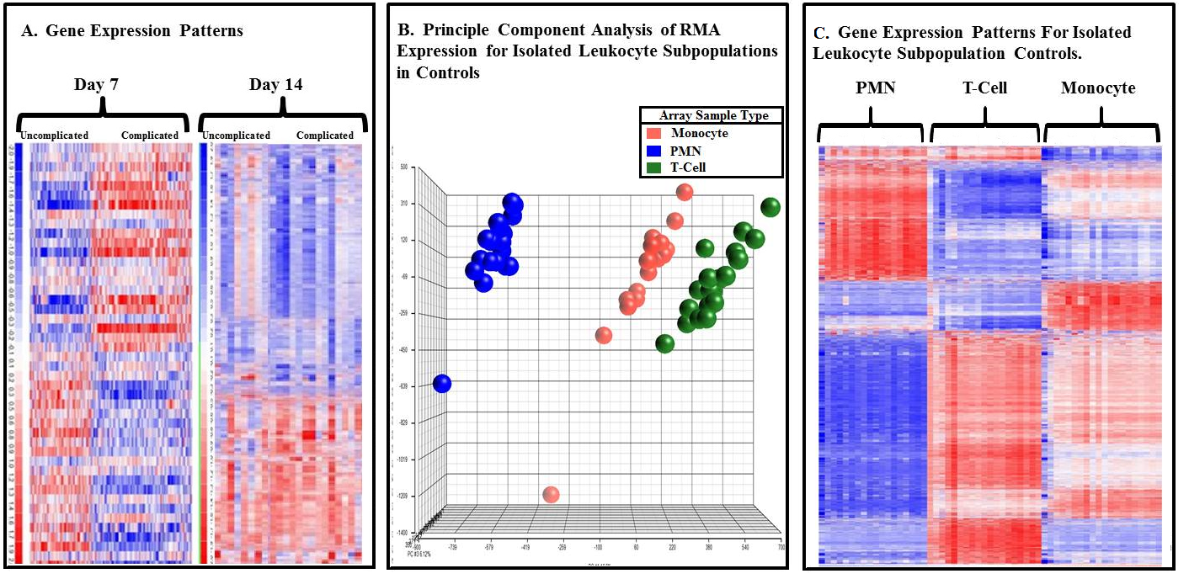
Figure 1a. Microarray analysis of gene changes associated with an uncomplicated or complicated Recovery. This is a heat map showing a cluster analysis of the expression of the probe sets between complicated (n=41) and uncomplicated (n=55) clinical trajectories in the 167 patients with whole blood leukocyte data on day 7 and 14. Blue indicates down regulated genes and red indicated up regulated genes. 415 probe sets were found to significantly differentiate between complicated and uncomplicated patients by t-test on day 7 (p <0.001) and on day 14, 26,842 probe sets were significantly deferentially expressed between complicated, uncomplicated and control cohorts by f-test (p <0.001). b. Visual Representation of Individual Leukocyte Subpopulation Gene RMA Expression for the 21 Healthy Controls. 20 monocyte (red), 18 neutrophil (PMN) (blue) and 19 T-Cell (green) control arrays were used for comparison of the 244 trauma patients with leukocyte subpopulation data. The gene patterns of the individual cell lines were analyzed by principle component analysis (PCA) creating a visual representation of the overall RMA expression for each cell line in the 21 healthy patients used for controls. PCA analysis showed overall RMA expression per array clustered together within cell lines and expression was different between the individual cell lines. c. Microarray analysis of genomic expression patterns in individual cell populations controls. This is a heat map showing a unsupervised cluster analysis of the expression of the probe set arrays between the individual leukocyte subpopulations in the 21 control patients. Blue indicates up regulated genes and red represents up regulated genes. 4614 probe sets were found to significantly differentiate between T-cell, monocyte and PMN cell lines (p<0.01).

