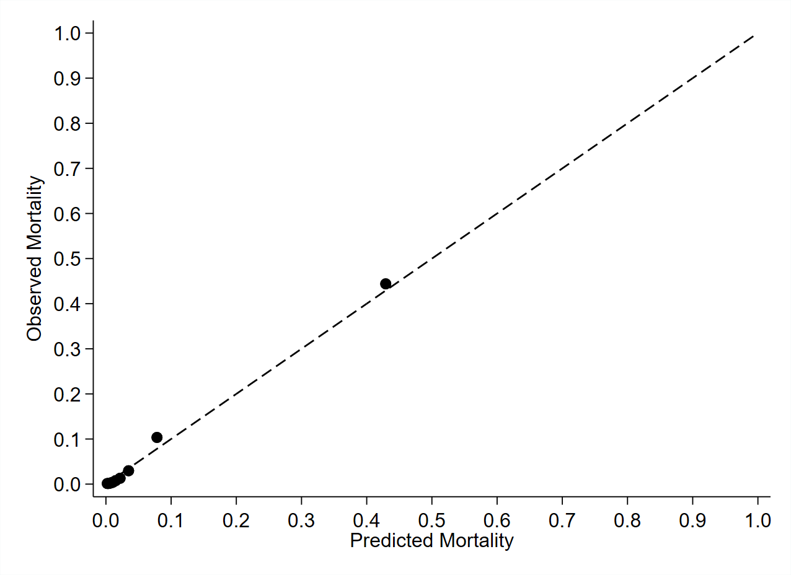
eFigure 1. Calibration curve of predicted versus observed mortality across predicted mortality risk deciles from the multivariable risk-adjustment logistic regression model.

