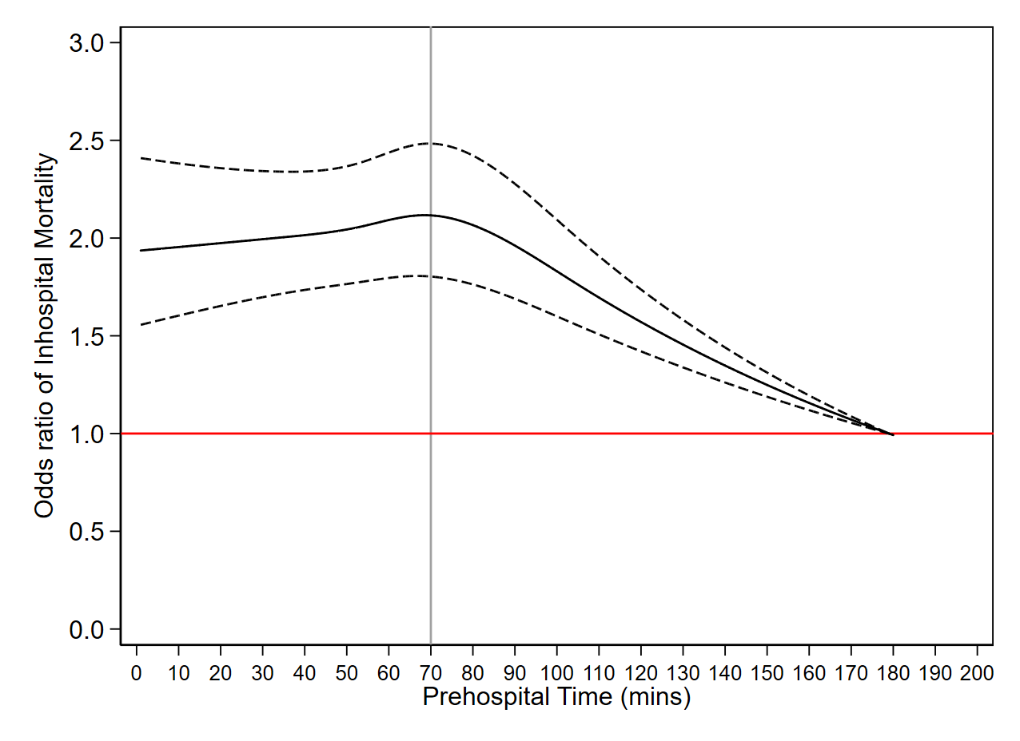
eFigure 2. Mortality rate (left axis) and odds of mortality (right axis) from cubic spline regression plotted against total prehospital time in PTOS. Top horizontal dashed line represents 5% mortality rate. Prehospital times ≤30 minutes have a mortality rate of 5% or greater, whereas prehospital times >30 minutes have a mortality rate less than 5%. Bottom horizontal dashed line represents odds of mortality of 1.0. The odds of mortality increase above 1.0 at prehospital times of ≤30minutes (vertical gray line).

