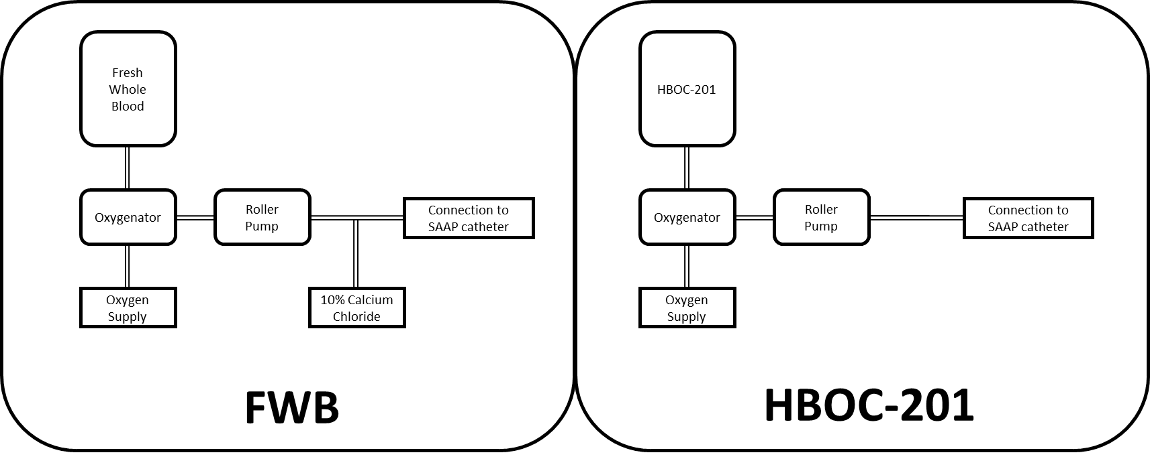
Supplemental Figure 1 – Bespoke SAAP circuit diagrams for each experimental group. SAAP – Selective Aortic Arch Perfusion; FWB – Fresh Whole Blood; HBOC – Hemoglobin-based oxygen carrier. During SAAP therapy, fresh whole blood or HBOC-201 is stored in a 3L reservoir, then oxygenated and pumped into the aorta in a retrograde fashion. When using fresh whole blood, concurrent administration of calcium chloride solution is necessary to maintain a normal range of ionized calcium.

