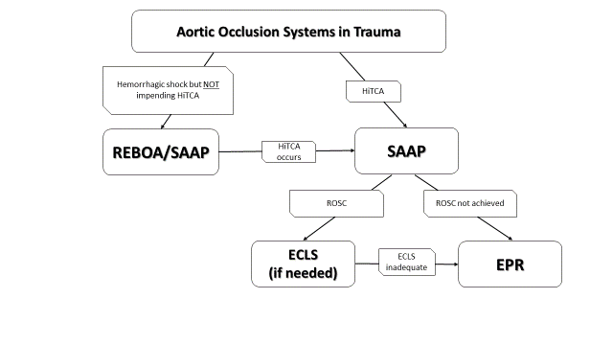
Supplemental Figure 2 – Spectrum of aortic interventions in the treatment of hemorrhagic shock and hemorrhage-induced cardiac arrest. REBOA – Resuscitative Endovascular Balloon Occlusion of the Aorta; SAAP – Selective Aortic Arch Perfusion; HiTCA – Hemorrhage-induced Traumatic Cardiac Arrest; ECLS – Extracorporeal Life Support; ROSC – Return of spontaneous circulation; EPR – Emergency Preservation and Resuscitation

