Supplemental Digital Content
Supplemental Figure 1: Bland-Altman Plots for the Primary Comparison Analysis for CK.R (panel A), CRT.MA (panel B), CRT.MA vs CK. MA (panel C), CFF.MA (panel D) and CK.LY30 (panel E)
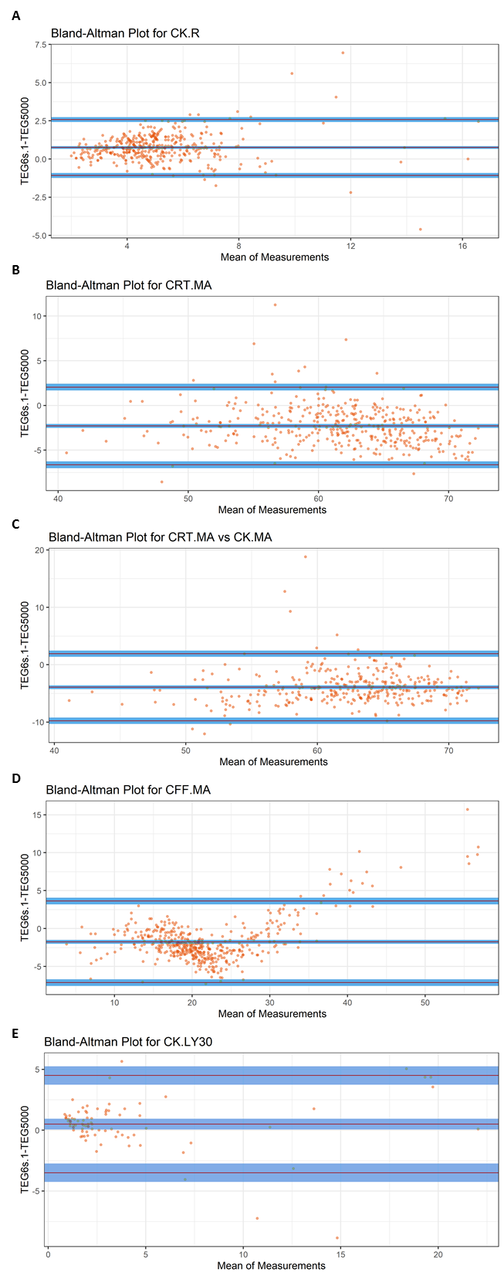
CFF.MA, citrated functional fibrinogen maximum amplitude; CK.LY30, citrated kaolin clot lysis at 30 minutes; CK.R, citrated kaolin reaction time; CRT.MA, citrated RapidTEG™ maximum amplitude

