Supplemental Figure 2: Bland-Altman Plots for the within device comparison for TEG® 6s for CK.R (panel A), CRT.MA (panel B), CRT.MA vs CK.MA (panel C), CFF.MA (panel D) and CK.LY30 (panel E)
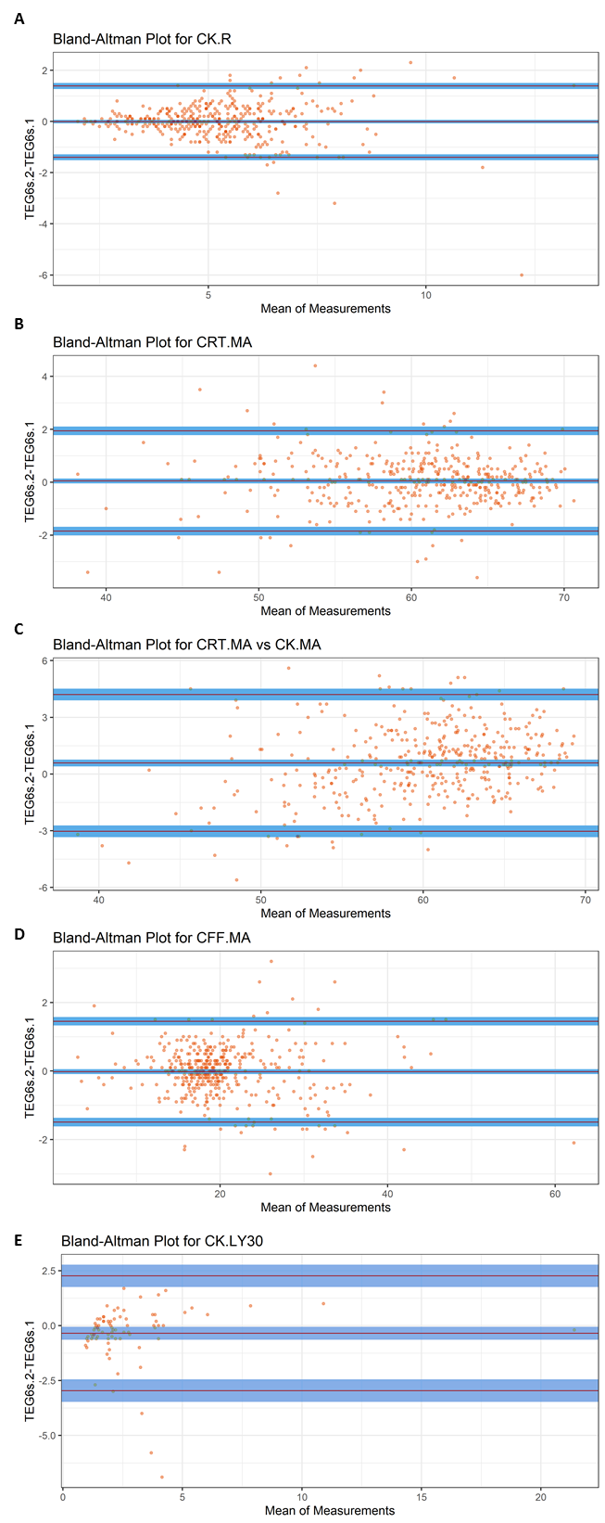
CFF.MA, citrated functional fibrinogen maximum amplitude; CK.LY30, citrated kaolin clot lysis at 30 minutes; CK.R, citrated kaolin reaction time; CRT.MA, citrated RapidTEG™ maximum amplitude
Supplemental Figure 3: Bland-Altman Plots for the within device comparison for TEG® 5000 for CK.R (panel A), CRT.MA (panel B), CRT.MA vs CK.MA (panel C), CFF.MA (panel D) and CK.LY30 (panel E)
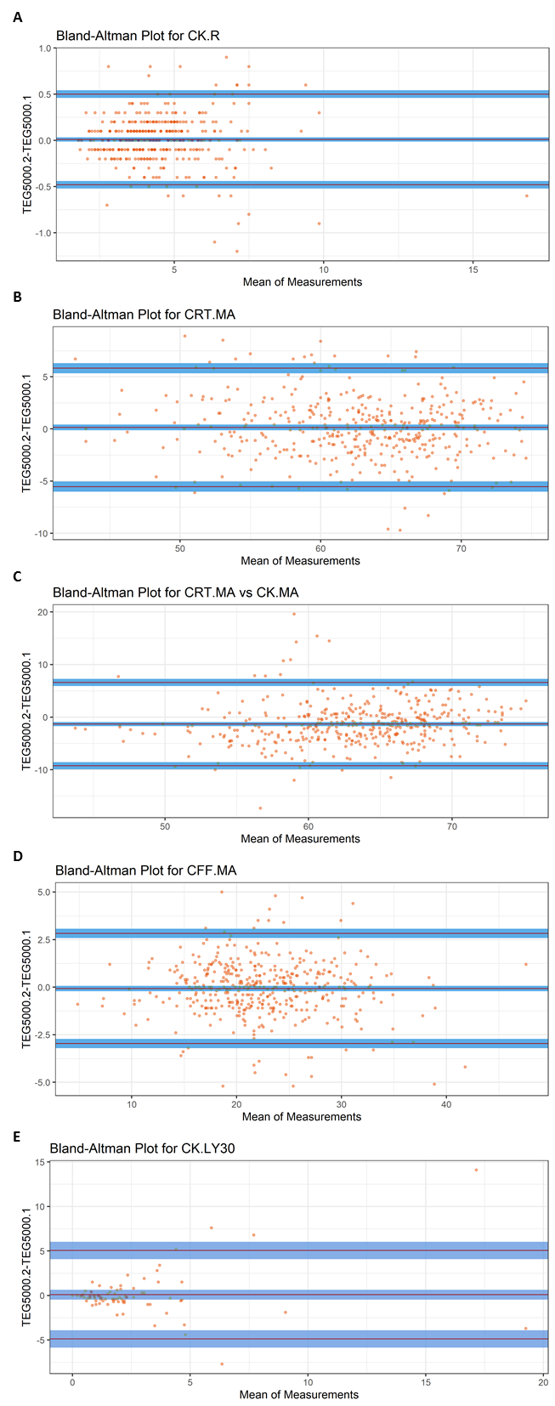
CFF.MA, citrated functional fibrinogen maximum amplitude; CK.LY30, citrated kaolin clot lysis at 30 minutes; CK.R, citrated kaolin reaction time; CRT.MA, citrated RapidTEG™ maximum amplitude

