Supplemental Figure 4: Comparison of TEG® 6s vs TEG® 5000 replicates for CK.R (panel A), CRT.MA (panel B), CRT.MA (TEG® 6s) vs. CK.MA (TEG® 5000) (panel C), CFF.MA (panel D) and CK.LY30 (panel E).
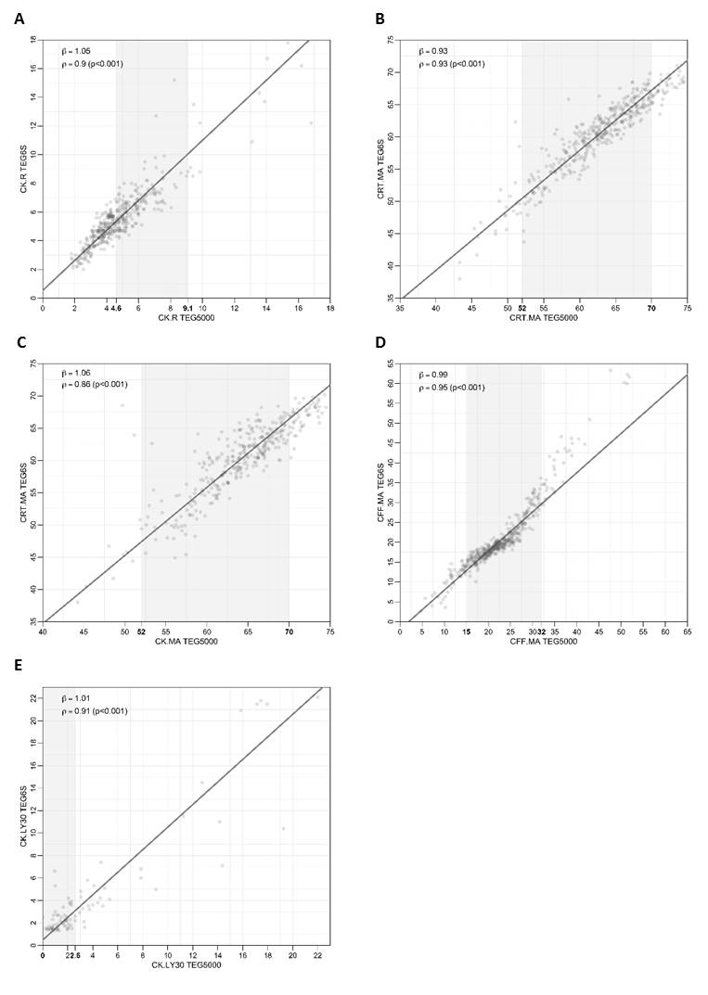
Axes numbers in bold indicate reference range; the overall range of graph is in line with the analytical measurement range
CFF.MA, citrated functional fibrinogen maximum amplitude; CK.LY30, citrated kaolin clot lysis at 30 minutes; CK.R, citrated kaolin reaction time; CRT.MA, citrated RapidTEG™ maximum amplitude

