Supplemental Figure 5: TEG® 5000 Comparison of Replicates for Internal Agreement for CK.R (panel A), CRT.MA (panel B), CRT.MA vs CK. MA (panel C), CFF.MA (panel D) and CK.LY30 (panel E).
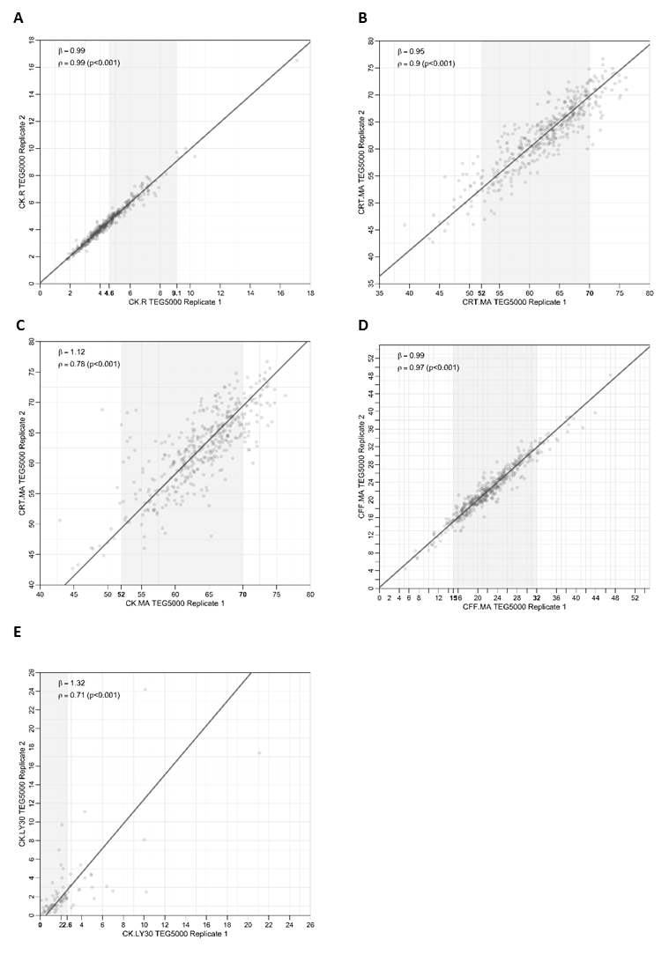
Axes numbers in bold indicate reference range; the overall range of graph is in line with the analytical measurement range
CFF.MA, citrated functional fibrinogen maximum amplitude; CK.LY30, citrated kaolin clot lysis at 30 minutes; CK.R, citrated kaolin reaction time; CRT.MA, citrated RapidTEG™ maximum amplitude

Supplemental Figure 6: TEG® 6s Comparison of Replicates for Internal Agreement for CK.R (Panel A), CFF.MA (Panel B), CK.LY30 (Panel C), CRT.MA vs. CK.MA (Panel D) and CRT.MA (Panel E).
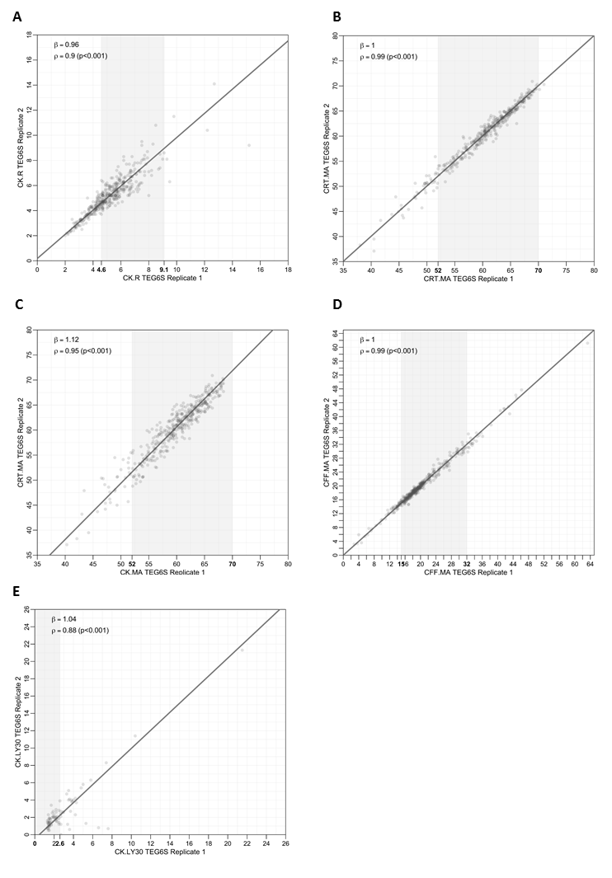
Axes numbers in bold indicate reference range; the overall range of graph is in line with the analytical measurement range
CFF.MA, citrated functional fibrinogen maximum amplitude; CK.LY30, citrated kaolin clot lysis at 30 minutes; CK.R, citrated kaolin reaction time; CRT.MA, citrated RapidTEG™ maximum amplitude

