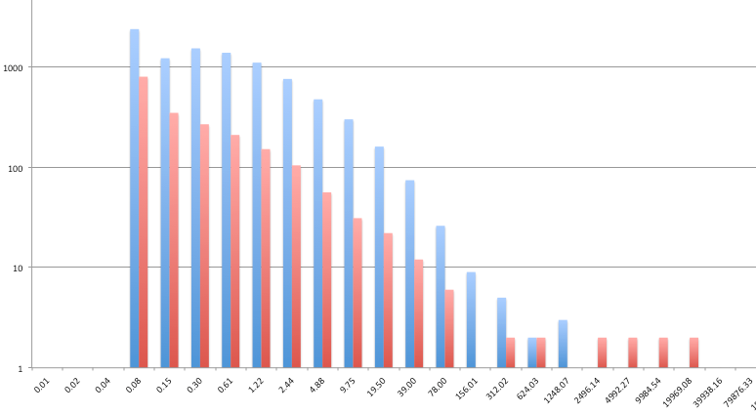
Supplemental Figure 3. Porosity measurements for control clots (blue) and t-PA hypersensitive hyperfibrinolytic samples (red) demonstrate that while both controls and t-PA hypersensitive hyperfibrinolytic trauma samples had many small pores in their 3-D structure, clots from this particular trauma subgroup also had massive pores up to 20,000µm³. X-axis, pore size in µm³, Y-axis in incidence, logarithmic scale.

