SUPPLEMENTAL METHODS AND RESULTS
1. Systematic review
1.1. Methods
We searched six databases from inception through June 2015 using subject headings and free text terms: Medline, Embase, PsycInfo (via Ovid), Cochrane Database of Systematic reviews (CDSR), Database of Abstracts and Reviews of Effects (DARE) and Cochrane Central Register of Controlled Trials (CENTRAL) (via the Cochrane Library of Systematic Reviews) (search strategy provided in Supplementary Figure 1). We contacted experts in the field and used backward and forward citation searching to identify additional publications. We included long-term (mean follow-up of >12 months) observational or interventional studies with a dementia assessment at baseline and follow-up in CABG patients and a comparison group. We excluded studies if incident dementia was not an outcome, mean length of follow-up was unclear or ≤12 months, or CABG patients were combined with patients receiving other revascularization procedures. We excluded case reports, narrative reviews, letters, editorials, opinions, meeting abstracts, and conference reports. No language restrictions were applied. Two reviewers (EK and JA) independently screened titles, abstracts, and full-texts. Discrepancies were resolved by discussion with a third reviewer (DJL). Two reviewers (EK and JA) independently assessed risk of bias using the Quality Assessment Tool for Quantitative Studies (1). This was checked by a third reviewer (IL) and discrepancies were resolved by discussion.
1.2 Results
Our searches yielded a total of 758 references. After removing 209 duplicates, 532 records were excluded based on title and abstract screening. We conducted a full-text review of 17 publications of which 6 studies (5 cohort and 1 case-control) met our inclusion criteria (see flowchart in Supplemental Figure 2). Key characteristics of included studies are presented in Supplemental Table 1 and a summary of their results is shown in Table 1. All included studies were of moderate quality (see Supplemental Table 2).

SUPPLEMENTAL REFERENCES
1. Thomas BH, Ciliska D, Dobbins M, et al. A process for systematically reviewing the literature: providing the research evidence for public health nursing interventions. Worldviews Evid Based Nurs. 2004;1(3):176-84.
SUPPLEMENTAL TABLE 1. Key Characteristics of Included Studies
Study | Study design | Country | Analytic sample sizeª | Mean baseline age | Male, % | Mean follow-up in years | Comparison group | Outcomes
Barnes et al.¹³ | Cohort (CHS) | USA | 3375^{b} | 75 | 41 | 6 | No CABG history | All-cause dementia
Kuller et al.¹⁸ | Cohort (CHS) | USA | 2531 | Not reported | Not reported | 5.7^{c} | No CABG history | VaD
Hayden et al.¹⁴ | Cohort (CCSMHA) | USA | 3264 | 74.0 | 41.8 | 3.2 | No CABG history | All-cause dementia, AD, VaD
Lee et al.¹⁷ | Cohort (VA patients) | USA | 9170 | 66.9 | 98.4 | 4.8 | PCI | AD
Mutch et al.¹⁶ | Cohort (Manitoba medical records) | Canada | 36261 | 73.8 | 57.6 | 4.9 | PCI and MM of ischemic heart disease | All-cause dementia
Knopman et al.¹⁵ | Case-control (REP) | USA | Dementia cases: 557  Controls: 557 | Dementia cases: 82^{d}  Controls: 82^{d} | Dementia cases: 30.5  Controls: 30.5 | Dementia cases: 5.5e  Controls: 3.9e | No CABG history | All-cause dementia, AD
Abbreviations: AD, Alzheimer’s disease; CABG, coronary artery bypass graft surgery; CCSMHA, Cache County Study of Memory Health and Aging; CHS, Cardiovascular Health Study; MM, medical management; PCI, percutaneous coronary intervention; REP, Rochester Epidemiology Project; VA, Veterans Affairs; VaD, vascular dementia
ª Analytic sample size for all-cause dementia unless otherwise stated
^{b} Participants of the Cardiovascular Health Cognition Study included in the study; analytic sample size not reported
^{c} Mean follow-up of N = 3375 dementia-free participants at the time of neuroimaging assessment (1991-1994)
^{d} Median
^{e} Median lag time from first CABG to dementia / index year

SUPPLEMENTAL TABLE 2. Quality Assessment of Included Studies
Study | Selection bias | Study design | Confounders | Blinding | Data collection method | Withdrawals and dropouts | Global rating
Barnes et al.¹³ | Moderate | Moderate | Strong | Moderate | Strong | Moderate | Moderate
Kuller et al.¹⁸ | Moderate | Moderate | Moderate | Moderate | Strong | Moderate | Moderate
Hayden et al.¹⁴ | Strong | Moderate | Strong | Moderate | Strong | Moderate | Moderate
Lee et al.¹⁷ | Moderate | Moderate | Strong | Moderate | Moderate | Moderate | Moderate
Mutch et al.¹⁶ | Strong | Moderate | Strong | Moderate | Moderate | Moderate | Moderate
Knopman et al.¹⁵ | Strong | Moderate | Moderate | Moderate | Strong | Not applicable | Moderate

SUPPLEMENTAL TABLE 3. Cox Proportional Hazards Regression Models of Incident All-cause Dementia, Alzheimer’s Disease, Vascular Dementia and Mixed Dementia by History of CABG, Where Participants Without a History of CABG Served as the Reference Group With Additional Adjustment for Potential Confounders or Exclusion of Those Without Cardiovascular Disease or Coronary Artery Disease or Early Converters
Dementia status | No. of participants | No. of dementia cases in those with CABG history / total CABG history | No. of dementia cases in those without CABG history / total no CABG history | HR | 95% CI | P value
All-cause dementia
Model Cª | 3128 | 35/158 | 395/2970 | 1.86 | 1.30, 2.66 | 0.001
Model D^{b} | 3154 | 37/161 | 402/2993 | 1.97 | 1.39, 2.80 | <0.001
Model E^{c} | 3064 | 36/157 | 394/2907 | 2.00 | 1.40, 2.85 | <0.001
Model F^{d} | 2898 | 30/148 | 350/2750 | 1.97 | 1.34, 2.90 | 0.001
Model G^{e} | 2317 | 37/161 | 321/2156 | 1.89 | 1.33, 2.68 | <0.001
Model H^{f} | 629 | 33/153 | 72/476 | 1.88 | 1.21, 2.93 | 0.01
Model I^{g} | 3126 | 35/159 | 375/2967 | 2.01 | 1.40, 2.87 | <0.001
Alzheimer’s disease
Model Cª | 2915 | 13/136 | 208/2779 | 1.59 | 0.89, 2.83 | 0.12
Model D^{b} | 2936 | 14/138 | 211/2798 | 1.77 | 1.01, 3.10 | 0.04
Model E^{c} | 2849 | 13/134 | 206/2715 | 1.68 | 0.94, 2.97 | 0.08
Model F^{d} | 2707 | 11/129 | 182/2578 | 1.68 | 0.90, 3.14 | 0.11
Model G^{e} | 2129 | 14/138 | 160/1991 | 1.73 | 0.99, 3.03 | 0.06
Model H^{f} | 571 | 12/132 | 36/439 | 1.55 | 0.77, 3.12 | 0.22
Model I^{g} | 2925 | 14/138 | 199/2787 | 1.83 | 1.05, 3.21 | 0.03
Vascular dementia
Model Cª | 2744 | 4/127 | 51/2617 | 1.11 | 0.39, 3.15 | 0.84
Model D^{b} | 2762 | 5/129 | 51/2633 | 1.45 | 0.56, 3.72 | 0.45
Model E^{c} | 2680 | 5/126 | 50/2554 | 1.54 | 0.60, 3.98 | 0.37
Model F^{d} | 2561 | 5/123 | 47/2438 | 1.56 | 0.60, 4.03 | 0.36
Model G^{e} | 2003 | 5/129 | 48/1874 | 1.38 | 0.54, 3.54 | 0.50
Model H^{f} | 538 | 5/125 | 14/413 | 1.21 | 0.41, 3.59 | 0.73
Model I^{g} | 2756 | 5/129 | 44/2627 | 1.65 | 0.64, 4.26 | 0.30
Mixed dementia
Model Cª | 2826 | 15/138 | 119/2688 | 2.75 | 1.56, 4.85 | <0.001
Model D^{b} | 2847 | 15/139 | 123/2708 | 2.76 | 1.56, 4.85 | <0.001
Model E^{c} | 2764 | 15/136 | 121/2628 | 3.01 | 1.71, 5.31 | <0.001
Model F^{d} | 2634 | 12/130 | 110/2504 | 2.90 | 1.54, 5.45 | 0.001
Model G^{e} | 2068 | 15/139 | 100/1929 | 2.67 | 1.51, 4.71 | 0.001
Model H^{f} | 554 | 14/134 | 20/420 | 3.39 | 1.60, 7.18 | 0.001
Model I^{g} | 2838 | 13/137 | 115/2701 | 2.63 | 1.44, 4.81 | 0.002
Abbreviations: CABG, coronary artery bypass graft surgery; CI, confidence interval; HR, hazard ratio;
ª Adjusted for age, sex, ethnicity, education, cardiovascular disease, hypertension, diabetes and body mass index
^{b} Adjusted for age, sex, ethnicity, education, cardiovascular disease, hypertension, diabetes and depressive symptoms
^{c} Adjusted for age, sex, ethnicity, education, cardiovascular disease, hypertension, diabetes and smoking, alcohol consumption, and physical activity
^{d} Adjusted for age, sex, ethnicity, education, cardiovascular disease, hypertension, diabetes and apolipoprotein E
^{e} Adjusted for age, sex, ethnicity, education, hypertension and diabetes; restricted to those with cardiovascular disease
^{f} Adjusted for age, sex, ethnicity, education, hypertension and diabetes; restricted to those with coronary artery disease
^{g} Adjusted for age, sex, ethnicity, education, cardiovascular disease, hypertension, diabetes after exclusion of early converters
SUPPLEMENTAL TABLE 4. Cox Proportional Hazards Regression Models of Incident All-cause Dementia, Alzheimer’s Disease, Vascular Dementia and Mixed Dementia by History of CABG Compared to History of PCI, Where Participants With a History of PCI Served as the Reference Group
Dementia status | No. of participants | No. of dementia cases in those with CABG history / total CABG history | No. of dementia cases in those with PCI history / total PCI history | Model Aª  HR | Model Aª  95% CI | P value | Model B^{b}  HR | Model B^{b}  95% CI | P value
All-cause dementia | 208 | 37/159 | 6/49 | 1.93 | 0.80, 4.68 | 0.15 | 2.16 | 0.88, 5.29 | 0.09
Alzheimer’s disease | 183 | 14/136 | 4/47 | 0.85 | 0.26, 2.77 | 0.79 | 0.85 | 0.25, 2.84 | 0.79
Vascular dementia | 171 | 5/127 | 1/44 | 1.06 | 0.11, 9.86 | 0.96 | 1.46 | 0.15, 14.22 | 0.75
Mixed dementia | 181 | 15/137 | 1/44 | 5.02 | 0.64, 39.43 | 0.13 | 6.04 | 0.77, 47.57 | 0.09
Abbreviations: CABG, coronary artery bypass graft surgery; CI, confidence interval; HR, hazard ratio; PCI, percutaneous coronary intervention;
ª Adjusted for age, sex, ethnicity and education
^{b} Adjusted for Model A, hypertension and diabetes

1 exp coronary artery bypass/ or exp coronary artery bypass, off-pump/ (46144)
2 exp Cardiopulmonary Bypass/ (20454)
3 exp Myocardial Revascularization/ (81602)
4 ((aortocoronary or aorto-coronary or coronary or cardiac or cardiopulmonary or cardio-pulmonary or thoracic or heart or myocardial or cardiovascular or cardio-vascular or cardiothoracic or cardio-thoracic) adj (bypass* or by-pass* or revasculari* or graft* or surg*)).ti,ab. (95954)
5 (coronary artery adj (bypass* or by-pass*)).ti,ab. (32577)
6 CABG.ti,ab. (13628)
7 ((bypass* or by-pass*) adj (graft* or surg*)).ti,ab. (49979)
8 1 or 2 or 3 or 4 or 5 or 6 or 7 (172302)
9 exp Dementia/ (126666)
10 exp Alzheimer Disease/ (71553)
11 *dementia, vascular/ or *dementia, multi-infarct/ (3635)
12 dement*.ti,ab. (76928)
13 alzheimer*.ti,ab. (99875)
14 "vascular dementia".ti,ab. (4690)
15 9 or 10 or 11 or 12 or 13 or 14 (180979)
16 8 and 15 (178)

SUPPLEMENTAL FIGURE 1. Search strategy (example shown for Medline, searched 01.07.2015)

Records identified by experts in the field: 1
Records identified from electronic database searches: 757

SUPPLEMENTAL FIGURE 2. Flowchart of search results and study retrieval
Articles reviewed and eligible: 6
Records identified via forward and backward citation searching: 804
Articles eligible from forwards and backward citation searching: 0

Articles included in systematic review: 6
Full-text articles assessed for eligibility: 17
Excluded: 11
Irrelevant outcome: 7
Cross-sectional or unclear
length of follow-up: 2
Review: 1
Unsuitable exposure: 1

Duplicates: 209
Records excluded after title and abstract screening: 532
Potentially relevant records: 758
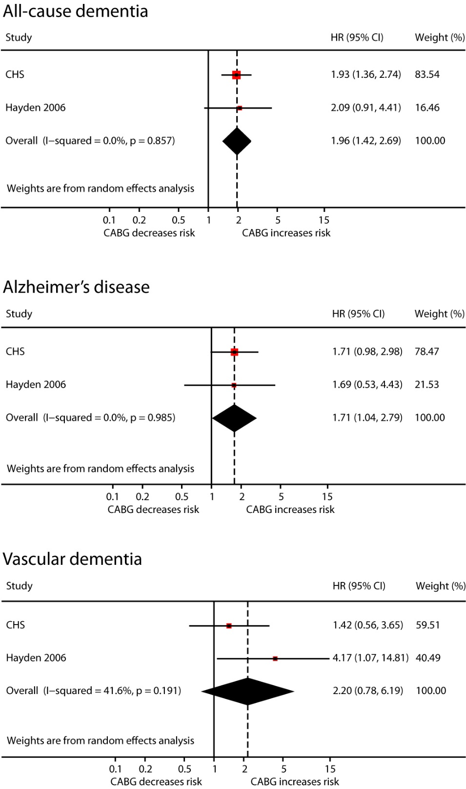
SUPPLEMENTAL FIGURE 3. Meta-analysis of the effect of history of coronary artery bypass graft surgery (CABG) compared to no history of CABG on incident all-cause dementia, Alzheimer’s disease and vascular dementia. HR, Hazard Ratio; CI, Confidence Interval
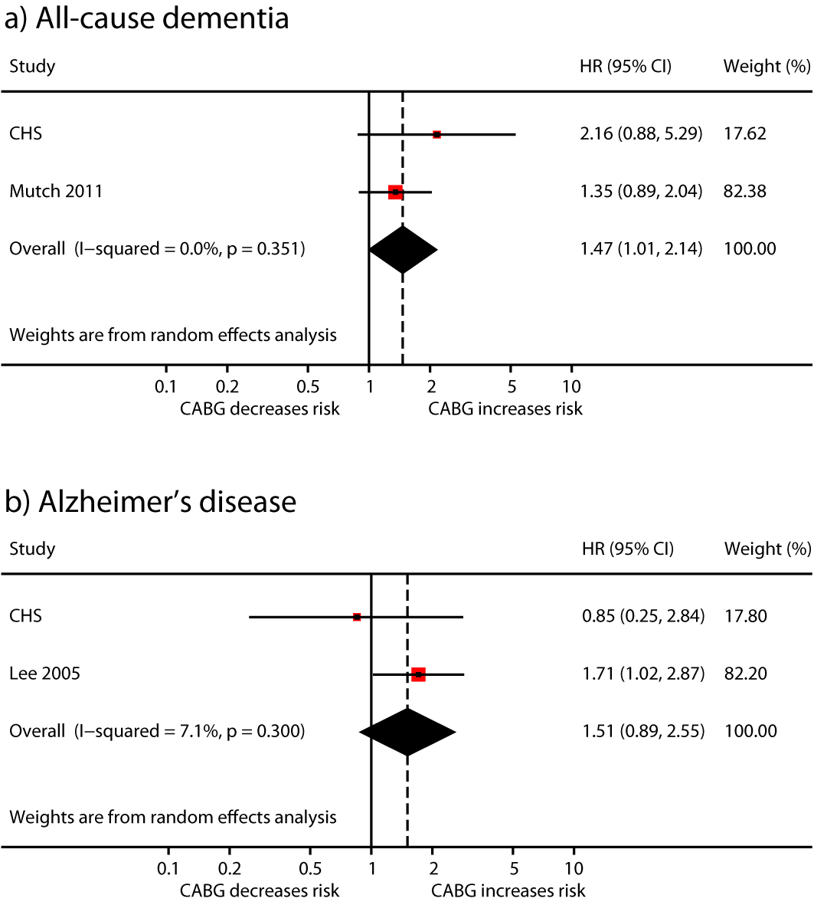
SUPPLEMENTAL FIGURE 4. Meta-analysis of the effect of history of coronary artery bypass graft surgery (CABG) compared to history of percutaneous coronary intervention on incident all-cause dementia and Alzheimer’s disease. HR, Hazard Ratio; CI, Confidence Interval

