 | Day |  |  |  |  |  |  |  |  |  |  |  |  | Sensitivity Analyses
 | 1 | 2 | 3 | 4 | 5 | 6 | 7 | 8 | 9 | 10 |  | Primary Definition |  | Naïve Definition |  | 2-Day Gap
 |  |  |  |  |  |  |  |  |  |  |  | 1 episode, 7 days |  | 2 episodes, 5 days & 2 days |  | 1 episode, 7 days
 |  |  |  |  |  |  |  |  |  |  |  | 2 episodes, 4 days & 3 days |  | 2 episodes, 4 days & 3 days |  | 1 episode, 7 days
 |  |  |  |  |  |  |  |  |  |  |  | 1 episode, 7 days |  | 1 episode, 7 days |  | 1 episode, 7 days
 |  |  |  |  |  |  |  |  |  |  |  | 1 episode, 7 days |  | 2 episodes, 4 days & 3 days |  | 1 episode, 7 days
 |  |  |  |  |  |  |  |  |  |  |  | 2 episodes, 4 days & 3 days |  | 2 episodes, 4 days & 3 days |  | 1 episode, 7 days
 |  | Antipsychotic medication used
 |  | No antipsychotic medication used
 |  | All medications stopped

Supplemental Figure 1. Examples of medication duration per each episode definition used.
The primary definition of antipsychotic medication duration was one-day gaps allowed, time away allowed within the episode. The naïve definition of antipsychotic medication duration was no gaps in use allowed and time away not allowed (i.e. episode ends if resident stops taking medication for one day, or if they the facility to hospital or elsewhere). 2-day gap definition of duration allowed up to two-day gaps within an episode and time away from facility allowed.

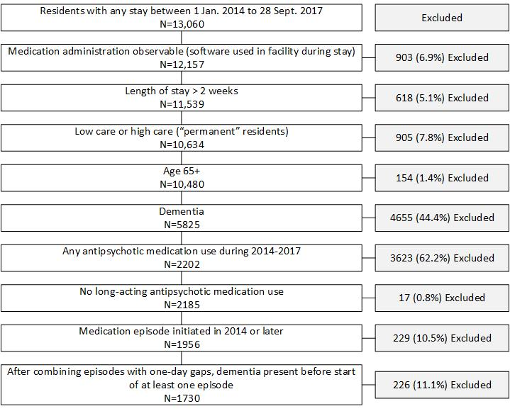
Supplemental Figure 2. Sample Size and Exclusions

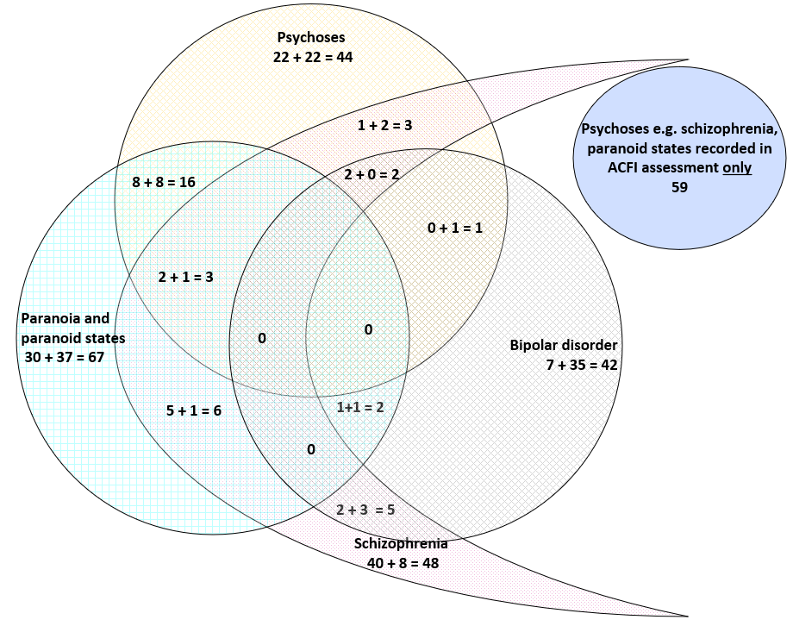
Supplemental Figure 3. Psychiatric comorbidities: identification of conditions by data source
A total of 298 cases of psychoses (includes paranoid states), schizophrenia or bipolar disorder (PSBD) were identified. Psychiatric comorbidities were identified using data from both the aged care funding instrument (ACFI) and notes in the electronic health record (EHR). The number of cases identified with ACFI added to the cases identified only with EHR notes is the total number of cases for each condition (e.g. “Psychoses e.g. schizophrenia, paranoid states” recorded in ACFI assessment + “Psychoses e.g. schizophrenia, paranoid states” not recorded in ACFI assessment but identified using EHR notes = total cases identified). Further detail is provided in Table S4.

