Materials and Methods
- Subdural electrode placement and cortical stimulation mapping (CSM)
Patient 1 had four 4-contact strips and one modified 32-contact grid placed subdurally. Patient 2 had three 4-contact subdural strips and one modified 64-contact grid. A 4-contact inferior frontal (IF) strip for Patient 1 and the grids for both patients were close to the Broca’s area thus the Cortical Stimulation Mapping (CSM) and time-frequency analysis were performed on these electrodes (see Fig. 1). Extra-operative CSM was performed on both patients with a cortical stimulator using a 5 second train of square-wave pulses (500 µs at 50 Hz), and amperage ranging from 3.0 to 16 mA until either a deficit in the performance of the function of interest, or after-discharges, was observed. Localization of expressive language cortex was tested by initiating stimulation immediately after sentence reading.
- Localization of iEEG contacts and map of Broca’s area
We used pre- and post-operative volumetric T1 weighted MRI and post-operative CT scan for the purpose of co-registering the location of the subdural electrodes on a 3-D reconstruction of the surface of the brain. All co-registrations were performed using the SPM8 software package (www.fil.ion.ucl.ac.uk/spm/software/spm8). First, a co-registration between the CT and post-operative MRI was performed. Second, the post-operative MRI was co-registered to the pre-operative MRI. Third, the pre-operative MRI was normalized to the Montreal Neurologic Institute (MNI) standard atlas. The transforms of the second and third steps were applied to the co-registered CT from the first step to have the CT images in the MNI coordinate system. Finally, the locations of the grid and strip contacts were extracted from the CT images using written scripts in MATLAB (http://www.mathworks.com/). Fig. 1 shows the overlay of the subdural contacts on the cortical surface in MNI atlas.
For the map of the Broca’s area (BA 44 and BA 45) in the MNI co-ordinate, we used the cytoarchitectonic maps from the SPM Anatomy toolbox [1]. These maps are based on cytoarchitectonic probabilistic maps of Broca's speech region proposed by Amunts, et al. [2,3]. The cytoarchitectonic probabilistic maps of BA 44 and BA 45 were first threshold above 50% and then projected on the cortical surface (Fig. 1). The cytoarchitectonic maps of BA 44 and BA 45 areas were calculated in the native (subject) space by applying the inverse normalization transform to the map of these area in MNI coordinate.
- Tasks
Object Naming Task: The overt object naming task consisted of 50 living objects (25 animals, 25 fruits-vegetables-plants) and 50 inanimate objects (25 objects, 25 tools) ), drawn from the CRL International Picture-Naming Project (http://crl.ucsd.edu/experiments/ipnp/index.html). The 100 stimuli were randomly presented for 1.5 sec, followed by a 1.5 sec central cross, and a fixed inter-stimulus interval of 3 sec. The patients were instructed to overtly name the object immediately after seeing the cross.
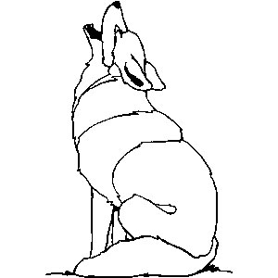
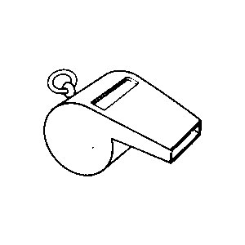
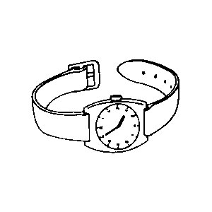
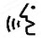

+

+

+

1.5 s
1.5 s
3 s
1.5 s
1.5 s
3 s
1.5 s
1.5 s
3 s
Time
…
…

Syllable Task: In this task, simple syllables, either “ba” or “pa”, followed by a short (120 ms) pure tone (as a cue) were presented as auditory stimuli. Patients were instructed to overtly repeat what they heard (either “ba” or “pa”) just after hearing the short tone. The syllable task consisted of 50 “ba” and 50 “pa” syllables in a random order.
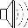

500 ms
50 ms
1500 ms
Time
“BA”
“tone”

500 ms
50 ms
1500 ms
“PA”
“tone”
…

Auditory Continuous Recognition Memory (CRM) Task: The receptive language mapping task was adapted from the continuous auditory word recognition protocol previously described in [4]. This task has been used for language lateralization and localization [5-9]. This task involves the auditory presentation of a set of five target words immediately before the recording session. During the recording session, the five target words were repeated in a random order, mixed with a different set of 30 distractors (non-repeating words) in each of four blocks of stimuli. After presenting the stimuli, there was a random inter-stimulus interval of 2-3 sec. The stimuli were delivered binaurally via plastic tubes terminating in ear inserts at the patient’s outer ear. The patients were instructed to lift the index finger of the dominant hand if they heard each of the five target words.

~500 ms
2000 ms
Time
“Brown”

~500 ms
2000 ms
“Jump”

~500 ms
2000 ms
“Little”
…

- iEEG recording and time-frequency analysis
iEEG data was recorded at a sampling rate of 1017.25 Hz using the online high-pass and low-pass filters with cutoffs of 0.08 Hz and 300 Hz, respectively. After discarding electrodes with recordings contaminated with artifacts and excessive epileptic activities, the recording from each electrode was re-referenced to the average of all the patient’s electrodes. For each task, the re-referenced iEEG signals were converted into epoch data containing all trails of specific conditions. The epoched iEEG data was then analyzed in the time-frequency (TF) domain using the multitaper method based on the prolate spheroidal (slepian) sequences [10,11]. All analyses were done in Matlab (The MathWorks), and using the FieldTrip toolbox [11]. Power-line artifact was removed by using notch filters at frequencies 60 and 120 Hz. The TF analysis covered 1–150 Hz using a spectral smoothing of 40% of the frequencies of interest. A sliding time-window with variable length and in steps of 50 ms was used that comprises 7 cycles of each frequency.

- Statistical analysis for significant high gamma activity
To test for statistical significance of the high gamma activity in each electrode, the following two steps were performed. In the first step, significant time-frequency bins per channel were identified on the basis of the permutation test established in [12]. Power in every time-frequency bin was compared to the mean power in the baseline (i.e., [-0.5 -0.1] sec) to calculate a t-value across all trials of each task. All bins whose t-value was larger than a specific threshold were identified as significant bins. The statistical significance of each time-frequency bin was determined by means of a Monte Carlo randomization test using the “ft_freqstatistics” function implemented in the Fieldtrip software package. In the Monte Carlo randomization test, the pre-stimulus (baseline) and the post-stimulus (activation) period were randomly permuted and the procedure was repeated 10,000 times. To find the significant bins, we set alpha to 0.05 and thus the t-values were thresholded at the 2.5-th and the 97.5-th quantiles for a two-sided t-test. To correct for the multiple comparisons, the Bonferoni correction was performed per channel. The number of samples, N_{s}, used in the Bonferoni correction resulted from multiplying the number of time bins, N_{t}, in the time window of interest by the number of frequency bins, N_{f}, in the range of [50 150] Hz. The corrected alpha was equal to 0.05/N_{s} = 0.05/(N_{t} × N_{f}). In the second step, a method similar to the one proposed in [13] was used to identify the significant cluster of bins. To this end, the clusters of significant bins spanning at least 20 Hz in bandwidth and at least 150 ms in duration were identified. Electrodes containing at least one significant cluster were identified as the electrodes showing significant HG activity. As shown in Figs. S1 and S2, significant enhancement of the high gamma activity during the object naming task is only present in electrodes 24 and 32 in Patient 1, and electrodes 7 and 15 in Patient 2.

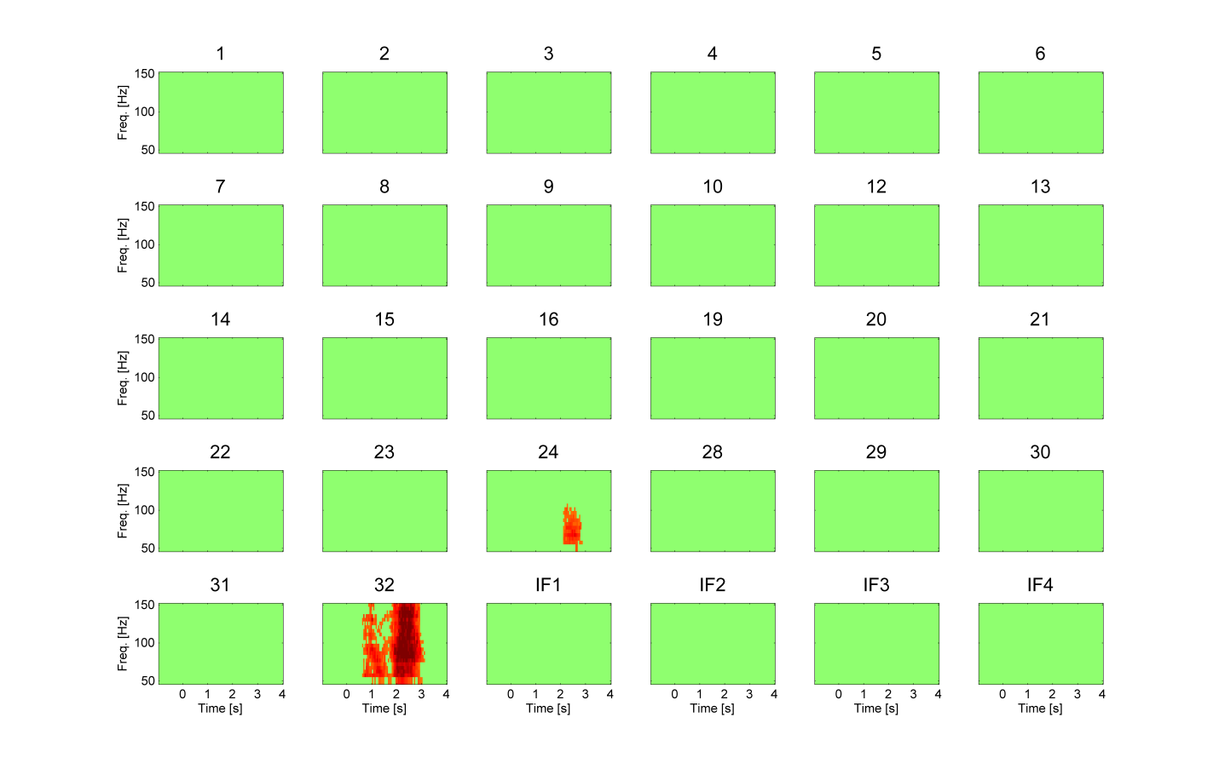
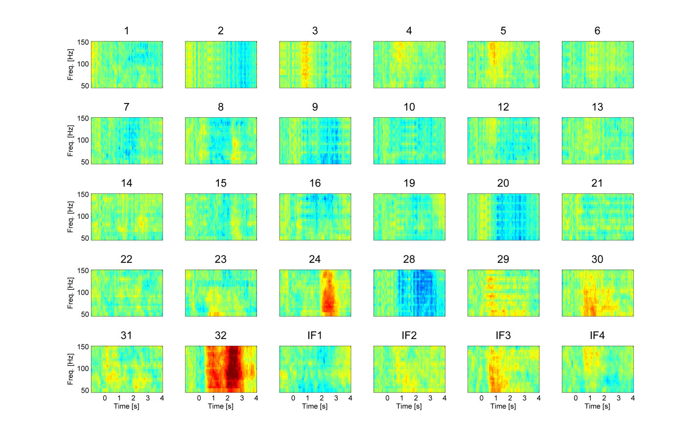
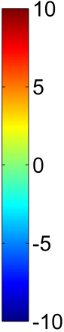
t-value

Fig. S1. Time-frequency (TF) analysis of recordings during the object naming task for Patient 1. Power in every time-frequency bin was compared to the mean power in the baseline (i.e., [-0.5 -0.1] sec) to calculate a t-value across all trials. Only significant time-frequency bins are retained in the bottom panels. The title of each subplot shows the subdural electrode number (see Fig. 1 for locations of the electrodes). Time 0 indicates the onset of the visual stimulus.
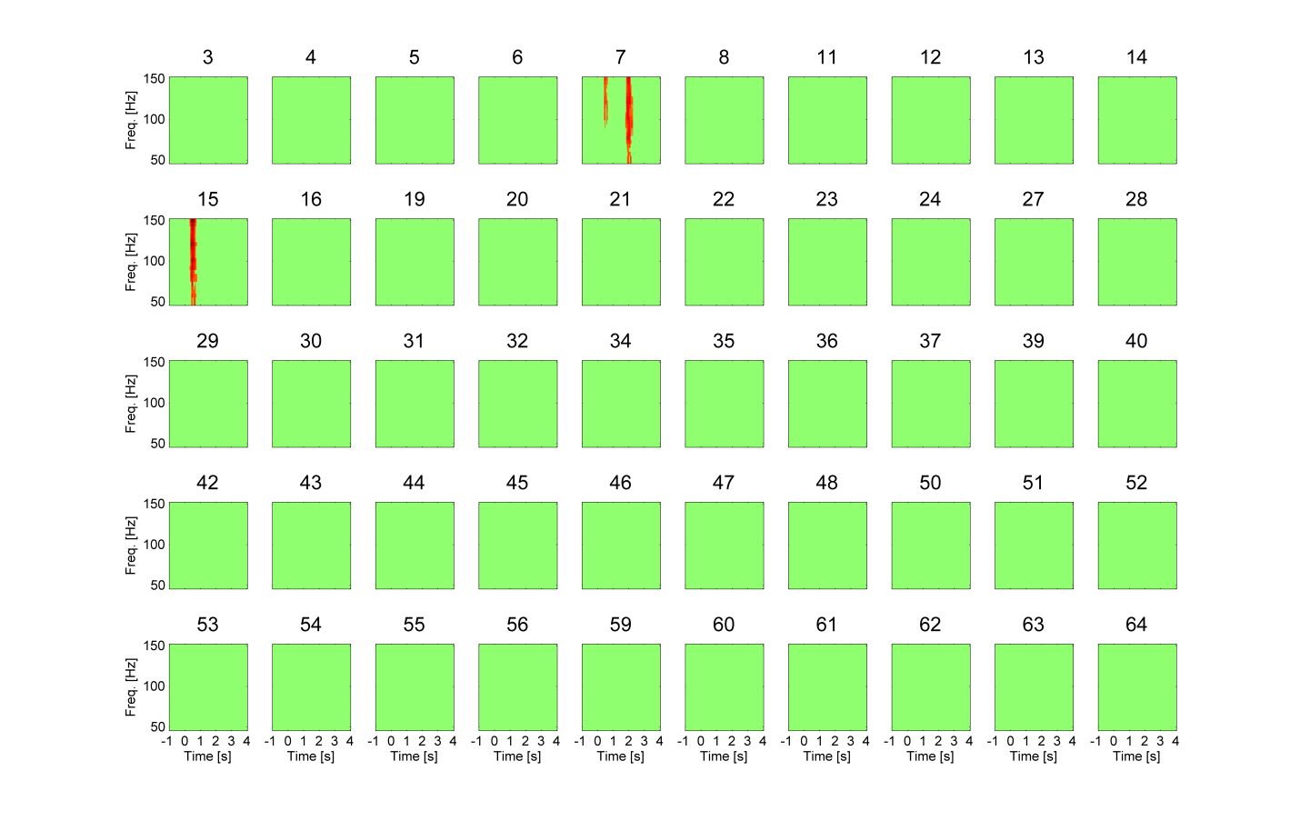
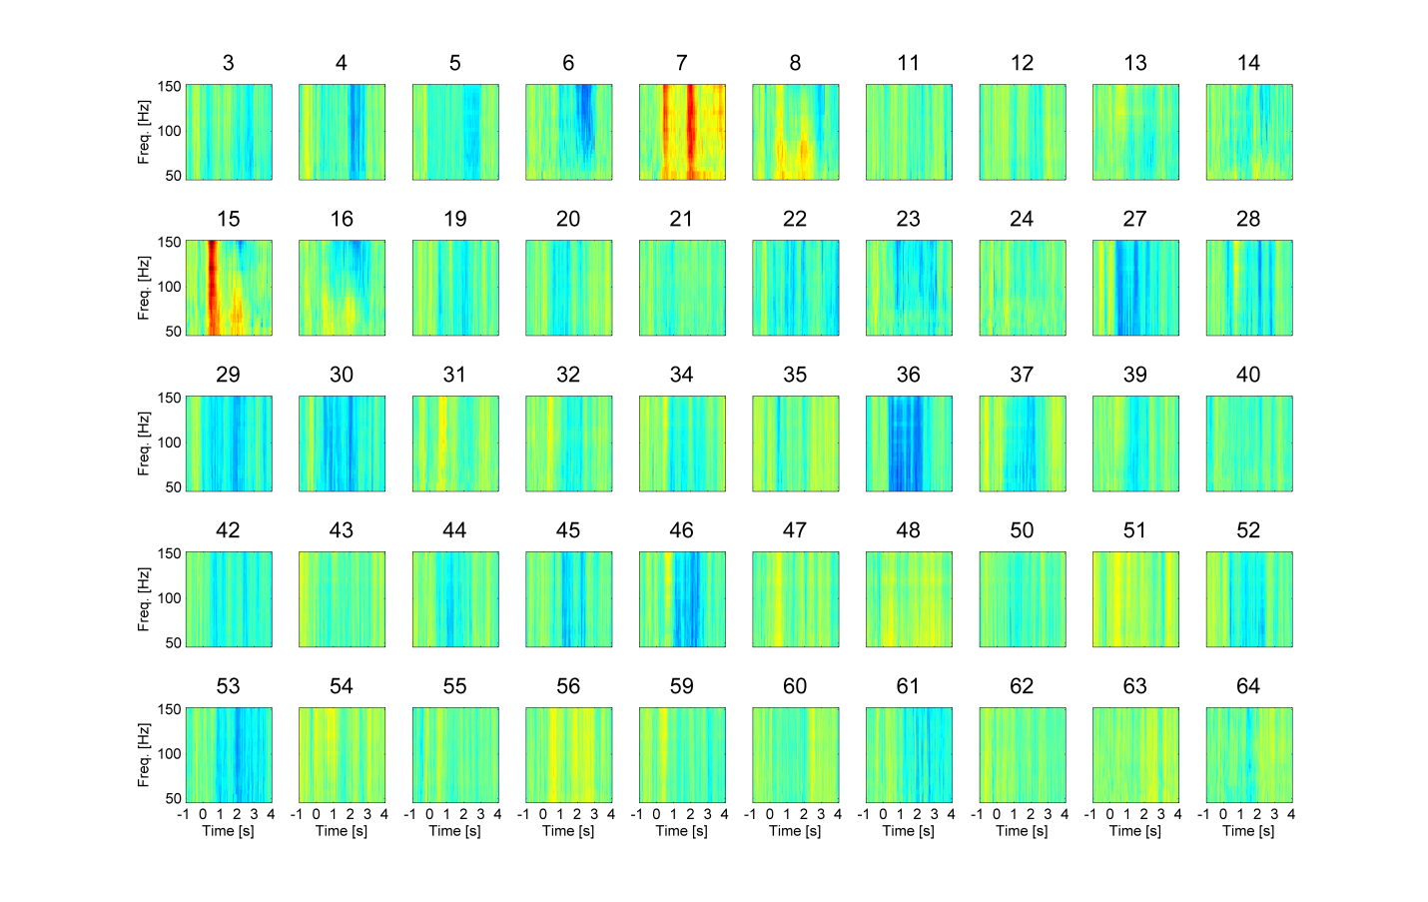
t-value

Fig. S2. Same as Fig. S1 except for Patient 2.

References
[1] Eickhoff SB, Stephan KE, Mohlberg H, Grefkes C, Fink GR, Amunts K et al. A new SPM toolbox for combining probabilistic cytoarchitectonic maps and functional imaging data. NeuroImage 2005; 25: 1325-1335.
[2] Amunts K, Schleicher A, Burgel U, Mohlberg H, Uylings HB, Zilles K. Broca's region revisited: cytoarchitecture and intersubject variability. The Journal of comparative neurology 1999; 412: 319-341.
[3] Amunts K, Weiss PH, Mohlberg H, Pieperhoff P, Eickhoff S, Gurd JM et al. Analysis of neural mechanisms underlying verbal fluency in cytoarchitectonically defined stereotaxic space--the roles of Brodmann areas 44 and 45. NeuroImage 2004; 22: 42-56.
[4] Papanicolaou AC, Simos PG, Castillo EM, Breier JI, Sarkari S, Pataraia E et al. Magnetocephalography: a noninvasive alternative to the Wada procedure. Journal of neurosurgery 2004; 100: 867-876.
[5] Simos PG, Sarkari S, Castillo EM, Billingsley-Marshall RL, Pataraia E, Clear T et al. Reproducibility of measures of neurophysiological activity in Wernicke's area: a magnetic source imaging study. Clinical neurophysiology : official journal of the International Federation of Clinical Neurophysiology 2005; 116: 2381-2391.
[6] Breier JI, Simos PG, Zouridakis G, Papanicolaou AC. Lateralization of activity associated with language function using magnetoencephalography: a reliability study. Journal of clinical neurophysiology : official publication of the American Electroencephalographic Society 2000; 17: 503-510.
[7] Maestu F, Saldana C, Amo C, Gonzalez-Hidalgo M, Fernandez A, Fernandez S et al. Can small lesions induce language reorganization as large lesions do? Brain and language 2004; 89: 433-438.
[8] Maestu F, Ortiz T, Fernandez A, Amo C, Martin P, Fernandez S et al. Spanish language mapping using MEG: a validation study. NeuroImage 2002; 17: 1579-1586.
[9] Merrifield WS, Simos PG, Papanicolaou AC, Philpott LM, Sutherling WW. Hemispheric language dominance in magnetoencephalography: sensitivity, specificity, and data reduction techniques. Epilepsy & behavior : E&B 2007; 10: 120-128.
[10] Mitra PP, Pesaran B. Analysis of dynamic brain imaging data. Biophysical journal 1999; 76: 691-708.
[11] Oostenveld R, Fries P, Maris E, Schoffelen JM. FieldTrip: Open source software for advanced analysis of MEG, EEG, and invasive electrophysiological data. Computational intelligence and neuroscience 2011; 2011: 156869.
[12] Maris E, Oostenveld R. Nonparametric statistical testing of EEG- and MEG-data. Journal of neuroscience methods 2007; 164: 177-190.
[13] Kojima K, Brown EC, Rothermel R, Carlson A, Fuerst D, Matsuzaki N et al. Clinical significance and developmental changes of auditory-language-related gamma activity. Clinical neurophysiology : official journal of the International Federation of Clinical Neurophysiology 2013; 124: 857-869.

