Supplemental digital content 1a

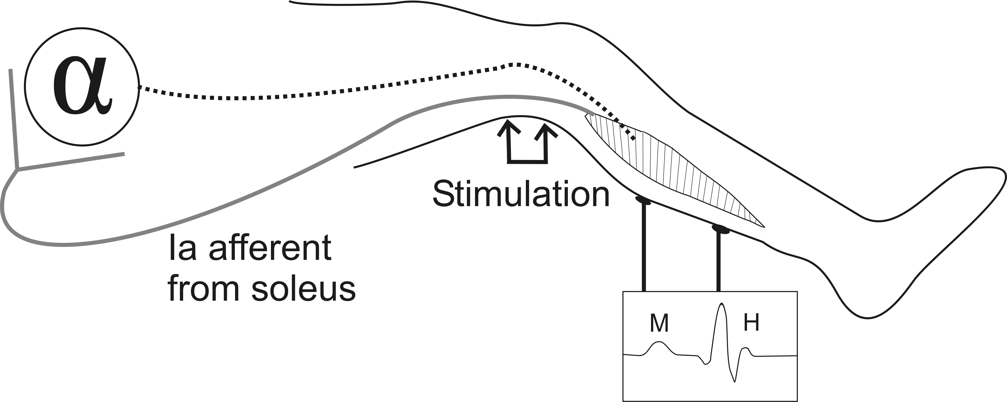
1a: Experimental setting of H-reflex recording
The H-reflex is elicited by electrical stimulation of the posterior tibial nerve in the popliteal fossa. Stimulation below motor threshold results in excitation of Ia afferent from the soleus muscle that induces largely monosynaptic excitation of homonymous α-motoneurons, which is evidenced electromyographically by surface electrodes on the belly of the soleus muscle as a H-reflex.

Supplemental digital content 1b
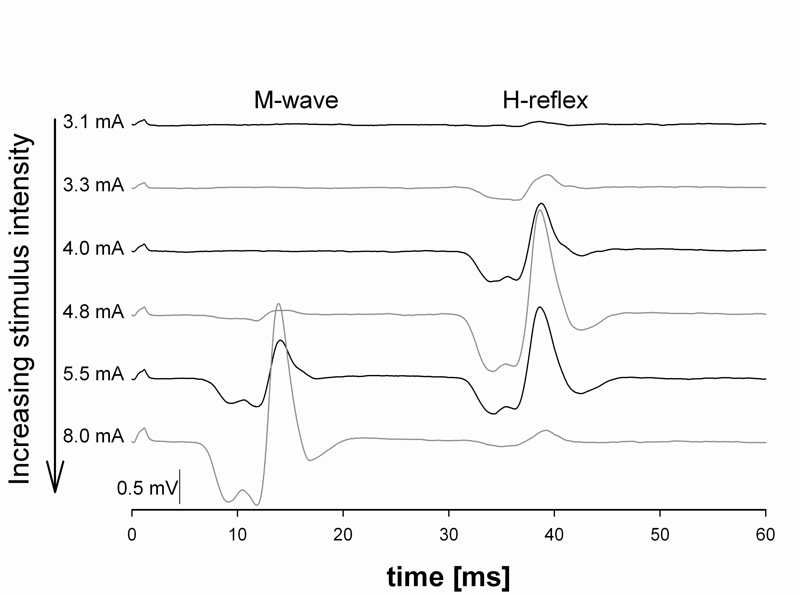
1b sample recordings of the H-reflex
Sample recordings of the H-reflex and M-wave at different stimulus intensities. With increasing stimulus, the H-reflex amplitude increases until the onset of the M-wave and then begins to decline. This decline is due to antidromic volleys set up in the motor axons that collide with and eliminate the H-reflex. The M wave is generated by direct stimulation of motor fibers that innervate the soleus muscle.

Supplemental digital content 1c
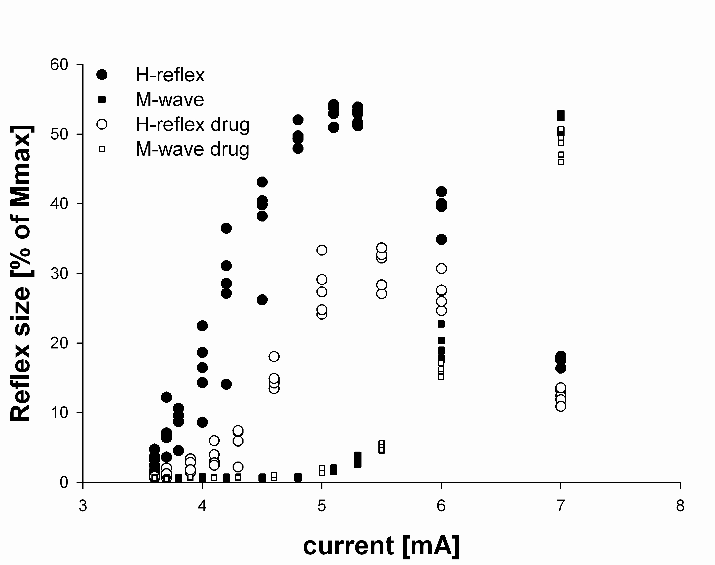
1c exemplary H-reflex recruitment curves before (filled symbols) and during (open symbols) inhalation of 1.4 Vol% sevoflurane.
The amplitudes of the H-reflex (circles) and M-wave (squares) are plotted against the stimulation current. For averaging at least three recordings were performed at each stimulation current. Only those amplitude values recorded at the stimulation current that produced the maximal mean H-reflex response of the 3 measurement cycles were included in the statistical analysis.

