Supplemental digital content 3a
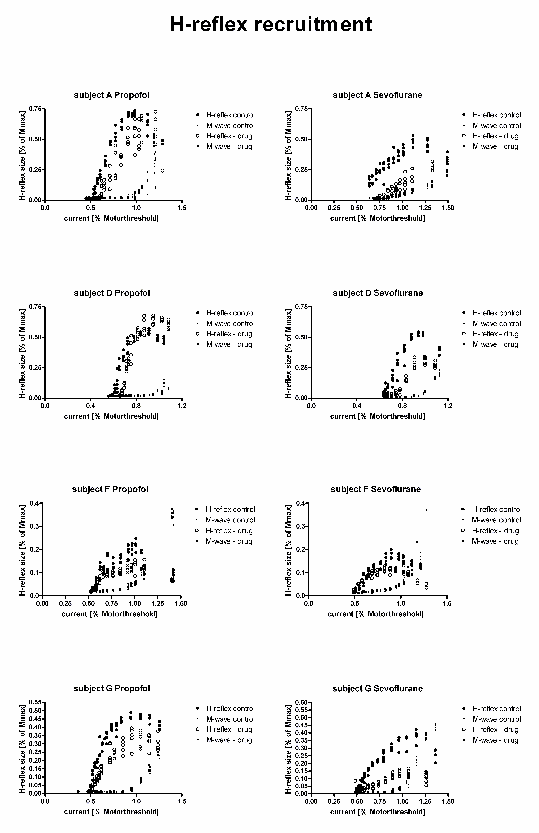
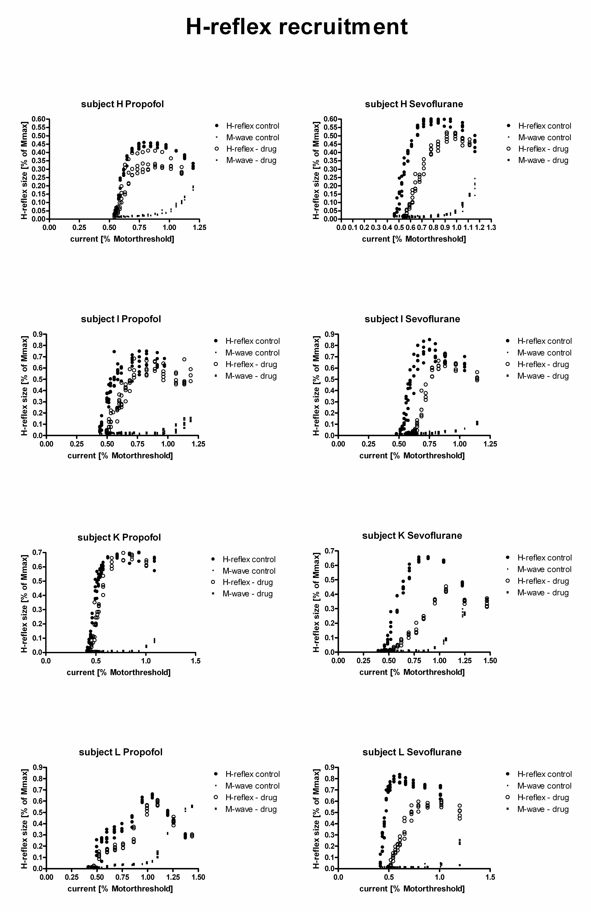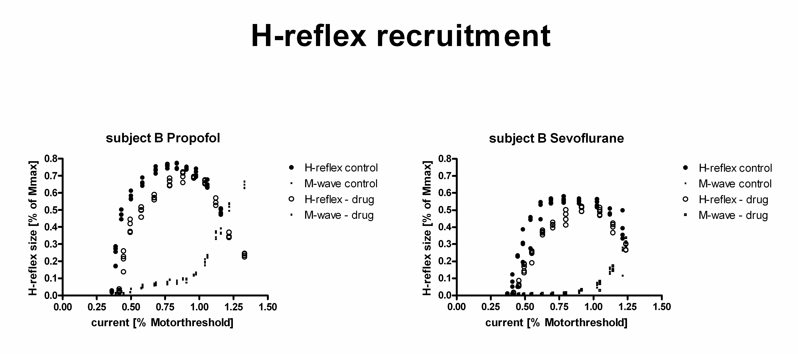
3a individual recruitment curves of all subjects
The graphs show all individual recruitment curves of the H-Reflex. The H-reflex amplitude is normalized to the maximal M-response, the H-reflex stimulation current is normalized to the stimulation current of the motor-threshold.
Suppplimental digital content 3b
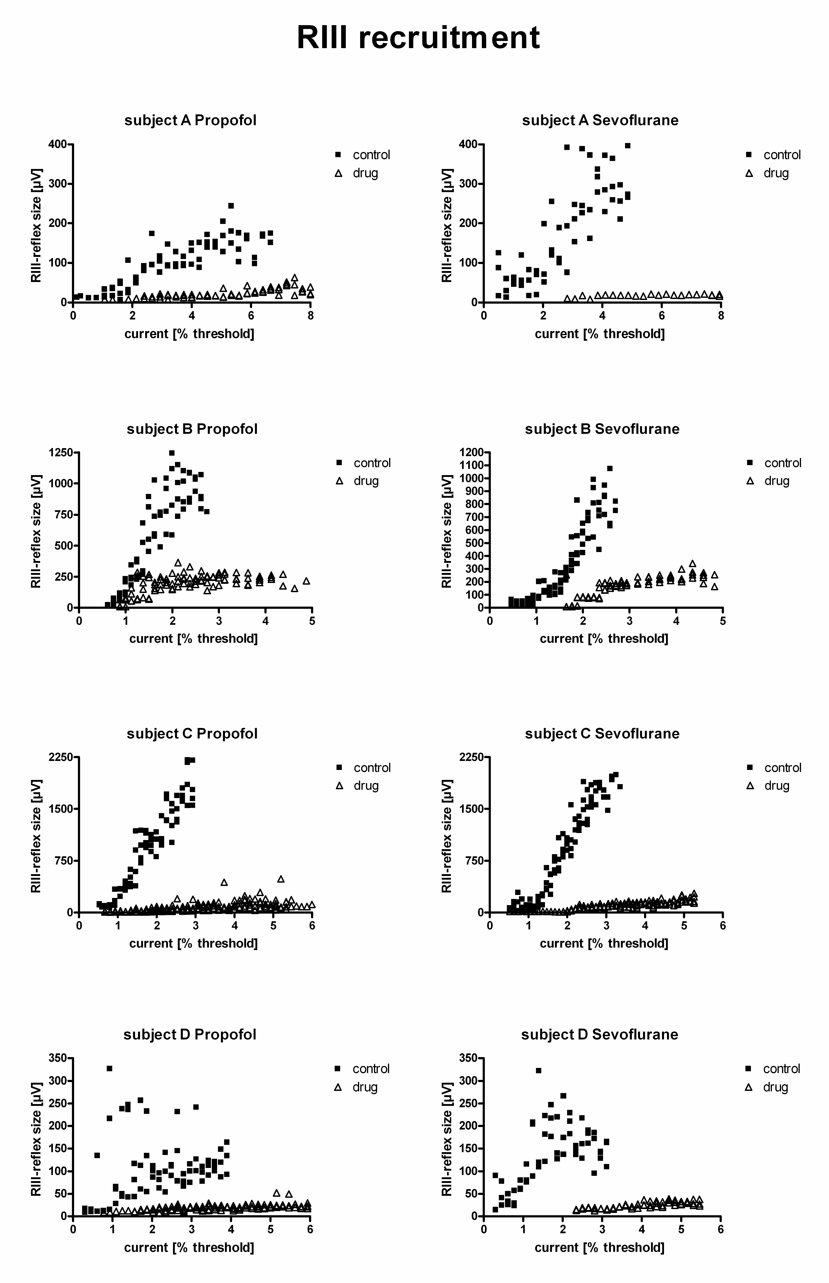
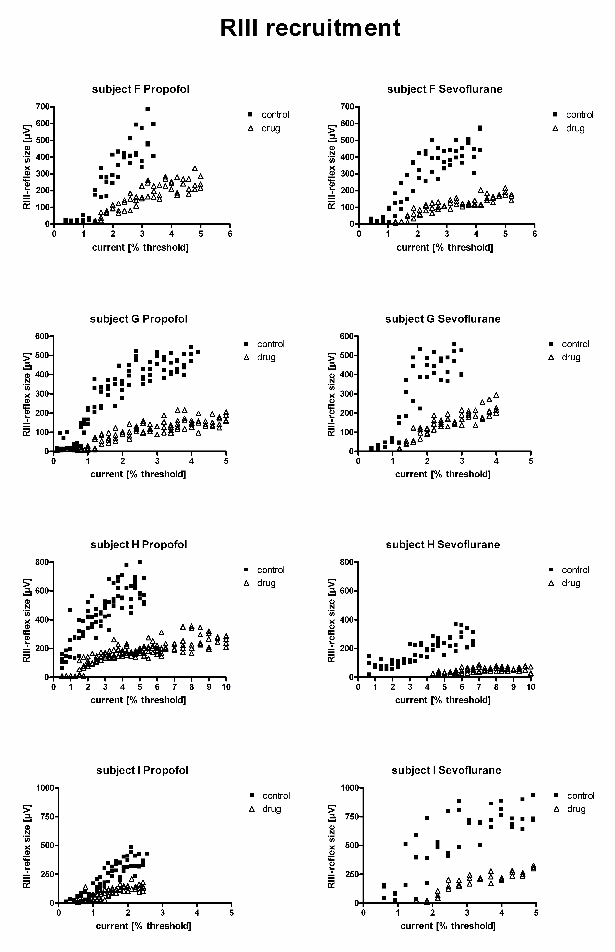
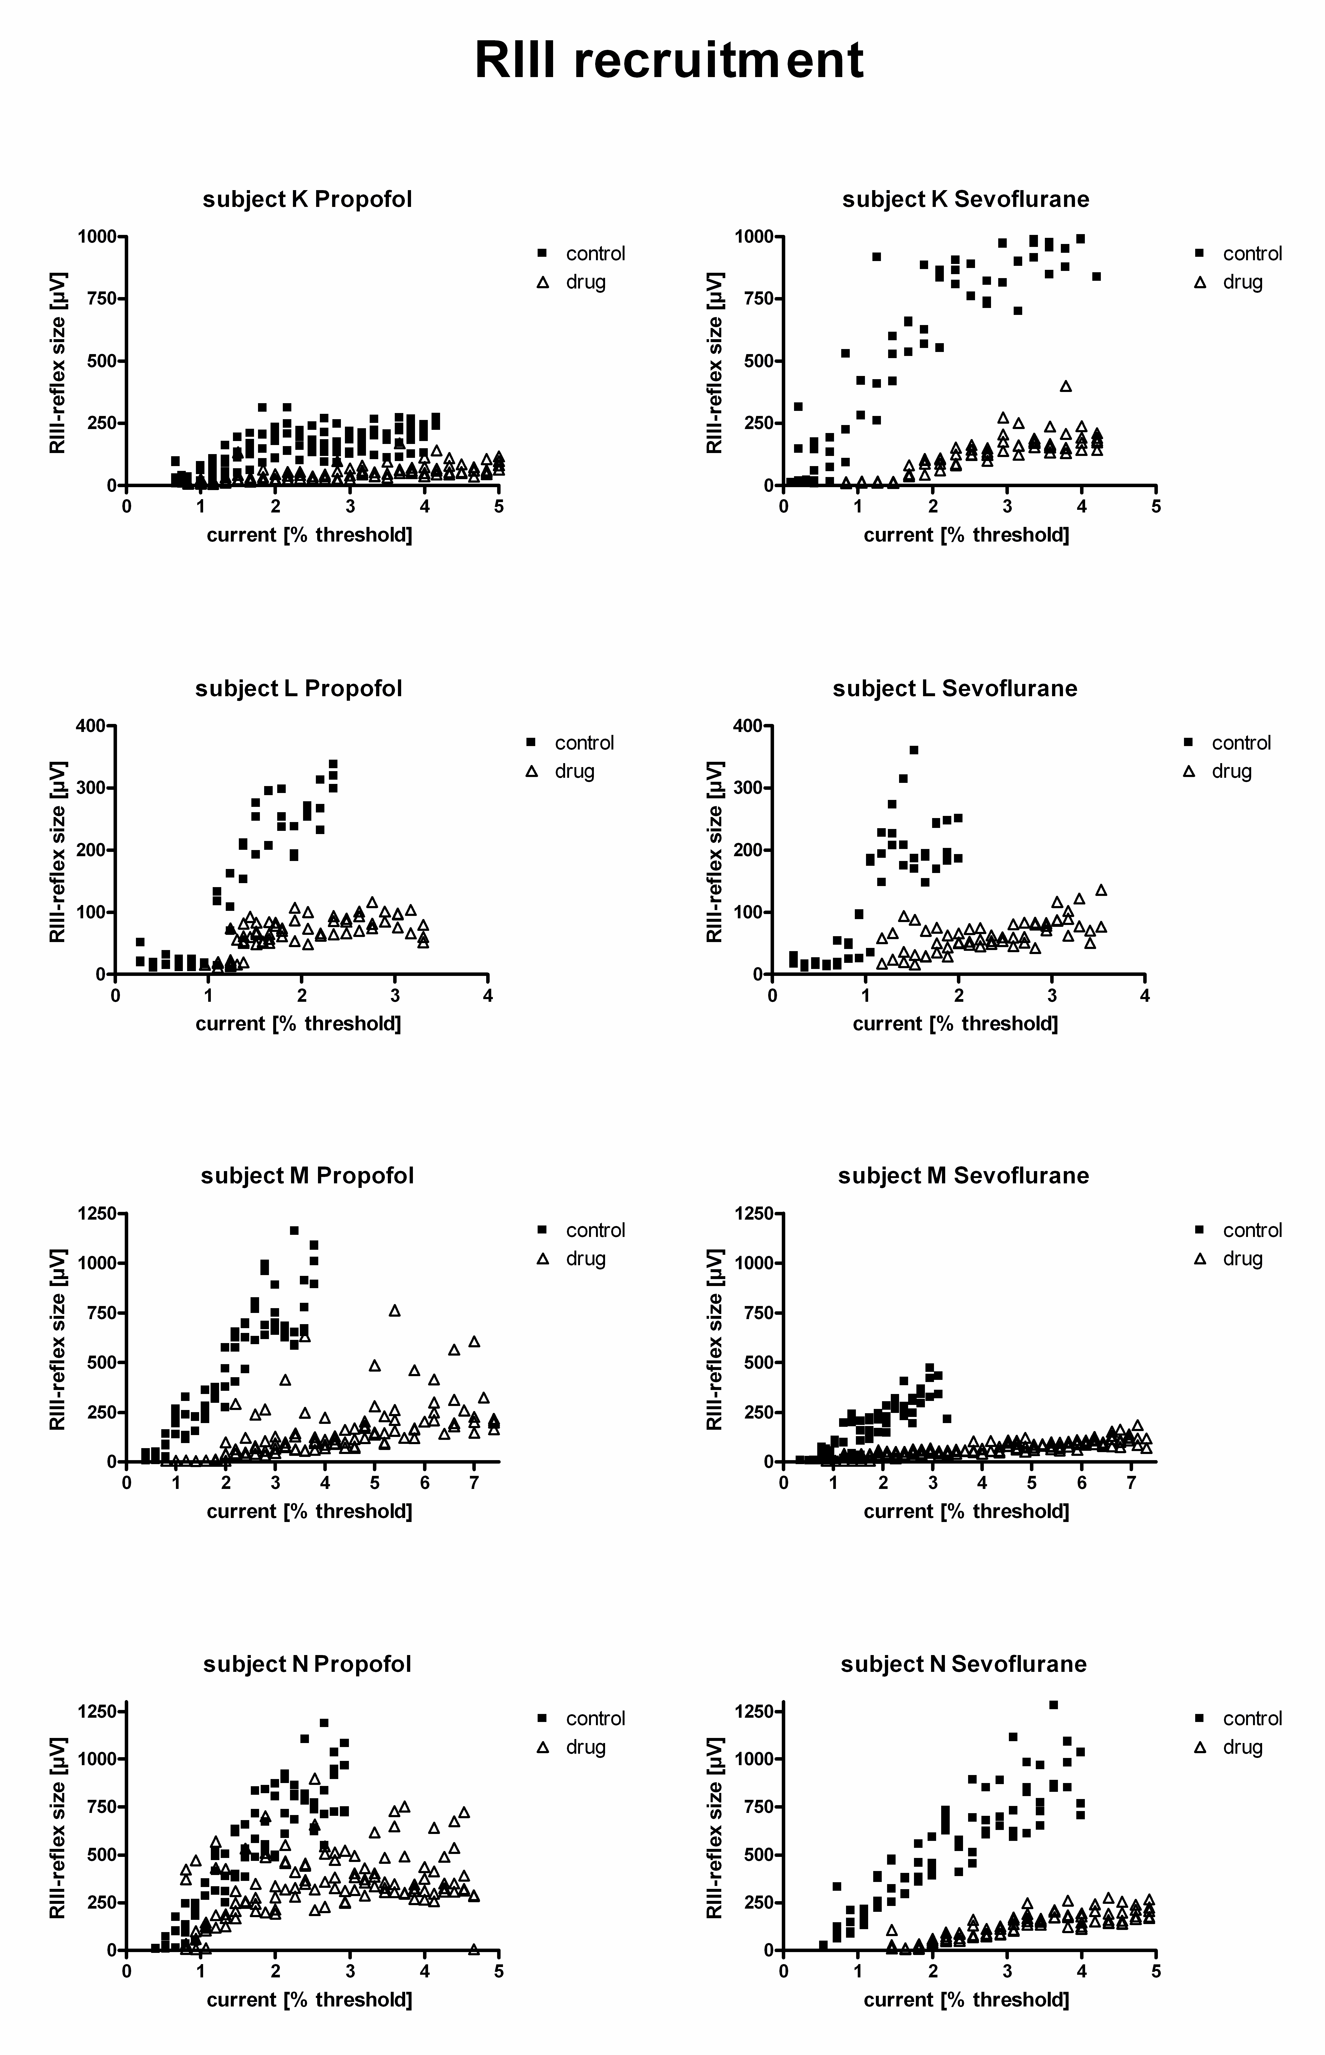 3b individual recruitment curves of all subjects
The graphs show all individual recruitment curves of the RIII reflex of all subjects. The stimulation current of the RIII reflex is normalized to the RIII reflex threshold during control conditions.

