**Supplemental Digital Content**

Supplemental Table 1. Recorded and validated QTc data

The content may be published in print or as an online supplement.



**Supplemental Figure 1**. QTc records of 4 patients from the general anesthesia cohort

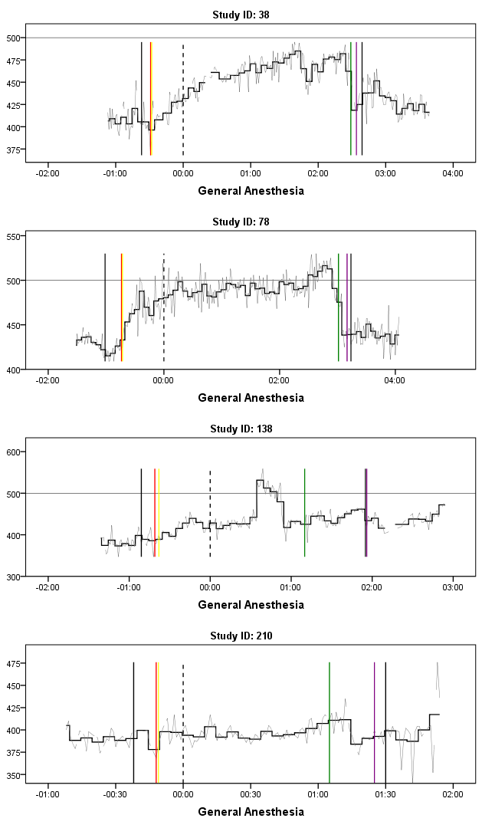The content may be published in the print journal or as an online supplement.

x-axis = HH:MM, y-axis = ms; gray zigzag line = QTcF minute-by-minute; black stepwise line = mean of 5 minutes of QTcF; *Vertical Lines:* first solid black line = patient goes to OR,

second solid black line = patient dismissed from OR, dashed black line = incision, red line = start of sedation, yellow line = intubation, green line = end of surgery, purple line = extubation

**Supplemental Figure 2.** QTc records of 4 patients from the spinal anesthesia cohort

The content may be published in the print journal or as an online supplement.

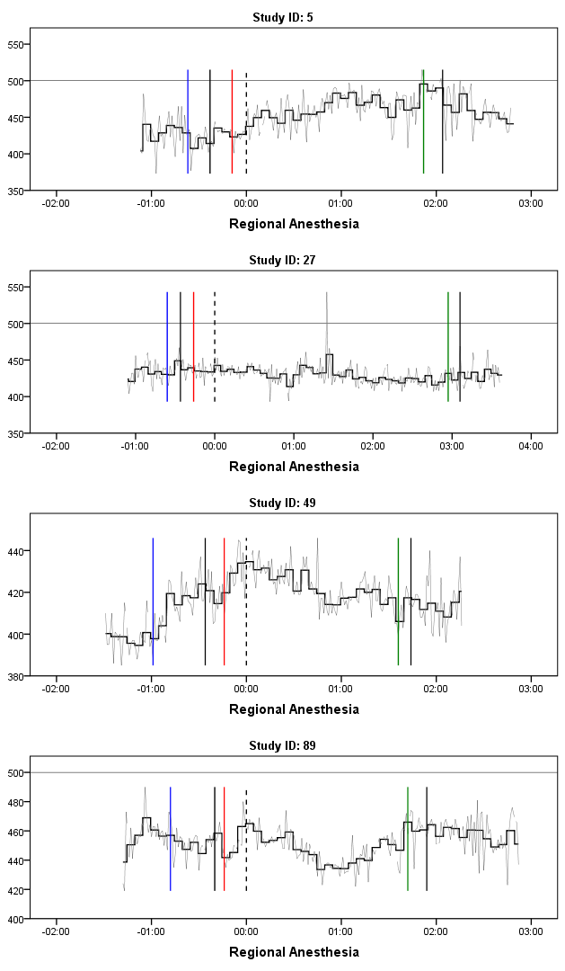

x-axis= HH:MM, y-axis= ms; gray zigzag line = QTcF minute-by-minute; black stepwise line = mean of 5 minutes of QTcF; *Vertical Lines:* first solid black line = patient goes to OR, second solid black line = patient dismissed from OR, dashed black line = incision, blue line = spinal puncture, red line = start of sedation, green line = end of surgery.

**Supplemental Figure 3.** QTc records of 4 patients from the local anesthesia cohort

The content may be published in the print journal or as an online supplement.

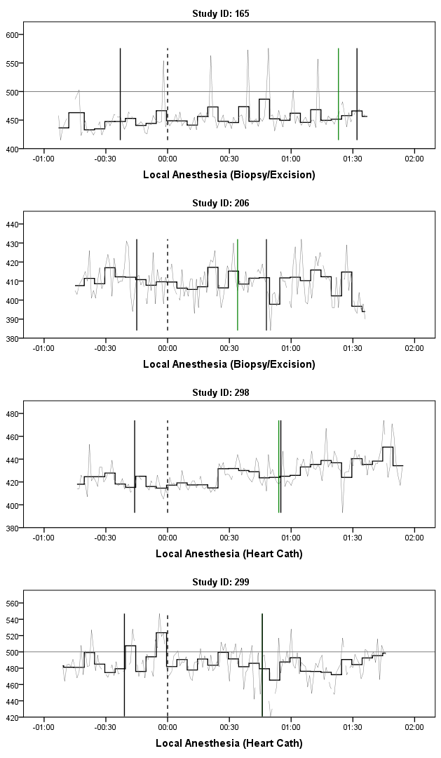

x-axis= HH:MM, y-axis= ms; gray zigzag line = QTcF minute-by-minute; black stepwise line = mean of 5 minutes of QTcF; *Vertical Lines:* first solid black line = patient goes to OR, second solid black line = patient dismissed from OR, dashed black line = incision, green line = end of surgery.