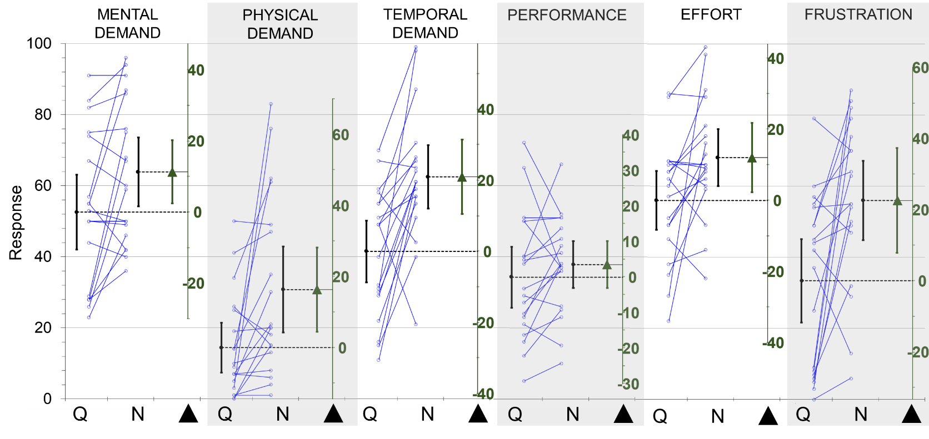
Effect of ‘Soundscape’ factor on the NASA-TLX items following the data presentation format from Figure 4 in the main text. ‘Soundscape’ had an effect on all items of the NASA-TLX instrument, with items being scored higher in ‘Noise’ relative to ‘Quiet’. The smallest effect was observed for the ‘Performance’ item (P = 0.264) while the largest effects were observed for the ‘Physical Demand’ (P = 0.0004) and ‘Frustration’ (P = 0.006) items.

