APPENDIX 4: Example of a Fundamentals of Ultrasound Program

***Main Objective***

The main objective of this training program is to impart and verify proficiency in performance of perioperative ultrasound (US) during anesthesiology residency. This multi-modal Fundamentals of Ultrasound (FUS) program includes web-based interactive didactics and integrated hands-on training sessions. Additionally, FUS program is designed to verify proficiency before clinical use of ultrasound (Figure 1).

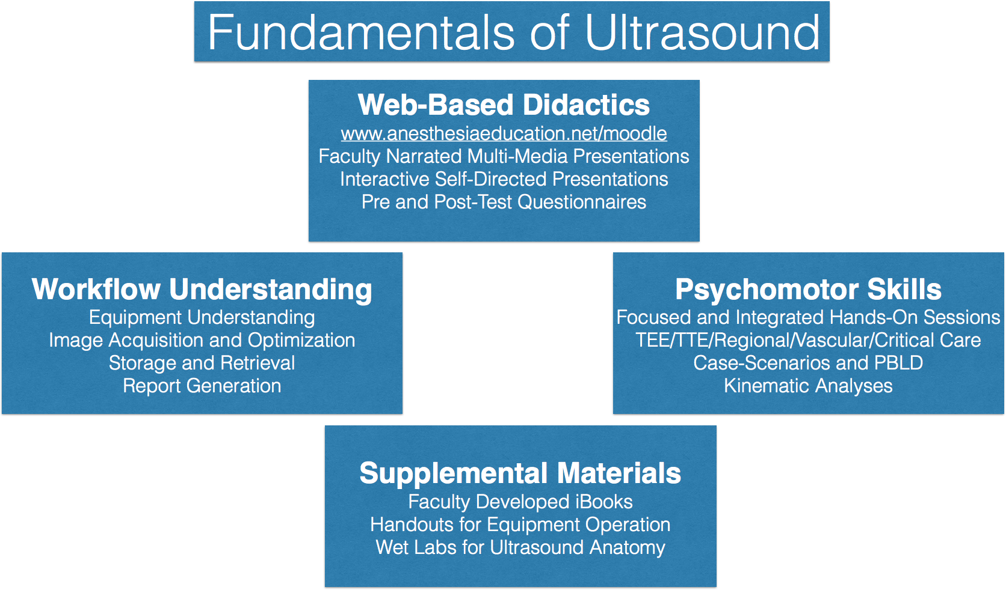

Figure 1. General Organization of the Fundamentals of Ultrasound Training Program.

The course is designed to impart proficiency in performance of perioperative ultrasound.

We define proficiency in perioperative ultrasound as a composite of cognitive knowledge, psychomotor skills and workflow understanding (Figure 2).

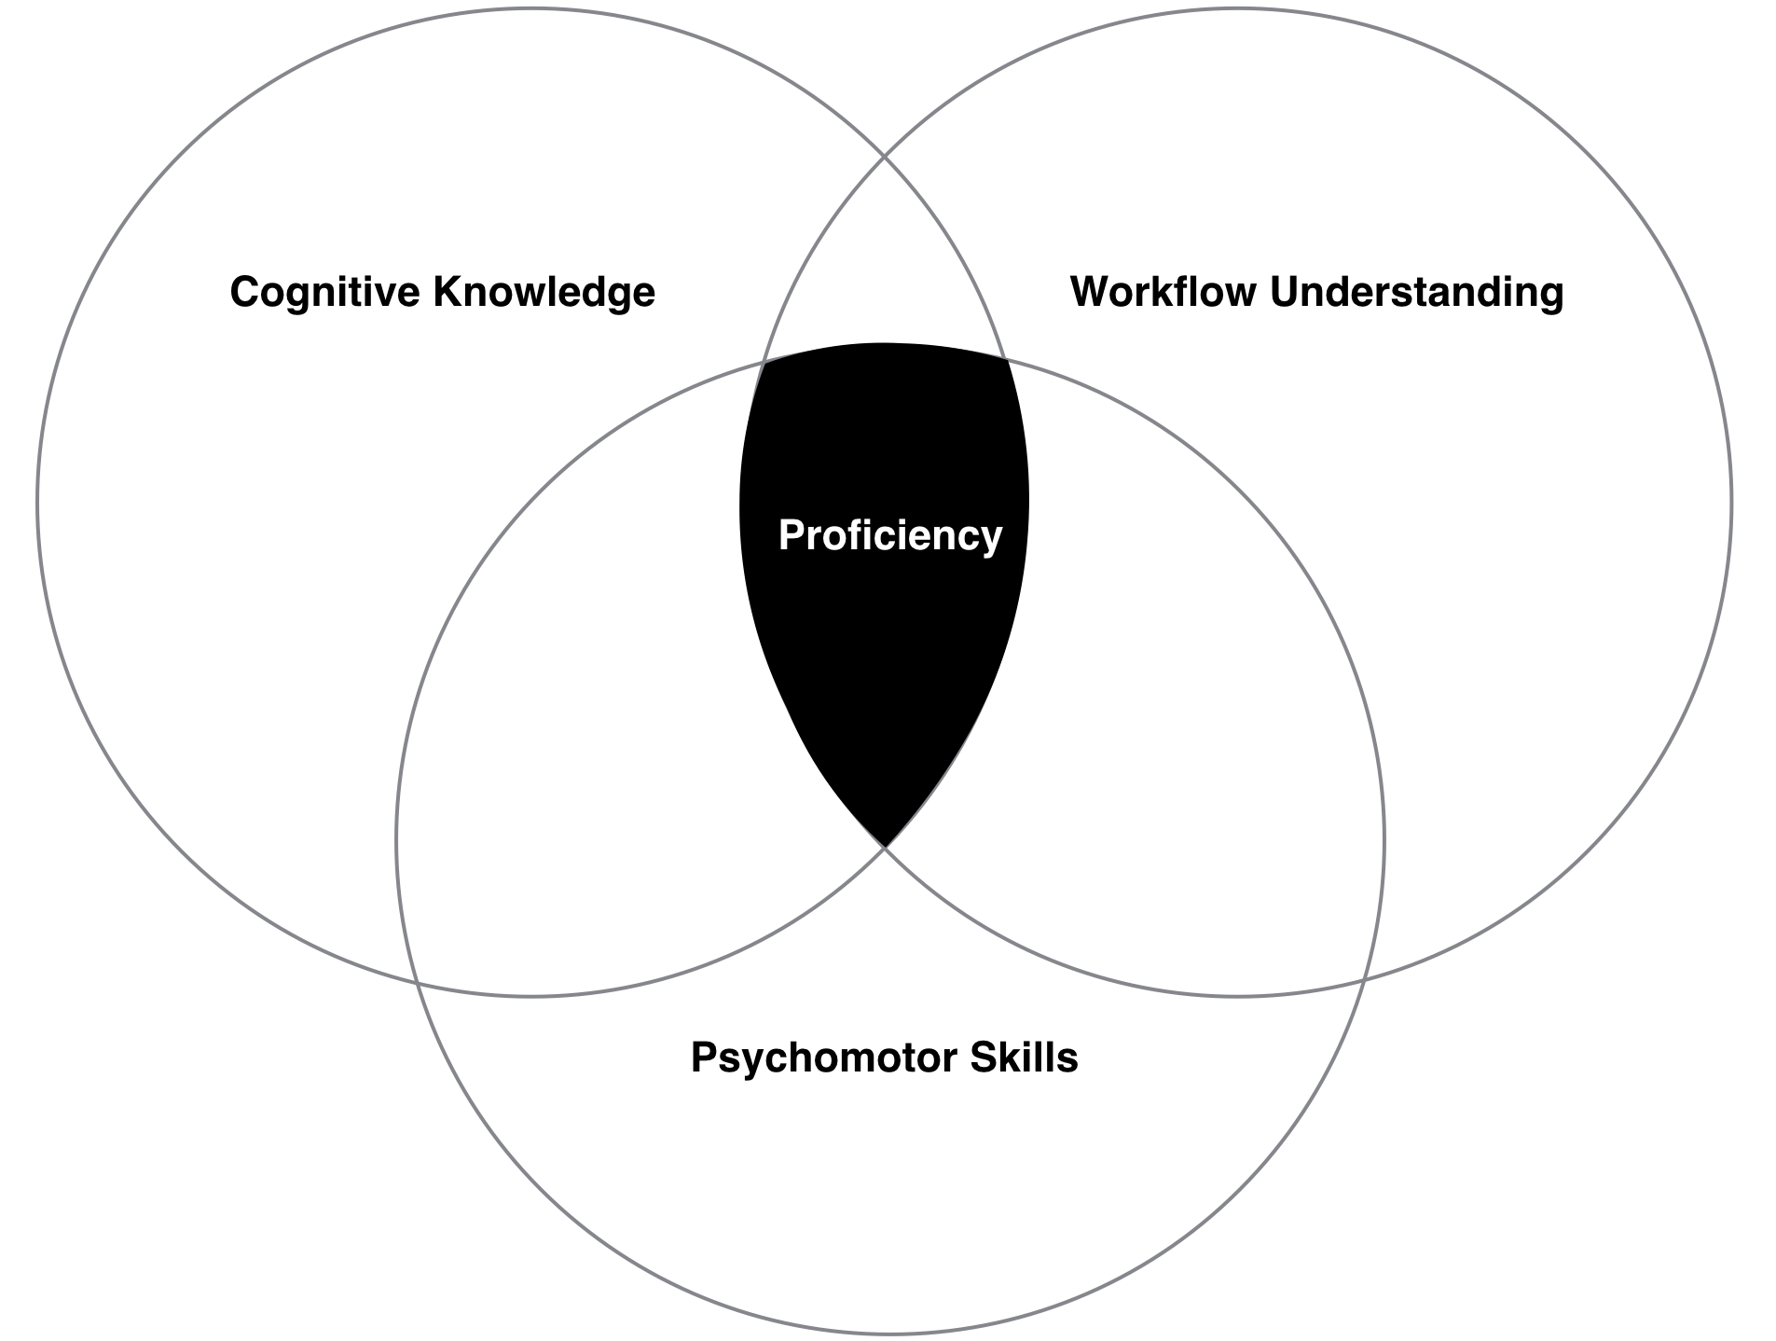

Figure 2. Components of proficiency in perioperative ultrasound.

Following completion of the FUS program, the resident is expected to have the following cognitive and technical skills (Table 1).These skills are important components of proficiencyand will be objectively demonstrated as pre-requisites for clinical performance. (Table 1)

Macintosh HD:Users:ferozemahmood:Dropbox:US GRANT APPLICATION:FAER SUBMISSION FOLDER:FINAL SUBMISSION:Table 1.pdf

Course Description

Basic ultrasound education could be made available as 2 separate programs: one course for categorical anesthesiology interns and the 1-year FUS course for clinical anesthesia (CA)- 1 residents. Additionally, CA-2 residents have a 1-month mandatory ultrasound guided regional anesthesia rotation, and CA-3 residents have 1 month for an elective rotation in perioperative TEE and 1 month for an elective ultrasound guided regional anesthesia rotation.

*Intern Course:*This course is a 13-day (8 hours per day) dedicated ultrasound training program for our categorical anesthesiology interns, in which we cover the basic concepts of ultrasound imaging and their broad perioperative use. Table 2 describes the contents covered during this course.

Table 2. Intern ultrasound course schedule.

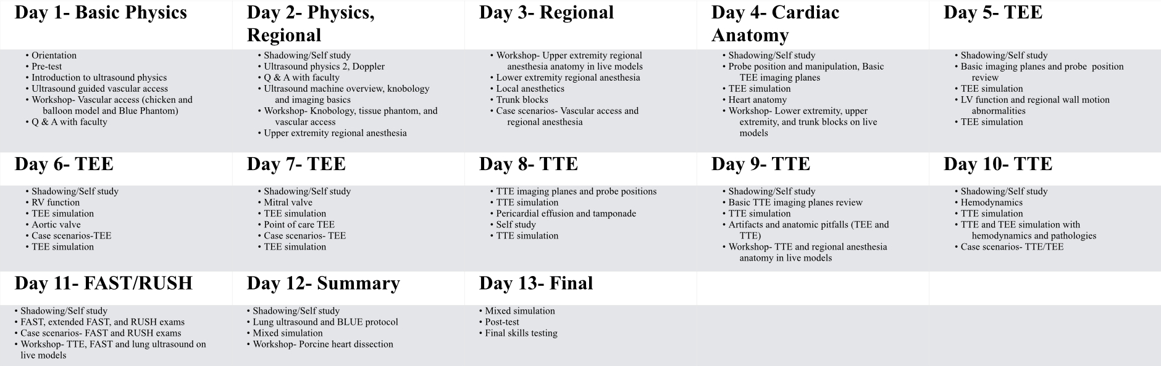

The CA-1 FUS course consists of an initial intensive phase, with twice a week, 3-hour hands-on sessions that take place during the first month of CA-1 training (8 total sessions). This initial training is followed by a longitudinal 11-month phase, in which 2-hour hands-on sessions are imparted once every 3 weeks, for a total of 14 training sessions, in addition to 3 remedial sessions (Table 3).

Table 3. FUS course schedule

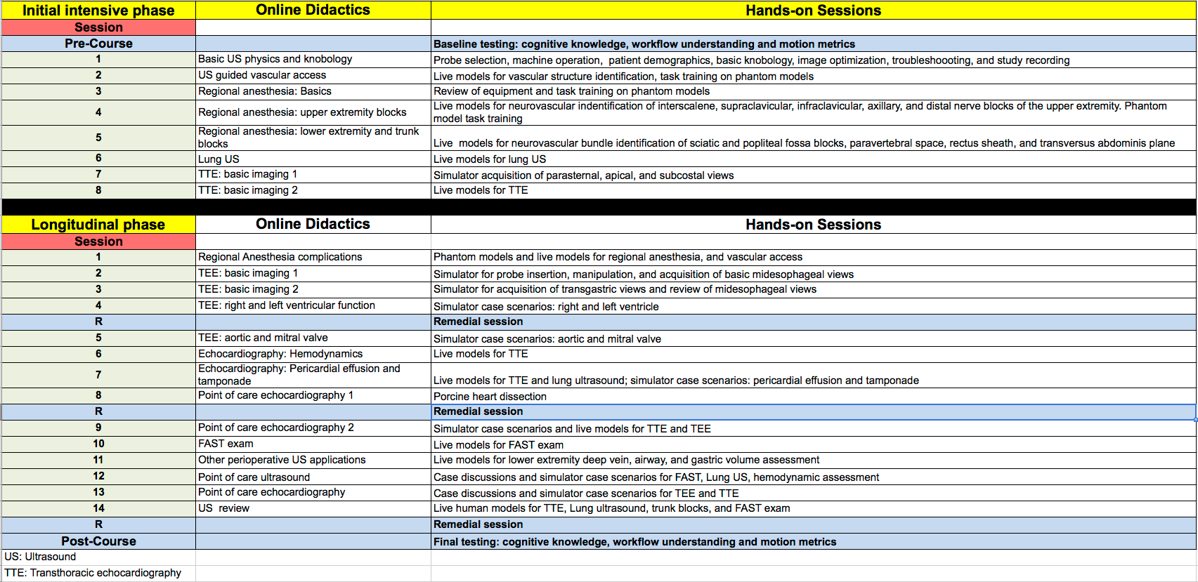

Didactics are largely web-based at anesthesiaeducation.net/moodle, with each module being between 10 and 30 minutes in duration. Trainees are expected to view the online module and answer the pre-test before the hands-on session, and answer the post-test questionnaire after completing the hands-on session.

Additionally, department-created electronic iBooks® (Apple Inc., Cupertino, CA) on Ultrasound Physics and Hemodynamics, Ultrasound Guided Regional Anesthesia, TTE, and TEE are available to the trainees for additional review.

Hands-on sessions vary according to the ultrasound modality studied, and include various teaching modalities, such as commercially available simulators, phantom models (commercial and ‘home-made’), live scanning on human models, and discussion of case scenarios.

Clinical proficiency is defined as the possession of a cognitive background and psychomotor skills for safe execution of a procedure. Specific to ultrasound, there is also a requirement of understanding of the workflow of an ultrasound exam. For the FUS program, we have defined workflow understanding as a trainee’s ability to integrate their cognitive knowledge with the available information to select, prepare and operate the ultrasound equipment most appropriate for the indicated examination. We have included this skill set as a component of clinical proficiency (Figure 5). For evaluation of proficiency, cognitive knowledge will be tested through multiple-choice exams, workflow understanding with completion of simulated tasks related to the conduct of an ultrasound exam and psychomotor skills with kinematic analyses to objectify progression and individualize training.