Supplementary Digital Files to

Anesthesiologists’ overconfidence in their perceived knowledge of neuromuscular monitoring and its relevance to all aspects of medical practice: an international survey
This supplement provides the contents of the survey, references supporting survey questions, and supplemental Tables 1 and 2.
-----------------------------------------------------------------------------------------------------------
Neuromuscular Survey
Participation in this minimal-risk survey study is entirely voluntary. This survey is conducted by research teams from Cleveland Clinic, and Mayo Clinic, who will be collecting information that may be shared with health authorities, study monitors who check the accuracy of the information, and individuals who collate report forms. No identifying information will be collected. By answering the questions, you are providing authorization for the research team to use and share this de-identified information at any time. If you do not want to authorize the use and disclosure of this information, you may choose not to answer these questions. There is no expiration date for the use of this information as stated in this authorization. Thank you for your consideration.

Neuromuscular Survey
Please fill out the survey by placing an "X" after your answer.
In addition, after each question, please indicate the level of confidence you have in your answer.

Please use a 50% to 100% scale:

1. If you are completely unsure whether your chosen answer is correct you should indicate 50% as your confidence; because there are two options, the likelihood of your answer being correct is only at the chance level of 50%.

2. On the other hand, if you are completely confident in your answer, you should indicate 100%.

3. You can indicate any confidence level from 50% to 100% that your answer is correct.
Demographic Data

A. Practice location/State

a) Americas (USA, Canada, Mexico, Brazil, etc.) __________________

b) Europe (please specify the country) ________________

c) Africa (please specify the country) ________________

d) Australia/New Zealand

e) Asia (please specify the country) ________________

B. Your academic degree(s):

a) Doctorate (MD, MB, CHB, BM, PhD, MD/PhD, DO) _______________

C. Years since completing your training:

a) 0-5

b) 6-10

c) 11-15

d) 16-20

e) More than 20

Please note:

Peripheral nerve stimulator (PNS) units require the clinician to evaluate the evoked response by subjective (or QUALITATIVE) means (i.e., visually or tactilely).

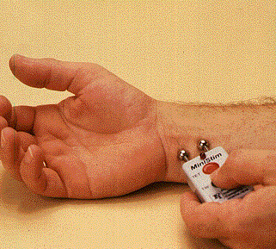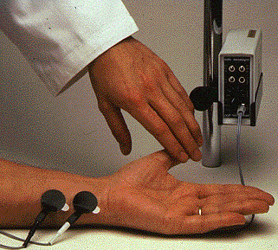

QUANTITATIVE train-of-four monitors measure and display the train-of-four ratio (TOFR) in real time.

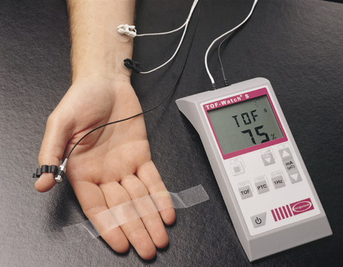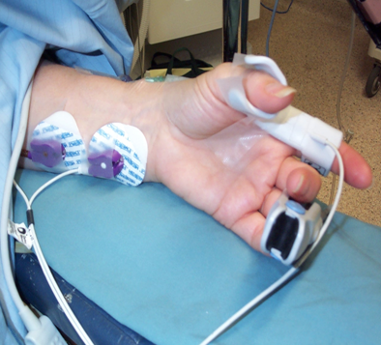

1. When rocuronium is administered and sugammadex is available, successful antagonism of residual block can be assured without the need for monitoring of neuromuscular function.
a) True
b) False
Confidence = ___________(50% to 100%). Remember, 50% means you are completely unsure, 100% means you are absolutely sure of the answer.
======

2. Subjective (visual or tactile) evaluation of TOF fade is a useful indicator of the adequacy of neuromuscular recovery. Once fade can no longer be detected visually or by touch, the TOF ratio is reliably above a value of 0.7.
a) True
b) False
Confidence = ___________(50% to 100%)
=======

3. Following a single “intubation dose” of an intermediate duration neuromuscular blocking agent (e.g., rocuronium 0.6 mg/kg), adequate spontaneous recovery can be expected in about 2 to 2.5 hours. Antagonism of residual block can be safely omitted once this interval has elapsed even when neuromuscular monitoring has not been employed.
a) True
b) False
Confidence = ___________(50% to 100%)
========

4. A patient’s ability to sustain a 5-second head lift is not a useful clinical indicator of recovery from neuromuscular blockade because it usually corresponds to a train-of-four ratio (TOFR) of 0.50 to 0.60.
a) True
b) False
Confidence = ___________(50% to 100%)
=======

5. A sustained (no fade) response to 50 Hz tetanic stimulation of 5 sec duration provides assurance that the TOFR has returned to a value ≥ 0.90. Antagonism of residual block is not required.
- True
- False
Confidence = ___________(50% to 100%)
=======

6. In the absence of an objective monitor, if the arms are not accessible during surgery, the TOF-count at the facial muscles (orbicularis oculi or corrugator supercilii) will give reliable estimates of what would be observed at the thumb (adductor pollicis) muscle.
a) True
b) False
Confidence = ___________(50% to 100%)
======

7. Antagonism of residual non-depolarizing block cannot be achieved reliably with neostigmine if it is administered at the time when the TOF-count at the adductor pollicis has returned to a value of two.
a) True
b) False
Confidence = ___________(50% to 100%)
=======

8. TOF counts of 1, 2, 3 and 4 correspond approximately to twitch height recovery of 10%, 20%, 30% and 40% of baseline, respectively.
a) True
b) False
Confidence = ___________(50% to 100%)
======

9. Up to a third of the postsynaptic receptors must be blocked by a nondepolarizing neuromuscular blocking agent (e.g., rocuronium) before there is a decrease in the strength of muscle contraction.
a) True
b) False
Confidence = ___________(50% to 100%)
=======

Thank you for your time and participation.
Correct answers are shown in bold.

References supporting survey questions
Question 1
1. Duvaldestin P, Kuizenga K, Saldien V, et al. A Randomized, Dose-Response Study of sugammadex given for the reversal of deep rocuronium- or vecuronium-induced neuromuscular blockade under sevoflurane anesthesia. Anesth Analg 2010;110(1):74-82. doi: 10.1213/ANE.0b013e3181c3be3c

Question 2
1. Viby-Mogensen J, Jensen NH, Engbaek J, et al. Tactile and visual evaluation of the response to train-of-four nerve stimulation. Anesthesiology 1985;63(4):440-3.

Question 3
1. Debaene B, Plaud B, Dilly MP, et al. Residual paralysis in the PACU after a single intubating dose of nondepolarizing muscle relaxant with an intermediate duration of action. Anesthesiology 2003;98(5):1042-48.

Question 4
1. Dupuis JY, Martin R, Tetrault JP. Clinical, electrical and mechanical correlations during recovery from neuromuscular blockade with vecuronium. Can J Anaesth 1990;37(2):192-6.
2. Sharpe MD, Lam AM, Nicholas JF, et al. Correlation between integrated evoked EMG and respiratory function following atracurium administration in unanaesthetized humans. Can J Anaesth 1990;37(3):307-12. doi: 10.1007/bf03005580
3. Beemer GH, Rozental P. Postoperative neuromuscular function. Anaesth Intensive Care 1986;14(1):41-5.

Question 5
1. Kopman AF, Epstein RH, Flashburg MH. Use of 100-Hertz tetanus as an index of recovery from pancuronium-induced non-depolarizing neuromuscular blockade. Anesth Analg 1982;61(5):439-41.
2. Ali HH, Savarese JJ, Lebowitz PW, et al. Twitch, tetanus and train-of-four as indices of recovery from nondepolarizing neuromuscular blockade. Anesthesiology 1981;54(4):294-7.

Question 6
1. Thilen SR, Hansen BE, Ramaiah R, et al. Intraoperative neuromuscular monitoring site and residual paralysis. Anesthesiology 2012;117(5):964-72. doi: 10.1097/ALN.0b013e31826f8fdd
2. Donati F. Neuromuscular monitoring: more than meets the eye. Anesthesiology 2012;117(5):934-6. doi: 10.1097/ALN.0b013e31826f9143
3. Caffrey RR, Warren ML, Becker KE, Jr. Neuromuscular blockade monitoring comparing the orbicularis oculi and adductor pollicis muscles. Anesthesiology 1986;65(1):95-7.

Question 7
1. Kirkegaard H, Heier T, Caldwell JE. Efficacy of tactile-guided reversal from cisatracurium-induced neuromuscular block. Anesthesiology 2002;96(1):45-50.

Question 8
1. Kopman AF. Tactile evaluation of train-of-four count as an indicator of reliability of antagonism of vecuronium- or atracurium-induced neuromuscular blockade. Anesthesiology 1991;75(4):588-93.
2. Kopman AF, Mallhi MU, Justo MD, et al. Antagonism of mivacurium-induced neuromuscular blockade in humans. Edrophonium dose requirements at threshold train-of-four count of 4. Anesthesiology 1994;81(6):1394-400.

Question 9
1. Waud BE, Waud DR. The relation between the response to "train-of-four" stimulation and receptor occlusion during competitive neuromuscular block. Anesthesiology 1972;37(4):413-6.

Supplemental Table 1. Location of the Respondents
Country Number of Respondents
Albania 1
Algeria 1
Argentina 6
Australia 94
Austria 30
Belarus 2
Belgium 46
Belize 1
Brazil 124
Bulgaria 1
Canada 11
Chile 9
China 10
Colombia 11
Croatia 8
Cyprus 2
Czech Republic 11
Denmark 15
Ecuador 1
Egypt 6
Estonia 3
Finland 13
France 62
Germany 126
Greece 25
Hungary 125
Iceland 3
India 23
Indonesia 1
Iraq 1
Ireland 12
Israel 11
Italy 65
Japan 7
Jordan 2
Kazakhstan 1
Kuwait 3
Latvia 2
Lithuania 2
Luxembourg 3
Malaysia 2
Malta 2
Mauritius 1
Mexico 6
Montenegro 1
Namibia 2
Nepal 1
Netherlands 55
New Zealand 47
Nigeria 2
Norway 16
Oman 1
Pakistan 1
Panama 1
Philippines 2
Poland 22
Portugal 46
Qatar 2
Republic of Korea 5
Republic of Macedonia 2
Republic of Moldova 2
Romania 12
Russian Federation 11
Saudi Arabia 16
Serbia 10
Singapore 3
Slovakia 2
Slovenia 6
South Africa 7
Spain 83
Sweden 27
Switzerland 94
Thailand 2
Trinidad & Tobago 1
Tunisia 2
Turkey 25
Ukraine 4
United Arab Emirates 5
United Kingdom 106
United States 114

Supplemental Table 2. Number and proportion (%) of respondents at each level of anesthetic experience.
Experience (years) | Number | (%)
0-5 | 523 | 32.1
6-10 | 262 | 16.1
11-15 | 232 | 14.2
16-20 | 177 | 10.9
>20 | 435 | 26.7

Supplemental Table 3. Proportion correct for each question and overall proportion at each level
Confidence Level
Questions | 50-59 | 60-69 | 70-79 | 80-89 | 90-99 | 100
1 | 63.3 | 51.6 | 52.9 | 62.5 | 58.6 | 80.3
2 | 49.4 | 36.5 | 51.0 | 62.2 | 58.3 | 86.0
3 | 62.5 | 50.0 | 59.8 | 68.9 | 70.6 | 90.5
4 | 54.7 | 43.8 | 60.7 | 60.8 | 64.3 | 68.6
5 | 61.1 | 56.3 | 60.2 | 58.2 | 60.7 | 77.1
6 | 42.4 | 41.7 | 38.3 | 34.1 | 37.8 | 58.5
7 | 59.5 | 58.0 | 56.5 | 60.6 | 57.2 | 63.4
8 | 36.1 | 34.3 | 26.9 | 27.9 | 11.1 | 7.3
9 | 31.7 | 29.4 | 27 | 45.6 | 42.7 | 63.8
Overall | 51.2 | 44.6 | 48.1 | 53.4 | 51.3 | 66.2

