Supplementary Material - Elevated Presepsin (sCD14-ST) is associated with perioperative major adverse cardiovascular and cerebrovascular complications in elevated-risk patients undergoing non-cardiac surgery
Supplementary Methods
Definition of the primary endpoint
Cardiovascular death was defined as any death of presumably cardiovascular origin. Myocardial ischemia was defined as either new ST-segment elevation ≥1 mm, new ST-segment depression ≥1 mm, new symmetric T-wave inversion, new left bundle branch block or new development of a pathological Q-wave in the routine postoperative ECG recordings or in the POD3 ECG. Myocardial infarction (MI) was defined according to the third universal definition of MI¹. Stroke was defined as new focal neurologic deficit and angiographic or radiologic evidence for thrombotic or embolic stroke.
Secondary endpoints
Secondary endpoints included individual components of the primary endpoint MACCE, new onset atrial fibrillation in a post-OP ECG, peripheral vascular occlusion confirmed by an angiography or if documented as a diagnosis in the patient file, acute kidney injury defined according to Acute Kidney Injury Network (AKIN) guidelines (absolute increase of serum creatinine by ≥0.3 mg dl⁻¹ within 48h or an increase of ≥1.5x from baseline within seven days)² and myocardial injury after non-cardiac surgery (MINS). MINS was defined as a postoperative hs-cTnT between 20 to 65 ng l⁻¹ with a perioperative change of ≥5 ng l⁻¹ or an hs-cTnT exceeding 65 ng l⁻¹. The diagnosis of MINS did not require clinical symptoms of ischemia but required patients to have no evidence of a non-ischemic etiology for hs-cTnT elevation³.

1. Thygesen K, Alpert JS, Jaffe AS, et al. Third universal definition of myocardial infarction. J Am Coll Cardiol. 2012;60(16):1581-1598.
2. (UK) LRCoP. Detecting acute kidney injury. Acute Kidney Injury: Prevention, Detection and Management Up to the Point of Renal Replacement Therapy. Vol 169: National Clinical Guideline Centre (UK). 2013.
3. Writing Committee for the VSI, Devereaux PJ, Biccard BM, et al. Association of Postoperative High-Sensitivity Troponin Levels With Myocardial Injury and 30-Day Mortality Among Patients Undergoing Noncardiac Surgery. JAMA. 2017;317(16):1642-1651.
4. Li C, Engstrom G, Hedblad B. Leukocyte count is associated with incidence of coronary events, but not with stroke: a prospective cohort study. Atherosclerosis. 2010;209(2):545-550.
5. Rogacev KS, Cremers B, Zawada AM, et al. CD14++CD16+ monocytes independently predict cardiovascular events: a cohort study of 951 patients referred for elective coronary angiography. J Am Coll Cardiol. 2012;60(16):1512-1520.
6. Berg KE, Ljungcrantz I, Andersson L, et al. Elevated CD14++CD16- monocytes predict cardiovascular events. Circ Cardiovasc Genet. 2012;5(1):122-131.
7. Urra X, Villamor N, Amaro S, et al. Monocyte subtypes predict clinical course and prognosis in human stroke. J Cereb Blood Flow Metab. 2009;29(5):994-1002.
8. Bjorkbacka H, Berg KE, Manjer J, et al. CD4+ CD56+ natural killer T-like cells secreting interferon-gamma are associated with incident coronary events. J Intern Med. 2016;279(1):78-88.
9. Wigren M, Bjorkbacka H, Andersson L, et al. Low levels of circulating CD4+FoxP3+ T cells are associated with an increased risk for development of myocardial infarction but not for stroke. Arterioscler Thromb Vasc Biol. 2012;32(8):2000-2004.

Table S1. Prospective studies correlating WBC and leukocyte subpopulation levels with cardiovascular risk.
Author | Study type | Sample size | Patient Population | Cell Population(s) | Marker(s) | Finding(s)
Li et al. (2010)⁴ | prospective observational | 20.160 | general population, Malmö, Sweden | leukocytes | N.A. | Leukocyte count was independently associated with higher incidence of coronary event (=fatal/non-fatal MI + death from ischemic heart disease) in men
Rogacev et al. (2012)⁵ | prospective observational | 951 | elective coronary angiography | classical, intermediate and non-classical monocytes | CD14⁺⁺CD16⁻, CD14⁺⁺CD16⁺, CD14⁺CD16⁺⁺ | Intermediate monocytes (CD14⁺⁺CD16⁺) independently predicted cardiovascular events (=cardiovascular death, acute MI, non-haemorrhagic stroke)
Berg et al. (2012)⁶ | prospective observational | 700 | general population, Malmö, Sweden | classical, intermediate and non-classical monocytes | CD14⁺⁺CD16⁻, CD14⁺⁺CD16⁺, CD14⁺CD16⁺⁺ | Classical monocytes (CD14⁺⁺CD16⁻) independently predicted future cardiovascular risk (=fatal/non-fatal MI, ischemic stroke + death from CHD)
Urra et al. (2009)⁷ | prospective observational | 59 | stroke | classical, intermediate and non-classical monocytes | CD14⁺⁺CD16⁻, CD14⁺⁺CD16⁺, CD14⁺CD16⁺⁺ | Decreased proportion of non-classical (CD14⁻CD16⁺) monocytes predicted poorer outcome (stroke-associated infection, mortality) at 3 months in stroke patients
Björkbacka et al. (2016)⁸ | prospective observational | 700 | general population, Malmö, Sweden | natural killer (NK) cells | CD3⁺CD4⁺CD56⁺ | Low levels of NK cells were associated with an increased risk for coronary events (=fatal/non-fatal MI + death from CHD)
Wigren et al. (2012)⁹ | prospective observational | 700 | general population, Malmö, Sweden | regulatory T cells | CD4⁺Foxp3⁺ and CD4⁺CD25⁺Foxp3⁺ | Low baseline levels of CD4⁺Foxp3⁺, but not CD4⁺CD25⁺Foxp3⁺ T cells independently predicted acute coronary events (=fatal/non-fatal MI + death from CHD) but not stroke
N.A.: not applicable; CD: cluster of differentiation; MI: myocardial infarction; CHD: coronary heart disease; ACS: acute coronary syndrome; UA: unstable angina

Table S2. Medication at admission, preoperative hemodynamics and anesthetic agents.
Variable | Analysis set (n=38) | no MACCE (n=33) | MACCE (n=5) | p value
Medication at admission - no. (%)
Calcium antagonists | 19 (50) | 15 (46) | 4 (80) | 0.34
Diuretics | 17 (45) | 14 (42) | 3 (60) | 0.64
ADP receptor inhibitor | 7 (18) | 6 (18) | 1 (20) | 1
Heparin | 10 (26) | 8 (24) | 2 (40) | 0.592
Vitamin K antagonists | 5 (13) | 5 (15) | 0 (0) | 1
New oral anticoagulants | 4 (11) | 4 (12) | 0 (0) | 1
Preoperative hemodynamics (mean ± SD)
RR systolic (mmHg) | 143 ± 34 | 148 ± 31.5 | 138 ± 34.2 | 0.38
RR diastolic (mmHg) | 77 ± 20 | 80.3 ± 19.5 | 74.5 ± 25.2 | 0.428
Heart frequency (bpm) | 71 ± 21 | 73.9 ± 22.2 | 68.0 ± 14.2 | 0.429
Anesthetic induction agents – no. (%)
Opioids
Sufentanil | 34 (89) | 5 (100) | 29 (88) | 1
Sedatives
Propofol | 32 (84) | 4 (80) | 28 (85) | 1
Etomidate | 2 (5) | 1 (20) | 1 (3) | 0.249
Muscle relaxants
Rocuronium | 29 (76) | 3 (60) | 26 (79) | 0.574
Cisatracurium | 2 (5) | 1 (20) | 1 (3) | 0.249
Atracurium | 1 (3) | 0 (0) | 1 (3) | 1
Anesthetic maintenance agents – no. (%)
Opioids
Sufentanil | 33 (87) | 5 (100) | 28 (85) | 1
Remifentanil | 4 (11) | 0 (0) | 4 (12) | 1
Narcotic gas
Sevoflurane | 25 (66) | 5 (100) | 20 (61) | 0.144
Desflurane | 9 (24) | 0 (0) | 9 (27) | 0.132
Statistical evaluation of no MACCE vs. MACCE was performed using two-tailed Mann-Whitney U and Fisher Exact test for continuous and categorical variables, respectively. Boldface indicates univariate statistical significance (p<0.05).
MACCE: Major Adverse Cardiac or Cerebrovascular Event; ADP: adenosine diphosphate; RR: Riva-Rocci

Figure S1 - Flow cytometric analysis and gating strategy of leukocyte subpopulations.
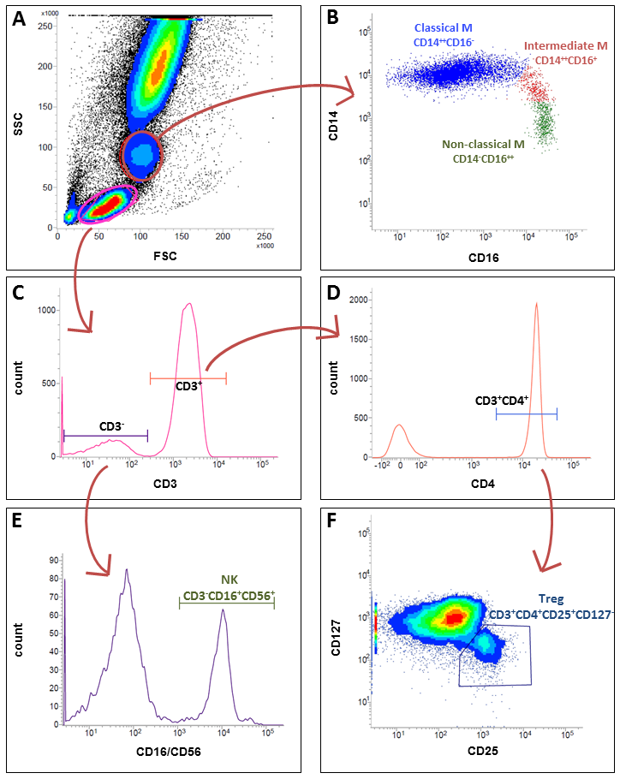
(A) Monocytes (red circle) and lymphocytes (pink circle) were identified based on their forward (FSC) and side scatter (SSC) properties. (B) According to the differential surface expression of the phenotypic markers CD14 and CD16, monocyte subsets (M) were defined as classical CD14⁺⁺CD16⁻ (blue), intermediate CD14⁺⁺CD16⁺ (red), and non-classical CD14⁺CD16⁺⁺ (green) monocytes. (C) Lymphocytes were divided into a CD3⁺ and CD3⁻ cell population, (E) the latter gated for simultaneous expression of CD16 and CD56, which is characteristic for natural killer (NK) cells (green gate). (D) CD3⁺ cells were analyzed for their presence of CD4. (F) CD3⁺CD4⁺ cells were further gated on CD127 and CD25 allowing identification of regulatory T cells (Treg) characterized by their low CD127 and high CD25 surface expression (blue gate).

Figure S2 - Participant flow chart.
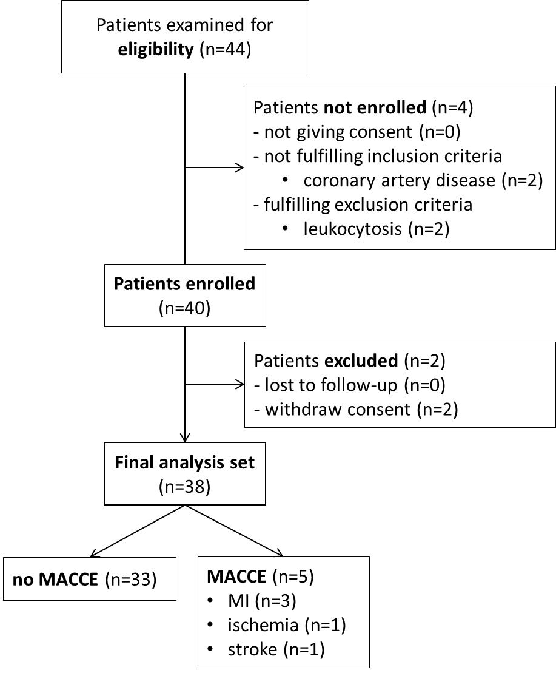

Figure S3 - Net reclassification improvement (NRI) for “preoperative NT-proBNP” alone versus a combination of “preoperative NT-proBNP and presepsin“ or “preoperative NT-proBNP and hs-cTnT”.
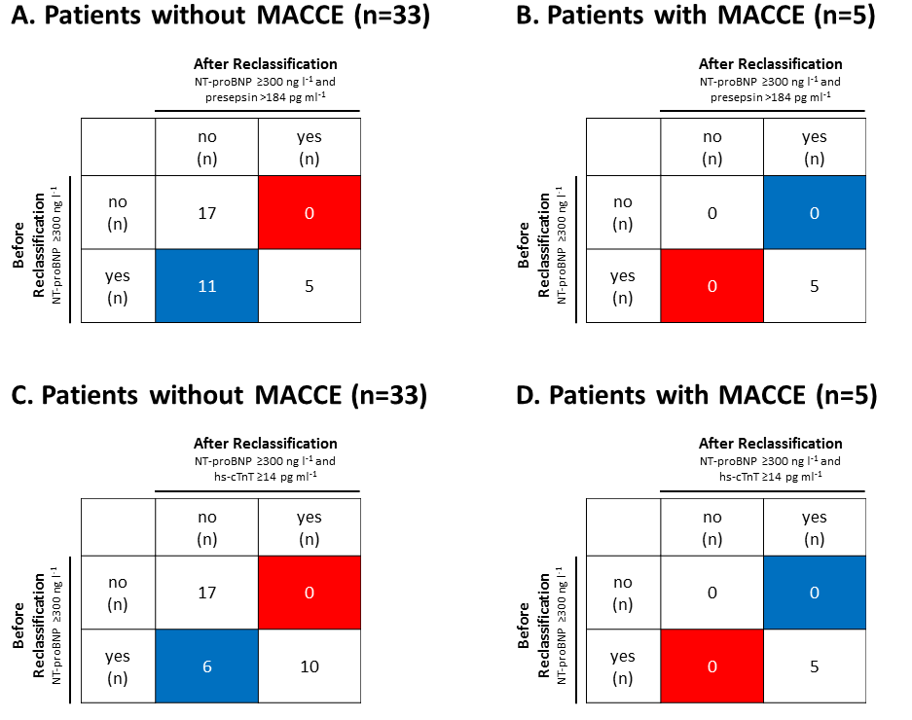
Reclassification tables for patients with and without MACCE are shown. With the NT-proBNP only classification (rows), patients are dichotomously grouped into at risk (yes) with NT-proBNP measurements ≥300 ng l⁻¹ versus not at risk (no) with NT-proBNP measurements <300 ng l⁻¹. (A+B) Presepsin (>184 pg ml⁻¹) or (C+D) hs-cTnT (≥14 pg ml⁻¹) were added to the model (columns). Blue cells mark correctly reclassified patients; red cells indicate incorrectly reclassified patients.
(A) In the non-event group, adding presepsin to the NT-proBNP-based model resulted in a higher number of correctly reclassified patients. No patient was incorrectly reclassified, thereby reducing the rate of false positive identifications. NRI in the non-event group was statistically significant (NRI=0.33; p=0.0009). (B) There were no reclassifications within the MACCE group (NRI=0; p=n.a.), resulting in a total NRI of 0.33 (95% CI [0.15; 0.49]; p=0.0009). (C) The combined measurement of NT-proBNP and hs-cTnT also reduced the rate of false positively identified patients (NRI=0.18, p=0.014) in the non-event group. (D) Like presepsin, adding hs-cTnT to the NT-proBNP-based model did not alter classifications in the MACCE group (NRI=0; p=n.a.). Total NRI of the NT-proBNP/hs-cTnT model was 0.18 (95% CI [0.04; 0.31]; p=0.014).

