Supplementary Figure 1: Bubble Plot showing the graphical relationships between the variables (Fentanyl dose and need for supplemental analgesia) with a weighted least squares regression line. The size of the circle corresponds to the inverse variance of the log-odds ratio in that trial. The area of each circle is inversely proportional to the total variance of the log odds ratio estimate. The line represents the predicted values from the regression model.

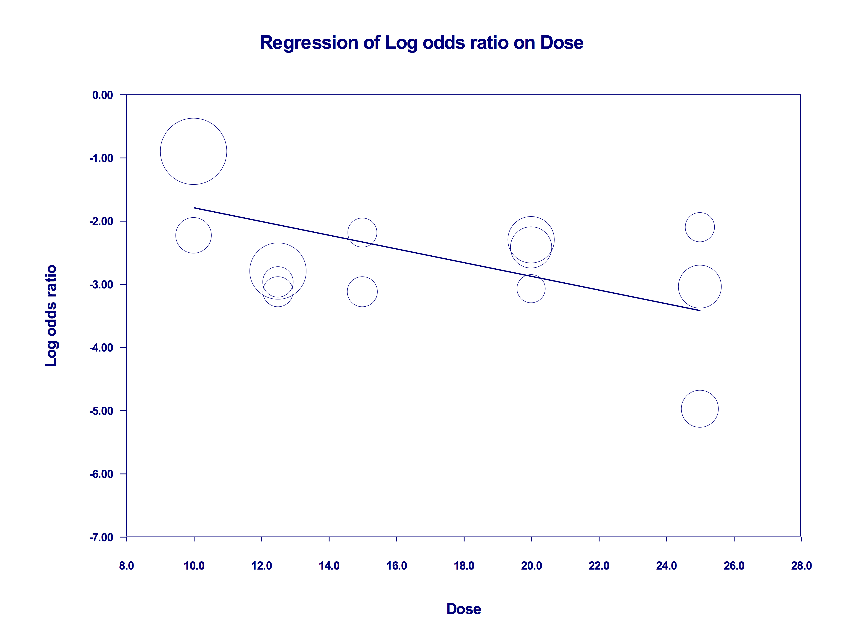
Supplementary Figure 2: Trial sequential analysis of the outcome “need for intra-operative supplemental analgesics." The Z-value is the test statistic, and Z = 1.96 corresponds to a P = 0.05; the higher the Z-value, the lower the P-value. The cumulative Z-curve (black "full" line with quadratic indicators of each trial) surpasses the traditional boundary for statistical significance after the fourth trial and the trial sequential monitoring boundaries (etched red curves above and below the traditional horizontal lines for statistical significance) after the eleventh trial. Therefore, the accumulated evidence from included studies is sufficient to make these finding conclusive.

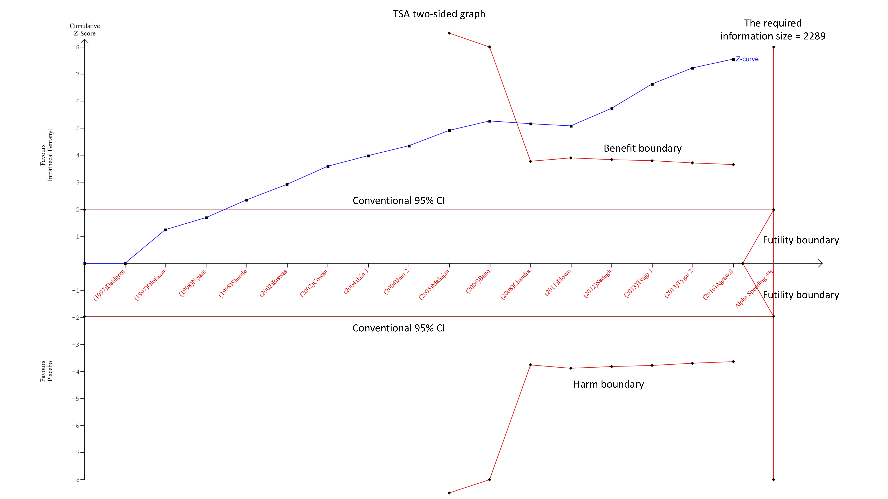
Supplementary Figure 3: Funnel plot for the primary outcome (need for supplemental analgesia) with use of IT fentanyl. The asymmetrical plot shows the presence of publication bias (studies showing no beneficial effects are missing).

