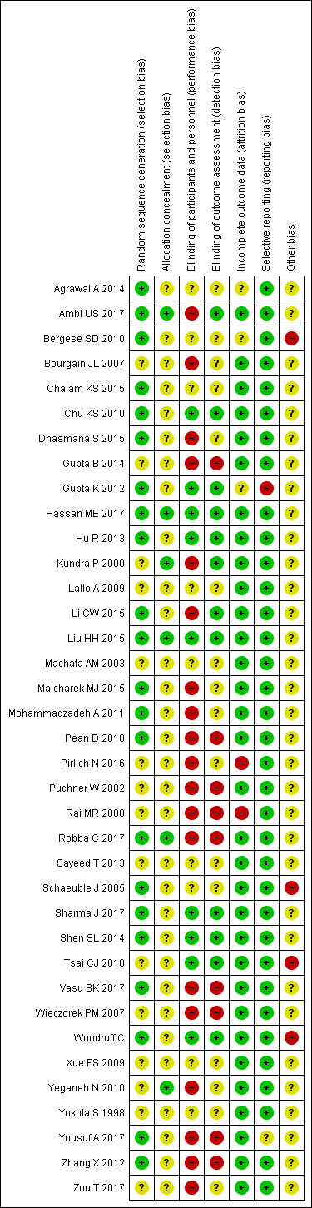

**eFigure 1:** Risk of bias summary: review authors' judgements about each risk of bias item for each included study.

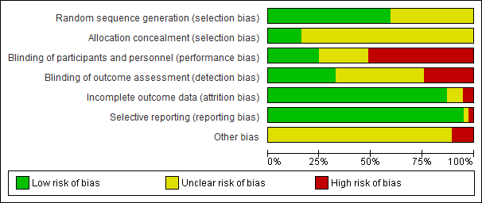

**eFigure 2:** Risk of bias graph: review authors' judgements about each risk of bias item presented as percentages across all included studies.



**eFigure 3:** Funnel plot for comparisons between dexmedetomidine and other sedation regimens. Dotted lines represent the limits of the 90%, 95% and 99% confidence interval regions.