Supplemental Material

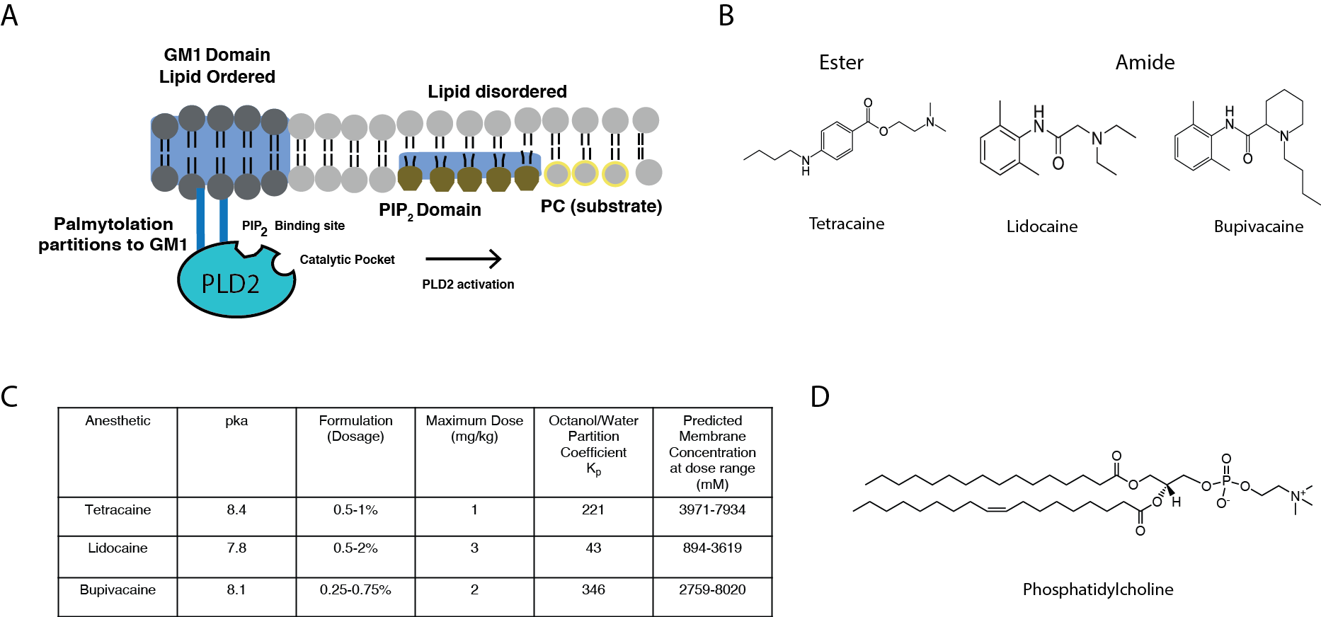

Fig. S1. Local anesthetics used in this study. (A) Cartoon representation of GM1 and PIP₂ domains (blue shading). GM1 domains contain saturated lipids (dark grey shading), cholesterol (not shown), and are thicker than bulk membranes. PIP₂ is a polyunsaturated glycol-lipid (hexagons lipids) that is negatively charged and clusters with proteins in the disordered region of the membrane. The enzyme phospholipase D2 (PLD2, cyan) is palmitoylated (blue sticks) and localizes to GM-1 domains through its palmitoylation and PIP₂ domains through its lipid binding site in the enzyme. Palmitoylation and PIP₂ binding oppose each other and the relative stability and affinitive respectively dictates the localization of PLD. The substrate of PLD is near PIP₂ domains and PLD2 is activated by substrate presentation when released from GM-1 domains.¹⁷ (B) Chemical structures of tetracaine, lidocaine and, bupivacaine. (C) pKa, formulation and doses of the local anesthetics.^{2,50} Membrane concentrations were estimated according to Herold et. al. (2017) in artificial membrane at the listed dose range.^{51,52} (D) Chemical structure phosphatidylcholine, the substrate of PLD.

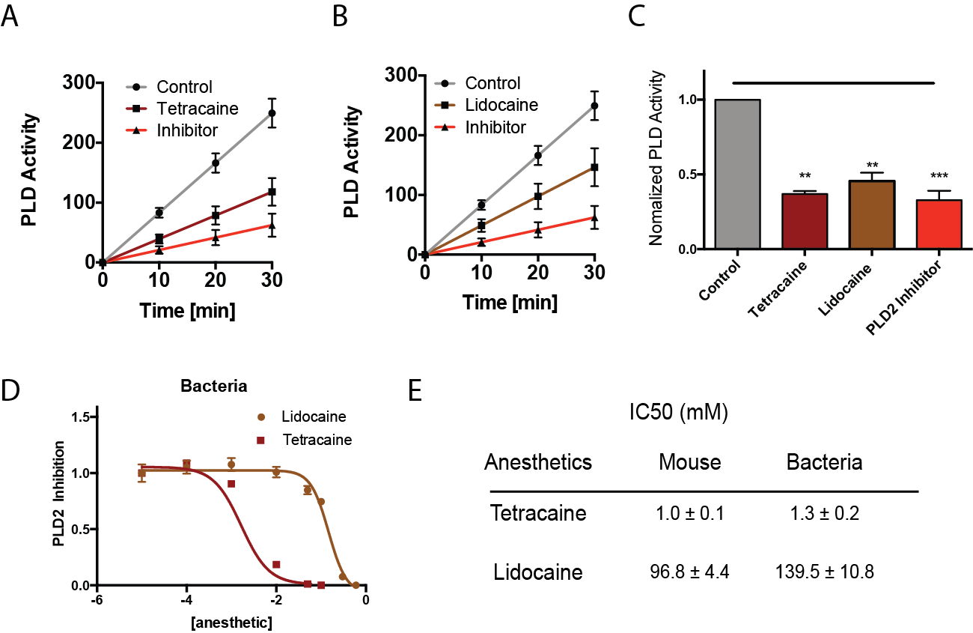
Fig. S2. Local anesthetics inhibit purified mouse and bacteria as well as PLD2 in live C2C12 cells. (A-B) Tetracaine (150 µM) (A), lidocaine (10 mM) (B), and PLD2 inhibitor (2.5-5 µM) inhibit the PLD2 activity compared to the control cells (n = 4, mean (SD)). (C) Summary of normalized activity of PLD2 after the local anesthetics’ treatment from (A-B) at 30 min (n = 4, mean (SD)). (D) Dose-response curve showing the inhibition of purified bacterial PLD2 by local anesthetics. (E) Half-maximum inhibiting concentrations (IC₅₀) for local anesthetics calculated from D and Fig. 1E. **P ≤ 0.01; ***P ≤ 0.001.
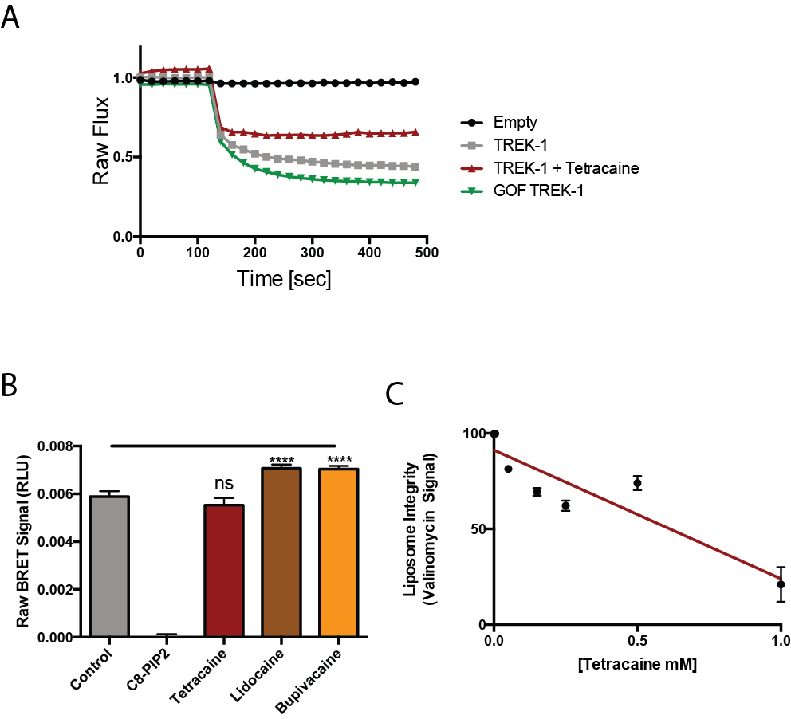

Fig. S3. Effect of local anesthetic on TREK-1 flux assay and liposomes. (A) Representative ion-flux assay of purified TREK-1 reconstituted into DOPC (18:1) liposomes with 15 mol% POPG anionic lipid. (B) Raw BRET assay signals comparing the competition of soluble C-8 PIP₂ (100 μM) and local anesthetics with FL-PIP₂ (500 nM) (n =8, mean (SD)). (C) Relative disruption of liposomes by tetracaine quantified based on the nonstandard quenching of signals after valinomycin was added to the liposomes. ****P ≤ 0.0001; ns P > 0.05.

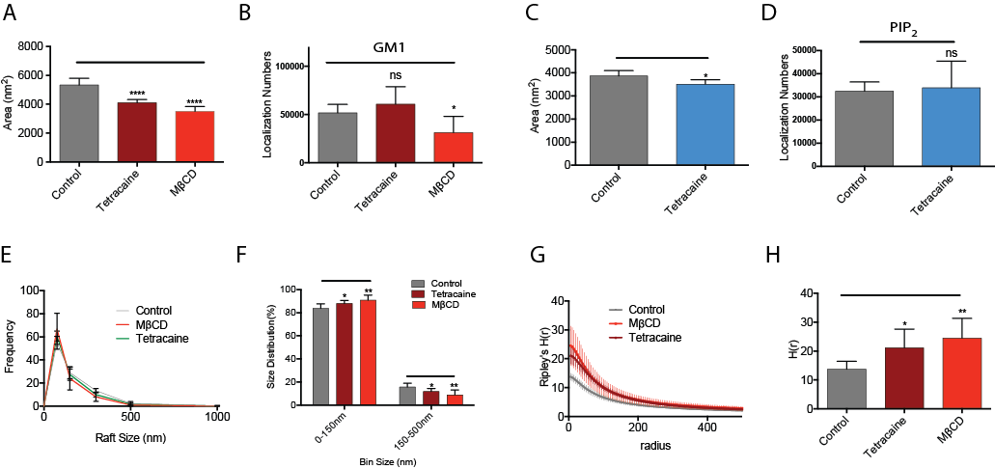

Fig. S4. Quantification of raft disruption by local anesthetic. (A) Bar graph of the mean Raft areas in N2A cells treated with tetracaine quantified by the cluster analysis (n = 2201-3406, mean (95% CI)) (B) Comparison of total localization numbers acquired in GM1 labeled images (n = 5, mean (SD)). The amount of observed label before and after anesthetic treatment appears to increase slightly but is not statistically significant. (C) Average PIP₂ areas in N2A cells treated with tetracaine (n = 1991-2128, mean (95% CI)) (D) Comparison of localization numbers acquired in PIP₂ labeled images (n = 6, mean (SD)). (E) Averages size distribution of lipid rafts in N2A cells treated with tetracaine (150 µM) or MβCD (100 µM) (n = 5, mean (SD)). (F) Bar graphs showing the size distribution of lipid rafts from N2A cells binned from 0-150 nm and 150-500 nm. (G) Derivatives of Ripley’s K-Function (H(r)) demonstrating the separation of lipid rafts after the treatment of tetracaine (150 µM) or MβCD (100 µM) (n = 5, mean (SD)). (H) Bar graphs comparing the Ripley’s K-Function H(r) values. *P ≤ 0.05; **P ≤ 0.01; ****P ≤ 0.0001.

Supplementary References:

50. French J, Sharp LM. Local anaesthetics. Ann R Coll Surg Engl 2012;94:76–80. Available at: http://www.ncbi.nlm.nih.gov/pubmed/22391358.
51. Herold KF, Nau C, Ouyang W, Hemmings HC, Jr. Isoflurane inhibits the tetrodotoxin-resistant voltage-gated sodium channel Nav1.8. Anesthesiology 2009;111:591–9.
52. Strichartz GR, Sanchez V, Arthur GR, Chafetz R, Martin D. Fundamental properties of local anesthetics. II. Measured octanol:buffer partition coefficients and pKa values of clinically used drugs. Anesth Analg 1990;71:158–70.

