Supplemental Digital Content 1, Text 1: Search strategies used for MEDLINE/PubMed, EMBASE, CINAHL, LILACS and CENTRAL.

DATABASES | SEARCH STRATEGIES
MEDLINE  (PUBMED) | (postoperative[tiab] OR perioperative[tiab] OR postsurgical[tiab] OR perioperative[tiab] OR intraoperative[tiab] OR "pain postoperative"[mh] OR "pain postoperative"[tiab] OR intraoperative[tiab) AND (Methadone[mh] OR Methadone[tiab] OR Amidone[tiab] OR Biodone[tiab] OR Dolophine[tiab] OR Metadol[tiab] OR Metasedin[tiab] OR Methaddict[tiab] OR Methadose[tiab] OR Methex[tiab] OR Phenadone[tiab] OR Phymet[tiab] OR Physeptone[tiab] OR Pinadone[tiab] OR Symoron[tiab] OR "Methadone Hydrochloride"[tiab] OR "Hydrochloride Methadone"[tiab]) AND (opioids[tiab] OR opioid[tiab] OR Fentanyl[mh] OR Fentanyl[tiab] OR Duragesic[tiab] OR Durogesic[tiab] OR Fentanest[tiab] OR "Fentanyl Citrate"[tiab] OR Fentora[tiab] OR "R-4263"[tiab] OR Sublimaze[tiab] OR "Transmucosal Oral Fentanyl Citrate"[tiab] OR "R 4263"[tiab] OR "R4263"[tiab] OR Phentanyl[tiab] OR remifentanil[tiab] OR "3-(4-methoxycarbonyl-4-((1-oxopropyl)phenylamino)-1-piperidine)propanoic acid methyl ester"[tiab] OR "remifentanil monohydrochloride"[tiab] OR "GI 87084B"[tiab] OR "GI87084B"[tiab] OR "GI-87084B"[tiab] OR "remifentanil hydrochloride"[tiab] OR Ultiva[tiab] OR Sufentanil[mh] OR Sufentanil[tiab] OR "R-30730"[tiab] OR "Sufenta"[tiab] OR "Sulfentanil"[tiab] OR "Sulfentanyl"[tiab] OR "R 30730"[tiab] OR "R30730"[tiab] OR "SufentanilHameln"[tiab] OR "SufentanilRatiopharm"[tiab] OR "sufentanil"[tiab] OR "alfentanil"[tiab] OR morphine[tiab~] OR morphine[mh]) AND ("pain control"[tiab] OR analgesic[tiab] OR anesthesia[tiab] OR "anesthesia care"[tiab] OR analgesia[tiab] OR "pain management"[tiab] OR "pain scores"[tiab] OR "PCA"[tiab] OR "patient-controlled analgesia"[tiab] OR "analgesia"[tiab] OR "pain control"[tiab] OR anaesthesia[tiab] OR anaesthetic[tiab])
EMBASE | ('postoperative pain'/exp OR 'pain, postoperative' OR 'post operation pain' OR 'postoperative pain' OR 'perioperative pain'/exp OR perioperative OR postsurgical OR intraoperative) AND ('methadone'/exp OR 'amidon' OR 'amidona' OR 'amidone' OR 'biodone' OR 'dolophine' OR 'metadol' OR 'metadon' OR 'metasedin' OR 'methaddict' OR 'methadone hydrobromide' OR 'methadone hydrochloride' OR 'methadose' OR 'phenadon' OR 'physeptone' OR 'symoron' OR methex OR phymet OR pinadone) AND ('opiate'/exp OR 'opium' OR 'opial' OR 'opiate' OR 'opioid' OR 'fentanyl'/exp OR 'duragesic' OR 'fentamyl' OR 'fentanyl' OR 'r 4263' OR 'r4263' OR 'durogesic' OR 'fentanil' OR 'phentanyl' OR 'sufentanil'/exp OR 'r 30730' OR 'r30, 730' OR 'r30730' OR 'sufentanil' OR 'sufentanyl' OR 'sulfentanil' OR 'sulfentanyl' OR 'fentathienyl' OR 'fentathianyl' OR 'r 30, 730' OR 'morphine'/exp OR 'morfin' OR 'morfine' OR 'morphin' OR 'morphine' OR 'fentanyl citrate'/exp OR 'fentanest' OR 'lazanda' OR 'sublimaze' OR 'fentanyl citrate' OR 'fentora' OR 'haldid' OR 'remifentanil'/exp OR '3 [4 methoxycarbonyl 4 (n phenylpropionamido) piperidino] propionic acid methyl ester' OR 'gi 87084' OR 'gi 87084b' OR 'gi87084' OR 'gi87084b' OR 'remifentanil' OR 'remifentanyl' OR 'ultiva') AND ('pain control'/exp OR 'analgesic agent'/exp OR 'analgesic' OR 'anesthesiological procedure'/exp OR 'anaesthesia and analgesia' OR 'anesthesia and analgesia' OR 'anesthesiological procedure' OR 'anesthesiological techniques' OR 'anesthesia'/exp OR 'anaesthesia' OR 'anesthesia' OR 'anesthetization' OR 'anesthesia care'/exp OR 'analgesia'/exp OR 'pain management' OR 'pain relief' OR 'sequential analgetic analgesia' OR 'surgical analgesia' OR 'analgesia' OR 'patient controlled analgesia'/exp OR 'analgesia, patient controlled' OR 'analgesia, patient-controlled' OR 'patient controlled anaesthesia' OR 'patient controlled analgesia' OR 'patient controlled anesthesia' OR 'pain scores' OR 'anesthetic agent'/exp OR 'anaesthetic') AND [embase]/lim NOT ([embase]/lim AND [medline]/lim)
LILACS | tw:((tw:postoperative OR tw:posoperatorio OR tw:"pos-operatoria" OR tw:"pos-operatorio" OR tw:perioperative OR tw:perioperatori* OR tw:postsurgical OR tw:posquirurgic* OR tw:postoperado OR tw:postquirurgica OR tw:postoperatorio OR tw:operado OR tw:pos-cirurgic* OR tw:poscirugia OR tw:intraoperator* OR tw:intraoperative OR mh:"pain, postoperative" OR tw:"Dolor Posoperatorio" OR tw:"Dor Pós-Operatória" OR tw:"Pain, Postoperative") AND (tw:methadone OR mh:methadone OR tw:metadona OR tw:amidone OR tw:biodone OR tw:dolophine OR tw:metadol OR tw:metasedin OR tw:methaddict OR tw:methadose OR tw:methex OR tw:phenadone OR tw:phymet OR tw:physeptone OR tw:pinadone OR tw:symoron OR tw:"Methadone Hydrochloride" OR tw:"Hydrochloride Methadone") AND (tw:opioid* OR tw:opiaceos OR mh:fentanyl OR tw:fentanyl OR tw:duragesic OR tw:durogesic OR tw:fentanest OR tw:"Fentanyl Citrate" OR tw:fentora OR tw:"R-4263" OR tw:sublimaze OR tw:"Transmucosal Oral Fentanyl Citrate" OR tw:"R 4263" OR tw:"R4263" OR tw:phentanyl OR tw:remifentanil ortw:fentanila OR tw:fentanilo OR tw:"remifentanil monohydrochloride" OR tw:"GI 87084B" OR tw:"GI87084B" OR tw:"GI-87084B" OR tw:"remifentanil hydrochloride" OR tw:ultiva OR mh:sufentanil OR tw:sufentanil* OR tw:"R-30730" OR tw:sufenta OR tw:sulfentanil OR tw:sulfentanyl OR tw:"R 30730" OR tw:"R30730" OR tw:"SufentanilHameln" OR tw:"SufentanilRatiopharm" OR tw:"alfentanil" OR mh:morphine OR tw:morphine OR tw:morfina) AND (tw:"pain control" OR tw:"controle da dor" OR tw:"manejo del dolor" OR tw:"control del dolor" OR tw:dor OR tw:dolor OR tw:analgesic OR tw:analgesico* OR tw: anestesia OR tw:anesthesia OR tw:anestecic* OR tw:"anesthesia care" OR tw:analgesia OR tw:"pain management" OR tw:"pain scores" OR tw:"PCA" OR tw:"patient-controlled analgesia" OR tw:"Colocación de analgesia controlada" OR tw:"analgesia controlada" OR tw:"tratamento da dor" OR tw:anaesthesia OR tw:anestesia OR tw:anestesico* OR tw:anaesthetic)) AND (instance:"regional") AND ( db:("LILACS"))
CENTRAL | #1 "postoperative pain" OR "pain, postoperative" OR "post operation pain" OR "postoperative pain" OR "perioperative pain" OR perioperative OR postsurgical OR intraoperative 51514  #2 MeSH descriptor: [Methadone] explode all trees 1147  #3 methadone OR amidon OR amidona OR amidone OR biodone OR dolophine OR metadol OR metadon OR metasedin OR methaddict OR "methadone hydrobromide" OR "methadone hydrochloride" OR methadose OR phenadon OR physeptone OR symoron OR methex OR phymet OR pinadone 2557  #4 #2 or #3 2568  #5 MeSH descriptor: [Fentanyl] explode all trees 5031  #6 MeSH descriptor: [Sufentanil] explode all trees 808  #7 MeSH descriptor: [Morphine] explode all trees 4515  #8 opiate OR opium OR opial OR opiate OR opioid OR fentanyl OR duragesic OR fentamyl OR fentanyl OR "r 4263" OR "r4263" OR durogesic OR fentanil OR phentanyl OR sufentanil OR "r 30730" OR "r30, 730" OR "r30730" OR sufentanil OR sufentanyl OR sulfentanil OR sulfentanyl OR fentathienyl OR fentathianyl OR morphine OR morfin OR morfine OR morphin OR morphine OR "fentanyl citrate" OR fentanest OR lazanda OR sublimaze OR "fentanyl citrate" OR fentora OR haldid OR "3 [4 methoxycarbonyl 4 (n phenylpropionamido) piperidino] propionic acid methyl ester" OR "gi 87084" OR "gi 87084b" OR "gi87084" OR "gi87084b" OR remifentanil OR remifentanyl OR ultiva 35397  #9 #5 OR #6 OR #7 OR #8 35676  #10 MeSH descriptor: [undefined] explode all trees 0  #11 MeSH descriptor: [Anesthesia] explode all trees 17871  #12 MeSH descriptor: [Analgesia, Patient-Controlled] explode all trees 1895  #13 MeSH descriptor: [Anesthetics] explode all trees 14063  #14 #10 or #11 or #12 or #13 26140  #15 "pain control" OR "analgesic agent" OR analgesic OR "anesthesiological procedure" OR anesthesiological OR anesthesia OR anaesthesia OR anesthetization OR analgesia OR "pain management" OR "pain relief" OR "sequential analgetic analgesia" OR "surgical analgesia" OR "patient controlled analgesia" OR "analgesia, patient-controlled" OR "patient controlled anaesthesia" OR "patient controlled anesthesia" OR "pain scores" OR "anesthetic agent" OR anaesthetic 96380  #16 #14 or #15 97907  #17 #4 and #9 and #14 and #16 27
CINAHL | (postoperative OR perioperative OR postsurgical OR intraoperative OR "pain postoperative") AND (Methadone OR Amidone OR Biodone OR Dolophine OR Metadol OR Metasedin OR Methaddict OR Methadose OR Methex OR Phenadone OR Phymet OR Physeptone OR Pinadone OR Symoron OR "Methadone Hydrochloride" OR "Hydrochloride Methadone") AND (opioids OR opioid OR Fentanyl OR Duragesic OR Durogesic OR Fentanest OR "Fentanyl Citrate" OR Fentora OR "R-4263" OR Sublimaze OR "Transmucosal Oral Fentanyl Citrate" OR "R 4263" OR "R4263" OR Phentanyl OR remifentanil OR "3-(4-methoxycarbonyl-4-((1-oxopropyl)phenylamino)-1-piperidine)propanoic acid methyl ester" OR "remifentanil monohydrochloride" OR "GI 87084B" OR "GI87084B" OR "GI-87084B" OR "remifentanil hydrochloride" OR Ultiva OR Sufentanil OR "R-30730" OR "Sufenta" OR "Sulfentanil" OR "Sulfentanyl" OR "R 30730" OR "R30730" OR "SufentanilHameln" OR "SufentanilRatiopharm" OR "alfentanil" OR morphine) AND ("pain control" OR analgesic OR anesthesia OR "anesthesia care" OR analgesia OR "pain management" OR "pain scores" OR "PCA" OR "patient-controlled analgesia" OR anaesthesia OR anaesthetic)

Supplemental Digital Content 2, Table 1: List of Studies Included in One or More of the Comparisons in the Meta-analysis.

Studies | Quality Score* | Methadone Patients | Control Patients | Methadone Dosing | Control Dosing | Methadone Dose Timing | Other opioids used during surgery | Type of Surgery
Berde et al. | 5 | 18 | 17  (Morphine) | 0.2mg/Kg | 0.2 mg/Kg | After anesthesia induction | None | Major surgery in 3 to 7 year-old children
Carvalho et al. | 5 | 50 | 50  (Morphine) | 0.1 mg/kg | 0.1 mg/kg | End of surgery | Sufentanil at anesthesia induction and maintenance | Coronary artery bypass graft
Chui et al. | 1 | 15 | 15  (Morphine) | 0.25 mg/kg | 0.25 mg/kg | At anesthesia induction | None | Elective abdominal hysterectomies
Gottschalk et al. | 5 | 13 | 16  (Sufentanil) | 0.2 mg/kg | 0.75 mcg/kg | After anesthesia induction | Sufentanil 0.25 mcg/kg/h only in control group | Multilevel thoracolumbar spine surgery
Gourlay et al. | 4 | 10 | 10  (Morphine) | 20 mg | 20 mg | After anesthesia induction | None | Open upper abdomen procedures
Komen et al. | 7 | 39 | 21 (short-duration opioids) | 0.1 or 0.15 mg/kg | Variable | At anesthesia induction | None | Ambulatory procedures
Machado et al. | 7 | 16 | 16  (Fentanyl) | 0.15 mg/kg + bolus 0.05 mcg/kg | 6 mcg/kg + bolus 2 mcg/kg | At anesthesia induction | None | Open bariatric surgery
Martin et al. | 1 | 22 | 19  (Remifentanil) | 0.1 mg/kg | 2.5 mcg/kg at induction | After anesthesia induction | Remifentanil infusion 0.05 to 0.15 mcg/kg/min | Spinal fusion
Murphy et al. (2017) | 6 | 62 | 53  (Hydromorphone) | 0.2 mg/kg | 2 mg | Methadone after induction and hydromorfone at the end of surgery | Fentanil 100 mcg at induction and remifentanil during surgery | Spinal fusion
Murphy et al. (2015) | 6 | 77 | 79  (Fentanyl) | 0.15 mg/kg + infusion of 0,15 mg/kg over 2h | 6 mcg/kg + infusion of 6 mcg/kg over 2h | At anesthesia induction + 2h infusion | None | Coronary artery bypass graft, valve surgery, atrial septal defect repair
Richlin et al. | 0 | 20 | 20  (Morphine) | 20 mg | 20 mg | After anesthesia induction | None | Elective abdominal hysterectomy or myomectomy
Simoni et al. | 5 | 42 | 42  (no other opioids) | 0,1 mg/kg | - | After anesthesia induction | Anesthesia induction with remifentanil | Laparoscopic surgery
Udelsmann et al. | 2 | 18 | 19  (Morphine) | 20 mg | 20 mg | After anesthesia induction | Anesthesia induction with sufentanil 0.1 mcg/kg | Cardiac surgery

* Quality accessed according to GRADE risk of bias (from 0 to 7)

Supplemental Digital Content 3, Figure 1: Risk of bias summary – Review authors' judgments about each risk of bias item for each included study according to Cochrane Collaboration’s criteria.
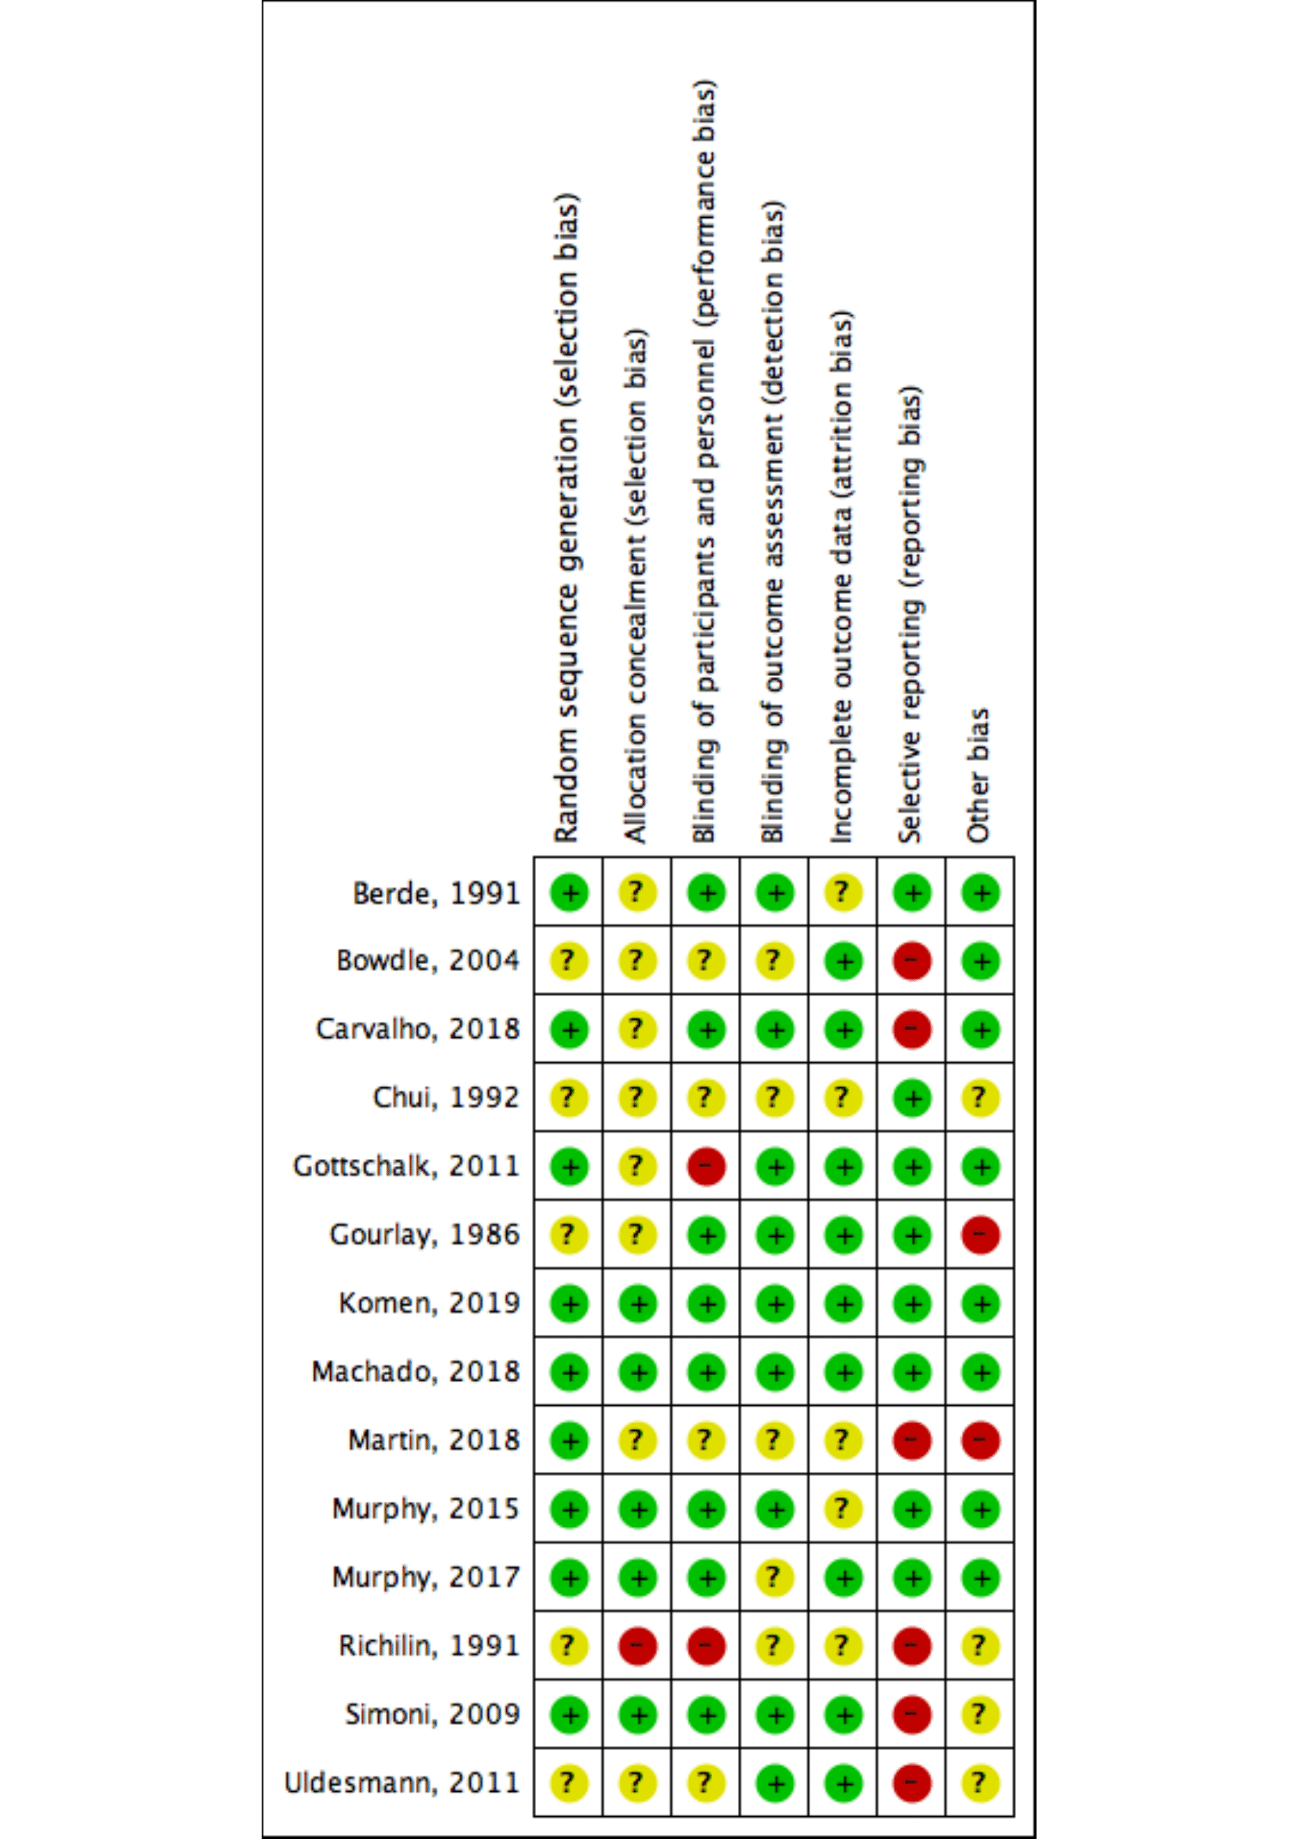
Supplemental Digital Content 4, Text 2: Summary of Findings.
Intraoperative methadone compared to control group for management of postoperative pain
Patient or population: Patient who underwent any surgical procedure.
Settings: Operating room.
Intervention: Methadone.
Comparison: Other opioids.
Outcomes | Illustrative comparative risks* (95% CI) |  | Relative effect  (95% CI) | No of Participants  (studies) | Quality of the evidence  (GRADE) | Comments
 | Assumed risk | Corresponding risk
 | Other opioids | Methadone
Pain assessment - Pain at rest  VAS . Scale from: 0 to 10.  Follow-up: mean 1 days | The mean pain assessment - pain at rest in the control groups was  3.5 | The mean pain assessment - pain at rest in the intervention groups was  1.09 lower  (1.47 to 0.72 lower)¹ |  | 486  (7 studies) | ⊕⊝⊝⊝  very low^{1,2,3}
Pain assessment - Pain at movement  VAS . Scale from: 0 to 10. | The mean pain assessment - pain at movement in the control groups was  6 | The mean pain assessment - pain at movement in the intervention groups was  2.48 lower  (3.04 to 1.92 lower) |  | 292  (3 studies) | ⊕⊕⊕⊝  moderate^{2,4}
Postoperative opioid consumption (mg eq mor) - until 24 h PO  morphine equivalents (mg). Scale from: 0 to 120.  Follow-up: mean 1 day | The mean postoperative opioid consumption (mg eq mor) - until 24 h po in the control groups was  45 mg eq morphine | The mean postoperative opioid consumption (mg eq mor) - until 24 h po in the intervention groups was  8.42 lower  (12.99 to 3.84 lower) |  | 460  (7 studies) | ⊕⊕⊝⊝  low^{2,4,5}
PONV  incidence of postoperative nausea and/or vomiting as defined by the trial authors  Follow-up: mean 3 days | Study population |  | RR 0.89  (0.66 to 1.2) | 573  (9 studies) | ⊕⊕⊝⊝  low^{2,4,6}
 | 46 per 100 | 41 per 100  (30 to 55)
 | Moderate
 | 40 per 100 | 36 per 100  (26 to 48)
Respiratory adverse effects  incidence of postoperative respiratory adverse effects as defined by the trial authors  Follow-up: mean 3 days | Study population |  | RR 1.24  (0.68 to 2.25) | 462  (6 studies) | ⊕⊝⊝⊝  very low^{2,7,8}
 | 7 per 100 | 9 per 100  (5 to 17)
 | Moderate
 | 8 per 100 | 10 per 100  (5 to 18)
Cardiovascular adverse effects  incidence of postoperative cardiovascular adverse effects as defined by the trial authors  Follow-up: mean 3 days | Study population |  | RR 1.18  (0.72 to 1.91) | 183  (2 studies) | ⊕⊝⊝⊝  very low^{8,9,10}
 | 23 per 100 | 28 per 100  (17 to 45)
 | Moderate
 | 6 per 100 | 7 per 100  (4 to 11)
Patient Satisfaction  Rank 0-100. Scale from: 0 to 100.  Follow-up: mean 2 days | The mean patient satisfaction in the control groups was  90 | The mean patient satisfaction in the intervention groups was  8.29 higher  (4.99 to 11.6 higher) |  | 293  (3 studies) | ⊕⊕⊕⊝  moderate²
*The basis for the assumed risk (e.g. the median control group risk across studies) is provided in footnotes. The corresponding risk (and its 95% confidence interval) is based on the assumed risk in the comparison group and the relative effect of the intervention (and its 95% CI).
CI: Confidence interval; RR: Risk ratio; mor: morphine; PO: postoperative
GRADE Working Group grades of evidence
High quality: Further research is very unlikely to change our confidence in the estimate of effect.
Moderate quality: Further research is likely to have an important impact on our confidence in the estimate of effect and may change the estimate.
Low quality: Further research is very likely to have an important impact on our confidence in the estimate of effect and is likely to change the estimate.
Very low quality: We are very uncertain about the estimate.
¹ The outcome was assessed by seven randomized studies. Most of them were well designed and had low risk of bias. Final decision: we downgraded one level (serious) for risk of bias.
² Different opioids and doses were given in control group, which may represent an impact on assessment of pain, opioid consumption and complications during postoperative period. Final decision we downgraded one level (serious) for indirectness.
³ The confidence intervals around the mean difference exceed the minimal important difference on VAS score for this outcome.
⁴ The high level of heterogeneity found in this outcome could be explained by different types of surgeries in the included studies.
⁵ Only two studies included in this outcome presented no detectable bias.
⁶ The outcome was assessed by nine randomized studies. Most of them were well designed and had low risk of bias. Final decision: we downgraded one level (serious) for risk of bias.
⁷ This outcome was provided from studies with high risk of bias (only one study had low level). Final decision: we downgraded two levels (very serious) for risk of bias.
⁸ The width of the confidence interval varied widely. Confidence interval crossed the null effect. Final decision: we rated down one level (serious) for imprecision.
⁹ Only two studies provided evidence for this outcome (small sample size) and both of them presented bias. Final decision: we downgraded two levels (very serious) for risk of bias.
¹⁰ One included study was conducted in cardiac surgery which may represent confounding factor for cardiovascular adverse effects. Final decision: we downgraded one level (serious) for inconsistency.

Supplemental Digital Content 5, Figure 2: Trial Sequential Analysis of the effect of intravenous methadone versus other opioids for postoperative control 24 h postoperatively at movement (A), 48 h postoperatively at movement (B), 72 h postoperatively at rest (C) and 72 h postoperatively at movement (D). Risk of type 1 error maintained at 5% with a power of 90%. Variance calculated from data deriving from included trials. Clinically significant reduction in pain scores was set at 1.1 / 10. Red lines on the left represent trial boundaries for efficacy (upper) or harm (lower). Blue line show cumulative Z-statistics for included studies, each black dot representing one trial. Region inside meeting red lines at the far right indicates the futility region. Horizontal green lines indicate efficacy and harm boundaries with no adjust to repeated testing (conventional p = 0.05). Red vertical line is Required Information Size (RIS).

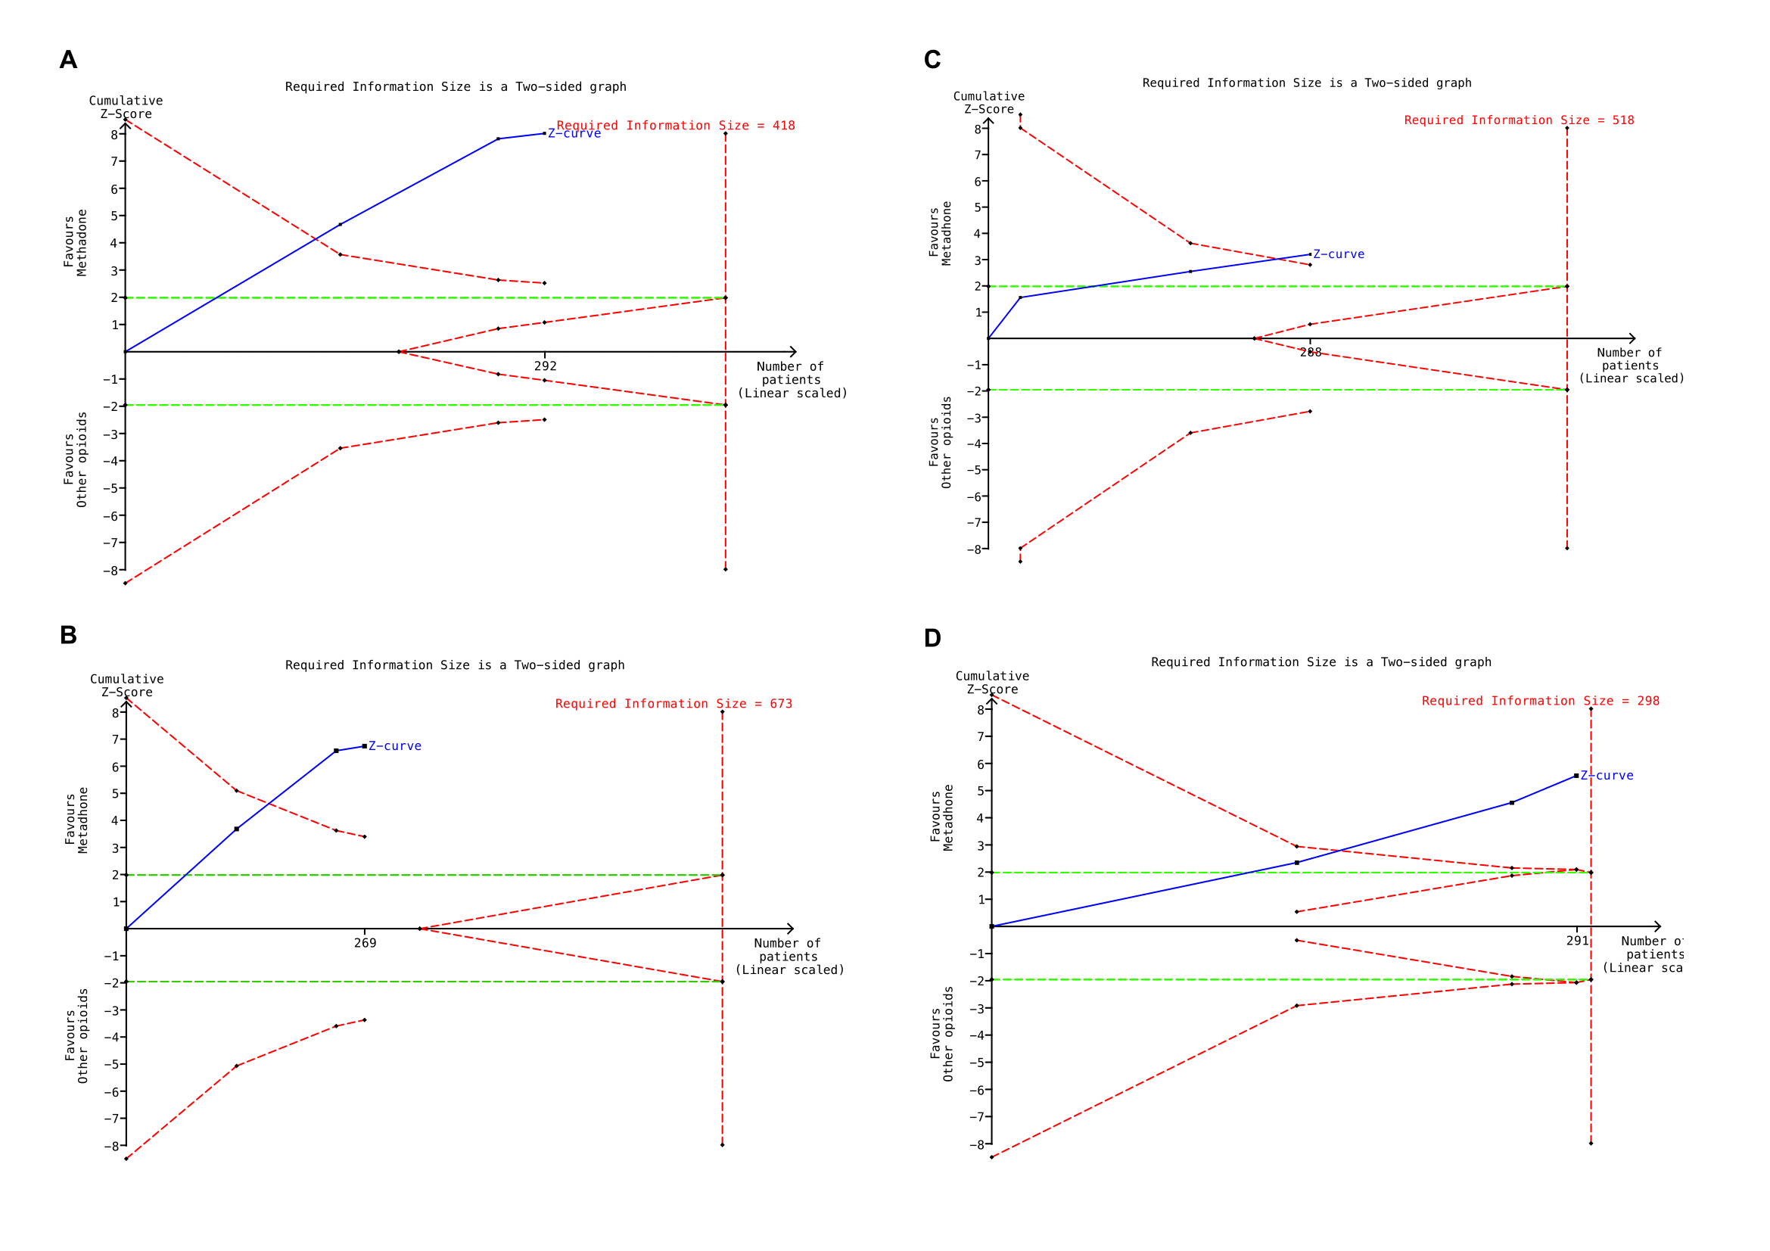
Supplemental Digital Content 6, Figure 3: Forest plot for methadone versus control for respiratory adverse effects (A) and for cardiovascular adverse effects (B). The table displays the study, mean, SD, sample size (total), difference in means with 95% CI, heterogeneity, overall effect, and P values.
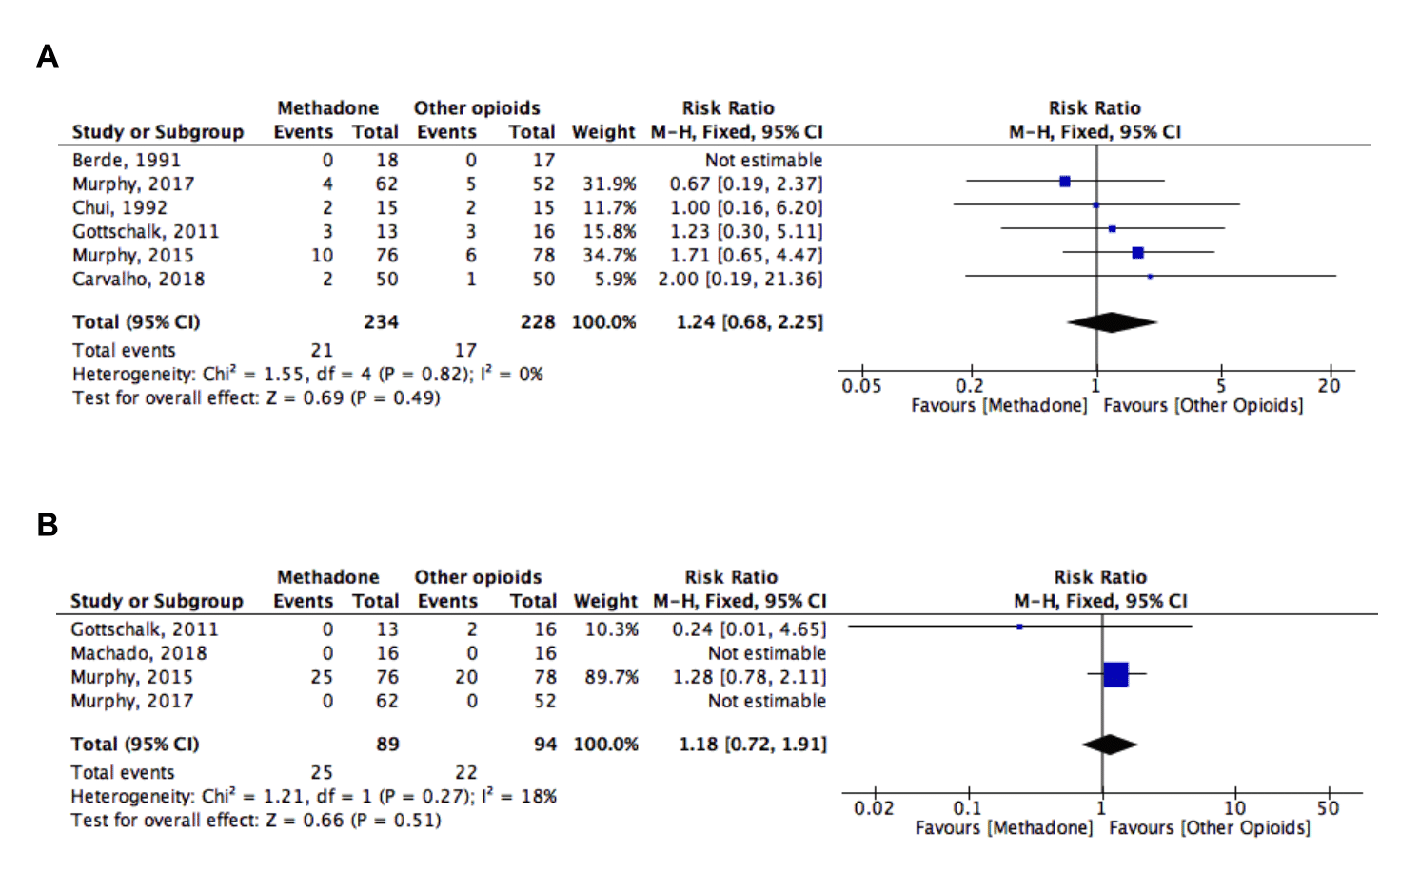
Supplemental Digital Content 7, Figure 4: Funnel plots for small-study effect for pain at rest 24 h (A), 48 h (B), 72 h (C) after surgery, and opioid consumption from Post Anesthesia Care Unit (PACU) until 72h after surgery (D)
