**Supplementary Material**

**Contents**

[**Table S1.** Characteristics of the currently available electroencephalographic (EEG) monitors. 2](#_Toc9454700)

[**Table S2.** Search strategies. 5](#_Toc9454701)

[**Table S3.** GRADE system used for POQI 6 Consensus Statement Ratings 7](#_Toc9454702)

[**Table S4.** Design characteristics of included trials. 8](#_Toc9454703)

[**Table S5.** Risk of bias table for included trials. 12](#_Toc9454704)

[**Figure S1.** Flow chart of the literature search and study selection for unintentional awareness during general anesthesia. 13](#_Toc9454705)

[**Figure S2.** Flow chart of the literature search and study selection for postoperative delirium. 14](#_Toc9454706)

[**Figure S3.** Flow chart of the literature search and study selection for postoperative neurocognitive disorders. 15](#_Toc9454707)

[**Figure S4.** Flow chart of the literature search and study selection for postoperative long-term survival. 16](#_Toc9454708)

[**Figure S5.** Difference in time (min) with BIS < 40 (normalized by surgical duration) in the CODA and the ENGAGES trials. 17](#_Toc9454709)

# **Table S1.** Characteristics of the currently available electroencephalographic (EEG) monitors.

|  |  |  |  |  |  |
| --- | --- | --- | --- | --- | --- |
| Monitor / Manufacturer | ParametersRef | Consumable | Physiologic signals / parameters display | Recommended range of values for anesthesia | Principles of measurement |
| BIS Complete 2-channel (or 4-channel) monitor (Medtronic, Boulder, CO) | Bispectral index (BIS)16 | BIS (4-electrode, bilateral, pediatric and extend) sensor  D:\1 POQI_Meeting_Dallas2018\#2_Monitore\foto\BIS_Monitor.jpg | 1-2 channels EEG   * Suppression ratio (SR) * Muscle artifacts (EMG) * Density spectral array (DSA) * Spectral edge frequency (SEF) * Asymmetry bifrontal recordings (ASYM) * Raw EEG | 40-60 | BIS is derived from the weighted sum of three EEG parameters:   1. relative α/ß ratio 2. biocherence of the EEG waves (SyncFastSlow) and 3. burst suppression   The relative contribution of these parameters has been tuned to correlate with the degree of sedation produced by various sedative agents. BIS ranges from 0 (asleep)-100 (awake). |
| SedLine brain function monitor (Masimo, Irvine, CA) | Patient state index (PSI)21 | PSArray2 sensor  D:\1 POQI_Meeting_Dallas2018\#2_Monitore\foto\SEDlineMonitor_root_Masimo.jpg | 4 Channels EEG   * Suppression ratio (SR) * Muscle artifacts (EMG) * Density spectral array (DSA) * Artifact (ARTF) * Spectral edge frequency (SEF) * Asymmetry display * Raw EEG | 25-50 | PSI is derived from progressive discriminant analysis of several quantitative EEG variables that are sensitive to changes in the level of anesthesia, but insensitive to the specific agents producing such changes. It includes changes in:   1. power spectrum in various EEG frequency bands 2. hemispheric symmetry, and synchronization between brain regions and the inhibition of regions of the frontal cortex.   PSI ranges from 0 (asleep)-100 (awake). |
| Nacrotrend monitor (MonitorTechnik, Bad Bramstedt, Germany) | Narcotrend stage  Narcotrend index19,26 | Ordinary ECG electrode  D:\1 POQI_Meeting_Dallas2018\#2_Monitore\foto\NarcotrendMonitor_Compact4.jpg | 1-2 channels EEG   * Suppression ratio (SR) * Muscle artifacts (EMG) * Spike monitoring (STI) * Density spectral array (DSA) * Relative frequency band (δ, θ, α and β) power Artifact (ARTF) * Spectral edge frequency (SEF) * Median frequency * Amplitude integrated EEG (aEEG) * Raw EEG | 35-65 (corresponds to stage D0-2 to C1) | The Narcotrend monitor classifies EEG signals into 15 stages of anesthesia (A=awake; B0–2=sedated; C0–2=light anesthesia; D0–2= general anesthesia; E0,1=general anesthesia with deep hypnosis; F0,1=burst suppression). The classification algorithm is based on a discriminant analysis of entropy measures and EEG spectral variables. More recently the monitor converts the Narcotrend stages into a dimensionless number from 0 (asleep) to 100 (awake) by nonlinear regression. |
| GE Datex-Ohmeda Entropy Module (GE Healthcare, Milwaukee, WI) | State and Response Entropy18 | Entropy sensor  https://cdn3.volusion.com/hfxrs.pcoru/v/vspfiles/photos/E-ENTROPY-00-2T.png?1547545611 | Single channel EEG   * Suppression ratio (SR) * State entropy (SE) * Response entropy (RE) | 40-60 | Entropy described the “regularity” of EEG signal. Entropy module calculates spectral entropy of the EEG spectrum. Two spectral parameters are calculated:   1. State entropy (SE, frequency band 0-32 Hz) and 2. Response entropy (RE, 0-47 Hz) also includes muscle activity   SE have been re-scaled, so that 0 is asleep and 91 is awake, while the range for RE is 0-100. |
| NeuroSENSE (NeuroWave Systems, Cleveland Heights, OH) | Wavelet Anesthetic value for Central Nervous System (WAVCNS) Index20 | ECG electrodes  http://www.neurowavesystems.com/img/NS3rdGen_Small.jpg | 2 channels EEG   * Raw EEG * Suppression ratio (SR) * Muscle artifacts (EMG) * Noise level to indicate electrode impedance and environmental noise * Artifact presence to detect ocular movement and electrocautery | 40-60 | WAVCNS is based on wavelet analysis of the γ frequency band (32-64 Hz) from short (1 second) epoch of EEG. |
| Cerebral state monitor (CSM), Danmeter A/S, Odense, Demark | Cerebral state index (CSI)23 | Ordinary ECG electrode  D:\1 POQI_Meeting_Dallas2018\#2_Monitore\foto\cerebral_State_monitor_Denmark.jpg | Single channel EEG   * Burst suppression (BS%) * Muscle activity (EMG%) * Signal quality (SQI%) * 3 seconds raw EEG waveform | 40-60 | CSI is a weighted sum of (1) α ratio, (2) β ratio, (3) difference between the two and (4) burst suppression. It correlates with the degree of sedation by adaptive neuro-fuzzy inference system. CSI ranges from 0 (asleep) to 100 (awake). |
| IoC-View monitor (**Morpheus Medical,** C/ Llacuna, Spain) | Index of Consciousness (IoC)22 | Ordinary ECG electrode | Single channel EEG   * Raw EEG * Signal quality (SQI) * Muscle activity (EMG) * EEG suppression rate (ESR) * 3 seconds raw EEG waveform | 40-60 | Symbolic dynamic method is used to encode EEG signals. Other components include β ratio and burst suppression to indicate light and deep anesthesia. The IoC value is obtained by correlating these EEG parameters with clinical level of consciousness using a discriminatory function. IoC ranges from 0 (asleep) to 99 (awake). |
| qCON 2000 monitor or CONOX monitor (Quantium Medical, Mataró, Barcelona, Spain) | qCON24 | Ordinary ECG electrode  D:\1 POQI_Meeting_Dallas2018\#2_Monitore\foto\QuantiumMedicalMonitor_qCON.png | Single channel EEG   * Burst suppression (BSR) * Muscle activity (EMG) * Signal quality (SQI) * 4 seconds raw EEG waveform * Nociceptive measurement (qNOX) | 40-60 | qCON calculates the spectral ratios at 4-8 Hz, 8-13 Hz, 11-22 Hz and 33-44 Hz with the total spectrum and correlates with the clinical states in 1,110 subjects using adaptive neuro-fuzzy inference system. qCON ranges from 0 (asleep) to 99 (awake). |
| SNAP II monitor (Stryker Instruments,  Kalamazoo, MI) | SNAP Index25 | Ordinary ECG electrode  SNAP II monitorçåçæå°çµæ | Single channel EEG   * Raw EEG | 40-60 | SNAP index compares spectral parameters at 80-120 Hz with that in 0.1-18 Hz. SNAP index ranges from 0-100. |

# **Table S2.** Search strategies.

|  |  |
| --- | --- |
| Search items | No. of citations |
| 1. Electroencephalography/ | 151,174 |
| 1. (“bispectral Index” or “bi-spectral index”).mp. | 2,995 |
| 1. Sedation monitor\*.tw. | 2,592 |
| 1. (“Brain function monitoring” or “brain state monitoring”).mp. | 26,494 |
| 1. Consciousness monitors/ | 770 |
| 1. “depth of an?esthesia monitor\*”.tw. | 1,098 |
| 1. (an?esthetic\* or an?esthesia or an?esthetist\*).tw. | 507,759 |
| 1. or/1-7 | 602,882 |
| 1. Surgical Procedures, Operative/ | 1,938,164 |
| 1. Intraoperative Period/ | 33,072 |
| 1. 9 or 10 | 1,872,285 |
| 1. 8 and 11 | 218,455 |
|  |  |
| **Unintentional Awareness During General Anaesthesia** |  |
| 1. Intraoperative Awareness/ or Awareness/ | 137,706 |
| 1. (recall\* or aware\* or memory or memories or wake\* or awake\* or arous\* or cry\* or sweat\* or tear\* or dream\* or remember\* or movement\* or grimac\*).tw. | 311,207 |
| 1. Mental Recall/ | 34,504 |
| 1. Wakefulness/ | 22,921 |
| 1. Consciousness/ | 42,413 |
| 1. Perception/ | 500,804 |
| 1. Arousal/ | 128,976 |
| 1. or/13-19 | 998,976 |
| 1. 12 and 20 | 782 |
| 1. Remove duplicates from 21 | 760 |
|  |  |
| **Postoperative delirium** |  |
| 1. Delirium/ | 16,091 |
| 1. Postoperative delirium/ | 2,619 |
| 1. Acute confusional state/ | 491 |
| 1. Acute brain dysfunction/ | 28,618 |
| 1. Psychosis/ | 78,404 |
| 1. ICU syndrome/ | 9,710 |
| 1. or/23-28 | 130,125 |
| 1. 12 and 29 | 120 |
| 1. Remove duplicates from 30 | 92 |
|  |  |
| **Postoperative neurocognitive disorders** |  |
| 1. POCD/ | 641 |
| 1. Postoperative cognitive dysfunction/ | 2,137 |
| 1. Postoperative cognitive decline/ | 835 |
| 1. (“Cognitive” or “cognition”).mp. | 489,902 |
| 1. Neurocognitive disorder/ | 11,418 |
| 1. or/32-36 | 267,036 |
| 1. 12 and 37 | 99 |
| 1. Remove duplicates from 38 | 95 |
|  |  |
| **Postoperative outcome - Mortality** |  |
| 1. Mortality/ | 1,148,051 |
| 1. Death/ | 788,905 |
| 1. Survival/ | 1,818,962 |
| 1. or/40-42 | 2,362,318 |
| 1. 12 and 43 | 78 |
| 1. Remove duplicates from 44 | 76 |

**Table S3.** GRADE system used for POQI 6 Consensus Statement Ratings\*

|  |  |
| --- | --- |
| **Quality of Evidence** | |
| A | Further research is very unlikely to change our confidence in the estimate of effect |
| B | Further research is likely to have an important impact on our confidence in the estimate of effect and may change the estimate |
| C | Further research is very likely to have an important impact on our confidence in the estimate of effect and is likely to change the estimate |
| D | Any estimate of effect is very uncertain |
|  | |
| **Strength of Recommendation\*\*** | |
| Strong | Concerning an intervention or action, most patients would want it; most clinicians would recommend it; it can be adopted as policy in most situations |
| Weak | Concerning an intervention or action, most people would want it, but many would not; clinicians would recognize a that different choices will be appropriate for different patients; policy-making will require substantial debate and involvement of many stakeholders. |

\*adapted from Guyatt GH, Oxman AD, Kunz R, Falck-Ytter Y, Vist GE, Liberati A, Schunemann HJ, the Grade Working Group: Going from evidence to recommendations. BMJ 2008; 336: 1049-51

\*\*took into account four key components: consequences, evidence, values/preferences, and cost

**Table S4.** Design characteristics of included trials.

|  |  |  |  |  |  |  |
| --- | --- | --- | --- | --- | --- | --- |
| TrialsReference | Year | No. of patients | Type of surgery, patients | Intervention | Controls | Outcomes measured |
| Puri *et al*47 | 2003 | 30 | Cardiac surgery only | BIS-guided (target range 45-55); *n* = 14 | Clinical signs; *n* = 16 | Primary outcome  *Awareness*: Unclear methods |
| B-Aware48,63 | 2004 | 2,463 | Cardiac and noncardiac surgery. Patients at risk of awareness.  Total intravenous anesthesia in 42.8% | BIS-guided (target range 40-60); *n* = 1,225 | Routine care (BIS sensor applied, BIS not measured nor recorded); *n* = 1,238 | Primary outcome  *Awareness*: Structure (Brice) questionnaire at 2-6 hours, 24-36 hours and 30 days after surgery |
|  |  |  |  | BIS monitored without periods of deep anesthesia | Deep anesthesia defined as BIS <45 for >5 min - 69.4% of patients | Secondary outcome  *Survival*: median follow-up of 4.1 years, by structured telephone interview and medical record review |
| B-Unaware51,61,62 | 2008 | 1,941 | Cardiac and noncardiac surgery. Patients at risk of awareness | BIS-guided (target range 40-60); *n* = 967 | Anesthesia guided using ETAG concentrations between 0.7-1.3 MAC; *n* = 974 | Primary outcome  *Awareness*: Brice questionnaire at 0-24 hours, 24-72 hours and 30 days after tracheal extubation |
|  |  |  |  | BIS monitored without periods of deep anesthesia | Deep anesthesia defined as duration with BIS <45 | Secondary outcome  *Survival*: 12 months follow-up by telephone interview and death registry review |
| Sieber *et al*56,60 | 2010 | 114 | Fixation of hip fracture; spinal anesthesia with propofol sedation | Light sedation with BIS targeted ≥ 80  BIS recorded:\*\* 86 ± 11; *n* = 57 | Deep sedation with BIS targeted at 50  BIS recorded: 50 ± 14; *n* = 57 | Primary outcome  *Postoperative delirium*: Confusion assessment method from day 2 to hospital discharge  Secondary outcome  *Long-term survival*: medical record and death registry review |
| BAG-RECALL 52,57 | 2011 | 5,713 | Cardiac and noncardiac surgery. Patients at risk of awareness | BIS-guided (target range 40-60);  *n* = 2,861 | Anesthesia guided using ETAG concentrations between 0.7-1.3 MAC; *n* = 2,852 | Primary outcome  *Awareness*: Modified Brice questionnaire at 0-24 hours, 24-72 hours and 30 days after tracheal extubation, classified using the Michigan Awareness Classification Instrument |
|  |  | 310 | Subgroup of patients having elective cardiothoracic surgery | *n* = 149 | *n* = 161 | Secondary outcome  *Delirium*: assessment method for ICU |
| Zhang *et al*50 | 2011 | 5,228 | Cardiac and noncardiac surgery receiving total intravenous anesthesia | BIS-guided (target range 40-60); *n* = 2,919 | Routine care (BIS sensor applied, BIS not measured nor recorded); *n* = 2,309 | Primary outcome  *Awareness*: Structure (Brice) questionnaire on first and fourth day after surgery |
| MACS49 | 2012 | 21,601 | Cardiac and noncardiac surgery | BIS-guided (target range 40-60); *n* = 9,460  (BIS failure *n* = 3,384) | Anesthesia guided using ETAG concentrations ≥ 0.5 MAC; *n* = 9,376 | Primary outcome  *Awareness*: Structure (Brice) questionnaire by phone interview on 28-30 days after surgery |
| Ballard *et al*58 | 2012 | 72 | Elective orthopedic and abdominal surgery in patients ≥ 60 years | BIS (40-60) and cerebral oximetry (rSO2 >50% or a decrease ≤15%-guided | Routine care (sensors attached and readings recorded, but not available to anesthesiologists) | Primary outcome  *Neurocognitive assessments*: cognitive measures included simple reaction time, digit vigilance accuracy, digit vigilance reaction time, choice reaction time accuracy, choice reaction time and cognitive reaction time at 12 weeks after surgery |
| CODA53 | 2013 | 921 | Patients ≥ 60 years, elective major noncardiac surgery; general anesthesia | BIS-guided (target range 40-60); BIS recorded: 53 ± 9; *n* = 462 | Routine care (BIS sensor applied, recorded but not revealed to attending anesthesiologists); BIS recorded: 39 ± 7; *n* = 459 | Primary outcome  *Neurocognitive assessments*: Neuropsychology battery test and cognitive failure questionnaire at baseline, 1 week and 3 months after surgery.  Secondary outcome  *Delirium*: Confusion assessment method twice daily until hospital discharge  *Survival*: medical record review |
| Radtke *et al*54 | 2013 | 1,155 | Patients ≥ 60 years, elective major noncardiac surgery; general anesthesia | BIS-guided (target unclear); *n* = 575  BIS recorded: 39 ± 7  No. with BIS < 20 – 10.8% | Routine care (BIS sensor applied, recorded but not revealed to attending anesthesiologists); *n* = 575  BIS recorded: 39 ± 7  No. with BIS < 20 – 19.5% | Primary outcome  *Delirium*: DSM IV criteria twice daily until day 7 after surgery  *Neurocognitive assessments*: CANTAB (Motor screening, pattern recognition, spatial recognition and choice reaction time |
| DeLit59 | 2013 | 381 | Adult patients ≥ 40 years having noncardiac surgery | Light anesthesia with BIS targeted at 55  Median BIS recorded 50; *n* = 194 | Deep anesthesia with BIS targeted at 35  Median BIS recorded 44; *n* = 197 | Primary outcome  *Survival*: medical record and registry review |
|  |  |  |  | * 3X2 Factorial trial (dexamethasone vs placebo; deep vs light anesthesia; intensive vs conventional glucose control) * Early stopping due to futility (39.3% of planned sample size) | |  |
| Mozafari *et al*46 | 2014 | 333 | Elective abdominal surgery (mostly laparoscopic cholecystectomy) | \*BIS-guided (target range 45-65); *n* = 163 | Routine care (protocol not described);*n* = 170 | Primary outcome  *Awareness*: Open-ended (validated) questionnaire administered at 24 hours and then 3-7 days after surgery |
| Balanced Pilot64 | 2014 | 125 | High-risk patients (ASA physical status 3 or 4) ≥ 60 years | High BIS/SE group; target at 50  *n* = 61 | Low BIS/SE group; target at 35  *n* = 64 | Primary outcome  *Survival*: medical record review |
| STRIDE55,66 | 2018 | 200 | Patients ≥ 65 years having nonelective hip fracture repair with spinal anesthesia and propofol sedation | Heavier sedation (modified observer’s assessment of sedation score of 0-2); BIS recorded: 57 ± 15; *n* = 100 | lighter (observer’s assessment of sedation score of 3-5); BIS recorded: 82 ± 9; *n* = 100 | Primary outcome  *Delirium*: consensus panel based on Diagnostic and Statistical Manual of Mental Disorders) criteria using the confusion assessment method, Delirium Rating Scale-Revised, digit span and medical records review  Secondary outcome  *Survival*: Telephone interview and registry review |
| ENGAGES45 | 2019 | 1,232 | Patients ≥ 60 years having major cardiac and noncardiac surgery | EEG-guided anesthesia to avoid EEG burst suppression and BIS <40 | Routine care (sensor attached, BIS and burst suppression measured but not revealed to the anesthesiologists | Primary outcome  *Delirium*: Confusion assessment method in the afternoon between day 1 and 5 after surgery  Secondary outcome  30-day mortality |

CODA = COgnitive Dysfunction after Anesthesia trial; MACS = Michigan Awareness Control Study; BAG-RECALL Trial = BIS or Anesthetic Gas to Reduce Explicit Recall trial; STRIDE Trial = STrategy to Reduce the Incidence of postoperative Delirum in Elderly patients trial; DeLiT = Dexamethasone, Light anesthesia and Tight glucose control trial; ENGAGES Trial = Electroencephalography Guidance of Anesthesia to Alleviate Geriatric Syndromes trial

MAC = minimum alveolar concentration; BIS = bispectral index; ICU = intensive care unit; ETAG = end-tidal anesthetic gas; SE = state entropy; ASA = American Society of Anesthesiologists

\*The trial may be using cerebral state monitor.

\*\*Values are mean ± standard deviations

**Table S5.** Risk of bias table for included trials.

|  |  |  |  |  |  |  |  |  |  |
| --- | --- | --- | --- | --- | --- | --- | --- | --- | --- |
| Trials | Complete Follow-up\* | Adequate sequence generation | Allocation concealment | Incomplete data addressed | Free of selective reporting | Free of other bias | Blinding | | |
| Patients | Anesthesiologists | Outcome assessors |
| Puri *et al* | 100% | + | ? | + | + | ? | + | ̶ | + |
| B-Aware | 97.3% | + | + | + | + | + | + | ̶ | + |
| B-Unaware | 98.1% | + | + | ? | + | + | + | ̶ | + |
| BAG-RECALL | 98.3% | + | + | + | + | + | + | ̶ | + |
| Zhang *et al* | 99.9% | + | + | ? | ? | ? | + | ̶ | + |
| MACS | 87.2% | + | + | + | + | ? | + | ̶ | + |
| Mozafari *et al* | 100% | ? | ? | ? | ? | ? | ? | ̶ | ? |
| Sieber ewt al | 100% | + | + | ̶ | + | + | + | ̶ | + |
| CoDA | 99.8% | + | + | + | + | + | + | ̶ | + |
| Radtke et al | 97.0% | + | + | + | + | + | + | ̶ | + |
| STRIDE | 100% | + | + | + | + | + | + | ̶ | + |
| DeLit | 100% | + | + | + | + | + | + | ̶ | + |
| Balanced Pilot | 100% | + | + | + | + | + | + | ̶ | + |
| ENGAGE Trial | 100% | + | + | + | + | + | + | ̶ | + |

+ = low risk of bias;

? = unclear;

̶ = high risk of bias;

\*Complete follow-up defined as having at least one postoperative interview during the postoperative period.

# **Figure S1.** Flow chart of the literature search and study selection for unintentional awareness during general anesthesia.

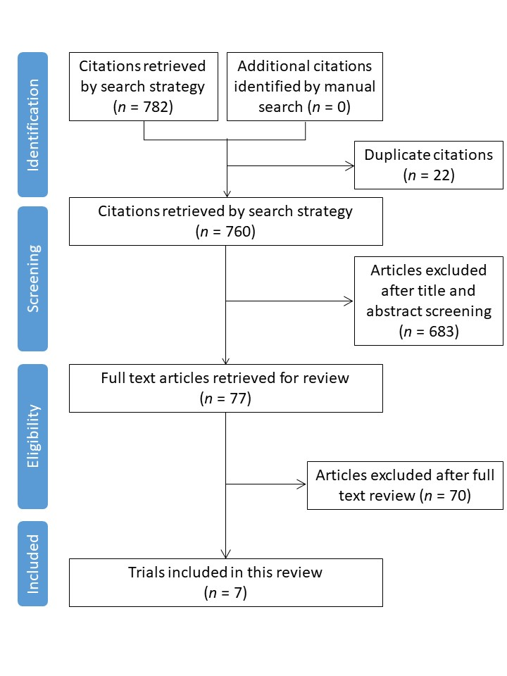

# **Figure S2.** Flow chart of the literature search and study selection for postoperative delirium.

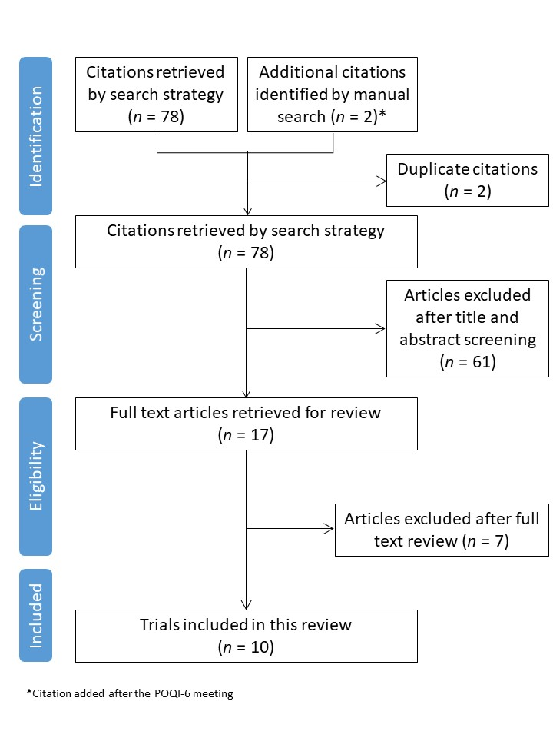

# **Figure S3.** Flow chart of the literature search and study selection for postoperative neurocognitive disorders.

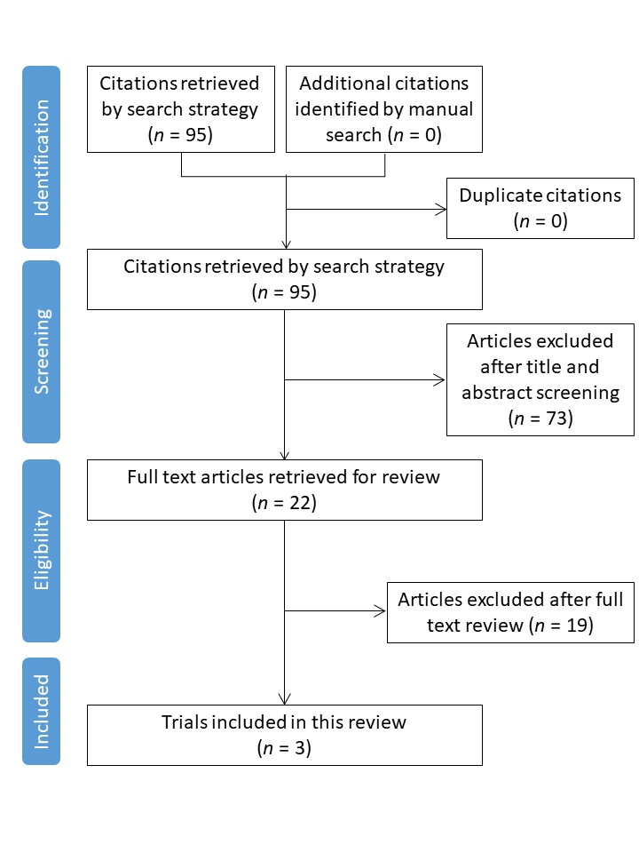

# **Figure S4.** Flow chart of the literature search and study selection for postoperative long-term survival.



# **Figure S5.** Difference in time (min) with BIS < 40 (normalized by surgical duration) in the CODA53 and the ENGAGES trials45.



The box plots indicate median and interquartile range.