TEG: is the TEG of a 33 years old COVID -19 patient before starting treatment dose of low molecular weight heparin. R: enzymatic clotting time. K: clot. The clot is formed very rapidly indicating a hypercoagulable state.

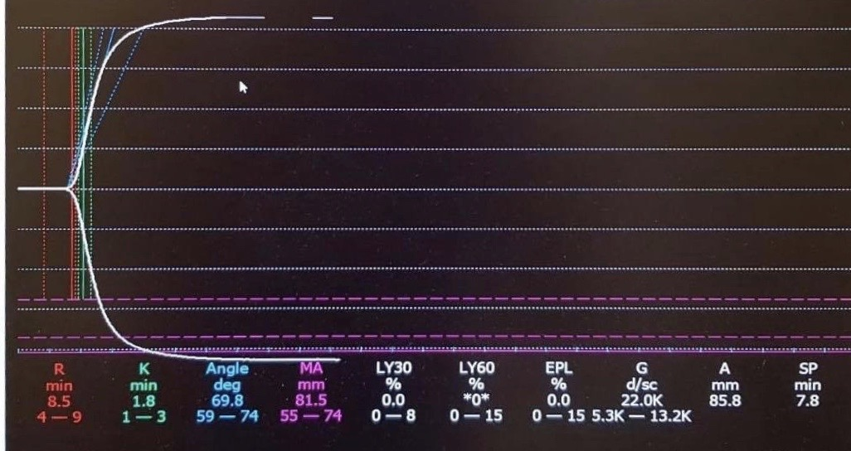

APPENDIX

Considerations when Using Anaesthesia Machines for Long-Term Ventilation of ICU Patients

1. Before Connecting a Patient
a. Many machines need to go through a calibration and pre-use checkout process before they are used. The anesthesia machine should be turned off and restarted before a patient is connected. A pre-use circuit and machine check should be performed according to the machines instructions for use. This process may take a number of minutes.
b. Volatile agents and the N2O supply should be removed or disconnected unless inhalational agents are planned to be used for sedation.
c. The machine should be protected from contamination with SARS-Cov-2 through an anti-microbial filter at the Y-piece. The sampling line for the gas monitor should be connected on the machine side of the antimicrobial filter.
d. The inspiratory CO2 alarm should be activated. It helps detect when the CO2 absorbent needs to be changed.
e. Residual anesthetic agent vapor should be flushed out to lessen the risk of triggering malignant hyperthermia.

2. Backup Equipment
a. Backup ventilation equipment should be immediately available for device failures and when the anesthesia machine needs to be disconnected from the patient during regular system test/calibration.
b. There should always be an alternative source of oxygen available

Note: The intubation team should keep all disposable parts of the VL (e.g. blades, stylets) with the COVID-19 patient after intubation in the isolation rooms. COVID-19 patients might require frequent proning and recruiting maneuvers and these are times where the endotracheal tube could be dislodged and the VL components are needed to be promptly available. Training of all bedside staff is paramount to guarantee that VL is available and its components stored by the COVID-19 patient. Simulation and training of non-experts is very important and highly recommended before the peak of the pandemic, to facilitate intubation and to prepare non-ICU trained staff working at the bedside.

3. Tests, Maintenance
a. Anesthesia machines need to undergo regular system tests/calibrations.
i. These tests should be done preferably every 24h, but maximally every 72h to avoid machine malfunction or inaccurate volume measurements. Some anesthesia machines will automatically shutdown if they are used without a restart for many days.
ii. The tests usually require disconnecting the patient and may take a number of minutes.
iii. Depending on the machine, the test may also require the Adjustable Pressure Limiting Valve (APL) to be set to very high pressures. It is critical that the APL valve be set to a more patient-appropriate limit following the test.
b. At least every 12 hours, there should be an inspection and correction, if applicable of
i. whether the CO2 absorbent is exhausted
ii. water in the gas sampling water trap
iii. standing water in the breathing hoses and at the bottom of the CO2 absorbent cannister
iv. excessive condensation of water in the filters, leading to higher respiratory resistance

4. Manual / Spontaneous Ventilation Mode and APL Valve
a. This mode is unique to anesthesia machines and can be switched to either by the user or automatically in case of device failure. In this mode, automatic ventilation of the patient ceases. Without spontaneous breathing by the patient or manual ventilation via a breathing bag, the patient will not be ventilated.
b. In this mode, the limit set at the APL valve determines the pressure generated by the fresh gas flow alone. If this limit is too low it may lead to no flow being deliverable to the patient. If it is too high, barotrauma may result. Because in some machines the Manual/Spontaneous Ventilation Mode is automatically activated when the anesthesia machine fails, it is important that the APL valve is always set appropriately. A manual ventilation bag should be accessible at every ventilator and the use of single-use equipment should be preferred. This includes filter systems (high efficiency particulate air, HEPA) filters, suction and monitoring equipment (ECG cables, SpO2, blood pressure monitor, temperature probe) and ventilation tubes.

5. CO₂ Absorber
a. The anesthesia machine should never be operated without functioning CO2 absorber except for a very brief time when exchanging the absorbent. It ensures that the patient does not inhale CO2 even in the case of errors, such as problems with the fresh gas supply or delivery.
b. Exhausted CO2 absorbent can be detected by its color (it turns purple upon exhaustion) or if there is inspiratory CO2. That is why it is important that the inspiratory CO2 alarm is activated and set correctly.

6. Fresh Gas Flow
a. Some anesthesia machines allow setting the oxygen concentration and the total fresh gas flow. The machine would then calculate and set the needed oxygen and medical air flow. In other machines the flow of each gas must be set individually and the resulting oxygen concentration calculated manually.
b. The use of high fresh gas flows (of at least 150% of the minute volume of the patient) will ensure that there is only limited rebreathing, that the absorber will last a long time, minimizes the risk of lower inspiratory oxygen, and prevents build-up of excessive moisture.
c. Low Fresh Gas Flow may cause excessive condensation in the breathing system and patient hoses, which may accumulate to a point where it impairs the therapy, will result in having to exchange the CO2-absorber more frequently, and may result in significant differences between the set fresh gas oxygen concentration and the actually delivered inspiratory oxygen concentration (FiO2)

7. Humidification
a. Long-term use may result in significant moisture build-up in the circuit. The use of higher fresh gas flows and of HME filters may reduce the build-up.
b. Passive Humidification can be achieved by using a heat-moisture-exchange-filter (HME) at the Y-Piece.
c. The use of lower fresh gas flows, as described above, will result in some humidification and heating of the gas by the CO2 absorbent.
d. Active Humidification is not recommended and might require paying close attention to the manufacturer's instructions on how this might affect the anesthesia machine operation. The use of active humidification is not validated for many of the anesthesia machines. In some machines it will interfere with the accuracy of the flow and volume measurement. Active humidification will likely not work well when an HME filter is installed at the same time.

8. Ventilation Modes
a. Pressure Controlled Ventilation is preferable, because leakages are not compensated for volume-controlled ventilation
b. Anesthesia machines are not designed for NIV (no leak compensation)
c. Anesthesia machines will not automatically switch to mechanical modes in the event of apnea, when the patient is first connected, or in critical device failure

9. Miscellaneous
a. Anesthesia machines do not compensate for externally added flow that may occur, for example, with nebulized drug delivery.
b. In some machines, inadequate scavenger flow will result in unintended PEEP. If inhalational agents are to be used for sedation it is important to connect a scavenging system to prevent contaminating the room with inhalational agents.
c. It is important to recognize that the inspiratory oxygen concentration supplied to the patient may be lower than the oxygen concentration of the gas mix supplied to the anesthesia machine, esp. when low fresh gas flows are used.
d. Anesthesia machines, and especially their alarm and safety approach, are designed for having an anesthesia provider always in their immediate vicinity. For long-term ventilation in an ICU-type setting, it is important to make sure that the alarms are loud enough to be heard, even without someone directly next to the machine. Also, many machines do not have a lock function that would prevent unauthorized changing of ventilation settings.

Multi-patient ventilation The Society of Critical Care Medicine (SCCM), American Association for Respiratory Care (AARC), American Society of Anesthesiologists (ASA), anaesthesia Patient Safety Foundation (APSF), American Association of Critical‐Care Nurses (AACN), and American College of Chest Physicians (CHEST) advise clinicians against the use of anaesthesia machines on more than one patient simultaneously. The severity of the disease and its complexity make it hard to manage single patient ventilation. Ventilating multiple patients at the same time might just reduce the likelihood of survival of all patients. Therefore, it might be more advisable to purpose the ventilator to the patient most likely to benefit from ventilation than risking multiple patients. We also do not recommend this. The reasons for avoiding ventilating multiple patients with a single ventilator are numerous. They range from difficulties in monitoring, over inaccurate ventilation parameters and control to possibilities of cross contamination. Set ventilation alarms would only monitor the response of all connected patients’ respiratory systems as a whole. Therefore, measuring pulmonary changes in an individual would be impossible and would require additional external monitoring. A full relaxation of all patients would be necessary since spontaneous breathing by a single patient sensed by the ventilator would set the respiratory frequency for all the other patients connected to the system. Connecting patients with different lung capacities and compliances would lead to an unequal distribution of volume. Furthermore, in a complex disease such as ARDS, it is unrealistic to assume patients would be or at the very least stay in the same stages of the disease. Patients might deteriorate and recover at different rates, and the distribution of gas to each patient would become unequal going to the most compliant lungs. The sicker patient would get the smaller tidal volume and the improving patient would get the larger tidal volume. Individual management of critical parameters (e.g. PEEP) would be impossible. The sudden deterioration of a single patient status (e.g. cardiac arrest, pneumothorax) would also lead to a rapid shift in the respiratory equilibrium between the other patients. The risk of transmission of infectious diseases either via close physical positioning of these patients (due to a shared ventilator) or via pedelluft swinging air between patients, might increase¹⁰. Attempting multi-patient ventilation can only really be considered if no other clinically proven, safe, and reliable therapy remains available (i.e., in a dire, temporary emergency)¹⁰⁻¹¹. Another important point using the ventilator outside the operating theatre in the ICU please check the suppling gas lines are suitable for the use of the Anaesthesia ventilator.

