Supplemental Table 1: Study Procedure Types, Frequency, and Cardiac Risk Level

Study | Procedures Included | Procedure Frequency | AHA Cardiac Risk Level of Procedure
Eide 2015* | SAVR | 78/143 patients | High
 | TAVI | 65/143 patients | High
Itagaki 2020 | Isolated off-pump CABG | 6/89 patients | High
 | Isolated on-pump CABG | 14/89 patients | High
 | Aortic Valvuloplasty | 6/89 patients | High
 | Mitral Valvuloplasty | 9/89 patients | High
 | Aortic Valve Replacement | 25/89 patients | High
 | Mitral Valve Replacement | 7/89 patients | High
 | CABG plus Valve Replacement | 22/83 patients | High
Jung 2015 | Isolated CABG | 65/133 patients | High
 | Isolated Valvuloplasty | 36/133 patients | High
 | CABG plus Valvuloplasty | 25/133 | High
 | Other Cardiac Procedure (not specified) | 7/133 | High
Khan 2016 | Femur Fracture Fixation | 10/25 | Intermediate
 | Abdominal Laparotomy | 12/25 | Intermediate
 | Total Knee Replacement | 3/25 | Intermediate
Leung 2011 | General Surgery (not specified) | 2/63 | Intermediate
 | Arthroplasty | 27/63 | Intermediate
 | Spine | 28/63 | Intermediate
 | Thoracic | 6/63 | Intermediate
Mahanna 2020 | Spine | 71/167 | Intermediate
 | Thoracic | 19/167 | Intermediate
 | Urologic | 28/167 | Intermediate
 | General Surgery (not specified) | 49/167 | Intermediate
Nomura 2019** | CABG | 62/133 | High
 | CABG plus Valve Surgery (not specified) | 20/133 | High
 | Valve Surgery (not specified) | 46/133 | High
 | Other Cardiac Surgery (not specified) | 5/133 | High
Partridge 2015 | Imaging/investigation | 12/125 | Low
 | Angioplasty/thrombolysis/thrombectomy/embolectomy | 29/125 | High
 | Lower limb bypass graft | 21/125 | High
 | EVAR | 22/125 | High
 | Open AAA Repair | 5/125 | High
 | Toe/Foot Amputation | 3/125 | High
 | BKA/TKA | 2/125 | High
 | AKA | 1/125 | High
 | Other Vascular Surgery, such as pseudoaneurysm repair or evacuation of haematoma | 8/125 | High
Pol 2011 | Open Aortic Surgery | 18/142 | High
 | Endovascular Procedures (not specified) | 30/142 | High
 | Peripheral Bypass Surgery | 39/142 | High
 | Arteriovenous Shunt Surgery | 2/142 | High
 | PCI | 27/142 | High
 | Amputation Surgery | 10/142 | High
 | Miscellaneous Vascular Surgery (not specified) | 16/142 | High
AAA, Abdominal Aortic Aneurysm; AKA, Above Knee Amputation; BKA, Below-Knee Amputation, CABG, Coronary Artery Bypass Graft; EVAR, Endovascular Aortic Repair; PCI, Percutaneous Intervention; SAVR, Surgical Aortic Valve Replacement; TAVI, Transcatheter Aortic Valve Implantation; TKA Through-Knee Amputation;
*For the Eide study, seven of the 143 patients who went into surgery did not receive delirium assessments, such that delirium was only measured for an N of 136 patients.
**For the Nomura study, five of the 133 patients who went into surgery did not receive delirium assessments, such that delirium was only measured for an N of 128 patients.

Supplemental Table 2. ROBIN-I Score Consensus by Domain for Included Studies
Eide et al., 2015
Domain | Consensus
Bias Due to Confounding:  Baseline confounding occurs when one or more prognostic variables (factors that predict the outcome of interest) also predicts the intervention received at baseline. | Moderate Risk. Analysis adjusted for confounders .However, adjustment includes postoperative opioids and anxiolytics which act as mediators and may lead to overadjustment..
Bias in selection of participants into the study:  When exclusion of some eligible participants, or the initial follow-up time of some participants, or some outcome events is related to both intervention and outcome, there will be an association between interventions and outcome even if the effects of the interventions are identical. | Low Risk. Unclear how many, if any, patients were eliminated during the pre-screening process due to comorbidities. After pre-screening, 15 of 162 patients were eliminated, and of the 144 patients that remained, 7 died before postoperative day 5 and one patient withdrew consent, leaving data for 136 patients. The patients who died/withdrew consent were not included in analysis.
Bias in classification of interventions:  Bias introduced by either differential or non-differential misclassification of intervention status. Non-differential misclassification is unrelated to the outcome and will usually bias the estimated effect of intervention towards the null. Differential misclassification occurs when misclassification of intervention status is related to the outcome or the risk of the outcome, and is likely to lead to bias. | Low Risk. The SOF is similar to the Fried model.
Bias due to deviations from intended interventions:  Bias that arises when there are systematic differences between experimental intervention and comparator groups in the care provided, which represent a deviation from the intended intervention(s). Assessment of bias in this domain will depend on the type of effect of interest (either the effect of assignment to intervention or the effect of starting and adhering to intervention). | Low Risk. The SOF was applied properly and with consistency.
Bias due to missing data:  Bias that arises when later follow-up is missing for individuals initially included and followed (such as differential loss to follow-up that is affected by prognostic factors); bias due to exclusion of individuals with missing information about intervention status or other variables such as confounders. | Moderate Risk. Delirium was assessed out to post-op day 5, and assessed daily without gaps. However, patients who died were not factored into the analysis.
Bias in measurement of outcomes:  Bias introduced by either differential or non-differential errors in measurement of outcome data. Such bias can arise when outcome assessors are aware of intervention status, if different methods are used to assess outcomes in different intervention groups, or if measurement errors are related to intervention status or effects. | Low Risk. Delirium was rigorously and regularly assessed by a qualified team.
Bias in selection of the reported result:  Selective reporting of results in a way that depends on the findings and prevents the estimate from being included in a meta-analysis (or other synthesis). | Moderate Risk. . People who died were eliminated from analysis.
Overall risk of bias judgement | Moderate Risk. No single domain was rated as having a risk of bias greater than Moderate.

Itagaki et al., 2020
Domain | Consensus
Bias Due to Confounding:  Baseline confounding occurs when one or more prognostic variables (factors that predict the outcome of interest) also predicts the intervention received at baseline. | Low Risk. Analysis adjusted for confounders, especially age and MOCA.
Bias in selection of participants into the study:  When exclusion of some eligible participants, or the initial follow-up time of some participants, or some outcome events is related to both intervention and outcome, there will be an association between interventions and outcome even if the effects of the interventions are identical. | Moderate Risk. 25 out of 114 patients were eliminated, three of whom were eliminated due to dementia and ADL dependency.
Bias in classification of interventions:  Bias introduced by either differential or non-differential misclassification of intervention status. Non-differential misclassification is unrelated to the outcome and will usually bias the estimated effect of intervention towards the null. Differential misclassification occurs when misclassification of intervention status is related to the outcome or the risk of the outcome, and is likely to lead to bias. | Low Risk. The J-CHS is well validated for the categorization of patients into frail versus nonfrail.
Bias due to deviations from intended interventions:  Bias that arises when there are systematic differences between experimental intervention and comparator groups in the care provided, which represent a deviation from the intended intervention(s). Assessment of bias in this domain will depend on the type of effect of interest (either the effect of assignment to intervention or the effect of starting and adhering to intervention). | Low Risk. Frailty assessment was rigorously conducted using a validated scale.
Bias due to missing data:  Bias that arises when later follow-up is missing for individuals initially included and followed (such as differential loss to follow-up that is affected by prognostic factors); bias due to exclusion of individuals with missing information about intervention status or other variables such as confounders. | Low Risk. Only 5 patients were excluded due to missing data.
Bias in measurement of outcomes:  Bias introduced by either differential or non-differential errors in measurement of outcome data. Such bias can arise when outcome assessors are aware of intervention status, if different methods are used to assess outcomes in different intervention groups, or if measurement errors are related to intervention status or effects. | Low risk. Delirium outcome was assessed rigorously and objectively with the Intensive Care Delirium Screening Checklist (ICDSC).
Bias in selection of the reported result:  Selective reporting of results in a way that depends on the findings and prevents the estimate from being included in a meta-analysis (or other synthesis). | Low Risk. Per the study design, all eligible patients were consented.
Overall risk of bias judgement | Moderate Risk: Due to moderate bias in selection of participants.

Jung et al., 2015
Domain | Consensus
Bias Due to Confounding:  Baseline confounding occurs when one or more prognostic variables (factors that predict the outcome of interest) also predicts the intervention received at baseline. | Critical Risk. This study adjusted for EUROSCORE II only, but did not adjust for age, sex or baseline cognition, all of which were different between frail and nonfrail groups.
Bias in selection of participants into the study:  When exclusion of some eligible participants, or the initial follow-up time of some participants, or some outcome events is related to both intervention and outcome, there will be an association between interventions and outcome even if the effects of the interventions are identical. | Moderate Risk. 23% of patients refused consent, and 7 patients dropped out after enrollment.
Bias in classification of interventions:  Bias introduced by either differential or non-differential misclassification of intervention status. Non-differential misclassification is unrelated to the outcome and will usually bias the estimated effect of intervention towards the null. Differential misclassification occurs when misclassification of intervention status is related to the outcome or the risk of the outcome, and is likely to lead to bias. | Low Risk. The frailty scale was implemented properly by assessors.
Bias due to deviations from intended interventions:  Bias that arises when there are systematic differences between experimental intervention and comparator groups in the care provided, which represent a deviation from the intended intervention(s) Assessment of bias in this domain will depend on the type of effect of interest (either the effect of assignment to intervention or the effect of starting and adhering to intervention). | Low Risk: There is no evidence that the frailty “intervention” affected surgery status in patients.
Bias due to missing data:  Bias that arises when later follow-up is missing for individuals initially included and followed (such as differential loss to follow-up that is affected by prognostic factors); bias due to exclusion of individuals with missing information about intervention status or other variables such as confounders. | Low risk. The CAM-ICU was administered regularly in the ICU and it is implied that the same time interval was used on the wards. Measurement was until discharge.
Bias in measurement of outcomes:  Bias introduced by either differential or non-differential errors in measurement of outcome data. Such bias can arise when outcome assessors are aware of intervention status, if different methods are used to assess outcomes in different intervention groups, or if measurement errors are related to intervention status or effects. | Low Risk. The CAM and CAM-ICU are well-validated tools and were administered regularly with no “filtering" steps.
Bias in selection of the reported result:  Selective reporting of results in a way that depends on the findings and prevents the estimate from being included in a meta-analysis (or other synthesis). | Low Risk. There was no selective reporting of the results.
Overall risk of bias judgement | Critical Risk. Due to failure to adjust for all confounders.

Khan et al., 2015
Domain | Consensus
Bias Due to Confounding:  Baseline confounding occurs when one or more prognostic variables (factors that predict the outcome of interest) also predicts the intervention received at baseline. | Moderate Risk. Total N of 25 patients limited statistical power to detect differences in baseline characteristics between groups.
Bias in selection of participants into the study:  When exclusion of some eligible participants, or the initial follow-up time of some participants, or some outcome events is related to both intervention and outcome, there will be an association between interventions and outcome even if the effects of the interventions are identical. | No information; the N value was so low as to have very little statistical meaning and also the selection process is difficult to discern.
Bias in classification of interventions:  Bias introduced by either differential or non-differential misclassification of intervention status. Non-differential misclassification is unrelated to the outcome and will usually bias the estimated effect of intervention towards the null. Differential misclassification occurs when misclassification of intervention status is related to the outcome or the risk of the outcome, and is likely to lead to bias. | Low Risk. The MFC was applied rigorously at the measurement and assignment stage.
Bias due to deviations from intended interventions:  Bias that arises when there are systematic differences between experimental intervention and comparator groups in the care provided, which represent a deviation from the intended intervention(s) Assessment of bias in this domain will depend on the type of effect of interest (either the effect of assignment to intervention or the effect of starting and adhering to intervention). | Low Risk. There were no systematic processes affecting the designation of frailty versus nonfrailty.
Bias due to missing data:  Bias that arises when later follow-up is missing for individuals initially included and followed (such as differential loss to follow-up that is affected by prognostic factors); bias due to exclusion of individuals with missing information about intervention status or other variables such as confounders. | Low Risk. Delirium data were collected for 3 days postop or until discharge, whichever was first. Delirium was assessed with a validated tool and no problematic intermediate steps.
Bias in measurement of outcomes:  Bias introduced by either differential or non-differential errors in measurement of outcome data. Such bias can arise when outcome assessors are aware of intervention status, if different methods are used to assess outcomes in different intervention groups, or if measurement errors are related to intervention status or effects. | Low Risk. This study used the CAM-ICU for delirium measurement, and there were no problematic intermediate steps for delirium screening and reporting.
Bias in selection of the reported result:  Selective reporting of results in a way that depends on the findings and prevents the estimate from being included in a meta-analysis (or other synthesis). | Low Risk. There is no evidence of selective reporting.
Overall risk of bias judgement | Moderate Risk. All domains were rated as either Low or Moderate in risk.

Leung et al., 2011
Domain | Consensus
Bias Due to Confounding:  Baseline confounding occurs when one or more prognostic variables (factors that predict the outcome of interest) also predicts the intervention received at baseline. | Low risk: Though no confounders were reported for frailty groups, impoortant confounders such as age and TICS were adjusted for in final analysis.
Bias in selection of participants into the study:  When exclusion of some eligible participants, or the initial follow-up time of some participants, or some outcome events is related to both intervention and outcome, there will be an association between interventions and outcome even if the effects of the interventions are identical. | Moderate Risk. Patients from this study were selected from a much larger study, and only 63 patients from the parent study were included.
Bias in classification of interventions:  Bias introduced by either differential or non-differential misclassification of intervention status. Non-differential misclassification is unrelated to the outcome and will usually bias the estimated effect of intervention towards the null. Differential misclassification occurs when misclassification of intervention status is related to the outcome or the risk of the outcome, and is likely to lead to bias. | Low Risk. The Fried criteria were properly applied in the differentiation of patients as frail versus nonfrail.
Bias due to deviations from intended interventions:  Bias that arises when there are systematic differences between experimental intervention and comparator groups in the care provided, which represent a deviation from the intended intervention(s). Assessment of bias in this domain will depend on the type of effect of interest (either the effect of assignment to intervention or the effect of starting and adhering to intervention). | Low Risk. There were no systematic processes affecting the designation of frailty versus nonfrailty.
Bias due to missing data:  Bias that arises when later follow-up is missing for individuals initially included and followed (such as differential loss to follow-up that is affected by prognostic factors); bias due to exclusion of individuals with missing information about intervention status or other variables such as confounders. | Low Risk. The data are complete for frailty and delirium.
Bias in measurement of outcomes:  Bias introduced by either differential or non-differential errors in measurement of outcome data. Such bias can arise when outcome assessors are aware of intervention status, if different methods are used to assess outcomes in different intervention groups, or if measurement errors are related to intervention status or effects. | Low Risk. "A trained research assistant conducted structured interviews preoperatively and on the first two postoperative days to determine the presence of delirium, defined using the Confusion Assessment Method. All cases were validated by a second investigator."
Bias in selection of the reported result:  Selective reporting of results in a way that depends on the findings and prevents the estimate from being included in a meta-analysis (or other synthesis). | Low Risk: Data were reported for all 63 patients.
Overall risk of bias judgement | Moderate Risk. Due to bias in selection of the reported result.

Mahanna-Gabrielli et al., 2020
Domain | Consensus
Bias Due to Confounding:  Baseline confounding occurs when one or more prognostic variables (factors that predict the outcome of interest) also predicts the intervention received at baseline. | Low Risk: Analysis adjusted for important confounders.of age and baseline cognition
Bias in selection of participants into the study:  When exclusion of some eligible participants, or the initial follow-up time of some participants, or some outcome events is related to both intervention and outcome, there will be an association between interventions and outcome even if the effects of the interventions are identical. | Low Risk: A broad variety of patients were included, with no potentially biasing screening steps.
Bias in classification of interventions:  Bias introduced by either differential or non-differential misclassification of intervention status. Non-differential misclassification is unrelated to the outcome and will usually bias the estimated effect of intervention towards the null. Differential misclassification occurs when misclassification of intervention status is related to the outcome or the risk of the outcome, and is likely to lead to bias. | Low Risk. The FRAIL scale was properly and consistently applied.
Bias due to deviations from intended interventions:  Bias that arises when there are systematic differences between experimental intervention and comparator groups in the care provided, which represent a deviation from the intended intervention(s). Assessment of bias in this domain will depend on the type of effect of interest (either the effect of assignment to intervention or the effect of starting and adhering to intervention). | Low Risk: There were no systematic processes affecting the designation of frailty versus nonfrailty.
Bias due to missing data:  Bias that arises when later follow-up is missing for individuals initially included and followed (such as differential loss to follow-up that is affected by prognostic factors); bias due to exclusion of individuals with missing information about intervention status or other variables such as confounders. | Low Risk. The data reported for postoperative delirium were comprehensive.
Bias in measurement of outcomes:  Bias introduced by either differential or non-differential errors in measurement of outcome data. Such bias can arise when outcome assessors are aware of intervention status, if different methods are used to assess outcomes in different intervention groups, or if measurement errors are related to intervention status or effects. | Low Risk. "All patients were assessed with the CAM-ICU by trained research personnel twice each day throughout their hospitalization. The same research personnel administered the CAM-ICU to each patient in the presurgical and postsurgical time points. Separate research personnel reviewed the scores to determine and adjudicate the presence of delirium.”
Bias in selection of the reported result:  Selective reporting of results in a way that depends on the findings and prevents the estimate from being included in a meta-analysis (or other synthesis). | Low Risk. The outcome of interest was reported without any obvious bias.
Overall risk of bias judgement | Low Risk. This study included domains of the same risk for bias.

Nomura et al., 2018
Domain | Consensus
Bias Due to Confounding:  Baseline confounding occurs when one or more prognostic variables (factors that predict the outcome of interest) also predicts the intervention received at baseline. | Moderate Risk. Analysis did not adjust for important confounder of baseline cognition.
Bias in selection of participants into the study:  When exclusion of some eligible participants, or the initial follow-up time of some participants, or some outcome events is related to both intervention and outcome, there will be an association between interventions and outcome even if the effects of the interventions are identical. | Serious Risk. Patients were selected from two separate parent trials, one of which excluded preoperative delirium and one that did not.
Bias in classification of interventions:  Bias introduced by either differential or non-differential misclassification of intervention status. Non-differential misclassification is unrelated to the outcome and will usually bias the estimated effect of intervention towards the null. Differential misclassification occurs when misclassification of intervention status is related to the outcome or the risk of the outcome, and is likely to lead to bias. | Low Risk. Used Fried scale for classification.
Bias due to deviations from intended interventions:  Bias that arises when there are systematic differences between experimental intervention and comparator groups in the care provided, which represent a deviation from the intended intervention(s). Assessment of bias in this domain will depend on the type of effect of interest (either the effect of assignment to intervention or the effect of starting and adhering to intervention). | Low Risk. There were no systematic processes affecting the designation of frailty versus nonfrailty.
Bias due to missing data:  Bias that arises when later follow-up is missing for individuals initially included and followed (such as differential loss to follow-up that is affected by prognostic factors); bias due to exclusion of individuals with missing information about intervention status or other variables such as confounders. | Low Risk. There is no evidence for incomplete reporting of data.
Bias in measurement of outcomes:  Bias introduced by either differential or non-differential errors in measurement of outcome data. Such bias can arise when outcome assessors are aware of intervention status, if different methods are used to assess outcomes in different intervention groups, or if measurement errors are related to intervention status or effects. | Moderate Risk: This study used chart review for delirium screening on some days, potentially underestimating delirium incidence. "Delirium was assessed in person on 3 of the first 4 postoperative days. For days on which patients were not assessed in person, a validated chart review was used."
Bias in selection of the reported result:  Selective reporting of results in a way that depends on the findings and prevents the estimate from being included in a meta-analysis (or other synthesis). | Low Risk: the reporting of the data is complete and accurate.
Overall risk of bias judgement | Serious Risk: Due to selection of participants into the study.

Partridge et al., 2015
Domain | Consensus
Bias Due to Confounding:  Baseline confounding occurs when one or more prognostic variables (factors that predict the outcome of interest) also predicts the intervention received at baseline. | Serious Risk:. No adjustment, univariate analysis only.
Bias in selection of participants into the study:  When exclusion of some eligible participants, or the initial follow-up time of some participants, or some outcome events is related to both intervention and outcome, there will be an association between interventions and outcome even if the effects of the interventions are identical. | Low Risk. 125/159 eligible patients were studied, but there were no systematic biases in the loss of patients between steps.
Bias in classification of interventions:  Bias introduced by either differential or non-differential misclassification of intervention status. Non-differential misclassification is unrelated to the outcome and will usually bias the estimated effect of intervention towards the null. Differential misclassification occurs when misclassification of intervention status is related to the outcome or the risk of the outcome, and is likely to lead to bias. | Low Risk. The Edmonton Frail Scale was administered correctly.
Bias due to deviations from intended interventions:  Bias that arises when there are systematic differences between experimental intervention and comparator groups in the care provided, which represent a deviation from the intended intervention(s). Assessment of bias in this domain will depend on the type of effect of interest (either the effect of assignment to intervention or the effect of starting and adhering to intervention). | Low Risk. There were no systematic processes affecting the designation of frailty versus nonfrailty.
Bias due to missing data:  Bias that arises when later follow-up is missing for individuals initially included and followed (such as differential loss to follow-up that is affected by prognostic factors); bias due to exclusion of individuals with missing information about intervention status or other variables such as confounders. | Moderate Risk: "Postoperative delirium was diagnosed according to the Confusion Assessment Method. This was performed daily with the exception of weekends."
Bias in measurement of outcomes:  Bias introduced by either differential or non-differential errors in measurement of outcome data. Such bias can arise when outcome assessors are aware of intervention status, if different methods are used to assess outcomes in different intervention groups, or if measurement errors are related to intervention status or effects. | Low Risk: There is no evidence that the administration process of the CAM was biased in any way.
Bias in selection of the reported result:  Selective reporting of results in a way that depends on the findings and prevents the estimate from being included in a meta-analysis (or other synthesis). | Low Risk: All available data were reported.
Overall risk of bias judgement | Serious Risk. Due to confounding

Pol et al., 2011
Domain | Consensus
Bias Due to Confounding:  Baseline confounding occurs when one or more prognostic variables (factors that predict the outcome of interest) also predicts the intervention received at baseline. | Serious risk. Analysis performed by GFI score, not by presence of frailty.
Bias in selection of participants into the study:  When exclusion of some eligible participants, or the initial follow-up time of some participants, or some outcome events is related to both intervention and outcome, there will be an association between interventions and outcome even if the effects of the interventions are identical. | Low Risk. Vascular surgery patients were all included consecutively.
Bias in classification of interventions:  Bias introduced by either differential or non-differential misclassification of intervention status. Non-differential misclassification is unrelated to the outcome and will usually bias the estimated effect of intervention towards the null. Differential misclassification occurs when misclassification of intervention status is related to the outcome or the risk of the outcome, and is likely to lead to bias. | Low Risk. The Groningen Frailty Index was properly administered.
Bias due to deviations from intended interventions:  Bias that arises when there are systematic differences between experimental intervention and comparator groups in the care provided, which represent a deviation from the intended intervention(s). Assessment of bias in this domain will depend on the type of effect of interest (either the effect of assignment to intervention or the effect of starting and adhering to intervention). | Low Risk. There were no systematic processes affecting the designation of frailty versus nonfrailty.
Bias due to missing data:  Bias that arises when later follow-up is missing for individuals initially included and followed (such as differential loss to follow-up that is affected by prognostic factors); bias due to exclusion of individuals with missing information about intervention status or other variables such as confounders. | Serious Risk. Delirium was measured for three nursing shifts, but it is unclear whether or not these shifts were consecutive, or on which postoperative day screening for delirium began. In addition, it is unclear what the duration of delirium screening was.
Bias in measurement of outcomes:  Bias introduced by either differential or non-differential errors in measurement of outcome data. Such bias can arise when outcome assessors are aware of intervention status, if different methods are used to assess outcomes in different intervention groups, or if measurement errors are related to intervention status or effects. | Serious Risk. "During admission, all patients were observed by nurses trained for this study during three shifts. When POD was highly suspected, the ward doctor was informed and further assessment was done by using the delirium observation screening scale (DOS)." This method involves a “filtering” step which could significantly underestimate the incidence of delirium.
Bias in selection of the reported result:  Selective reporting of results in a way that depends on the findings and prevents the estimate from being included in a meta-analysis (or other synthesis). | Low Risk: There is no evidence of bias.
Overall risk of bias judgement | Serious Risk: Due to confounding, Missing Data and Measurement of Outcomes.

Supplemental Figures

Supplemental Figure 1. Funnel Plot for Frail versus Nonfrail.

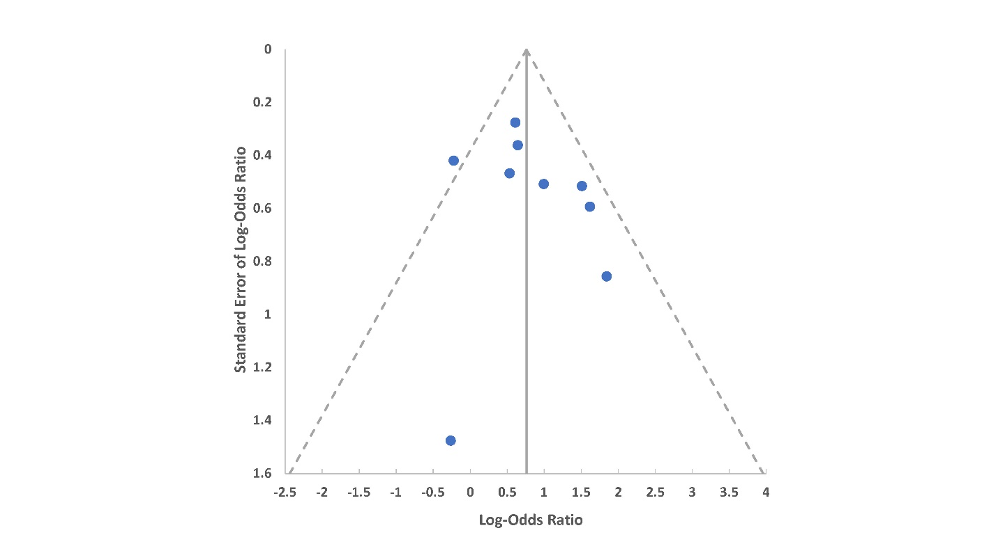

Supplemental Figure 2. Random-Effect Forest plot for prefrail vs nonfrail.
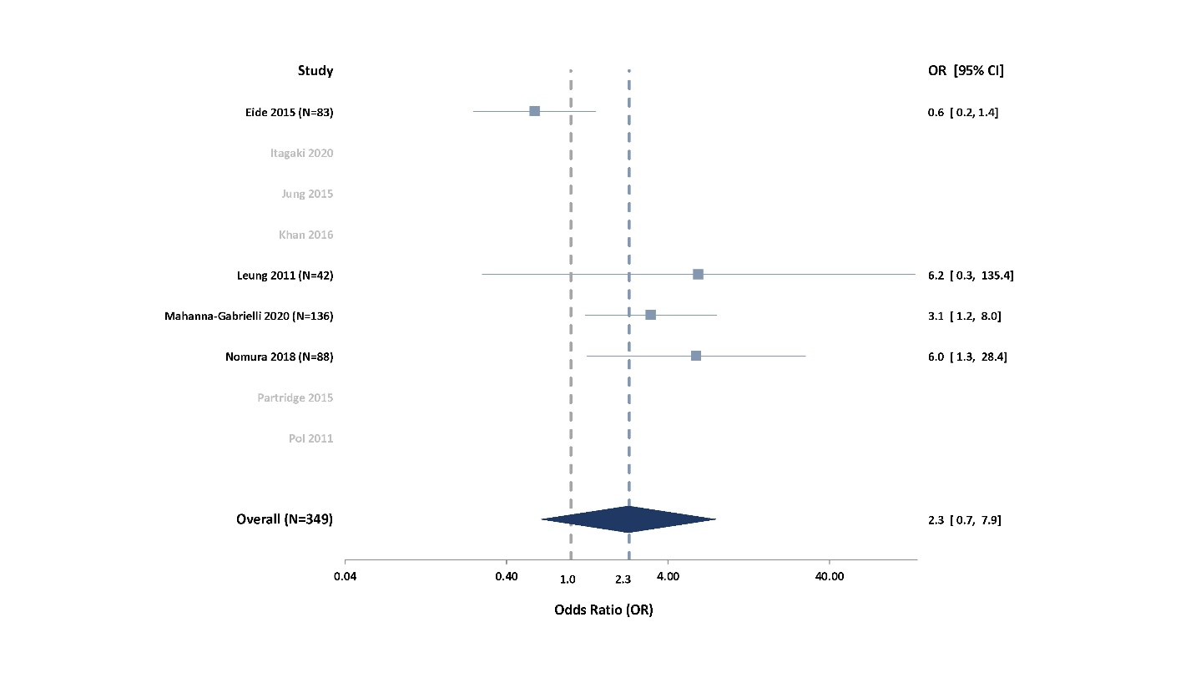

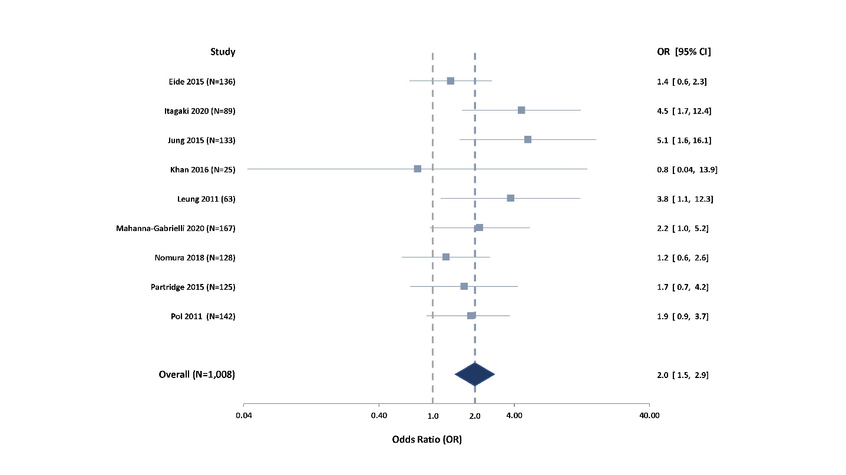
Supplemental Figure 3. Random-Effect Forest plot for frail vs (prefrail + nonfrail).

