Supplementary Material

The following material accompanies the article the facilitatory effects of adjuvant pharmaceutics to prolong the duration of local anesthetic for peripheral nerve bloke: A systematic review and network meta-analysis

**Table 1. Selected study information:**

|  |  |  |  |  |  |  |  |  |
| --- | --- | --- | --- | --- | --- | --- | --- | --- |
| Number | First Author | Year | Surgery | Block method | Intervention | Sample size | sex (Female %) | Outcome |
| 1 | Casati A | 2000 | Foot surgery | Sciatic-Femoral Nerve block | Pla(ropivacaine), Clo(ropivacaine) | 30 | 83.3 | MBT, FART |
| 2 | El Saied AH | 2000 | Hand or forearm surgery | Axillary brachial plexus | Clo(ropivacaine), Pla(ropivacaine) | 46 | 23.9 | SBT, MBT, FART |
| 3 | Erlacher W | 2000 | Hand or forearm surgery | Axillary perivascular brachial plexus block | Pla(ropivacaine), Clo(ropivacaine) | 40 | 40 | SBT |
| 4 | Erlacher W | 2001 | Forearm or hand surgery | Axillary perivascular brachial plexus block | Pla(ropivacaine), Clo(ropivacaine), Pla(bupivacaine), Clo(bupivacaine) | 80 |  | MBT |
| 5 | Karakaya D | 2001 | Hand, forearm, elbow surgery | Axillary brachial plexus | Pla(bupivacaine), Fen(bupivacaine) | 40 | 52.5 | SBT, MBT, FART |
| 6 | Kesimci E | 2007 | Hand or forearm surgery | Axillary brachial plexus block | Pla(ropivacaine), Tra(ropivacaine) | 40 | 45 | SBT, MBT, FART |
| 7 | Chakraborty S | 2010 | Upper limb orthopedic procedures | Supracalvicular brachial plexus block | Clo(bupivacaine), Pla(bupivacaine) | 63 | 31.7 | SBT, MBT, FART |
| 8 | Esmaoglu A | 2010 | Forearm and hand surgery | Axilary brachial plexus blockade | Pla(levobupivacaine), Dexm(levobupivacaine) | 60 | 25 | SBT, MBT, FART |
| 9 | Ammar AS | 2012 | upper limb surgery | Infraclavicular brachial plexus block | Pla(bupivacaine), Dexm(bupivacaine) | 60 | 48.3 | SBT, MBT, FART |
| 10 | Behr A | 2012 | Arthroscopic rotator cuff repair | Middle interscalene brachial plexus block | Pla(levobupivacaine), Bup(levobupivacaine) | 100 | 40 | SBT |
| 11 | Dogru K | 2012 | Arteriovenous fistule surgery | Axillary brachial plexus | Pla(Levobupivacaine), MgS(levobupivacaine) | 40 | NR | SBT, MBT |
| 12 | Geze S | 2012 | Orthopaedic upper extremity surgery | Axillary plexus block | Pla(levobupivacaine+lidocaine), Tra(levobupivacaine+lidocaine), Fen(levobupivacaine+lidocaine) | 60 | 36.7 | SBT, MBT, FART |
| 13 | Kaygusuz K | 2012 | Forearm and hand surgery | Axillary plexus block | Pla(levobupivacaine), Dexm(levobupivacaine) | 60 | 38.3 | SBT, MBT, FART |
| 14 | Swami SS | 2012 | Upper limb surgeries | Supraclavicular brachial plexus block | Clo(bupivacaine), Dexm(bupivacaine) | 60 | 31.7 | SBT, MBT, FART |
| 15 | Agarwal S | 2014 | Upper limb surgeries | Supraclavicular brachial plexus block | Pla(bupivacaine), Dexm(bupivacaine) | 50 | 28 | SBT, MBT, FART |
| 16 | Ali QE | 2014 | Surgeries on upper extremities | Supraclavicular brachial plexus block | Pla(ropivacaine), Clo(ropivacaine) | 40 | 47.5 | SBT, MBT |
| 17 | Biswas S | 2014 | Forearm and hand surgery | Brachial plexus block | Pla(levobupivacaine), Dexm(levobupivacaine) | 60 | NR | SBT, MBT, FART |
| 18 | Das A | 2014 | Orthopedic surgeries of elbow | Supraclavicular brachial plexus block | Dexm(ropivacaine), Pla(ropivacaine) | 80 | 81.3 | SBT, MBT |
| 19 | Gupta K | 2014 | Upper extremity surgery | Supracalvicular brachial plexus block | Pla(ropivacaine), Clo(ropivacaine) | 64 | 31.3 | SBT, MBT, FART |
| 20 | Kumar S | 2014 | Upper limb surgery | Supraclavicular brachial plexus block | Dexa(ropivacaine), Pla(ropivacaine) | 80 | 32.5 | SBT, MBT, FART |
| 21 | Mukherjee K | 2014 | Forearm and hand surgery | Supraclavicular brachial plexus block | MgS(ropivacaine), Pla(ropivacaine) | 100 | 42 | SBT, MBT, FART |
| 22 | Persec J | 2014 | Upper-extremity surgery | Supraclavicular brachial plexus block | Dexa(Levobupivacaine), Pla(levobupivacaine) | 60 | NR | SBT, MBT, FART |
| 23 | Rohan B | 2014 | Upper extremity surgery | Supraclavicular brachial plexus block | Pla(ropivacaine), Clo(ropivacaine) | 50 | 22 | SBT, MBT, FART |
| 24 | Faria-Silva R | 2014 | Shoulder arthroscopy | Brachial plexus block | Pla(ropivacaine), Clo(ropivacaine) | 50 | 56 | MBT |
| 25 | Zhang Y | 2014 | Forearm and hand surgery | Axillary brachial plexus block | Pla(ropivacaine), Dexm(ropivacaine) | 30 | 40 | SBT, MBT |
| 26 | Deshmukh R | 2015 | Orthopaedic upper limb surgery | Interscalene brachial plexus blockade | Pla(ropivacaine), Clo(ropivacaine) | 60 | NR | SBT, MBT, FART |
| 27 | Kathuria S | 2015 | Upper limb surgery | Supraclavicular brachial plexus block | Pla(ropivacaine), Dexm(ropivacaine) | 40 | 15 | SBT, MBT, FART |
| 28 | Kaur H | 2015 | Upper limb orthopedic surgeries | Brachial plexus block | Pla(levobupivacaine+lignocaine), Dexm(levobupivacaine+lignocaine) | 90 | 44.4 | SBT, MBT, FART |
| 29 | Liu J | 2015 | Shoulder arthroscopy | Supraclavicular brachial plexus block | Pla(bupivacaine), Dexa(bupivacaine) | 40 | NR | MBT, FART |
| 30 | Patil KN | 2015 | Upper limb surgeries | Supraclavicular brachial plexus block | Pla(ropivacaine), Clo(ropivacaine) | 60 | 38.3 | SBT, MBT, FART |
| 31 | Alarasan AK | 2016 | Upper limb surgery | Supraclavicular brachial plexus block | Pla(bupivacaine), Dexa(bupivacaine) | 60 | 23.3 | SBT, MBT |
| 32 | Baloda R | 2016 | Elbow, forearm and hand surgery | Supraclavicular brachial plexus block | Pla(levobupivacaine), Dexa(levobupivacaine) | 60 | 31.7 | SBT, MBT |
| 33 | Bangera A | 2016 | Forearm and hand surgery | Axillary brachial plexus | Pla(ropivacaine), Dexm(ropivacaine) | 80 | 35 | SBT, MBT, FART |
| 34 | Das B | 2016 | Upper limb orthopaedic surgery | Supraclavicular brachial plexus block | Pla(ropivacaine), Dexm(ropivacaine) | 80 | 46.3 | SBT, MBT, FART |
| 35 | Helal SM | 2016 | Below knee surgery | Femoral sciatic nerve block | Pla(bupivacaine), Dexm(bupivacaine) | 60 | 35 | SBT, MBT, FART |
| 36 | Lee MJ | 2016 | Forearm and hand surgery | Axillary brachial plexus block | Pla(ropivacaine), Dexa(ropivacaine), Dexm(ropivacaine) | 51 | 37.3 | SBT |
| 37 | Nazir N | 2016 | Upper limb | Supraclavicular brachial plexus block | Pla(bupivacaine), Dexm(bupivacaine) | 70 | 47.1 | SBT, MBT, FART |
| 38 | Tripathi A | 2016 | upper limb surgery | Supraclavicular brachial plexus block | Clo(bupivacaine), Dexm(bupivacaine) | 60 | 30 | SBT, MBT, FART |
| 39 | Wang C | 2016 | Lower extremity surgery | Lumbar plexus and sciatic nerve block | Pla(ropivacaine), Dexm(ropivacaine) | 60 | 48.3 | SBT, MBT, FART |
| 40 | Chinnappa J | 2017 | Upper limb Surgery | Supraclavicular brachial plexus block | Pla(ropivacaine), Dexm(ropivacaine) | 60 | 33.3 | SBT, MBT, FART |
| 41 | Nasir D | 2017 | Upper extremity surgery | Supraclavicular brachial plexus block | Pla(ropivacaine), Clo(ropivacaine), Dexa(ropivacaine), Clo+Dexa(ropivacaine) | 83 | 49.4 | SBT, MBT |
| 42 | Pani N | 2017 | Upper limb surgery | Supraclavicular brachial plexus block | Pla(levobupivacaine), Dexa(levobupivacaine) | 60 | 31.7 | SBT, MBT, FART |
| 43 | Koraki E | 2017 | forearm and hand surgery | Axillary brachial plexus block | Dexm(ropivacaine), Pla(ropivacaine) | 37 | NR | SBT, MBT, FART |
| 44 | Sakae TM | 2017 | Shoulder arthroscopy | Interscalene brachial plexus blocks | Pla(ropivacaine), Dexa(ropivacaine) | 40 | 42.5 | SBT, MBT |
| 45 | Wang X | 2017 | Distal arm or forearm surgery | Brachial plexus block | Pla(ropivacaine), Dexm(ropivacaine), Mor(ropivacaine) | 92 | 25 | SBT, MBT |
| 46 | Jung HS | 2018 | Arthroscopic shoulder surgery | Interscalene brachial plexus blockade | Pla(ropivacaine), Dexm(ropivacaine) | 47 | 53.2 | SBT, MBT, FART |
| 47 | Liu Z | 2018 | Upper limb surgery | Brachial plexus block | Pla(ropivacaine), Dexm(ropivacaine) | 114 | NR | SBT, MBT, FART |
| 48 | Mangal V | 2018 | Upper limb surgery | Subclavian perivascular brachial plexus block | Pla(ropivacaine), Dexm(ropivacaine) | 87 | 20.7 | SBT, MBT, FART |
| 49 | Nazir O | 2019 | Upper limb surgery | Supraclavicular brachial plexus block | Pla(ropivacaine), Clo(ropivacaine), Dexm(ropivacaine) | 75 | 26.7 | SBT, MBT, FART |
| 50 | Seering MS | 2019 | Shoulder surgery | Interscalene brachial plexus blocks | Pla(ropivacaine), Clo(ropivacaine), Dexa(ropivacaine), Bup(ropivacaine) | 158 | 24.7 | SBT, MBT, FART |
| 51 | Sharma A | 2019 | Upper extremity surgery | Interscalene brachial plexus block | MgS(bupivacaine), Pla(bupivacaine) | 60 | 30 | SBT, MBT, FART |
| 52 | Eletheria Soulioti | 2019 | Shoulder Surgery | Intersalene brachial plexus block | Tra(ropivacaine), Pla(ropivacaine) | 78 | NR | SBT, MBT |
| 53 | Soulioti E, | 2017 | Upper limb surgery | Infraclavicular block | Pla(ropivacaine), Pla(bupivacaine),  Dexa(ropivacaine),  Dexa(bupivacaine) | 218 | 38.1 | SBT, FART |

Pla=placebo, Clo=clonidine, Tra=tramadol, Bup=buprenorphine, Dexa=dexamethasone, Dexm=dexmedetomidine, Fen=fentanyl, MgS=MgSO4, SB=sensory block, MB=motor block, FAR=first analgesia request.

**Included references:**

1. Casati A, Magistris L, Fanelli G, et al. Small-dose clonidine prolongs postoperative analgesia after sciatic-femoral nerve block with 0.75% ropivacaine for foot surgery. Anesth Analg. 2000 Aug;91(2):388-392.
2. El Saied AH, Steyn MP, Ansermino JM. Clonidine prolongs the effect of ropivacaine for axillary brachial plexus blockade. Can J Anaesth. 2000 Oct;47(10):962-967.
3. Erlacher W, Schuschnig C, Orlicek F, et al. The effects of clonidine on ropivacaine 0.75% in axillary perivascular brachial plexus block. Acta Anaesthesiol Scand. 2000 Jan;44(1):53-57.
4. Erlacher W, Schuschnig C, Koinig H, et al. Clonidine as adjuvant for mepivacaine, ropivacaine and bupivacaine in axillary, perivascular brachial plexus block. Can J Anaesth. 2001 Jun;48(6):522-525.
5. Karakaya D, Büyükgöz F, Bariş S, et al. Addition of fentanyl to bupivacaine prolongs anesthesia and analgesia in axillary brachial plexus block. Reg Anesth Pain Med. 2001 Sep-Oct;26(5):434-438.
6. Kesimci E, Izdes S, Gozdemir M, et al. Tramadol does not prolong the effect of ropivacaine 7.5 mg/ml for axillary brachial plexus block. Acta Anaesthesiol Scand. 2007 Jul;51(6):736-741.
7. Chakraborty S, Chakrabarti J, Mandal MC, et al. Effect of clonidine as adjuvant in bupivacaine-induced supraclavicular brachial plexus block: A randomized controlled trial. Indian J Pharmacol. 2010 Apr;42(2):74-77.
8. Esmaoglu A, Yegenoglu F, Akin A, et al. Dexmedetomidine added to levobupivacaine prolongs axillary brachial plexus block. Anesth Analg. 2010 Dec;111(6):1548-1551.
9. Ammar AS, Mahmoud KM. Ultrasound-guided single injection infraclavicular brachial plexus block using bupivacaine alone or combined with dexmedetomidine for pain control in upper limb surgery: A prospective randomized controlled trial. Saudi J Anaesth. 2012 Apr;6(2):109-114.
10. Behr A, Freo U, Ori C, et al. Buprenorphine added to levobupivacaine enhances postoperative analgesia of middle interscalene brachial plexus block. J Anesth. 2012 Oct;26(5):746-751.
11. Dogru K, Yildirim D, Ulgey A, et al. Adding magnesium to levobupivacaine for axillary brachial plexus block in arteriovenous fistule surgery. Bratisl Lek Listy. 2012;113(10):607-609.
12. Geze S, Ulusoy H, Ertürk E, et al. Comparison of Local Anesthetic Mixtures with Tramadol or Fentanyl for Axillary Plexus Block in Orthopaedic Upper Extremity Surgery. Eur J Gen Med 2012;9(2):118-123
13. Kaygusuz K, Kol IO, Duger C, et al. Effects of adding dexmedetomidine to levobupivacaine in axillary brachial plexus block. Curr Ther Res Clin Exp. 2012 Jun;73(3):103-111.
14. Swami SS, Keniya VM, Ladi SD, et al. Comparison of dexmedetomidine and clonidine (α2 agonist drugs) as an adjuvant to local anaesthesia in supraclavicular brachial plexus block: A randomised double-blind prospective study. Indian J Anaesth. 2012 May;56(3):243-249.
15. Agarwal S, Aggarwal R, Gupta P. Dexmedetomidine prolongs the effect of bupivacaine in supraclavicular brachial plexus block. J Anaesthesiol Clin Pharmacol. 2014 Jan;30(1):36-40.
16. Ali QE, Manjunatha L, Amir SH, et al. Efficacy of clonidine as an adjuvant to ropivacaine in supraclavicular brachial plexus block: A prospective study. Indian J Anaesth. 2014 Nov-Dec;58(6):709-713.
17. Biswas S, Das RK, Mukherjee G, et al. Dexmedetomidine an adjuvant to levobupivacaine in supraclavicular brachial plexus block: a randomized double blind prospective study. Ethiop J Health Sci. 2014 Jul;24(3):203-208.
18. Das A, Majumdar S, Halder S, et al. Effect of dexmedetomidine as adjuvant in ropivacaine-induced supraclavicular brachial plexus block: A prospective, double-blinded and randomized controlled study. Saudi J Anaesth. 2014 Nov;8(Suppl 1):S72-77.
19. Gupta K, Tiwari V, Gupta PK, et al. Clonidine as an adjuvant for ultrasound guided supraclavicular brachial plexus block for upper extremity surgeries under tourniquet: A clinical study. J Anaesthesiol Clin Pharmacol. 2014 Oct;30(4):533-537.
20. Kumar S, Palaria U, Sinha AK, et al. Comparative evaluation of ropivacaine and ropivacaine with dexamethasone in supraclavicular brachial plexus block for postoperative analgesia. Anesth Essays Res. 2014 May-Aug;8(2):202-208.
21. Mukherjee K, Das A, Basunia SR, et al. Evaluation of Magnesium as an adjuvant in Ropivacaine-induced supraclavicular brachial plexus block: A prospective, double-blinded randomized controlled study. J Res Pharm Pract. 2014 Oct;3(4):123-129.
22. Persec J, Persec Z, Kopljar M, et al. Low-dose dexamethasone with levobupivacaine improves analgesia after supraclavicular brachial plexus blockade. Int Orthop. 2014 Jan;38(1):101-105.
23. Rohan B, Singh PY, Gurjeet K. Addition of clonidine or lignocaine to ropivacaine for supraclavicular brachial plexus block: a comparative study. Singapore Med J. 2014 Apr;55(4):229-232.
24. Faria-Silva R, de Rezende DC, Ribeiro JM, et al. Association of clonidine and ropivacaine in brachial plexus block for shoulder arthroscopy. Braz J Anesthesiol. 2016 Jul-Aug;66(4):335-340.
25. Zhang Y, Wang CS, Shi JH, et al. Perineural administration of dexmedetomidine in combination with ropivacaine prolongs axillary brachial plexus block. Int J Clin Exp Med. 2014 Mar 15;7(3):680-685.
26. Deshmukh R, Rashid S, Gulati SK. Comparative evaluation of ropivacaine hydrochloride 0.75% and ropivacaine hydrochloride 0.75% with clonidine in interscalene brachial plexus block for orthopaedic upper limb surgery. Sri Lankan Journal of Anaesthesiology. 2015;23(2):56-60.
27. Kathuria S, Gupta S, Dhawan I. Dexmedetomidine as an adjuvant to ropivacaine in supraclavicular brachial plexus block. Saudi J Anaesth. 2015 Apr-Jun;9(2):148-154.
28. Kaur H, Singh G, Rani S, et al. Effect of dexmedetomidine as an adjuvant to levobupivacaine in supraclavicular brachial plexus block: A randomized double-blind prospective study. J Anaesthesiol Clin Pharmacol. 2015 Jul-Sep;31(3):333-338.
29. Liu J, Richman KA, Grodofsky SR, et al. Is there a dose response of dexamethasone as adjuvant for supraclavicular brachial plexus nerve block? A prospective randomized double-blinded clinical study. J Clin Anesth. 2015 May;27(3):237-242.
30. Patil KN, Singh ND. Clonidine as an adjuvant to ropivacaine-induced supraclavicular brachial plexus block for upper limb surgeries. J Anaesthesiol Clin Pharmacol. 2015 Jul-Sep;31(3):365-369.
31. Alarasan AK, Agrawal J, Choudhary B, et al. Effect of dexamethasone in low volume supraclavicular brachial plexus block: A double-blinded randomized clinical study. J Anaesthesiol Clin Pharmacol. 2016 Apr-Jun;32(2):234-239.
32. Baloda R, Bhupal JP, Kumar P, et al. Supraclavicular Brachial Plexus Block With or Without Dexamethasone as an Adjuvant to 0.5% Levobupivacaine: A Comparative Study. J Clin Diagn Res. 2016 Jun;10(6):UC09-12.
33. Bangera A, Manasa M, Krishna P. Comparison of effects of ropivacaine with and without dexmedetomidine in axillary brachial plexus block: A prospective randomized double-blinded clinical trial. Saudi J Anaesth. 2016 Jan-Mar;10(1):38-44.
34. Das B, Lakshmegowda M, Sharma M, et al. Supraclavicular brachial plexus block using ropivacaine alone or combined with dexmedetomidine for upper limb surgery: A prospective, randomized, double-blinded, comparative study. Rev Esp Anestesiol Reanim. 2016 Mar;63(3):135-140.
35. Helal SM, Eskandr AM, Gaballah KM, et al. Effects of perineural administration of dexmedetomidine in combination with bupivacaine in a femoral-sciatic nerve block. Saudi J Anaesth. 2016 Jan-Mar;10(1):18-24.
36. Lee MJ, Koo DJ, Choi YS, et al. Dexamethasone or Dexmedetomidine as Local Anesthetic Adjuvants for Ultrasound-guided Axillary Brachial Plexus Blocks with Nerve Stimulation. Korean J Pain. 2016 Jan;29(1):29-33.
37. Nazir N, Jain S. A Randomized Controlled Trial Study on the Effect of Adding Dexmedetomidine to Bupivacaine in Supraclavicular Block Using Ultrasound Guidance. Ethiop J Health Sci. 2016 Nov;26(6):561-566.
38. Tripathi A, Sharma K, Somvanshi M, et al. A comparative study of clonidine and dexmedetomidine as an adjunct to bupivacaine in supraclavicular brachial plexus block. J Anaesthesiol Clin Pharmacol. 2016 Jul-Sep;32(3):344-348.
39. Wang C, Yang J, Hu C. [The effect of adding dexmedetomidine to ropivacaine for lumbar plexus and sciatic nerve block.](https://vpns.jlu.edu.cn/http/77726476706e69737468656265737421e3e40f862f3972587b06c7af9758/detail_38502727e7500f2667b0a5457aec77d90915f762d1e9db5e1921b0a3ea255101c944b624736f9e85a56b8ec2e9d5c28c6555573f5511ef830a9d9eaa1e6d8de7de478b2a0ffe7e8793481830e80d8b1a?) Int J Clin Exp Med 2016;9(7):14198-14204
40. Chinnappa J, Shivanna S, Pujari VS, et al. Efficacy of dexmedetomidine with ropivacaine in supraclavicular brachial plexus block for upper limb surgeries. J Anaesthesiol Clin Pharmacol. 2017 Jan-Mar;33(1):81-85.
41. Nasir D, Gasanova I, Drummond S, et al. Clonidine, but not Dexamethasone, Prolongs Ropivacaine-Induced Supraclavicular Brachial Plexus Nerve Block Duration. Curr Clin Pharmacol. 2017;12(2):92-98.
42. Pani N, Routray SS, Mishra D, et al. A clinical comparison between 0.5% levobupivacaine and 0.5% levobupivacaine with dexamethasone 8 mg combination in brachial plexus block by the supraclavicular approach. Indian J Anaesth. 2017 Apr;61(4):302-307.
43. Koraki E, Stachtari C, Kapsokalyvas I, et al. Dexmedetomidine as an adjuvant to 0.5% ropivacaine in ultrasound-guided axillary brachial plexus block. J Clin Pharm Ther. 2018 Jun;43(3):348-352.
44. Sakae TM, Marchioro P, Schuelter-Trevisol F, et al. Dexamethasone as a ropivacaine adjuvant for ultrasound-guided interscalene brachial plexus block: A randomized, double-blinded clinical trial. J Clin Anesth. 2017 May;38:133-136.
45. Wang X, Yu F, Li K. Which is the better adjuvant to ropivacaine in brachial plexus block: dexmedetomidine or morphine? A prospective, randomized, double-blinded, comparative study. Int J Clin Exp Med 2017;10(7):10813-10819
46. Jung HS, Seo KH, Kang JH, et al. Optimal dose of perineural dexmedetomidine for interscalene brachial plexus block to control postoperative pain in patients undergoing arthroscopic shoulder surgery: A prospective, double-blind, randomized controlled study. Medicine (Baltimore). 2018 Apr;97(16):e0440.
47. Liu Z, Jiang M, Xu T, et al. Analgesic effect of Ropivacaine combined with Dexmedetomidine on brachial plexus block. BMC Anesthesiol. 2018 Aug 16;18(1):107.
48. Mangal V, Mistry T, Sharma G, et al. Effects of dexmedetomidine as an adjuvant to ropivacaine in ultrasound-guided supraclavicular brachial plexus Block: A prospective, randomized, double-blind study. J Anaesthesiol Clin Pharmacol. 2018 Jul-Sep;34(3):357-361.
49. Nazir O, Bhat AH, Sharma T, et al. Comparison of clonidine and dexmedetomidine as adjuvants for ropivacaine in supraclavicular brachial plexus block. Sri Lankan Journal of Anaesthesiology. 2019;27(1):53-58.
50. Seering MS, Bayman EO, Wong CA, et al. Comparison of the effect of three different adjuvants on the analgesic duration of single injection interscalene brachial plexus block: a prospective, randomized, triple blinded clinical trial. Reg Anesth Pain Med. 2019 Jul 14:rapm-2018-100201.
51. Sharma A, Jaswal S, Jaswal V, et al. Effect of Magnesium Sulphate as an

Adjuvant to Bupivacaine in Interscalene Brachial Plexus Block for Postoperative Analgesia. Journal of Clinical and Diagnostic Research. 2019 Oct, Vol-13(10): UC01-UC04

1. Soulioti E, Tsaroucha A, Makris A, et al. Addition of 100 mg of Tramadol to 40 mL of 0.5% Ropivacaine for Interscalene Brachial Plexus Block Improves Postoperative Analgesia in Patients Undergoing Shoulder Surgeries as Compared to Ropivacaine Alone-A Randomized Controlled Study. Medicina (Kaunas). 2019 Jul 23;55(7):399.
2. Completed clinical trial with unpublished data. PI: Kenneth Cummings. The effect of dexamethasone on the duration of interscalene nerve blocks with ropivacaine of bupivacaine. NCT00801138.

**Table 2. Summary table of relevant counts.**

|  |  |  |  |  |
| --- | --- | --- | --- | --- |
|  | Total included trials | SB time | MB time | Time of FAR |
| Number of studies | 53 | 49 | 49 | 38 |
| Number of Studies of each local anesthetic | | | | |
| Bupivacaine | 11 | 10 | 12 | 10 |
| Ropivacaine | 30 | 28 | 28 | 20 |
| Levobupivacaine | 8 | 8 | 7 | 5 |
| Ropivacaine/  Bupivacaine | 2 | 1 | 1 | 1 |
| Levobupivacaine +  lidocaine | 1 | 1 | 1 | 1 |
| Levobupivacaine +  lignocaine | 1 | 1 | 1 | 1 |
| Number of studies of each adjuvant/adjuvant combination | | | | |
| Clonidine | 16 | 13 | 15 | 11 |
| Fentanyl | 2 | 2 | 2 | 2 |
| Tramadol | 3 | 3 | 3 | 2 |
| MgSO4 | 3 | 3 | 3 | 2 |
| Dexamethasone | 11 | 10 | 9 | 6 |
| Dexmedetomidine | 24 | 24 | 23 | 20 |
| Buprenorphine | 2 | 2 | 0 | 0 |
| Number of studies of surgery | | | | |
| Upper extremity | 51 | 48 | 47 | 35 |
| Lower extremity | 2 | 1 | 2 | 2 |

SB=sensory block, MB=motor block, FAR=first analgesia request.

**Figure 1**





Risk of bias summary

**Figure 2**



Risk of Bias graph

**Figure 3**

**A**

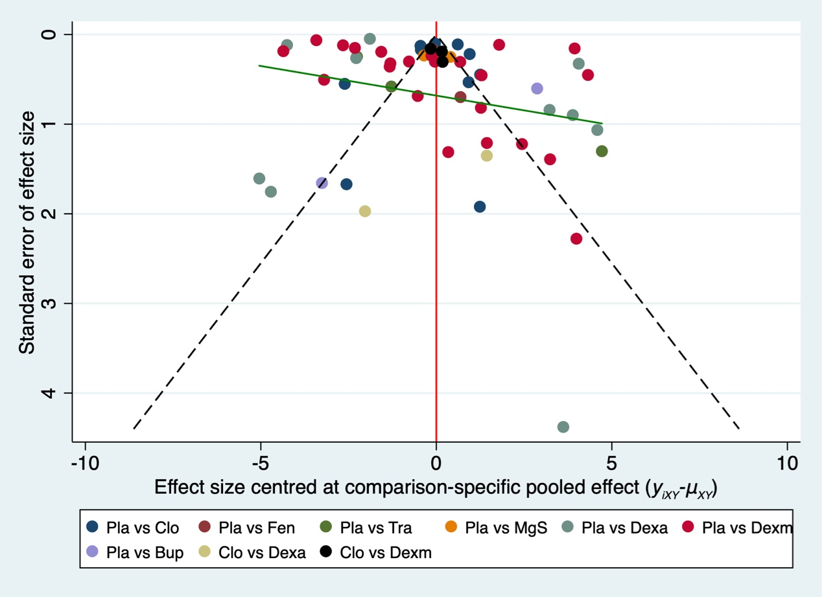

**B**

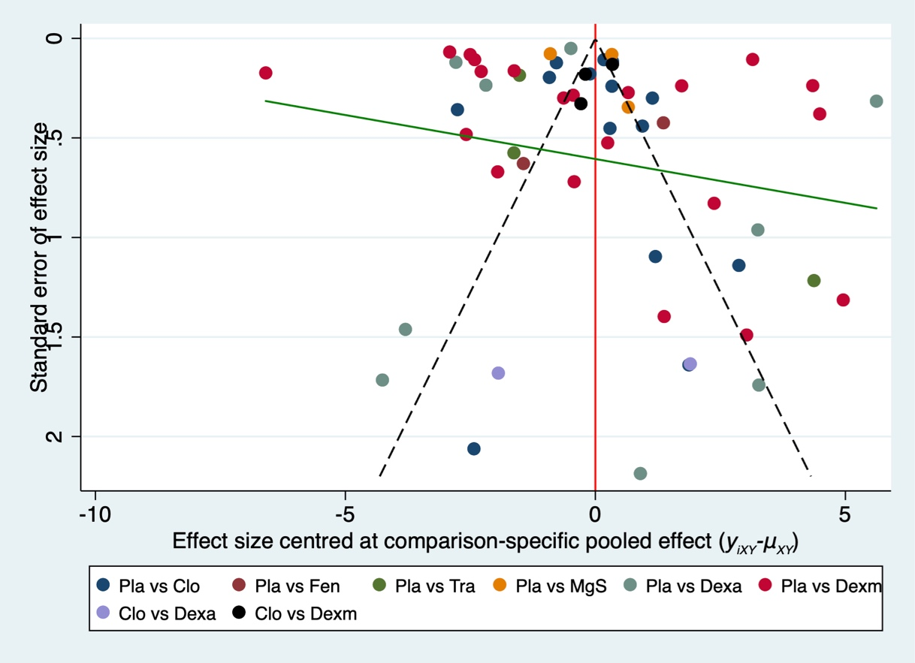

**C**

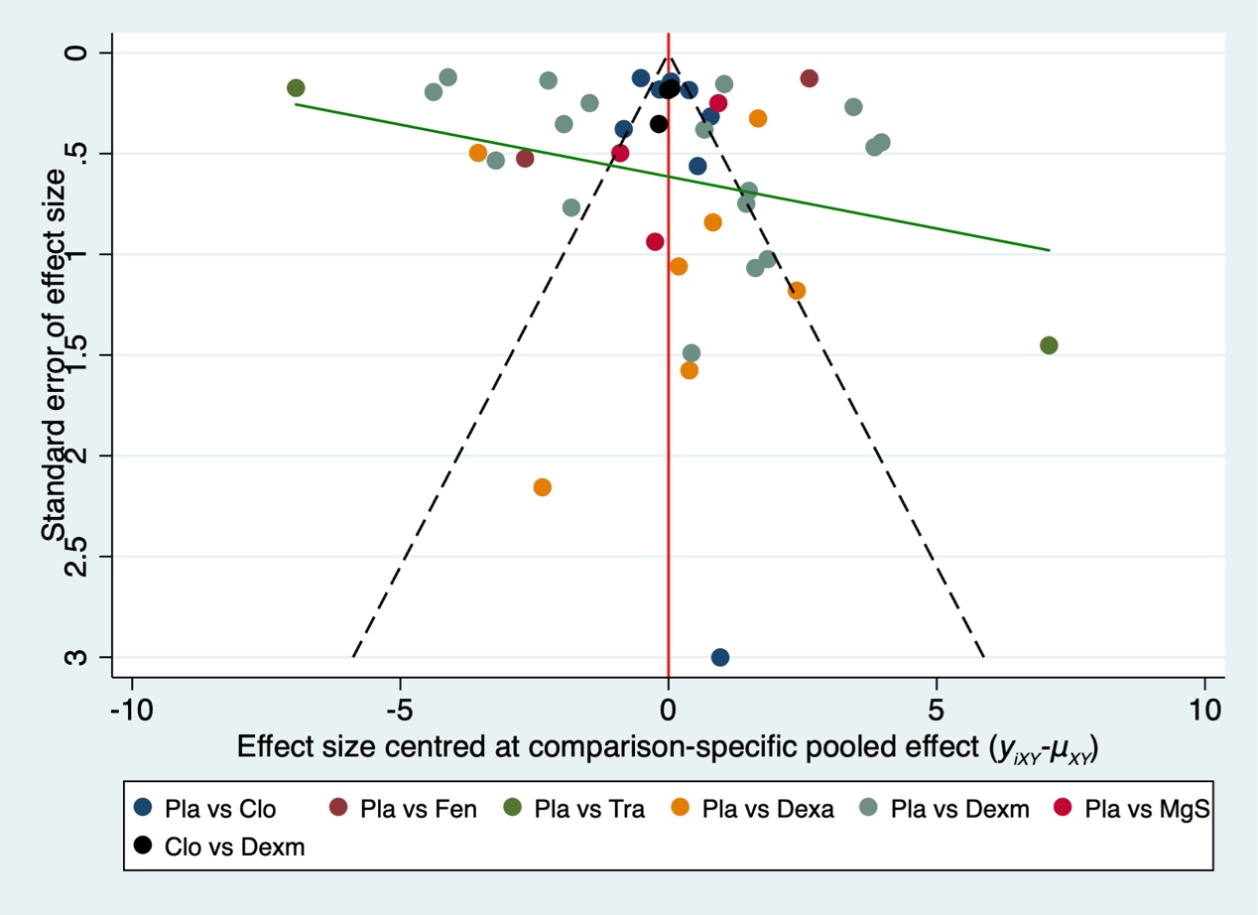

Comparison-adjust funnel plot for the analgesia network. A is funnel plot of sensory block time, B is funnel plot of motor block time, and C is funnel plot of time of first analgesia request. The red line represents the null hypothesis that the study-specific effect sizes do not differ from the respective comparison-specific pooled effect estimates. The green line is the regression line. Different colors correspond to different comparisons. (Pla=placebo, Clo=clonidine, Tra=tramadol, Bup=buprenorphine, Dexa=dexamethasone, Dexm=dexmedetomidine, Fen=fentanyl, MgS=MgSO4)

**Figure 4**

**A**

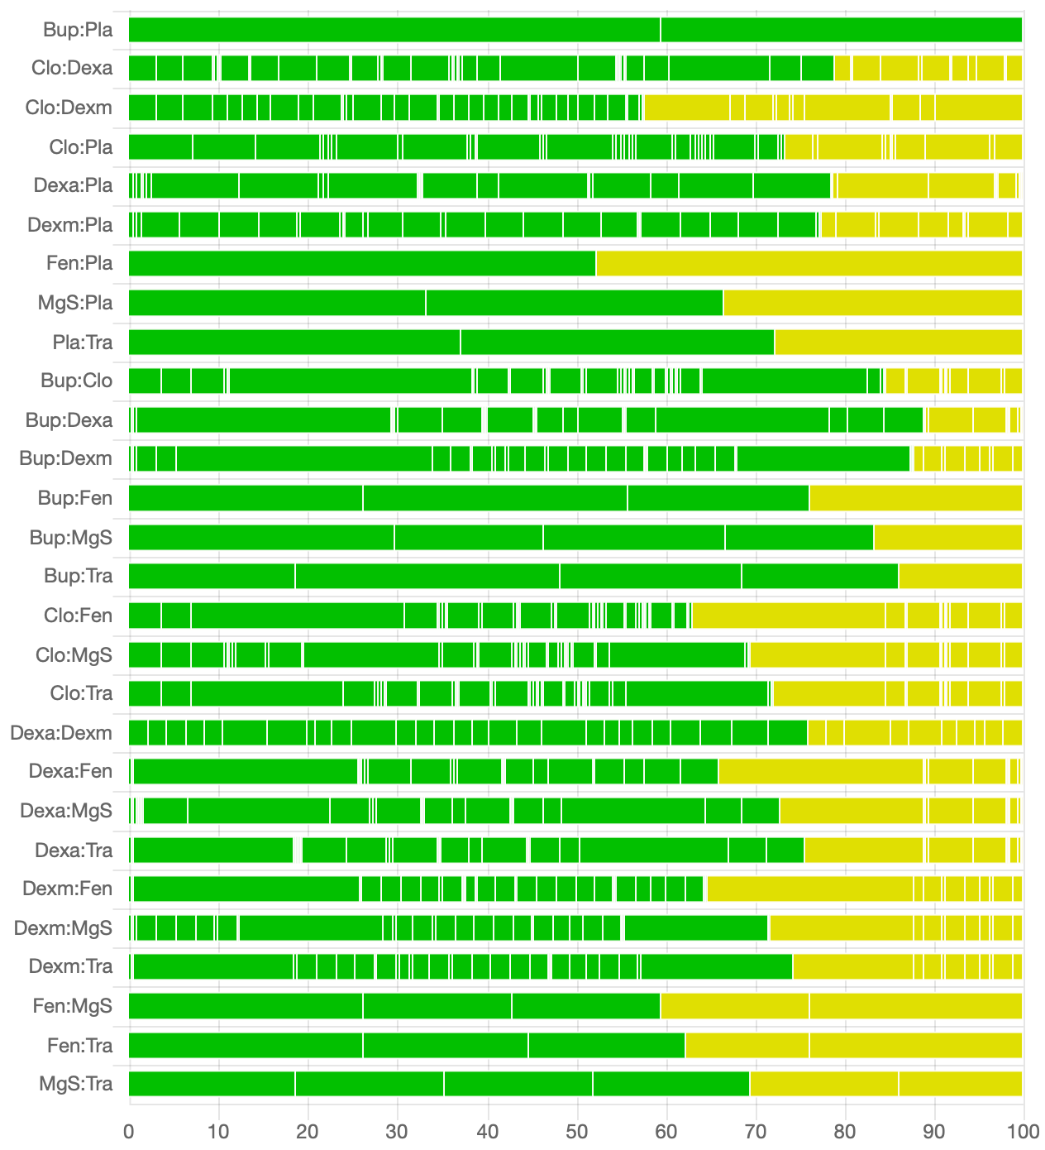

B

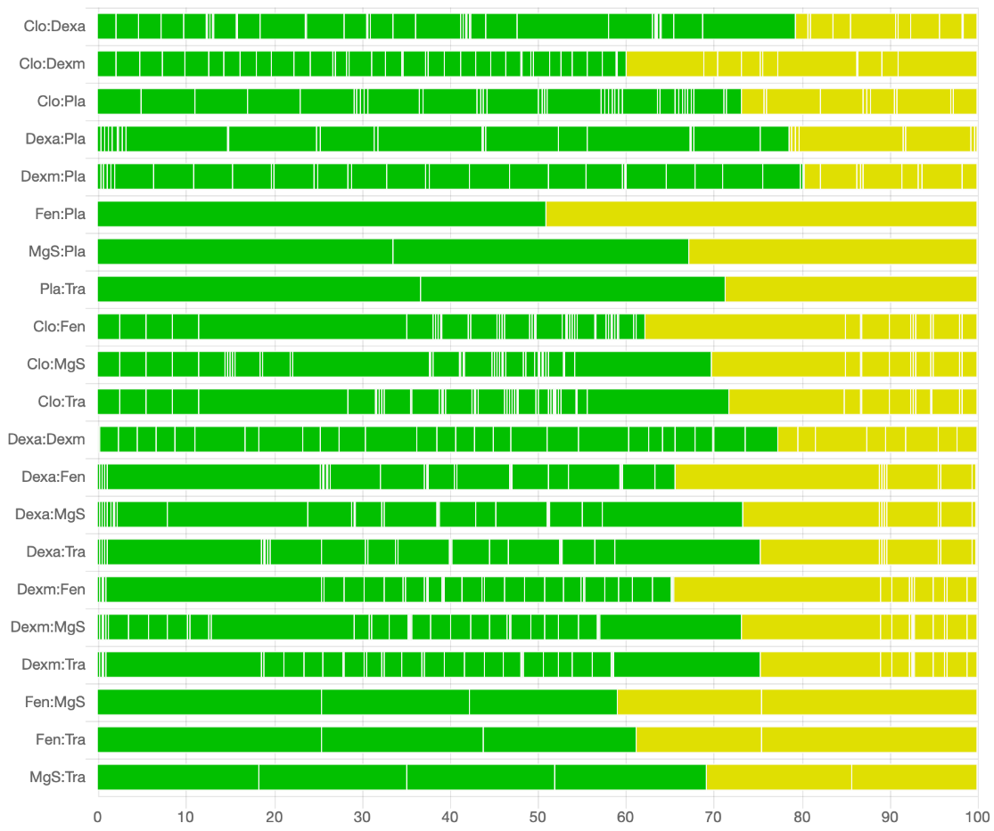

C

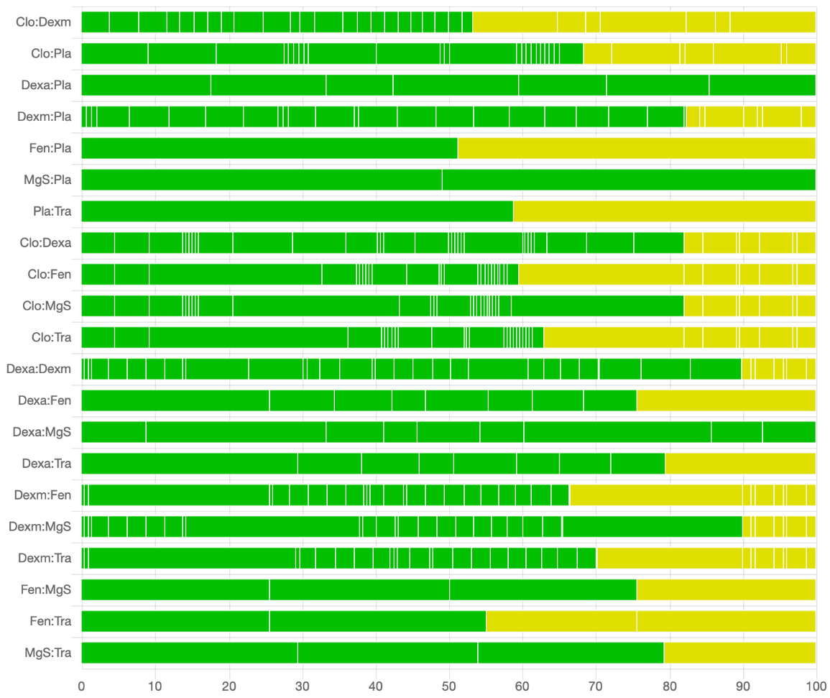

Risk of bias bar chart for the comparison of effects of adjuvants to prolong the duration of local anesthetics. A is risk of bias bar chart of sensory block time, B is risk of bias bar chart of motor block time, and C is risk of bias bar chart of time of first analgesia request. The bar chart shows the contributions of each piece of study to the network estimate. While vertical lines separate the percentage contribution of different studies. Each bar shows the percentage contribution from studies judged to be at low (green), moderate (yellow), and high (red) risk of bias. We do not have high risk of bias in this network. (Pla=placebo, Clo=clonidine, Tra=tramadol, Bup=buprenorphine, Dexa=dexamethasone, Dexm=dexmedetomidine, Fen=fentanyl, MgS=MgSO4)

**Figure 5**

**A**

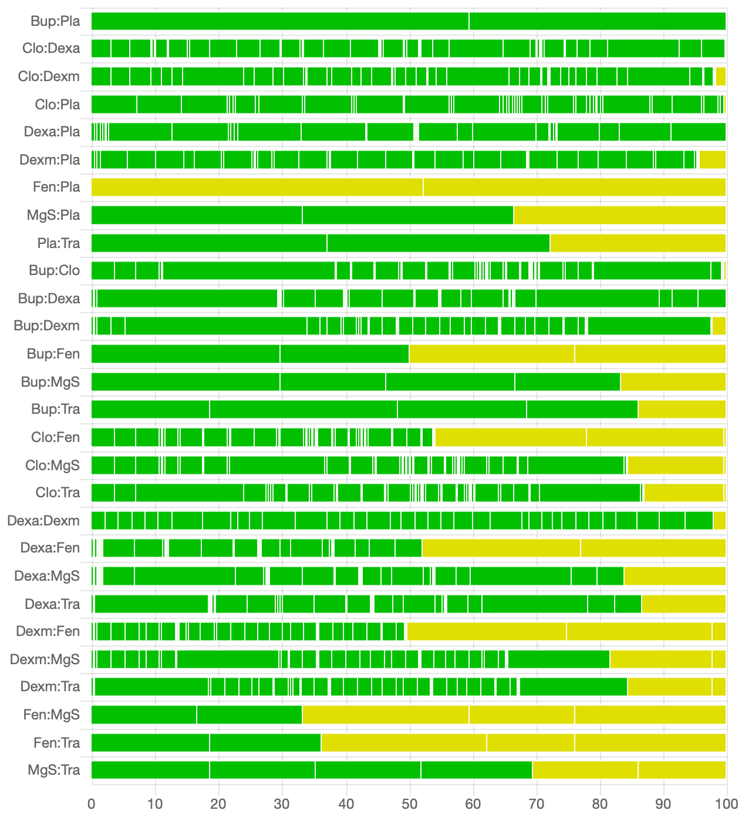

B

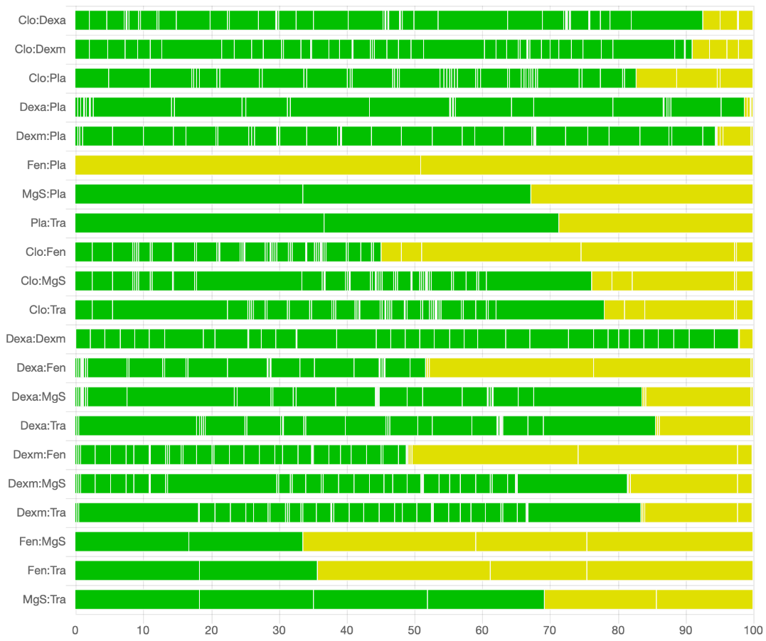

C

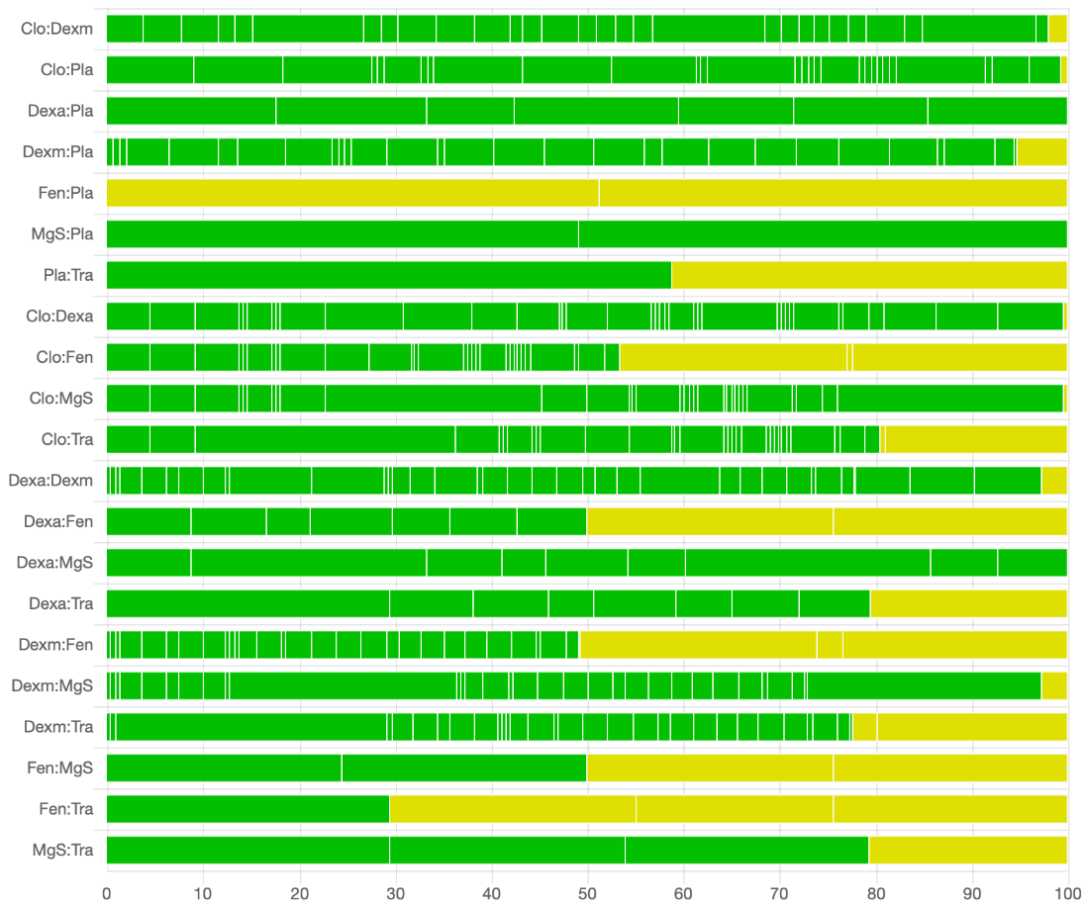

Indirectness contributions bar chart for the comparison of effects of adjuvants to prolong the duration of local anesthetics. A is risk of bias bar chart of sensory block time, B is risk of bias bar chart of motor block time, and C is risk of bias bar chart of time of first analgesia request. The bar chart shows the contributions of each study to the network estimate. While vertical lines separate the percentage contribution of different studies. Each bar shows the percentage contribution from studies judged to be at low (green), moderate (yellow), and high (red) risk of indirectness contribution. We do not have high risk of indirectness contribution in this network. (Pla=placebo, Clo=clonidine, Tra=tramadol, Bup=buprenorphine, Dexa=dexamethasone, Dexm=dexmedetomidine, Fen=fentanyl, MgS=MgSO4)

**Figure 6**

**A**

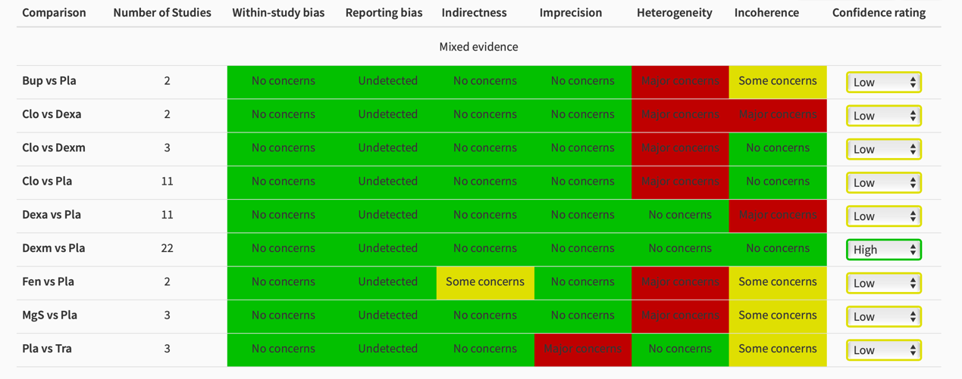

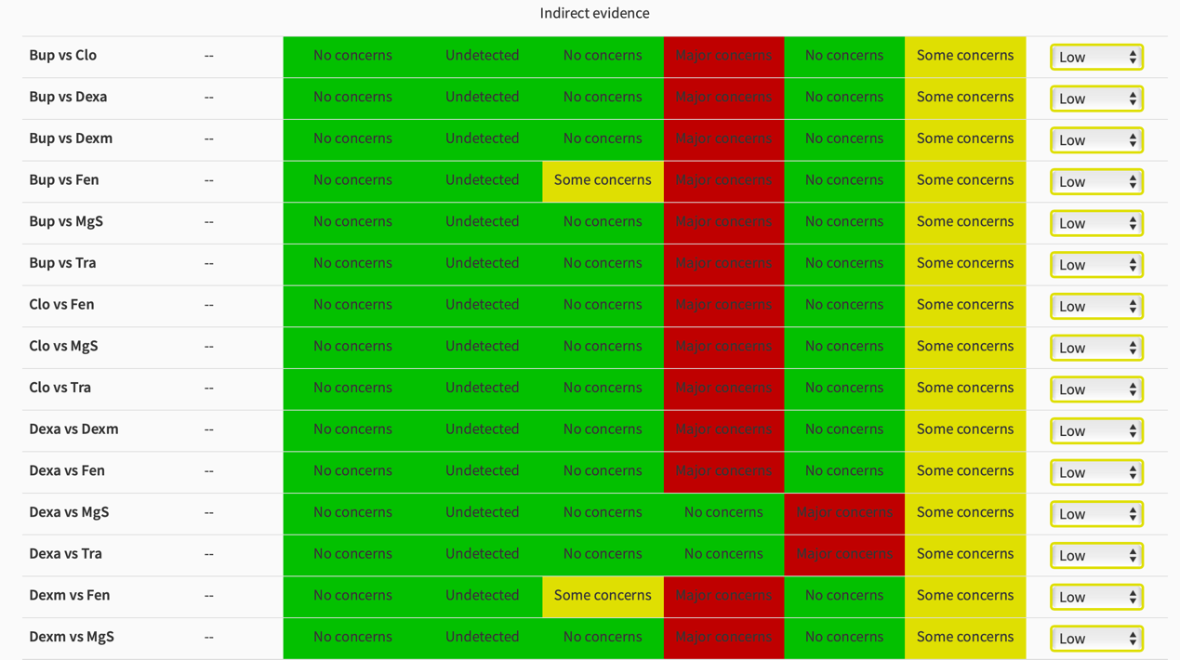

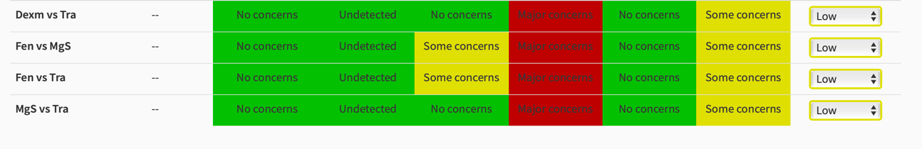

**B** 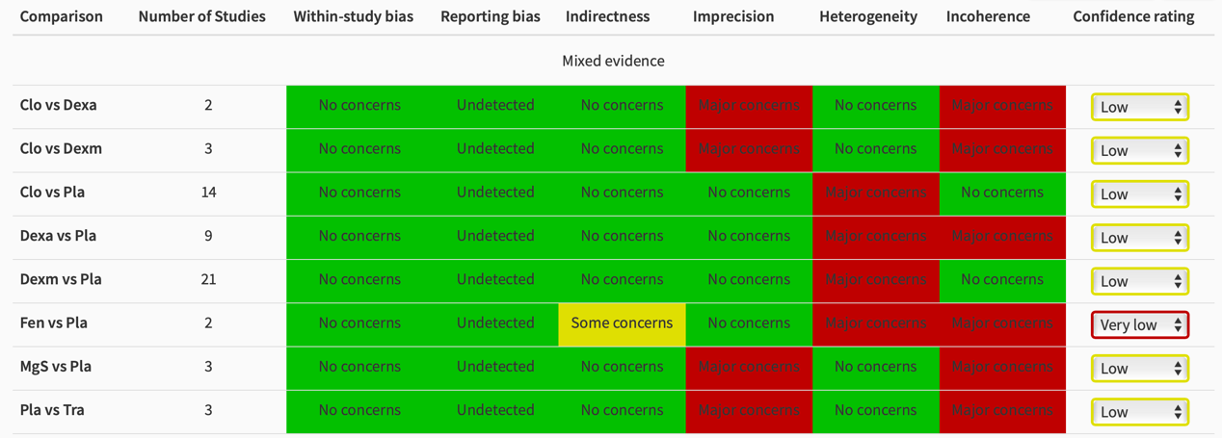

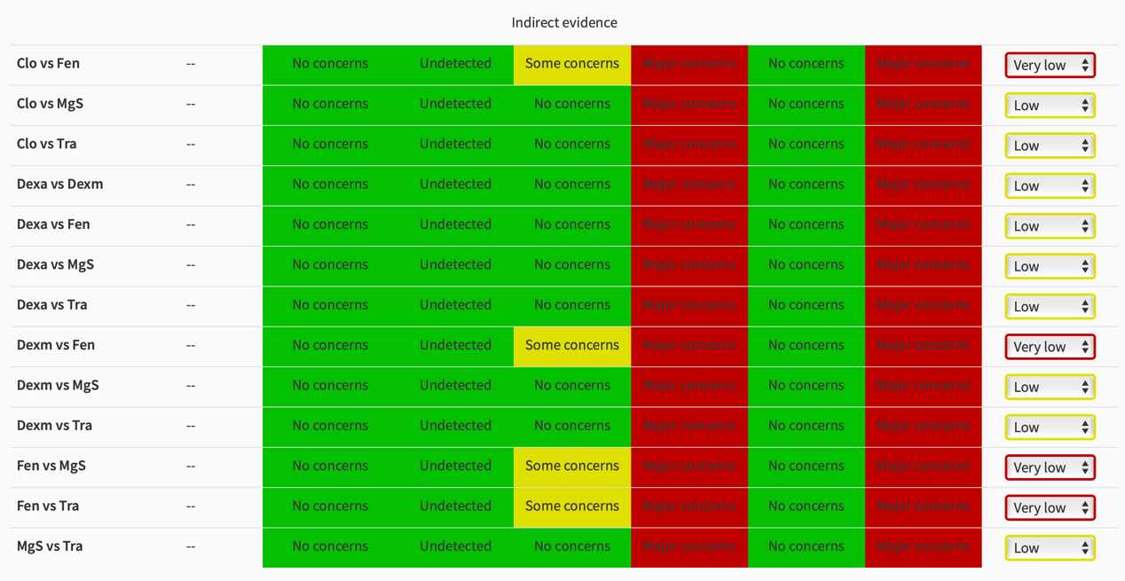

**C**  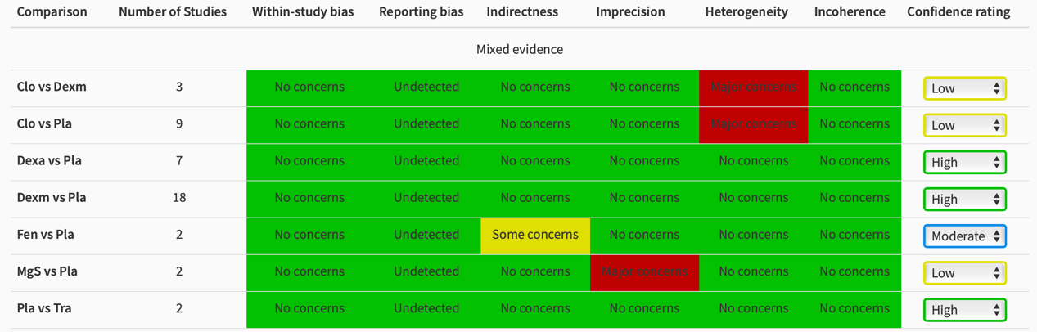

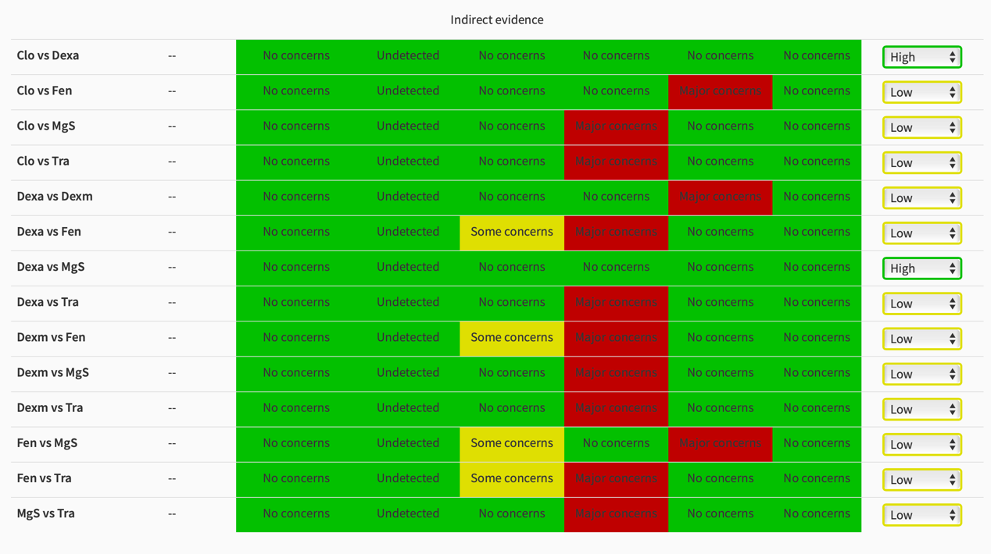

Confidence rating report of the comparison of effects of adjuvants to prolong the duration of local anesthetics. A is confidence rating report of sensory block time, B is confidence rating report of motor block time, and C is confidence rating report of time of first analgesia request. The confidence rating report brings together all the judgments for the six domains (within study bias, reporting bias, indirectness, imprecision, heterogeneity, and incoherence) across all evaluated treatment effects. The default judgment is “High” confidence; downgrading by one, two, or three levels will lead to a confidence rating of “Moderate,” “Low,” or “Very Low”, respectively.

**Figure 7**

**A**

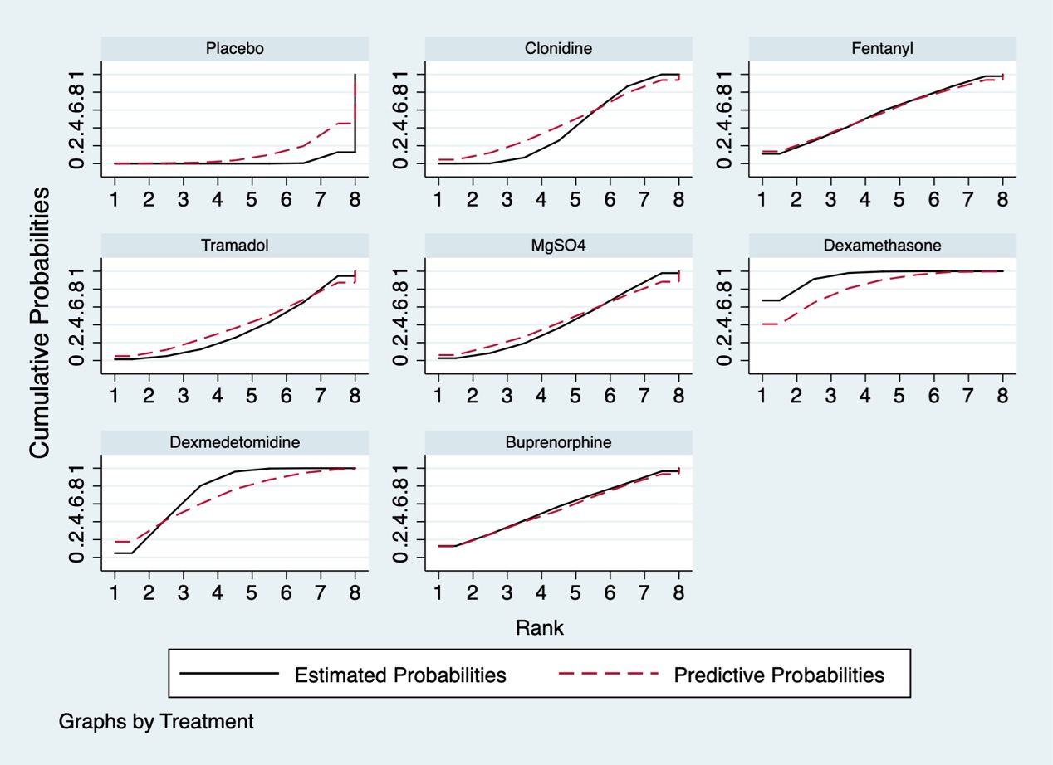

**B**

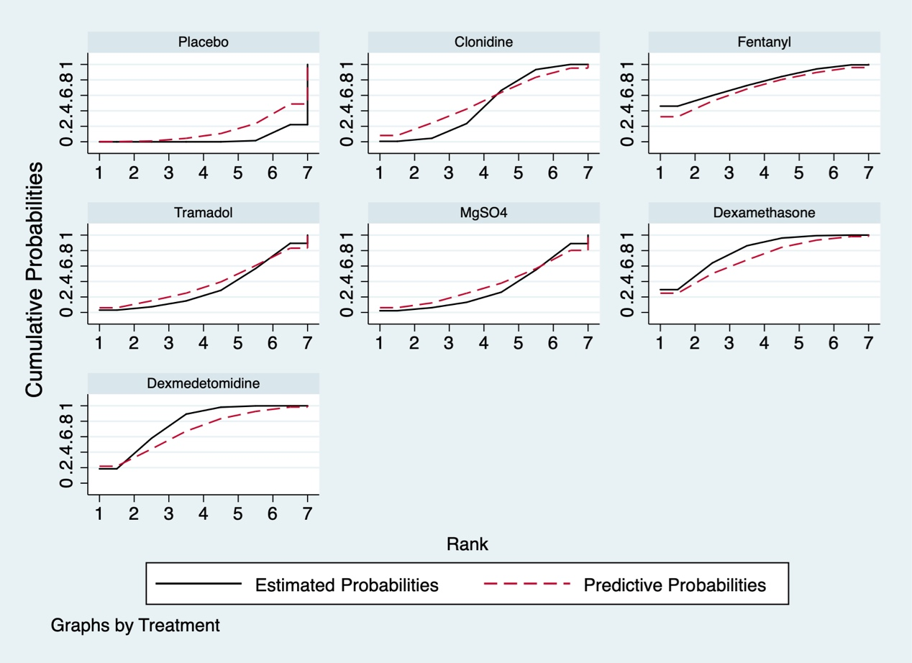

**C**

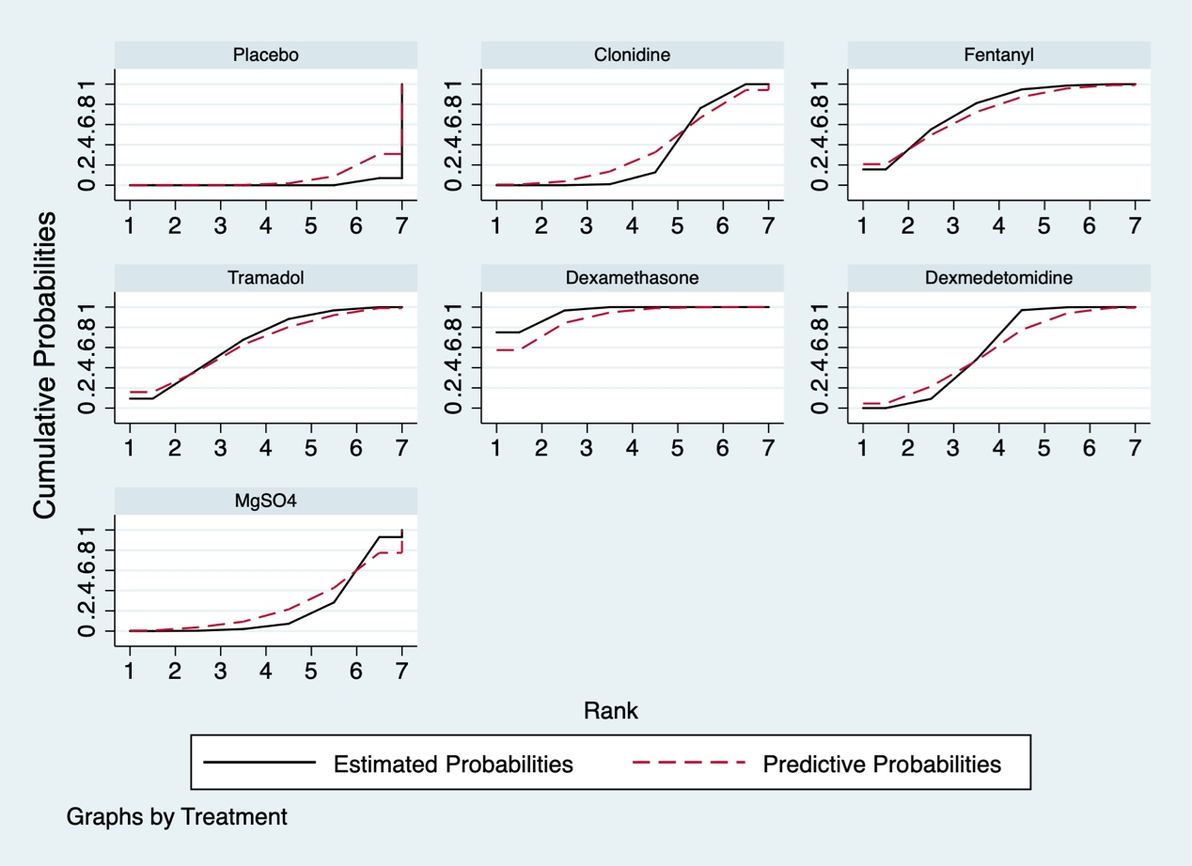

Plots of the surface under the cumulative ranking curves for all treatments in the network meta. A is a plot of sensory block time, B is plot of motor block time, and C is plot of s the time of first analgesia request. Black solid lines correspond to the estimated probabilities and red dashed lines to the predictive probabilities.

**Table3. SUCRA values of ranking probabilities**

|  |  |  |  |
| --- | --- | --- | --- |
| LA adjuvant | SB time | MB time | Time of FAR |
| Dexamethasone | 93.7 | 79.1 | 95.0 |
| Dexmedetomidine | 75.3 | 77.6 | 59.0 |
| Fentanyl | 55.8 | 76.3 | 74.5 |
| Buprenorphine | 55.2 | NA | NA |
| MgSO4 | 43.0 | 31.9 | 21.5 |
| Clonidine | 39.5 | 48.6 | 32.1 |
| Tramadol | 35.6 | 32.1 | 66.6 |
| Placebo | 1.9 | 4.2 | 1.3 |

Surface under the cumulative ranking curve (SUCRA), a simple transformation of the mean rank, is used to provide the hierarchy for the all treatments. The larger the SUCRA value, the better the rank of the treatment.

**Figure 8**

**A**

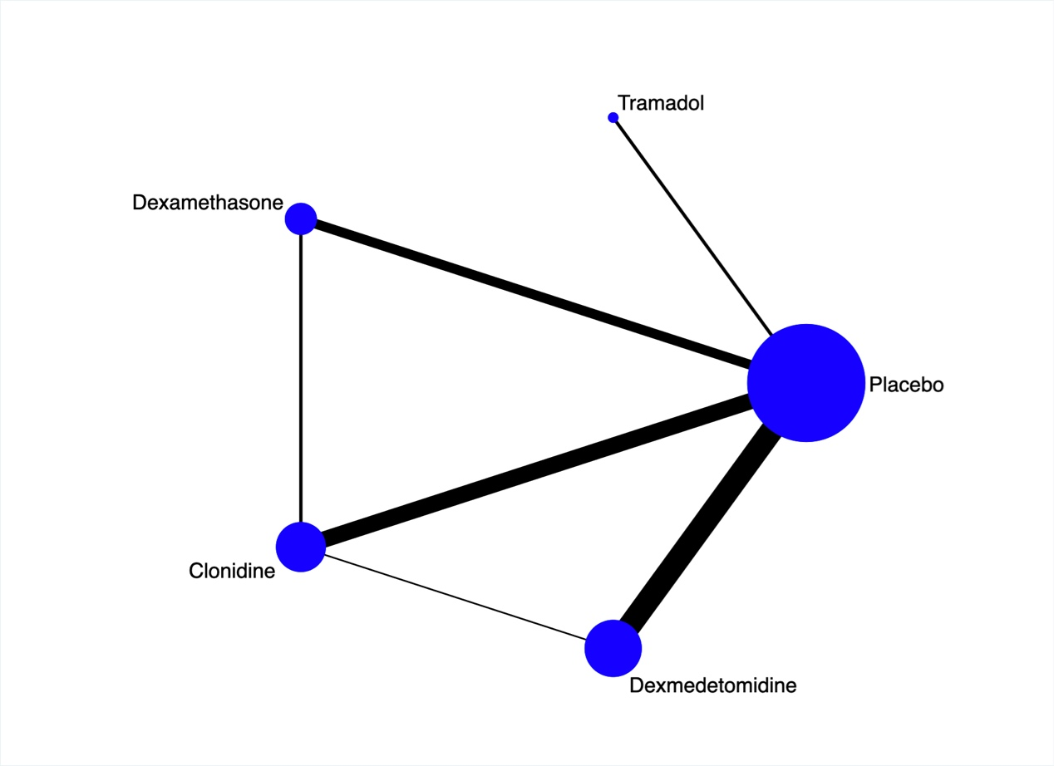

**B**

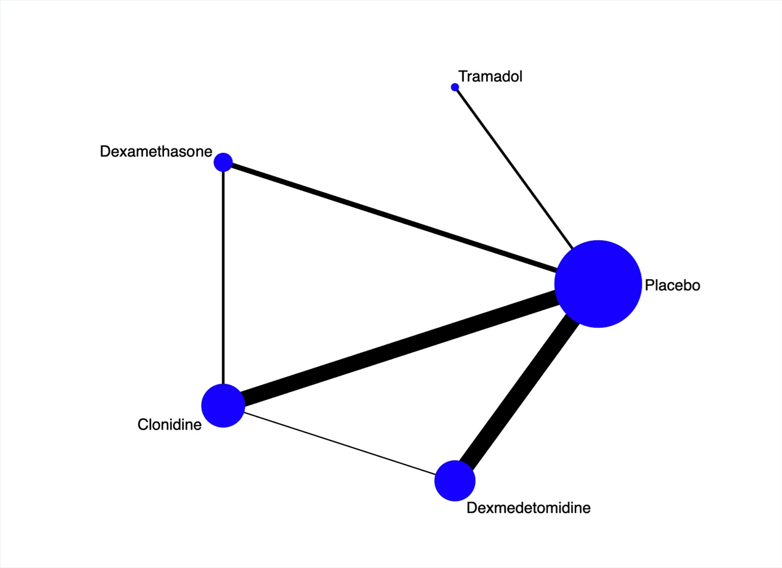

**C**

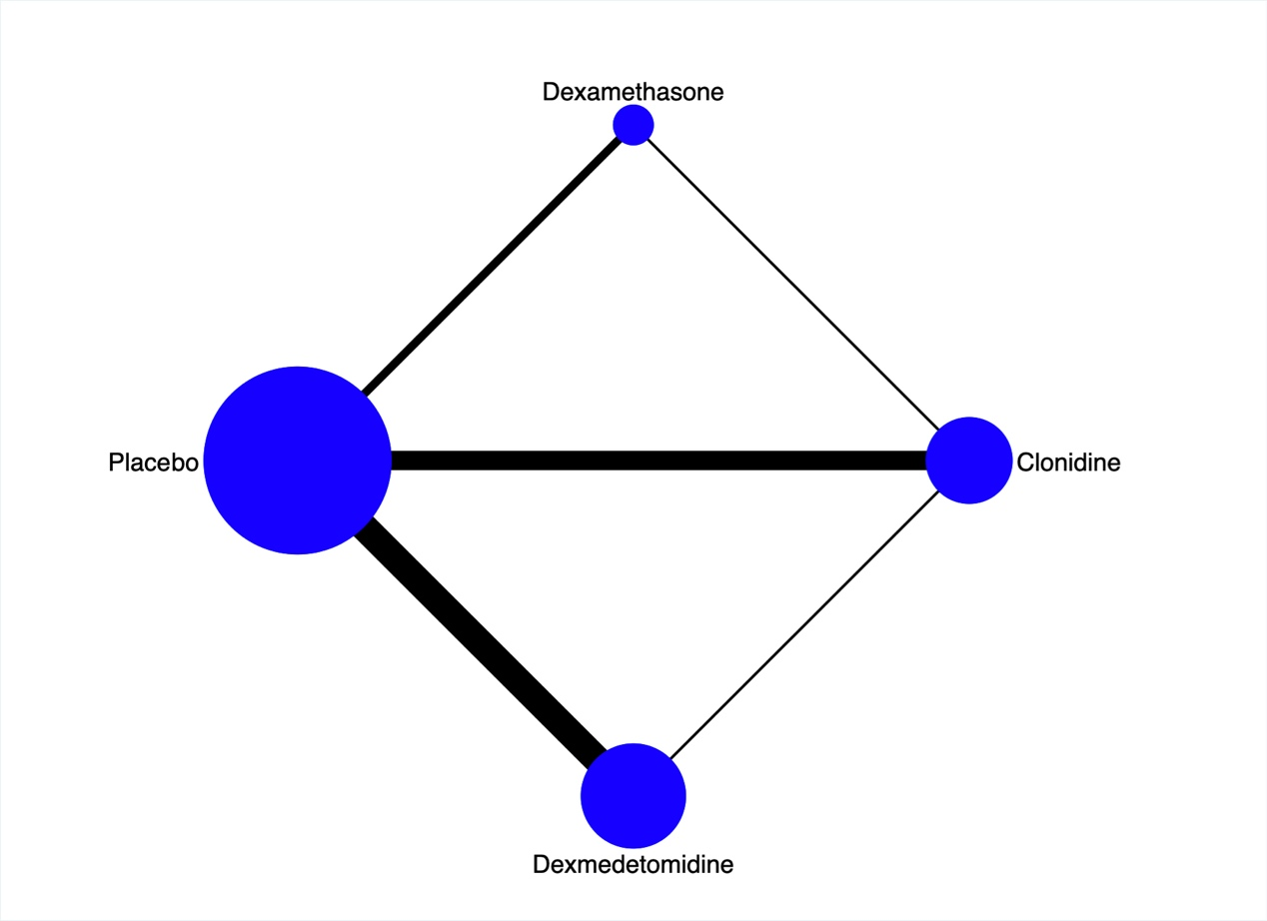

Network Plot for subgroup network meta-analysis of ropivacaine. A is a network plot of a subgroup analysis of sensory block time, B is a network plot of a subgroup analysis of motor block time, and C is a network plot of a subgroup analysis of the time of first analgesia request. Nodes are weighted according to the number of studies including the respective treatments. The widths of edges are weighted according to the number of studies in each comparison.

**Figure 9**

**A**

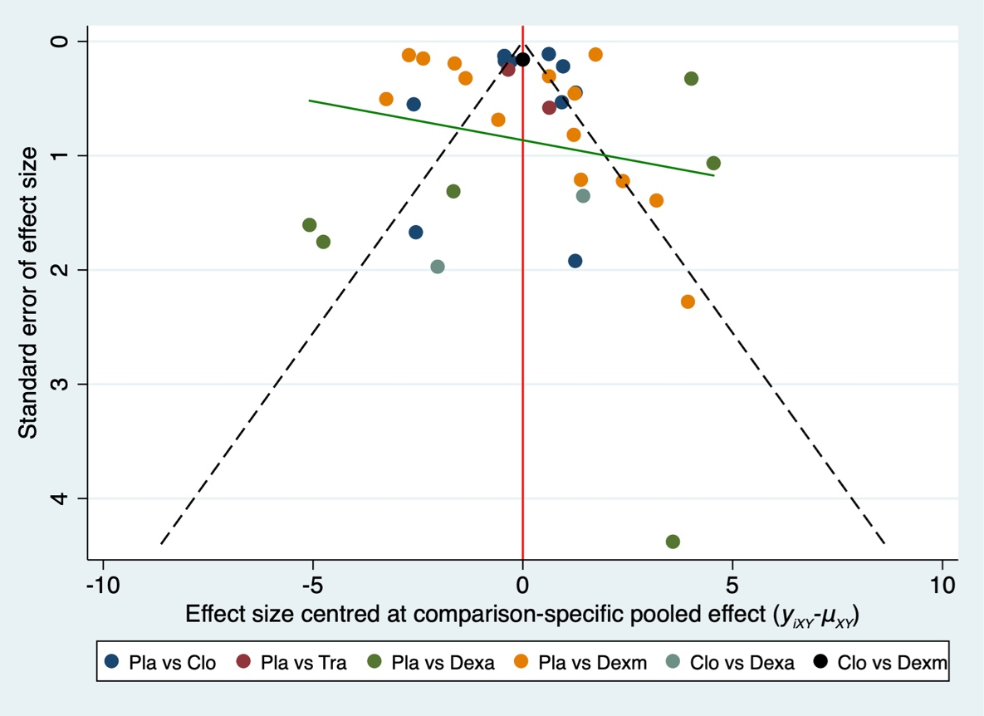

**B**

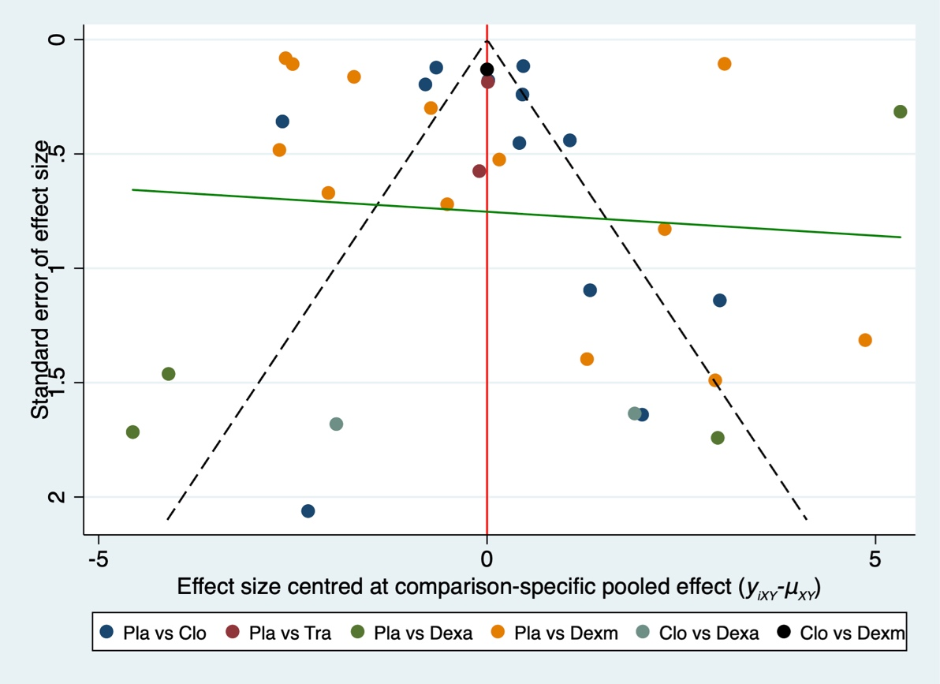

**C**

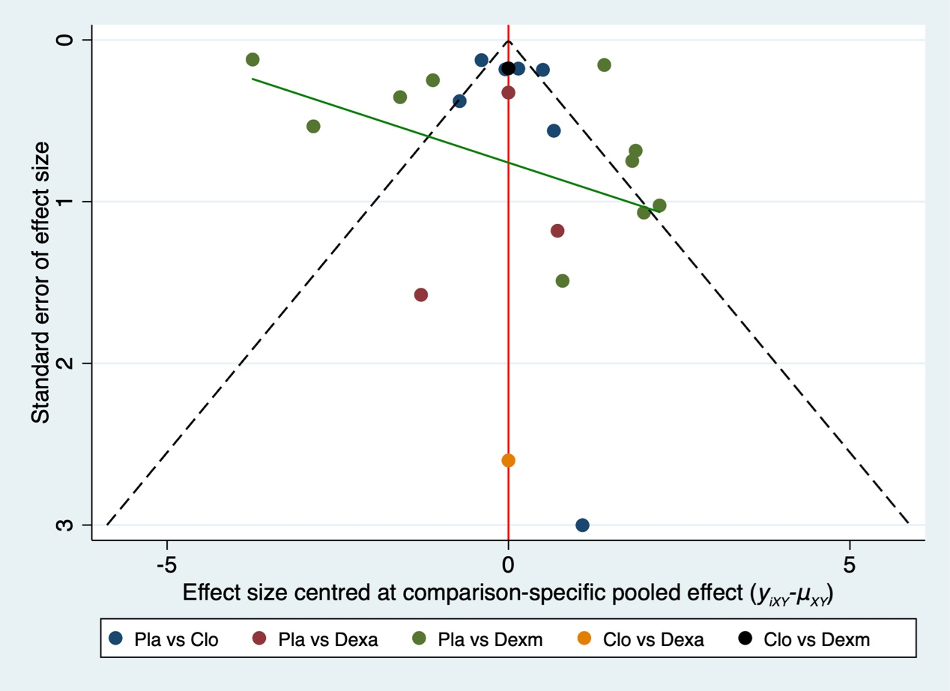

Comparison-adjust funnel plot for subgroup analysis of the analgesia network. A is a funnel plot of a subgroup analysis of sensory block time, B is a funnel plot of a subgroup analysis of motor block time, and C is a funnel plot of a subgroup analysis of the time of first analgesia request. The red line represents the null hypothesis that the study-specific effect sizes do not differ from the respective comparison-specific pooled effect estimates. The green line is the regression line. Different colors correspond to different comparisons. (Pla=placebo, Clo=clonidine, Tra=tramadol, Dexa=dexamethasone, Dexm=dexmedetomidine)