Supplemental Table 1. Flow diagram describing cohort inclusion criteria.
Inclusion Criteria | Number of Surgeries | % of Surgeries Lost
Surgeries defined using CPT  January 1, 2016 – September 16, 2019 | 58,273 | -
First surgery per patient | 44,833 | 23.1%
Planned (not emergency) Surgery | 37,398 | 16.6%
Inpatient length <=4 nights | 32,300 | 13.6%
Discharged home | 27,606 | 14.5%
No prior gabapentinoids | 24,714 | 10.5%
No prior epilepsy or postherpetic neuralgia diagnosis | 24,606 | 0.4%
No history of prolonged opioid use | 24,257 | 1.4%
No prior opioid abuse | 24,237 | 0.1%
At least 90 days of follow-up | 22,876 | 5.6%
Surgery performed in one of two included facilities* | 13,985 | 23.8%
*analyses were subset to the two facilities conducting the most surgeries to ensure positivity.
Supplemental Table 2. Follow-up and censoring reasons for patients with less than 90 days of follow-up after surgery.
 | Exposed (N=3,061) |  | Not Exposed (N=11,730) |  | Overall (N=14,791)
 | N | % of Total | N | % of Total | N | % of Total
Less than 90 days of follow-up | 130 | 4.2% | 703 | 6.0% | 833 | 5.6%
Censoring Reason | N | % of Censored | N | % of Censored | N | % of Censored
Follow-up surgery | 123 | 94.6% | 654 | 93.0% | 777 | 93.3%
Death | 4 | 3.1% | 46 | 6.5% | 50 | 6.0%
End of data | 3 | 2.3% | 3 | 0.4% | 6 | 0.7%

Supplemental Table 3. Adjusted risk ratios of prolonged opioid use comparing patients who received preoperative gabapentinoids to those who did not (referent) controlling for calendar time using 6-month categorical variables and continuous (number of days since the start of the study) variables.
Calendar Time | Adjustedª Risk Ratio (95% CI)
Main Analysis: 6-month categories | 1.19 (0.67,2.12)
Day of surgery (quadratic) | 1.10 (0.63, 1.93)
Day of surgery (cubic spline) | 1.09 (0.62, 1.93)
ªStabilized Inverse probability of treatment weights (IPTW) were calculated after conducting 1% asymmetric trimming to adjust for baseline confounding.

Supplemental Table 4. Crude and adjusted risk and risk ratios of prolonged opioid use comparing patients who received preoperative gabapentinoids to those who did not (referent) including supplemental analyses.
Population | Exposure Status | Number of Patients | Observed Risk (95% CI) | Number of Patients after Trimming | Adjustedª Risk (95% CI) | Adjustedª Risk Ratio (95% CI)
Full Population | Overall | 13,958 | 0.91% (0.77,1.08) | 11,303 | 0.87% (0.70,1.09) | 1.19 (0.67,2.12)
 | Gabapentinoid=1 | 2,931 | 1.19% (0.86,1.66) | 2,491 | 1.00% (0.59,1.68)
 | Gabapentinoid=0 | 11,027 | 0.83% (0.68,1.02) | 8,812 | 0.84% (0.66,1.06)
Pre-ERAS: Jan 2016 - Feb 2018^{b} | Overall | 7,842 | 1.05% (0.84,1.30) | 5,983 | 1.08% (0.84,1.39) | 1.23 (0.66,2.28)
 | Gabapentinoid=1 | 1,191 | 1.93% (1.29,2.89) | 959 | 1.28% (0.73,2.23)
 | Gabapentinoid=0 | 6,651 | 0.89% (0.69,1.14) | 5,024 | 1.04% (0.79,1.38)
Post-ERAS: Mar 2018 - Dec 2019^{b} | Overall | 6,116 | 0.74% (0.55,0.98) | 4,873 | 0.79% (0.51,1.23) | 1.01 (0.31,3.33)
 | Gabapentinoid=1 | 1,740 | 0.69% (0.39,1.21) | 1,443 | 0.80% (0.26,2.44)
 | Gabapentinoid=0 | 4,376 | 0.75% (0.54,1.06) | 3,430 | 0.79% (0.52,1.20)
Surgeries with ≥30% Exposed | Overall | 2,587 | 0.62% (0.38,1.01) | 2,398 | 0.70% (0.41,1.21) | 1.01 (0.30,3.33)
 | Gabapentinoid=1 | 1,570 | 0.76% (0.44,1.34) | 1,458 | 0.70% (0.39,1.28)
 | Gabapentinoid=0 | 1,017 | 0.39% (0.15,1.05) | 940 | 0.70% (0.25,1.98)
Surgeries with <30% Exposed | Overall | 11,371 | 0.98% (0.81,1.17) | 9,737 | 1.15% (0.88,1.51) | 2.34 (1.02,5.41)
 | Gabapentinoid=1 | 1,361 | 1.69% (1.13,2.53) | 1,272 | 2.30% (1.03,5.15)
 | Gabapentinoid=0 | 10,010 | 0.88% (0.71,1.08) | 8,465 | 0.98% (0.79,1.23)
Outpatient Visit and Rx in Prior 182 Days | Overall | 5,084 | 1.63% (1.32,2.02) | 4,192 | 1.85% (1.42,2.40) | 1.06 (0.57,1.99)
 | Gabapentinoid=1 | 1,128 | 1.86% (1.22,2.84) | 927 | 1.94% (1.11,3.36)
 | Gabapentinoid=0 | 3,956 | 1.57% (1.22,2.01) | 3,264 | 1.82% (1.35,2.45)
Did not have ≥ 1 Outpatient Visit and Rx in Prior 182 Days | Overall | 8,874 | 0.50% (0.37,0.67) | 6,892 | 0.48% (0.30,0.75) | 1.73 (0.57,5.30)
 | Gabapentinoid=1 | 1,803 | 0.78% (0.46,1.31) | 1,553 | 0.71% (0.25,1.98)
 | Gabapentinoid=0 | 7,071 | 0.42% (0.30,0.61) | 5,339 | 0.41% (0.26,0.64)
ªStabilized Inverse probability of treatment weights (IPTW) were calculated within each population after conducting 1% asymmetric trimming to adjust for baseline confounding.
^{b}Due to extreme weights, 1.5% asymmetric trimming was used in the time period stratified analyses.

Supplemental Table 5. Baseline characteristics for patients undergoing colorectal resection, hip arthroplasty, knee arthroplasty, or hysterectomy, stratified by receipt of preoperative gabapentinoids, before and after IPTW weighting.
Characteristic | Observed Patients Before IPTW |  |  | After IPTW with 1% Asymmetric Trimming
 | No Preoperative Gabapentinoid | Preoperative Gabapentinoid | ASMD | No Preoperative Gabapentinoid | Preoperative Gabapentinoid | ASMD
 | N=1,017 | N=1,570 |  | N=940 | N=1,458
Female | 72.2(5.58) | 71.8(5.35) | 0.06 | 72.1(5.60) | 72.1(5.35) | 0.01
Age at admission, mean (SD) | 685 (67.4%) | 1,007 (64.1%) | 0.07 | 606 (64.5%) | 936 (64.2%) | 0.00
Patient Race |  |  | 0.10 |  |  | 0.00
White | 840 (82.6%) | 1,333 (84.9%) |  | 794 (84.5%) | 1,231 (84.4%)
Black | 120 (11.8%) | 168 (10.7%) |  | 103 (11.0%) | 160 (11.0%)
Other | 57 (5.6%) | 69 (4.4%) |  | 43 (4.5%) | 67 (4.6%)
Date of Surgery |  |  | 0.39 |  |  | 0.00
2016 | 272 (26.7%) | 185 (11.8%) |  | 151 (16.1%) | 233 (16.0%)
2017 | 232 (22.8%) | 373 (23.8%) |  | 232 (24.7%) | 362 (24.8%)
2018 | 241 (23.7%) | 521 (33.2%) |  | 280 (29.8%) | 430 (29.5%)
2019 | 272 (26.7%) | 491 (31.3%) |  | 277 (29.4%) | 432 (29.7%)
Location |  |  | 0.29 |  |  | 0.01
Facility 1 | 927 (91.2%) | 1,374 (87.5%) |  | 864 (91.9%) | 1,342 (92.0%)
Facility 2 | 90 (8.8%) | 196 (12.5%) |  | 76 (8.1%) | 116 (8.0%)
Patient BMI |  |  | 0.17 |  |  | 0.00
Low / Optimal BMI | 224 (22.0%) | 296 (18.9%) |  | 184 (19.5%) | 286 (19.6%)
Overweight | 346 (34.0%) | 563 (35.9%) |  | 335 (35.6%) | 516 (35.4%)
Obese | 446 (43.9%) | 711 (45.3%) |  | 421 (44.8%) | 656 (45.0%)
Maximum Presurgical Pain Recorded |  |  | 0.15 |  |  | 0.01
0 | 548 (53.9%) | 693 (44.1%) |  | 430 (45.7%) | 672 (46.1%)
1-3 | 165 (16.2%) | 244 (15.5%) |  | 153 (16.3%) | 239 (16.4%)
4-6 | 225 (22.1%) | 502 (32.0%) |  | 275 (29.3%) | 422 (29.0%)
7+ | 79 (7.8%) | 131 (8.3%) |  | 82 (8.7%) | 125 (8.6%)
Alcohol Use | 470 (46.2%) | 812 (51.7%) | 0.11 | 463 (49.3%) | 722 (49.5%) | 0.01
Smoking Status |  |  | 0.09 |  |  | 0.00
Current | 43 (4.2%) | 50 (3.2%) |  | 33 (3.5%) | 52 (3.6%)
Former | 414 (40.7%) | 668 (42.5%) |  | 403 (42.9%) | 623 (42.7%)
Other | 27 (2.7%) | 35 (2.2%) |  | 26 (2.7%) | 37 (2.5%)
Never | 533 (52.4%) | 817 (52.0%) |  | 477 (50.8%) | 746 (51.2%)
Baseline Outpatient Medication Orders
# unique orders |  |  | 0.09 |  |  | 0.03
0 | 516 (50.7%) | 734 (46.8%) |  | 470 (50.1%) | 742 (50.9%)
1-6 | 329 (32.4%) | 522 (33.2%) |  | 300 (32.0%) | 466 (31.9%)
7+ | 172 (16.9%) | 314 (20.0%) |  | 169 (18.0%) | 250 (17.1%)
Opioids | 137 (13.5%) | 130 (8.3%) | 0.17 | 82 (8.8%) | 126 (8.6%) | 0.00
Benzodiazepines | 74 (7.3%) | 121 (7.7%) | 0.02 | 76 (8.0%) | 99 (6.8%) | 0.05
Baseline Health Conditions
Recent outpatient visit and outpatient medication order | 171 (16.8%) | 385 (24.5%) | 0.19 | 186 (19.8%) | 277 (19.0%) | 0.02
Arthritis | 195 (19.2%) | 358 (22.8%) | 0.09 | 178 (18.9%) | 277 (19.0%) | 0.00
Cancer | 123 (12.1%) | 254 (16.2%) | 0.12 | 139 (14.8%) | 210 (14.4%) | 0.01
Depression | 31 (3.0%) | 68 (4.3%) | 0.07 | 31 (3.3%) | 46 (3.2%) | 0.01
Chronic Back Pain | 106 (10.4%) | 215 (13.7%) | 0.10 | 115 (12.2%) | 174 (11.9%) | 0.01
Surgical Procedure
Colorectal Resection | 172 (16.9%) | 227 (14.5%) | 0.07 | 146 (15.6%) | 226 (15.5%) | 0.00
Hip Arthroplasty | 194 (19.1%) | 393 (25.0%) | 0.14 | 218 (23.2%) | 338 (23.2%) | 0.00
Knee Arthroplasty | 505 (49.7%) | 875 (55.7%) | 0.12 | 520 (55.3%) | 806 (55.3%) | 0.00
Hysterectomy | 146 (14.4%) | 75 (4.8%) | 0.33 | 56 (6.0%) | 88 (6.0%) | 0.00
ASMD-absolute standardized mean difference; BMI-body mass index; IPTW-inverse probability of treatment weights; SD-standard deviation.

Supplemental Table 6. Baseline characteristics for patients with at least one outpatient visit and prescription medication in the 182 days prior to undergoing surgery, stratified by receipt of preoperative gabapentinoids, before and after IPTW weighting.
Characteristic | No Preoperative Gabapentinoid | Preoperative Gabapentinoid | ASMD | No Preoperative Gabapentinoid | Preoperative Gabapentinoid | ASMD
 | N=3,956 | N=1,128 |  | N=3,264 | N=927
Female | 2,238 (56.6%) | 736 (65.2%) | 0.18 | 1,944 (59.5%) | 544 (58.7%) | 0.02
Age at admission, mean (SD) | 73.2(6.21) | 71.7(5.38) | 0.26 | 72.7(6.01) | 72.8(5.86) | 0.02
Patient Race |  |  | 0.06 |  |  | 0.05
White | 3,209 (81.1%) | 939 (83.2%) |  | 2,689 (82.4%) | 762 (82.1%)
Black | 563 (14.2%) | 134 (11.9%) |  | 428 (13.1%) | 130 (14.0%)
Other | 184 (4.7%) | 55 (4.9%) |  | 148 (4.5%) | 35 (3.8%)
Date of Surgery |  |  | 0.56 |  |  | 0.09
2016 | 1,203 (30.4%) | 129 (11.4%) |  | 655 (20.1%) | 198 (21.3%)
2017 | 1,049 (26.5%) | 261 (23.1%) |  | 898 (27.5%) | 244 (26.3%)
2018 | 1,021 (25.8%) | 409 (36.3%) |  | 1,009 (30.9%) | 264 (28.5%)
2019 | 683 (17.3%) | 329 (29.2%) |  | 702 (21.5%) | 221 (23.9%)
Location |  |  | 0.42 |  |  | 0.12
Facility 1 | 1,856 (46.9%) | 792 (70.2%) |  | 1,912 (58.6%) | 536 (57.8%)
Facility 2 | 2,100 (53.1%) | 336 (29.8%) |  | 1,352 (41.4%) | 391 (42.1%)
Patient BMI |  |  | 0.16 |  |  | 0.14
Missing | 10 (0.3%) | 8 (0.7%) |  | 11 (0.4%) | 6 (0.6%)
Low / Optimal | 1,118 (28.3%) | 284 (25.2%) |  | 893 (27.4%) | 251 (27.1%)
Overweight | 1,408 (35.6%) | 395 (35.0%) |  | 1,181 (36.2%) | 347 (37.4%)
Obese | 1,420 (35.9%) | 441 (39.1%) |  | 1,179 (36.1%) | 323 (34.8%)
Maximum Presurgical Pain Recorded |  |  | 0.28 |  |  | 0.08
Missing | 9 (0.02%) | 1 (0.1%) |  | 7 (0.2%) | 0 (0.0%)
0 | 3,215 (81.3%) | 776 (68.8%) |  | 2,536 (77.7%) | 695 (74.9%)
1-3 | 289 (7.3%) | 124 (11.0%) |  | 279 (8.6%) | 81 (8.7%)
4-6 | 298 (7.5%) | 157 (13.9%) |  | 293 (9.0%) | 99 (10.7%)
7+ | 145 (3.7%) | 70 (6.2%) |  | 149 (4.6%) | 52 (5.6%)
Alcohol Use | 1,250 (31.6%) | 405 (35.9%) | 0.09 | 1,035 (31.7%) | 281 (30.3%) | 0.03
Smoking Status |  |  | 0.20 |  |  | 0.03
Current | 241 (6.1%) | 43 (3.8%) |  | 170 (5.2%) | 48 (5.1%)
Former | 1,519 (38.4%) | 366 (32.4%) |  | 1,146 (35.1%) | 323 (34.9%)
Other | 764 (19.3%) | 298 (26.4%) |  | 792 (24.3%) | 231 (24.9%)
Never | 1,432 (36.2%) | 421 (37.3%) |  | 1,157 (35.4%) | 325 (35.1%)
Baseline Outpatient Medication Orders
# unique orders |  |  | 0.07 |  |  | 0.07
0 | 96 (2.4%) | 33 (2.9%) |  | 86 (2.6%) | 34 (3.6%)
1-6 | 2,045 (51.7%) | 590 (52.3%) |  | 1,712 (52.4%) | 458 (49.4%)
7+ | 1,815 (45.9%) | 505 (44.8%) |  | 1,467 (44.9%) | 436 (47.0%)
Opioids | 788 (19.9%) | 227 (20.1%) | 0.01 | 661 (20.3%) | 202 (21.8%) | 0.04
Benzodiazepines | 728 (18.4%) | 187 (16.6%) | 0.05 | 591 (18.1%) | 156 (16.8%) | 0.04
Baseline Health Conditions
Arthritis | 1,108 (28.0%) | 424 (37.6%) | 0.21 | 991 (30.4%) | 299 (32.2%) | 0.04
Cancer | 1,260 (31.9%) | 398 (35.3%) | 0.07 | 1,081 (33.1%) | 314 (33.8%) | 0.02
Depression | 277 (7.0%) | 99 (8.8%) | 0.07 | 239 (7.3%) | 63 (6.8%) | 0.02
Chronic Back Pain | 1,106 (28.0%) | 277 (24.6%) | 0.08 | 897 (27.5%) | 292 (31.4%) | 0.09
Fibromyalgia | 94 (2.4%) | 22 (2.0%) | 0.03 | 70 (2.1%) | 16 (1.8%) | 0.03
Neuralgia | 247 (6.2%) | 57 (5.1%) | 0.05 | 189 (5.8%) | 50 (5.4%) | 0.02
Headache/Migraine | 247 (6.2%) | 69 (6.1%) | 0.01 | 197 (6.0%) | 49 (5.3%) | 0.03
Abdominal Pain | 627 (15.8%) | 174 (15.4%) | 0.01 | 495 (15.2%) | 161 (17.4%) | 0.06
Surgical Procedure
Knee Arthroplasty | 59 (1.5%) | 172 (15.2%) | 0.51 | 108 (3.3%) | 30 (3.3%) | 0.00
Lumpectomy | 438 (11.1%) | 80 (7.1%) | 0.14 | 332 (10.2%) | 55 (6.0%) | 0.15
Inguinal / Femoral Hernia Repair | 146 (3.7%) | 13 (1.2%) | 0.17 | 89 (2.7%) | 28 (3.0%) | 0.02
Laminectomy | 128 (3.2%) | 23 (2.0%) | 0.08 | 114 (3.5%) | 55 (5.9%) | 0.11
Hip Arthroplasty | 28 (0.7%) | 76 (6.7%) | 0.32 | 53 (1.6%) | 14 (1.5%) | 0.01
Laparoscopic Cholecystectomy | 167 (4.2%) | 4 (0.4%) | 0.26 | 24 (0.7%) | 6 (0.6%) | 0.01
Prostate Surgery | 115 (2.9%) | 4 (0.4%) | 0.20 | 43 (1.3%) | 10 (1.1%) | 0.02
Colorectal Resection | 41 (1.0%) | 110 (9.8%) | 0.39 | 74 (2.3%) | 19 (2.0%) | 0.01
Hysterectomy | 43 (1.1%) | 27 (2.4%) | 0.10 | 54 (1.7%) | 15 (1.6%) | 0.01
ASMD-absolute standardized mean difference; BMI-body mass index; IPTW-inverse probability of treatment weights; SD-standard deviation.

Supplemental Table 7. Bias-adjusted risk ratios accounting for outcome misclassification.
Gold Standard | Bias adjusted RR* (95% CI) | Probabilistic Bias Analysis Parameters
 |  | PPV Unexposed (SE) | PPV Exposed (SE) | NPV Unexposed (SE) | NPV Exposed (SE)
Combined: EHR+Medicare | 1.45 (0.78,2.17) | 1 (0) | 1 (0) | 0.956 (0.004) | 0.934 (0.015)
Medicare Claims | 1.48 (0.78,2.27) | 0.327 (0.063) | 0.327 (0.063) | 0.956 (0.004) | 0.934 (0.015)
*Probabilistic bias analyses using 1,000 bootstraps to estimate impact of outcome misclassification in EHR data.
Supplemental Table 8. Proportion of patients with at least one outpatient prescription in the 90 days immediately following discharge from surgery.
Population | Number of Patients | Preoperative Gabapentinoids | No Preoperative Gabapentinoid | ASMD
Main Analysis | 13,985 | 0.40 | 0.42 | 0.05
182-day baseline | 5,084 | 0.62 | 0.63 | 0.02
ASMD-absolute standardized mean difference
Supplemental Figure 1. Propensity score distributions for the main analysis following 1% asymmetric trimming.
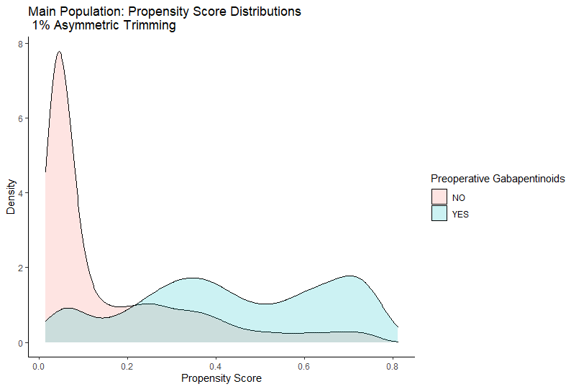

Supplemental Figure 2. Propensity score distributions for the population colorectal resection, hip arthroplasty, knee arthroplasty, or hysterectomy following 1% asymmetric trimming. 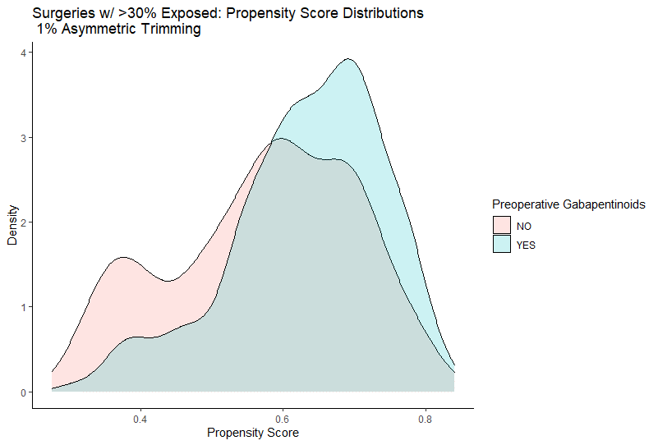
Supplemental Figure 3. Propensity score distributions for the population with at least one outpatient visit and one outpatient order in the 182 days prior to surgery following 1% asymmetric trimming.
