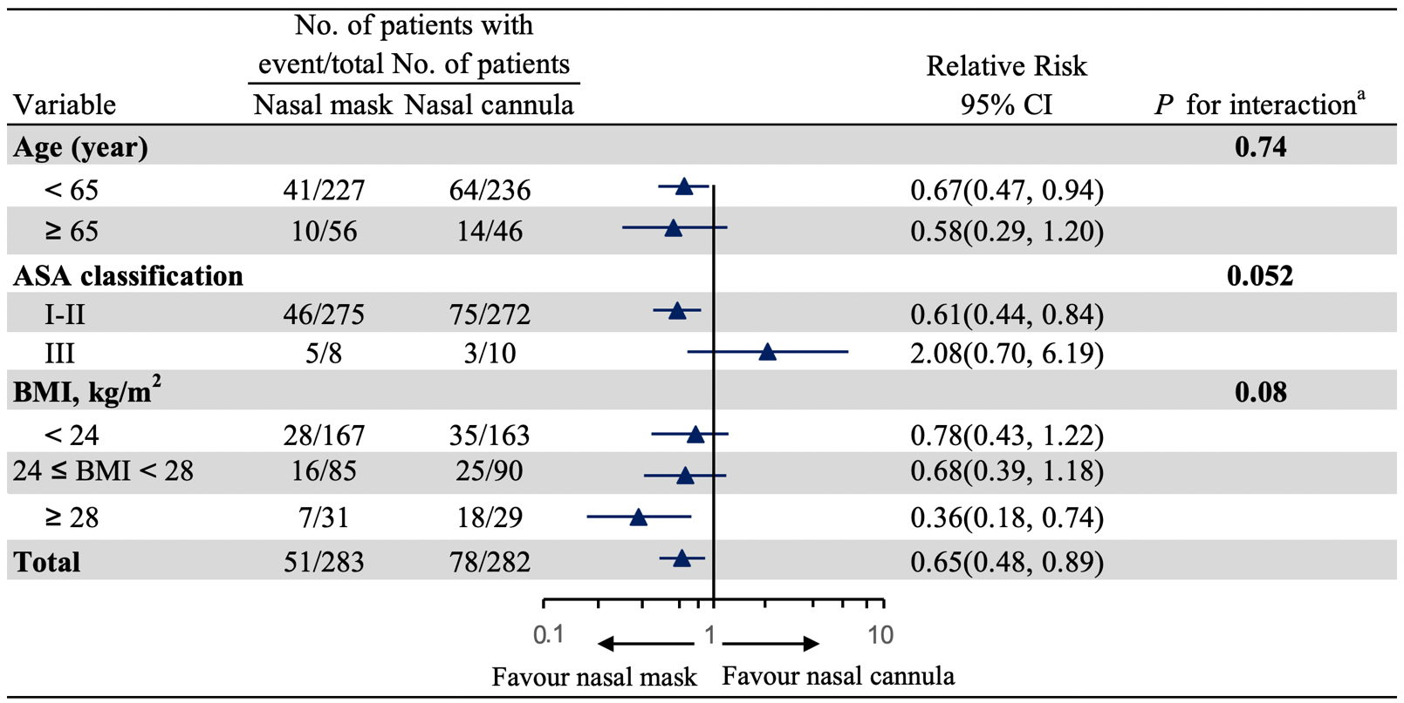
Supplementary Figure S1: Assessment of treatment effect heterogeneity.
ª P values less than .0167 indicates statistical significance (Bonferroni correction).
Abbreviations: ASA, American Society of Anesthesiologists; BMI, body mass index; CI, confidence interval; RR, Relative Risk.

