Supplemental Digital Content - Statistical Analysis Plan

Statistical Analysis Plan for the study of
High flow nasal cannula oxygen in patients having anesthesia for GI endoscopy

This document lays out the analysis plan we intend to use for the study of whether Vapotherm Precision Flow high flow nasal cannula oxygen systems (HIFLO) will result in a lower rate of hypoxemia during anesthesia for GI endoscopy, compared with the standard therapy (ST).

1.0 Brief description of the design of the study.
At the time of study enrollment, eligible patients were randomized to receive either Vapotherm Precision Flow or standard therapy. Random group assignment was made using permuted blocks of random size and random number generating software. Study outcomes were determined from electronic medical records by persons that were blinded to group assignment. The primary outcome was hypoxemia during anesthesia.
2.0 Statistical Test of the Primary Hypotheses.
2.1 Comparison of the groups. The treatment groups will be compared at baseline with respect to age, sex, BMI, smoking history and medical history.
2.2 Primary Analysis. To estimate the risk of experiencing oxygen desaturation over time during the procedure, we will construct Kaplan-Meier curves separately in each group. In these curves, the time-scale will be time since anesthesia start. In constructing these curves, patients will be censored at the end of their anesthesia. From these curves, we will estimate the risk of oxygen desaturation by any specified point in time, with confidence intervals calculated by Greenwood’s formula. The statistical significance of differences between the treatment groups will be determined using a log-rank test.
3.0 Secondary Analyses
3.1 Secondary Outcome Variables. Similar analyses will be performed to explore the impact of HIFLO vs ST on the following secondary outcomes:
Hypercarbia
Hypotension
Rescue Intubation
3.2 Subgroup Analyses. Similar analyses will be performed in the following subgroups:
Patients with chronic lung disease This include asthma, COPD, and interstitial lung disease
Obese patients (BMI> or equal to 30)
3.3 Other predictors of outcomes. Using similar methods, we will analyze the impact of patient demographics and medical history on risk for hypoxia, hypercarbia, or hypotension. Variables to consider will include age, sex, BMI smoking, and medical history.
3.4 Adjusted analysis of Primary Outcome. If some of the patient characteristics are strongly predictive of hypoxia or the secondary outcomes, and the treatment groups are imbalanced with respect to these variables, we will estimate the impact of treatment on risk of outcomes adjusting for covariates, using a Cox model:
Cox proportional hazards model:
h(t)=h0(t)exp(β₁(HIFLO) + β(Covariates)
where,
- t represents the survival time
- h(t)is the hazard function determined by HIFLO and covariates
- the coefficient β₁ measure the impact (i.e., the effect size) of treatment HIFLO vs ST, while β stands for the impacts from the covariates
- the term h0 is the baseline hazard

2.4 Impact of Missing Outcomes. Other than those who withdrew, there are no missing outcomes for the primary outcome (time to hypoxia) or hypotension. There were 7 missing outcomes for our secondary outcome of hypercarbia (2.7%). Considering the missing rate is very small, the analysis for the secondary outcome of hypercarbia will use the available data only.

Supplementary Table 1. Patients who completed and did not complete study procedures

Variable | Completed study procedures  N=262 | Did not complete study procedures  N=9
Age, mean (sd), years | 62 (14) | 68 (11)
Sex, No. (%), male | 158 (60.3) | 7 (77.8)
Body Mass Index, mean (sd), kg/m² | 28 (6) | 27 (6)
Hypertension, No. (%) | 166 (63.3) | 8 (88.9)
Diabetes mellitus, No. (%) | 66 (25.2) | 2 (22.2)
Prior cerebral vascular accident, No. (%) | 20 (7.6) | 1 (11.1)
Peripheral vascular disease, No. (%) | 3 (1.1) | 0 (0)
Congestive heart failure, No. (%) | 6 (2.3) | 2 (22.2)
Coronary artery disease, No. (%) | 38 (14.5) | 2 (22.2)
Cancer, No. (%) | 82 (31.3) | 4 (44.4)
Obstructive sleep apnea, No. (%) | 32 (12.2) | 2 (22.2)
COPD, No. (%) | 20 (7.6) | 1 (11.1)
Asthma, No. (%) | 23 (8.8) | 1 (11.1)
Interstitial lung disease, No. (%) | 2 (0.7) | 0 (0)
Current or prior tobacco use, No. (%) | 144 (55.0) | 8 (88.9)
Baseline SpO2, mean (sd), (% saturation) | 97 (2) | 98 (2)
Baseline mean arterial pressure, mean (sd), mmHg | 100 (13) | 102 (17)
COPD=chronic obstructive pulmonary disease,

Supplementary Figure 1. Panel A) Vapotherm Precision Flow® high flow nasal cannula oxygen delivery system control panel. Panel B) Vapotherm Precision Flow® disposable circuit insert, nasal cannula, and gas connections.

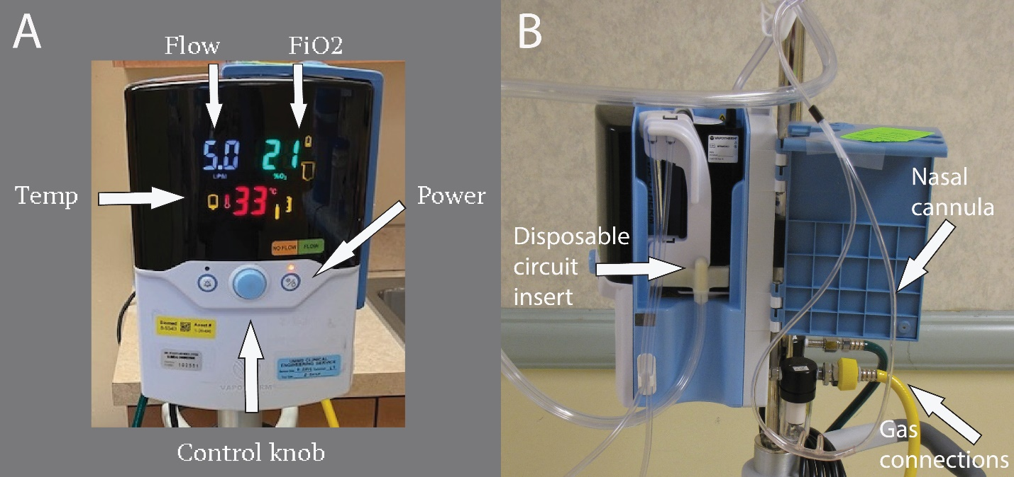

Supplementary Figure 2. Lowest arterial oxygen saturation in patients with one or more hypoxemia events in the standard nasal cannula (SNC) oxygen and high flow nasal cannula (HFNC) oxygen groups. The number of patients in each category are listed above each bar.

*87 patients in the SNC group and 104 patients in the HFNC group did not have a hypoxemia event.

