Supplemental Appendix A:

MSS and HE Interventions

An Outline of the My Surgical Success Intervention:

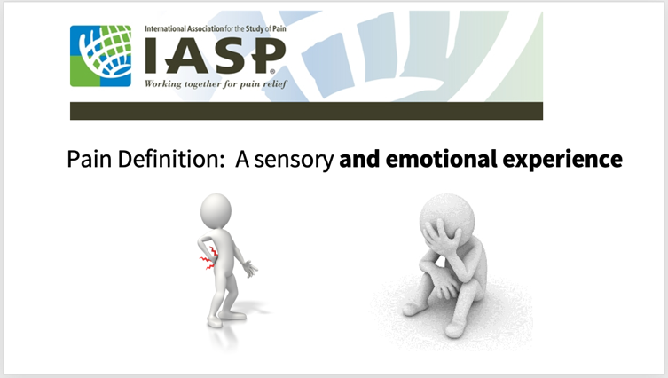

- Three pain psychoeducation modules (15 minutes per video, totaling 45 minutes), housed within REDCap platform.
- Prior to the first module, a brief video with a welcome message from the orthopedic trauma surgeon is presented inviting patients to watch the video for optimizing their recovery from surgery.
- Module 1: psychoeducation about surgical pain and how pain is processed in the body and brain. Participants learned about physiologic hyperarousal related to pain and were guided through a 10-minute relaxation exercise.
- Module 2: psychoeducation about cognitive and emotional processes related to pain, and identifying and addressing thoughts and emotions that are known to increase distress and pain intensity.
- Module 3: psychoeducation about pain relief behaviors which modulate the body’s response to pain and counteract helplessness. This module also included a review of the concepts and skills covered in all modules.
- During the last video, learners were guided to self-tailor and apply the information by completing their Personalized Plan for Surgical Success
- Access to download a 20-minute binaural relaxation response app was provided to participants, and they were instructed to download the app onto a personal computer device or smartphone for daily use and integration into their personalized plan.
- Upon completion of the videos, the automatic post-treatment satisfaction and acceptability survey were deployed.

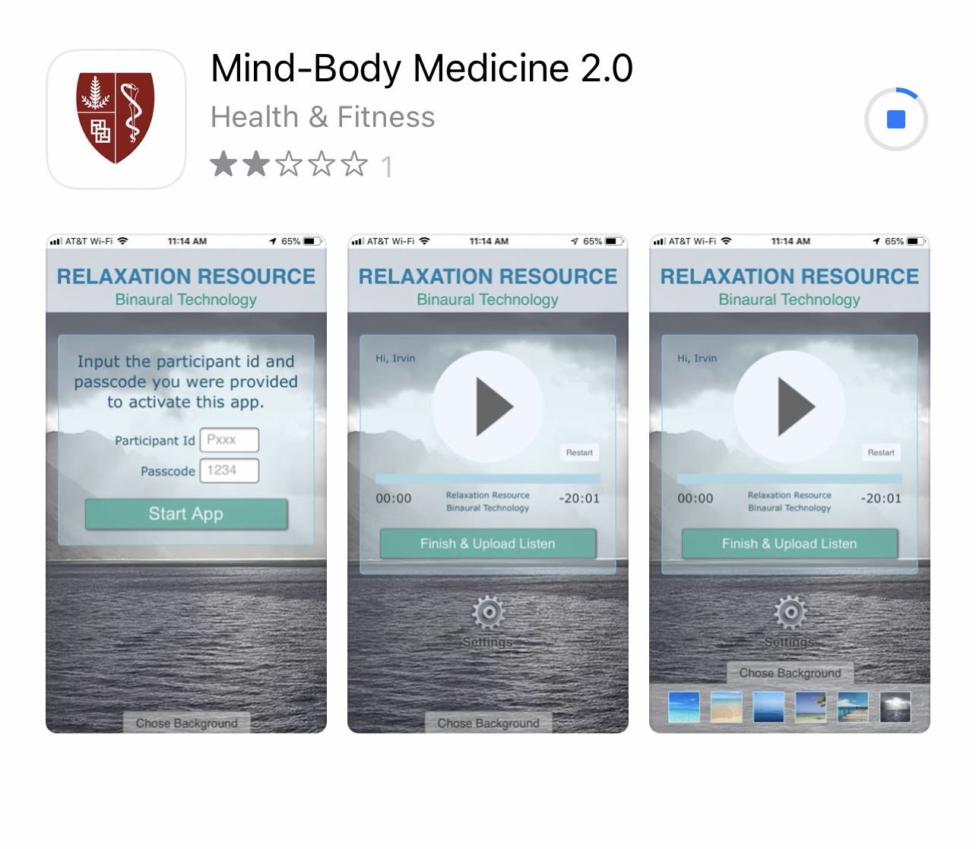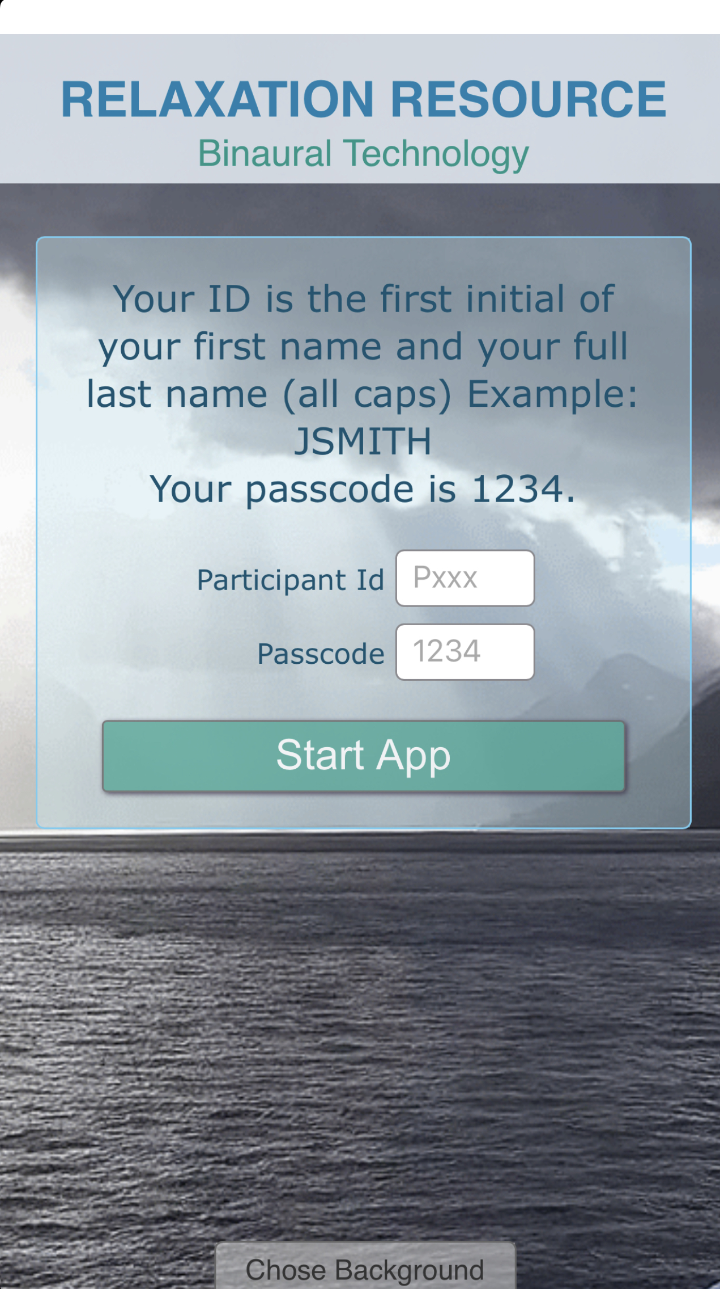

An Outline of the Health Education Intervention:

- Patients received digital text education about general health information framed in terms of its importance in enhancing recovery after surgery (this group did not receive any video). Topics included the following:
- Information about the importance of physical activity and duration of physical activity.
- Basic types of physical activity including aerobic training, strength training, and stretching
- Tips for success as related to physical training.
- Information about nutrition, portion sizes, and the basics of a healthy diet.
- Tips for success as related to nutrition in the context of surgical recovery.
- The online information was provided as downloadable text with images; no video component was offered.

