Rescue Treatment of Postoperative Nausea and Vomiting: A Systematic Review of Current Clinical Evidence
Appendix 1: Search strategy
PubMed
((“PONV”) OR (“Postoperative nausea and vomiting”)) AND ((“rescue”[Title]) OR (“treatment”[Title]) OR (“rescue antiemetic”[Title]) OR (“established”[Title]) OR (“breakthrough”[Title])) NOT (“chemotherapy” [Title])

Cinahl
((“PONV”) OR (“Postoperative nausea and vomiting”)) AND ((TI “rescue”) OR (TI “treatment”) OR (TI “rescue antiemetic”) OR (TI “established”) OR (TI “breakthrough”)) NOT (TI “chemotherapy”)
Embase
((“PONV”) OR (“Postoperative nausea and vomiting”)) AND ((“rescue”:TI) OR (“treatment”:TI) OR (“rescue antiemetic”:TI) OR (“established”:TI) OR (“breakthrough”:TI)) NOT (“chemotherapy”:TI)

Web of Science:
#1. ALL FIELDS: ('PONV') OR ALL FIELDS: ('Postoperative nausea and vomiting')
#2. TITLE: ('Rescue') OR TITLE: ('treatment') OR TITLE: ('rescue antiemetic') OR TITLE: ('established') OR TITLE: ('breakthrough')
#3. 1 AND 2

Appendix 2: Level of evidence grading, adapted from ASA Task Force on Acute Pain Management and the Fourth Consensus Guidelines on Management of Postoperative Nausea and Vomiting ^{12,13}
Category A: Supportive Literature.
Randomized controlled trials report statistically significant (p < 0.01) differences between clinical interventions for a specified clinical outcome.
Level 1: The literature contains multiple randomized controlled trials, and aggregated findings are supported by meta-analysis.
Level 2: The literature contains multiple randomized controlled trials, but the number of studies is insufficient to conduct a viable meta-analysis for the purpose of these Guidelines.
Level 3: The literature contains a single randomized controlled trial.

Category B: Suggestive Literature.
Information from observational studies permits inference of beneficial or harmful relationships among clinical interventions and clinical outcomes.
Level 1: The literature contains observational comparisons (e.g., cohort, case-control research designs) of clinical interventions or conditions and indicates statistically significant differences between clinical interventions for a specified clinical outcome.
Level 2: The literature contains non-comparative observational studies with associative (e.g., relative risk, correlation) or descriptive statistics.
Level 3: The literature contains case reports.
Category C: Equivocal Literature.
The literature cannot determine whether there are beneficial or harmful relationships among clinical interventions and clinical outcomes.
Level 1: Meta-analysis did not find significant differences (p > 0.01) among groups or conditions.
Level 2: The number of studies is insufficient to conduct meta-analysis, and (1) randomized controlled trials have not found significant differences among groups or conditions or (2) randomized controlled trials report inconsistent findings.
Level 3: Observational studies report inconsistent findings or do not permit inference of beneficial or harmful relationships.

Category D: Insufficient Evidence from Literature.
The lack of scientific evidence in the literature is described by the following terms.
Inadequate: The available literature cannot be used to assess relationships among clinical interventions and clinical outcomes. The literature either does not meet the criteria for content as defined in the “Focus” of the Guidelines or does not permit a clear interpretation of findings due to methodological concerns (e.g., confounding in study design or implementation).
Silent: No identified studies address the specified relationships among interventions and outcomes.

Supplementary Figure 1: Search flowchart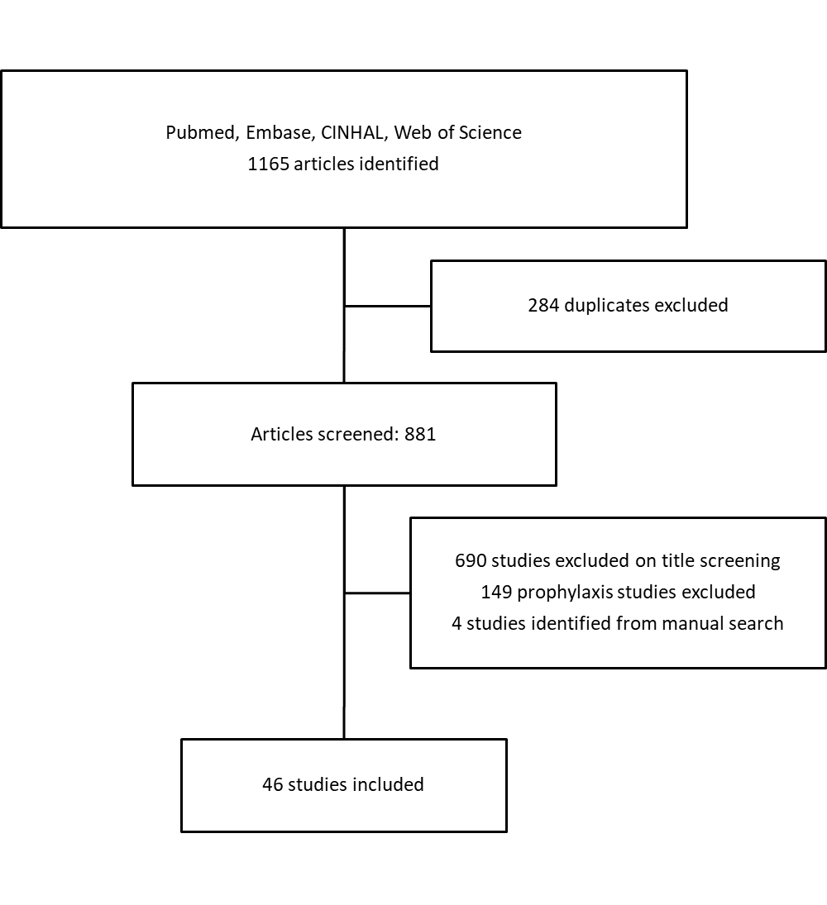

Supplementary Figure 2: Risk of bias summary of the included studies
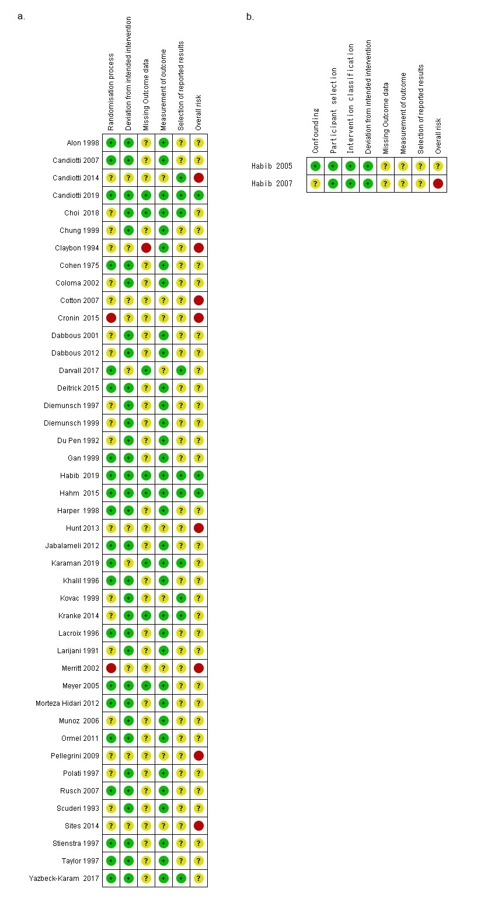
Supplementary table 1: characteristics of the included studies
 | Surgical procedure | PONV prophylaxis | NO. patients enrolled | No. patients received intervention | Control | Intervention | Outcome
Alon 1998 ²³ | Surgery under GA (including N₂O) | None | 1,513 patients | 314 patients | Placebo | Tropisetron 0.5, 2, or 5 mg | Further episodes of PONV, additional rescue antiemetic
Barton 1975 ²⁹ | Surgery under thiopental/ cyclopropane and N₂O | None | No separate figure reported | 62 patients | Placebo | Haloperidol 1mg | Vomiting episodes, nausea severity
Candiotti 2007 ⁴³ | Elective surgery under IA with N₂O | Ondansetron 4mg | 250 female patients | 88 patients | Ondansetron 4mg | Granisetron 0.1 or 1mg | CR, additional rescue antiemetic, N&V score
Candiotti 2014 ⁴⁴ | Laparoscopic abdominal or gynecological surgery | Ondansetron4mg | 220 female patients with Apfel score of at least 2 | 98 patients | Ondansetron 4mg | Palonosetron 0.075 mg | CR, additional rescue antiemetic, adverse reaction
Candiotti 2019 ⁴⁶ | Elective surgeries under IA | No prophylaxis | 1,988 patients | 560 patients | Placebo | 5mg or 10mg amisulpride | CR, additional rescue antiemetic, N&V score, AE
Choi 2018 ¹⁹ | Elective laparoscopic surgery under IA | None | 610 patients | 210 patients | Ondansetron 4mg | Ramosetron 0.3mg | CR, PONV incidence, additional rescue antiemetic requirement
Chung 1999 ¹⁷ | Surgery under regional or GA | None | 4511 patients | 1366 patients | Ondansetron 8mg | Ondansetron 16mg or metoclopramide 10mg | CR, AE
Claybon 1994 ¹⁴ | Surgery under GA (including N₂O) | None | 2,812 patients | 866 patients | Placebo | Ondansetron 1, 4, 8mg | Further episodes of PONV
Coloma 2002 ⁵⁶ | Laparoscopic surgery with IA with N₂O | Metaclopramide 10mg or droperidol 0.625mg | 268 patients | 90 patients | Ondansetron 4mg | PC6 acustimulation or ondansetron plus acustimulation | N&V episodes, additional rescue antiemetic, quality of recovery score
Cotton 2007 ³⁸ | Laparoscopic gynecological surgery under IA with N₂O | None | 100 female patients (28 excluded for protocol violation) | 72 patients | Ondansetron 4-8mg | Isopropylalcohol 70% | Time to 50% reduction of PONV severity, additional antiemetic requirement
Cronin 2015 ⁵¹ | Ambulatory laparoscopic procedures | Scopolamine, ondansetron or dexamethasone | 250 female patients | 102 patients | Breathing exercise | Breathing exercise plus isopropylalcohol | Nausea score, additional antiemetic requirement
Dabbous 2001 ²⁶ | Laparoscopic surgeries | None | No separate figure reported | 173 patients | Ondansetron 4 mg | Droperidol 1.25 mg or metoclopramide 10 mg | PONV score, additional rescue antiemetic, adverse event
Dabbous 2012 ⁸¹ | Elective surgery under IA plus N₂O | None | No separate figure reported | 44 patients with 1-2 Apfel risk factors | Metoclopramide 10mg | Naloxone 0.5mcg/kg | CR, Partial response (significantly improved nausea severity)
Darvall 2017 ⁵³ | Laparoscopic or breast surgery | 0-2 antiemetics including dexamethasone and droperidol | 94 female patients | 25 patients | Ondansetron 4mg | Sugar free peppermint chewing gum | Full resolution, time to full resolution, further antiemetic treatment
Deitrick 2015 ³⁴ | Ambulatory surgery patients | None or ondansetron and/or dexamethasone | 352 female and 271 male patients | 120 patients, mostly female | Promethazine 12.5mg | Promethazine 6.25mg | Additional rescue antiemetic, nausea severity, sedation
Diemunsch 1997 ³⁰ | Surgery under IA | None | 2032 patients | 746 patients | Ondansetron 4mg | Metoclopramide 10mg | Further episodes of PONV, additional rescue antiemetic, patient satisfaction, adverse reactions
Diemunsch 1999 ³⁵ | Gynecological surgery | None | No separate figure reported | 36 patients | Vofopitant 25mg | Placebo | Vomiting episodes, nausea severity
Du Pen 1992 ¹⁸ | Surgery under IA and N₂O | None | No separate figure reported | 500 patients | Placebo | Ondansetron 1, 4, 8mg | CR
Gan 1999 ³⁶ | Ambulatory surgery with IA and N₂O | None | 200 patients | 69 patients | Placebo | Propofol 20 or 40mg with 5 minute lockout | CR, additional rescue antiemetic, PACU discharge time, Patient satisfaction
Habib 2019 ⁸ | Elective surgeries under IA | 1-3 antiemetics including ondansetron, granisetron, dexamethasone and scopolamine | 2,295 patients | 702 patients | Placebo | 5mg or 10mg amisulpride | CR, additional rescue antiemetic, N&V score
Habib* 2005 ⁴⁷ | Day surgery under GA | Ondansetron, droperidol or nothing | No separate figure reported | 431 patients, mostly female | Ondansetron 4mg | Droperidol 0.625-1.25mg, metoclopramide 10mg, promethazine 6.5-25mg, and dimenhydrinate 25-50mg | CR
Habib* 2007 ⁴⁸ | Surgery under IA and N₂O | Ondansetron | No separate figure reported | 4391 patients | Ondansetron | Promethazine | CR, PONV score, PACU discharge time
Hahm 2015 ²⁴ | Elective laparoscopic surgery under IA with N₂O | None | No separate figure reported | 152 patients with history of PONV, motion sickness or expected intraoperative opioid use | Placebo | Palonosetron 0.075mg | C, incidence of nausea and vomiting, additional rescue antiemetic requirement
Harper 1998 ³⁷ | Gynecological laparoscopic procedures under IA and N₂O | None | 77 patients | 48 patients | Placebo | Propofol 3mg, 9mg or 27mg | Nausea score, additional antiemetic requirement, further vomiting episodes
Heidari 2011 ⁵⁸ | Cholecystectomy under IA and N₂O | None | No separate figure reported | 132 patients | Metoclopramide, up to 10mg | Midazolam up to 2mg, or both | Nausea and vomiting incidences
Hunt 2013 ⁴⁰ | Elective surgery under GA | None | 1,151 patients | 301 patients | Saline | Aromatherapy with ginger, alcohol, blended essential oil | PONV score, additional rescue antiemetic
Jabalameli 2012 ⁵⁷ | Elective cesarean delivery under spinal anesthesia | None | No separate figure reported | 132 patients | Midazolam 30 μg/kg | Ondansetron 8 mg or ondansetron plus midazolam | PONV score, additional rescue antiemetic
Karaman 2019 ⁴¹ | Elective surgery under GA | None | 5,205 patients | 184 patients | Placebo | Ginger, lavender or rose aromatherapy | PONV score, additional rescue antiemetic requirement
Khalil 1996 ¹⁶ | Surgery under IA and N₂O | None | 2,720 children between ages of 2 and 12 | 375 children | Placebo | Ondansetron 0.1mg/kg up to 4mg | CR, additional antiemetic requirement, further vomiting episodes, PACU LOS, AE
Kovac 1997²¹ | Elective ambulatory surgery IA and N₂O | None | 1557 patients | 620 patients | Placebo | Dolasetron 12.5 mg to 100mg | CR, AE
Kovac 1999 ³ | Ambulatory surgery under IA with N₂O | Ondansetron 4mg | 2,199 patients | 428 patients | Placebo | Ondansetron 4mg | CR, nausea severity, additional rescue antiemetic
Kranke 2014 ⁴⁹ | Elective surgery under GA | Ondansetron 4mg | 527 patients with Apfel score of at least 3 | 130 patients | Ondansetron 4mg | Vestipitant 4, 6, 12, 18, 24, or 36 mg | CR, additional rescue antiemetic, treatment failure
Lacroix 1996 ²⁸ | Surgery under IA | None | 859 patients | 78 patients | Propofol 10mg, | Droperidol 1.25 mg or metoclopramide 10 mg | Further episodes of PONV, additional rescue antiemetic, AE
Larijani 1991 ⁴² | Surgery under thiopental and N₂O anesthesia | Scopolamine 0.4mg | 229 patients | 36 patients | Placebo | Ondansetron 8mg | CR, vomiting episodes
Merritt 2002 ³⁹ | Surgery under GA | None | 111 patients | 39 patients | Standard antiemetic | Isopropylalcohol 70% | Treatment failure, Nausea score
Meyer 2005 ²² | Ambulatory surgery under IA | 25% of patients received PONV prophylaxis | 559 patients | 92 patients | Ondansetron 4mg | Dolasetron 12.5mg | Additional antiemetic requirement, further vomiting episodes, unplanned admission, PACU LOS
Munoz 2006 ²⁷ | All surgical patients | none | No separate figure reported | 120 patients | Ondansetron 2mg | Dexamethasone 8mg or droperidol 1.25mg | CR
Ormel 2011 ⁵⁵ | Gynecological day surgery | Dexamethasone 8mg, Ondansetron 4mg, Droperidol 0.625mg or placebo | 343 patients | 80 patients | Ondansetron 4mg, Droperidol 0.625mg | Dexamethasone 8mg, Ondansetron 4mg, Droperidol 0.625mg | PONV score, additional rescue antiemetic
Pellegrini 2009 ⁵⁰ | Elective surgery under IA | Ondansetron 4mg | 96 patients (11 withdrew from the study) | 85 patients with 2 Apfel risk factors | Promethazine 12.5 or 25mg | Isopropylalcohol 70% | Time to 50% reduction of PONV severity
Polati 1997 ³¹ | Gynecological laparoscopy under IA with N₂O | None | 378 female patients | 175 patients | Placebo | Metoclopramide 10mg or ondansetron 4mg | Further episodes of PONV
Rusch 2007 ⁵⁴ | Elective surgery under GA | 0-2 antiemetics including dexamethasone and ondansetron | 1,800 patients | 242 patients | Dolasetron 12.5mg | Haloperidol 0.75mg, Dolasetron with dexamethasone 8mg, Haloperidol with 8mg dexamethasone | Further episodes of vomiting, AE
Scuderi 1993 ¹⁵ | Surgery under IA and N₂O | None | 1,346 patients | 500 patients | Placebo | Ondansetron 1mg, 4mg, 8mg | CR, vomiting episodes
Sites 2014 ⁵² | Ambulatory surgery under GA | Ondansetron, metoclopramide and/or dexamethasone | 196 patients | 42 patients | Controlled breathing | Peppermint aromatherapy | Nausea score, additional antiemetic requirements
Stienstra 1997 ²⁵ | Gynecological surgery under IA and N₂O | None | No separate figure reported | 74 female patients | Ondansetron 8mg | Droperidol 1 mg or alizapride 100 mg | Further episodes of PONV, additional rescue antiemetics, PONV score
Taylor 1997 ²⁰ | Surgery under IA and N₂O | None | No separate figure reported | 519 patients | Placebo | Granisetron 0.1mg, 1mg or 3mg | Further episodes of PONV, additional rescue antiemetic
Yazbeck-Karam 2017 ⁴⁵ | Elective surgery under GA | 0-2 antiemetics including dexamethasone and ondansetron | 450 patients | 112 patients, mostly female | ondansetron 4mg | haloperidol 1mg | PONV free period, QTc change

*: retrospective studies, AE: adverse events, CR: complete response, GA: general anesthesia, IA: inhalational anesthesia, LOS: length of stay, PACU: post-anesthesia care unit, PONV: postoperative nausea vomiting

Supplementary table 2: Risk of bias gradings
Alon 1999
Domain | Risk of bias | Justification
Randomization process | Low | Study substances are block randomized and provided as coded and identical appearing vials
Deviation from intended intervention | Low | Patient and clincian blinded
Missing Outcome data | Some concerns | CONSORT diagram/ missing data report not available
Measurement of outcome | Low | Investigator blinded
Selection of reported results | Some concerns | Trial not registered
Overall | Some concerns

Barton 1975
Domain | Risk of bias | Justification
Randomization process | Low | Study substances are provided as coded identical containers
Deviation from intended intervention | Low | Patient blinded
Missing Outcome data | Some concerns | CONSORT diagram/ missing data report not available
Measurement of outcome | Low | Investigator blinded
Selection of reported results | Some concerns | Trial not registered
Overall | Some concerns

Candiotti 2019
Domain | Risk of bias | Justification
Randomization process | Low | Study substances are block randomized, provided as coded and identical appearing vials
Deviation from intended intervention | Low | Patients and clinicians blinded, deviations are evenly distributed across all interventions
Missing Outcome data | Low | Less than 5% participant attrition
Measurement of outcome | Low | Blinded investigator
Selection of reported results | Low | NCT02449291
Overall | Low

Candiotti 2014
Domain | Risk of bias | Justification
Randomization process | Some concerns | Allocation concealment not reported
Deviation from intended intervention | Some concerns | Clinician nor patient blinded
Missing Outcome data | Some concerns | Open label study, one patient was removed by sponsor decision
Measurement of outcome | Some concerns | Investigator not blinded
Selection of reported results | Low | NCT00967499
Overall | High

Candiotti 2007
Domain | Risk of bias | Justification
Randomization process | Low | Study substances are randomized and provided as coded and identical appearing vials
Deviation from intended intervention | Low | Patient and clincian blinded
Missing Outcome data | Some concerns | Consort diagram not available
Measurement of outcome | Low | Investigator blinded
Selection of reported results | Some concerns | Trial not registered
Overall | Some concerns

Choi 2018
Domain | Risk of bias | Justification
Randomization process | Sone concerns | Randomization and allocation concealment procedures not reported, cohorts characteristics are balanced
Deviation from intended intervention | Low | Patient and clincian blinded
Missing Outcome data | Low | 4 out of 210 patients excluded
Measurement of outcome | Low | Investigator blinded
Selection of reported results | Low | NCT03017222
Overall | Some concerns

Chung 1999
Domain | Risk of bias | Justification
Randomization process | Some concerns | Allocation concealment not reported
Deviation from intended intervention | Low | Patient blinded
Missing Outcome data | Some concerns | CONSORT diagram/ missing data report not available
Measurement of outcome | Low | Investigator blinded
Selection of reported results | Some concerns | Trial not registered
Overall | Some concerns

Claybon 1994
Domain | Risk of bias | Justification
Randomization process | Some concerns | Randomization and allocation concealment procedures not reported, cohorts characteristics are balanced
Deviation from intended intervention | Some concerns | Patient blinded, clinician blinding not clear, significnat proportion of protocol deviation
Missing Outcome data | High | 156 out of 1022 patients did not follow protocol
Measurement of outcome | Low | Investigator blinded
Selection of reported results | Some concerns | Trial not registered
Overall | High

Coloma 2002
Domain | Risk of bias | Justification
Randomization process | Some concern | Allocation concealment not reported
Deviation from intended intervention | Low | Patient and clinician blinded
Missing Outcome data | Some concern | 7 out of 90 patients who developed PONV had data missing
Measurement of outcome | Low | Investigator blinded
Selection of reported results | Some concerns | Trial not registered
Overall | Some concerns

Cotton 2007
Domain | Risk of bias | Justification
Randomization process | Some concerns | Randomization and allocation concealment procedures not reported, cohorts characteristics are balanced
Deviation from intended intervention | Some concerns | 28 out of the initial 100 patients were excluded due to protocol deviation
Missing Outcome data | Some concerns | 28 out of the initial 100 patients were excluded due to protocol deviation
Measurement of outcome | Some concerns | Investigator blinding not specified
Selection of reported results | Some concerns | Trial not registered
Overall | High

Cronin 2015
Domain | Risk of bias | Justification
Randomization process | High | Allocation was determined by month of surgery, significantly more smokers in the IPA cohort
Deviation from intended intervention | Some concerns | Patient not blinded, no protocol deviation
Missing Outcome data | Some concerns | 19 out of 102 patients excluded
Measurement of outcome | Some concerns | Investigator not blinded
Selection of reported results | Some concerns | Trial not registered
Overall | High

Dabbous 2012
Domain | Risk of bias | Justification
Randomization process | Some concerns | Randomization and allocation concealment procedures not reported, cohorts characteristics are balanced
Deviation from intended intervention | Low | Patient blinded
Missing Outcome data | Some concerns | CONSORT diagram/ missing data report not available
Measurement of outcome | Low | Investigator blinded
Selection of reported results | Some concerns | Trial not registered
Overall | Some concerns

Dabbous 2001
Domain | Risk of bias | Justification
Randomization process | Some concern | Allocation concealment not reported
Deviation from intended intervention | Low | Patient and clinician blinded
Missing Outcome data | Some concerns | CONSORT diagram/ missing data report not available
Measurement of outcome | Low | Investigator blinded
Selection of reported results | Some concerns | Trial not registered
Overall | Some concerns

Darvall 2017
Domain | Risk of bias | Justification
Randomization process | Low | Computer randomization and sealed envelope allocation concealment
Deviation from intended intervention | Some concerns | Patient and clinician blinding not clear, no protocol deviation
Missing Outcome data | Low | No treated patient was lost to follow up
Measurement of outcome | Some concerns | Investigator blinding not specified
Selection of reported results | Low | ACTRN12615001327572
Overall | Some concerns

Deitrick 2015
Domain | Risk of bias | Justification
Randomization process | Low | Study substances are block randomized and provided as coded and identical appearing syringes
Deviation from intended intervention | Low | Patient and clinician blinded
Missing Outcome data | Some concerns | CONSORT diagram/ missing data report not available
Measurement of outcome | Low | Investigator blinded
Selection of reported results | Some concerns | Trial not registered
Overall | Some concerns

Diemunsch 1999
Domain | Risk of bias | Justification
Randomization process | Some concerns | Randomization and allocation concealment procedures not reported, cohorts characteristics are balanced
Deviation from intended intervention | Low | Patient blinded
Missing Outcome data | Some concerns | CONSORT diagram/ missing data report not available
Measurement of outcome | Low | Investigator blinded
Selection of reported results | Some concerns | Investigator blinded
Overall | Some concerns

Diemunch 1997
Domain | Risk of bias | Justification
Randomization process | Some concern | Allocation concealment not reported
Deviation from intended intervention | Low | Patient blinded, clinician blinding not clear, no protocol deviation
Missing Outcome data | Some concerns | CONSORT diagram/ missing data report not available
Measurement of outcome | Low | Investigator blinded
Selection of reported results | Some concerns | Trial not registered
Overall | Some concerns

Du Pen 1992
Domain | Risk of bias | Justification
Randomization process | Some concerns | Randomization and allocation concealment procedures not reported, cohorts characteristics are balanced
Deviation from intended intervention | Low | Patient blinded
Missing Outcome data | Some concerns | CONSORT diagram/ missing data report not available
Measurement of outcome | Low | Investigator blinded
Selection of reported results | Some concerns | Trial not registered
Overall | Some concerns

Gan 1999
Domain | Risk of bias | Justification
Randomization process | Low | Study substances are provided as coded and identical appearing syringes
Deviation from intended intervention | Low | Patient and clincian blinded
Missing Outcome data | Some concerns | CONSORT diagram/ missing data report not available
Measurement of outcome | Low | Investigator blinded
Selection of reported results | Some concerns | Trial not registered
Overall | Some concerns

Habib 2019
Domain | Risk of bias | Justification
Randomization process | Low | Study substances are block randomized, provided as coded and identical appearing vials
Deviation from intended intervention | Low | Patients and clinicians blinded, deviations are evenly distributed across all interventions
Missing Outcome data | Low | Less than 5% participant attrition
Measurement of outcome | Low | Blinded investigator
Selection of reported results | Low | NCT02646566
Overall | Low

Habib 2007
Domain | Risk of bias | Justification
Confounding | Some concerns | Promethazine cohort had more female patients
Participant selection | Low | Patients with PONV after prophylaxis were included
Intervention classification | Low | Intervention classified according to rescue antiemetic given
Deviation from intended interventions | Low | Intervention classified according to rescue antiemetic given
Missing Outcome data | Some concerns | CONSORT diagram/ missing data report not available
Measurement of outcomes | Some concerns | Blinding of investigators to the rescue antiemetic choice not specified
Selection of reported results | Some concerns | Protocol is not registered
Overall | High

Habib 2005
Domain | Risk of bias | Justification
Confounding | Low | Baseline and surgical risk factor for PONV is comparable, patients stratified according to the prophylaxis received
Participant selection | Low | Patients with PONV after prophylaxis were included
Intervention classification | Low | Intervention classified according to rescue antiemetic given
Deviation from intended interventions | Low | Intervention classified according to rescue antiemetic given
Missing Outcome data | Some concerns | CONSORT diagram/ missing data report not available
Measurement of outcomes | Some concerns | Blinding of investigators to the rescue antiemetic choice not specified
Selection of reported results | Some concerns | Post hoc analysis, protocol not registered
Overall | Some concerns

Hahm 2015
Domain | Risk of bias | Justification
Randomization process | Low | Study substances are provided as coded identical containers
Deviation from intended intervention | Low | Patient and clincian blinded
Missing Outcome data | Low | 6 out of 152 randomized patients were excluded
Measurement of outcome | Low | Investigator blinded
Selection of reported results | Low | NCT01568268
Overall | Low

Harper 1998
Domain | Risk of bias | Justification
Randomization process | Low | Study substances are provided as coded identical containers
Deviation from intended intervention | Low | Patient blinded
Missing Outcome data | Some concerns | CONSORT diagram/ missing data report not available
Measurement of outcome | Low | Investigator blinded
Selection of reported results | Some concerns | Trial not registered
Overall | Some concerns

Hunt 2013
Domain | Risk of bias | Justification
Randomization process | Some concerns | Randomization and allocation concealment process not described
Deviation from intended intervention | Some concerns | Patient and clinician not blinded, 2 protocol deviation due to aromatherapy degredation
Missing Outcome data | Some concerns | No consort diagram
Measurement of outcome | Some concerns | Investigator blinding not specified
Selection of reported results | Some concerns | Trial not registered
Overall | High

Jabalameli 2012
Domain | Risk of bias | Justification
Randomization process | Low | Study substances are block randomized, coded and provided as identical appearing vials
Deviation from intended intervention | Low | Patient and clincian blinded
Missing Outcome data | Some concerns | No consort diagram
Measurement of outcome | Low | Investigator blinded
Selection of reported results | Some concerns | Trial not registered
Overall | Some concerns

Karaman 2020
Domain | Risk of bias
Randomization process | Low | Allocation made after patient develops PONV, randomization using table
Deviation from intended intervention | Some concerns | Patient not blinded, no protocol deviation
Missing Outcome data | Low | All randomized patients were analysed
Measurement of outcome | Low | Investigator blinded
Selection of reported results | Low | NCT02732379
Overall | Some concerns

Khalil 1996
Domain | Risk of bias | Justification
Randomization process | Low | Study substances are provided as coded identical containers
Deviation from intended intervention | Low | Patient blinded, 12 protocol violation out of 375 participants
Missing Outcome data | Some concerns | CONSORT diagram/ missing data report not available
Measurement of outcome | Low | Investigator blinded
Selection of reported results | Some concerns | Trial not registered
Overall | Some concerns

Kovac 1997
Domain | Risk of bias | Justification
Randomization process | Low | Study substances are provided as coded identical containers
Deviation from intended intervention | Low | Patient and clinician blinded
Missing Outcome data | Some concerns | No CONSORT data
Measurement of outcome | Low | Investigator blinded
Selection of reported results | Some | Trial not registered
Overall | Some Concerns

Kovac 1999
Domain | Risk of bias | Justification
Randomization process | Some concerns | Allocation concealment not reported
Deviation from intended intervention | Low | Patient and clinician blinded
Missing Outcome data | Some concerns | No CONSORT data
Measurement of outcome | Some concerns | Investigator blinding not specified
Selection of reported results | Low | Glaxo Wellcome Protocol S3AA4001
Overall | Some Concerns

Kranke 2014
Domain | Risk of bias | Justification
Randomization process | Some concerns | Randomization and allocation concealment process not described
Deviation from intended intervention | Low | Patient and clinician blinded, no protocol deviation
Missing Outcome data | Low | No treated patient was lost to follow up
Measurement of outcome | Low | Investigator blinded
Selection of reported results | Low | NCT01507194
Overall | Some concerns

Lacroix 1996
Domain | Risk of bias | Justification
Randomization process | Low | Study substances are block randomized and provided as coded and identical appearing syringes
Deviation from intended intervention | Low | Patient and clincian blinded
Missing Outcome data | Some concerns | CONSORT diagram/ missing data report not available
Measurement of outcome | Low | Investigator blinded
Selection of reported results | Some concerns | Trial not registered
Overall | Some concerns

Lairjani 1991
Domain | Risk of bias | Justification
Randomization process | Some concerns | Allocation concealment not reported
Deviation from intended intervention | Low | Patient blinded
Deviation from intended intervention | Some concerns | CONSORT diagram/ missing data report not available
Measurement of outcome | Low | Investigator blinded
Selection of reported results | Some concerns | Trial not registered
Overall | Some concerns

Merritt 2002
Domain | Risk of bias | Justification
Randomization process | High | Allocation was determined by date of surgery, control group had significantly more females
Deviation from intended interventions | Some concerns | Patient and clinician blinding not clear, no protocol deviation reported
Missing Outcome data | Some concerns | CONSORT diagram/ missing data report not available
Measurement of outcomes | Some concerns | Investigator blinding not specified
Selection of reported results | Some concerns | Trial not registered
Overall | High

Meyer 2005
Domain | Risk of bias | Justification
Randomization process | Low | Study substances are block randomized and provided as coded and identical appearing syringes
Deviation from intended intervention | Low | Patient and clinician blinded
Missing Outcome data | Low | No patients excluded
Measurement of outcome | Low | Investigator blinded
Selection of reported results | Some concerns | Trial registered in a closed registry
Overall | Some concerns

Morteza Hidari 2012
Domain | Risk of bias | Justification
Randomization process | Low | Study substances are block randomized and provided as coded and identical appearing syringes
Deviation from intended intervention | Low | Patient blinded
Missing Outcome data | Some concerns | CONSORT diagram/ missing data report not available
Measurement of outcome | Low | Investigator blinded
Selection of reported results | Some concerns | Trial not registered
Overall | Some concerns

Munoz 2006
Domain | Risk of bias
Randomization process | Some concerns | Randomization and allocation concealment procedures not reported, cohorts characteristics are balanced
Deviation from intended intervention | Low | Patient blinded
Missing Outcome data | Some concerns | CONSORT diagram/ missing data report not available
Measurement of outcome | Low | Investigator blinded
Selection of reported results | Some concerns | Trial not registered
Overall | Some concerns

Ormel 2011
Domain | Risk of bias | Justification
Randomization process | Low | Study substances are block randomized, provided as coded and identical appearing vials
Deviation from intended intervention | Low | Patient and clincian blinded
Missing Outcome data | Some concerns | 22 of the original 337 patients excluded
Measurement of outcome | Low | Investigator blinded
Selection of reported results | Some concerns | Trial not registered
Overall | Some concerns

Pelligrini 2009
Domain | Risk of bias | Justification
Randomization process | Some concerns | Randomization and allocation concealment procedures not reported, cohorts characteristics are balanced
Deviation from intended intervention | Some concerns | Patient not blinded, no protocol deviation
Missing Outcome data | Some concerns | CONSORT diagram/ missing data report not available
Measurement of outcome | Some concerns | Investigator blinding not specified
Selection of reported results | Some concerns | Trial not registered
Overall | High

Polati 1997
Domain | Risk of bias | Justification
Randomization process | Some concern | Allocation concealment not reported
Deviation from intended intervention | Low | Patient blinded, clinician blinding not clear
Missing Outcome data | Some concerns | 22 patients excluded, further 18 patients with PONV was excluded
Measurement of outcome | Low | Investigator blinded
Selection of reported results | Some concerns | Trial not registered
Overall | Some concerns

Rusch 2007
Domain | Risk of bias | Justification
Randomization process | Low | Study substances are block randomized and provided as identical appearing vials
Deviation from intended intervention | Low | Patient and clincian blinded
Missing Outcome data | Some concerns | No consort data
Measurement of outcome | Low | Investigator blinded
Selection of reported results | Some concerns | Trial not registered
Overall | Some concerns

Scuderi 1993
Domain | Risk of bias | Justification
Randomization process | Some concerns | Allocation concealment procedures not reported, cohorts characteristics are balanced
Deviation from intended intervention | Low | Patient blinded
Missing Outcome data | Some concerns | CONSORT diagram/ missing data report not available
Measurement of outcome | Low | Investigator blinded
Selection of reported results | Some concerns | Trial not registered
Overall | Some concerns

Sites 2014
Domain | Risk of bias | Justification
Randomization process | Some concerns | Allocation concealment procedures not reported
Deviation from intended intervention | Some concerns | Protocol deviation resulted in the exclusion of 22 out of 330 patients
Missing Outcome data | Some concerns | 134 out of 330 patients excluded
Measurement of outcome | Some concerns | Investigator blinding not clear
Selection of reported results | Some concerns | Trial not registered
Overall | High

Steinstra 1997
Domain | Risk of bias | Justification
Randomization process | Low | Study substances are block randomized and provided as coded and identical appearing vials
Deviation from intended intervention | Low | Patient and clinician blinded
Missing Outcome data | Some concerns | No consort data
Measurement of outcome | Low | Investigator blinded
Selection of reported results | Some concerns | Trial not registered
Overall | Some concerns

Taylor 1997
Domain | Risk of bias | Justification
Randomization process | Low | Study substances are randomized and provided as coded and identical appearing syringes
Deviation from intended intervention | Low | Patient blinded
Missing Outcome data | Some concerns | 53 out of 519 patients excluded from analysis
Measurement of outcome | Low | Investigator blinded
Selection of reported results | Some concerns | Trial not registered
Overall | Some concerns

Yazbeck-Karam 2017
Domain | Risk of bias | Justification
Randomization process | Low | Computer randomization and sealed envelope allocation concealment
Deviation from intended intervention | Low | Patient and clincian blinded
Missing Outcome data | Some concern | 7 out of 120 patients excluded due to incomplete data
Measurement of outcome | Low | Inestigator blinded
Selection of reported results | Low | NCT02143531
Overall | Some concern

Supplementary table 3: Factors associated with failed PONV prophylaxis
 | PONV prophylaxis | factors associated with failed prophylaxis | Comments
Larijani 1991 ³⁹ | Scopolamine 0.4mg | Female gender (OR 4.88  95 % CI: 1.8 to 12.9) | No other variables were investigated
Kovac 1999 ³ | Ondansetron 4mg | Female gender (OR 2.09, 95 % CI: 1.60 to 2.71)  History of motion sickness (1.80, 95 % CI: 1.42 to 2.26)  History of PONV (OR 2.30,  95 % CI: 1.80 to 2.95) | Multivariable analysis were not conducted
Candiotti 2007 ⁴⁰ | Ondansetron 4mg | Not reported
Candiotti 2014 ⁴¹ | Ondansetron 4mg | Not reported
Yazbeck-Karam 2017 ⁴² | 0-2 antiemetics including dexamethasone and ondansetron | Not reported
Habib 2019 ⁸ |  | Not reported
Kranke 2014 ⁴⁴ | 4mg ondansetron | Not reported
Pellegrini 2009 ⁴⁵ | 4mg ondansetron | Not reported
Sites 2014 ⁴⁷ | Ondansetron, metoclopramide and/or dexamethasone | Female gender (p<0.01), but not any other Apfel score criteria was associated with failed prophylaxis | Raw data was not published
Darvall 2017 ⁴⁸ | 0-2 antiemetics including dexamethasone and droperidol | Not reported

