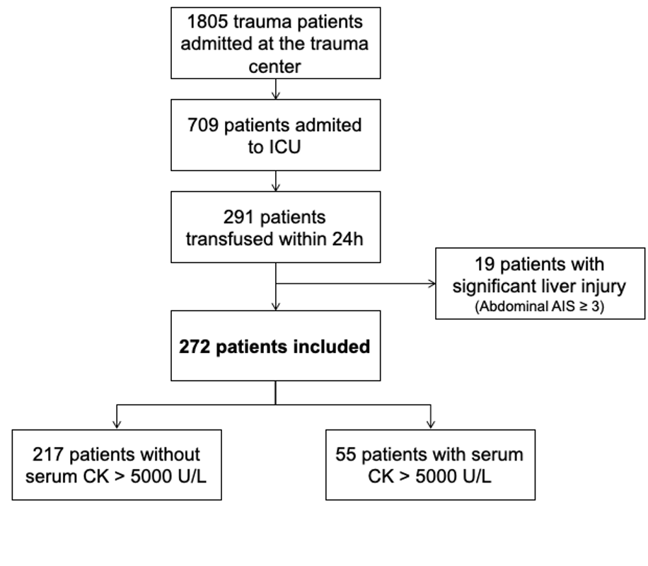

Supplemental Figure 1: Study flow chart

ICU: intensive care unit; CK: creatine kinase, AIS: Abbreviated injury score

