SUPPLEMENTARY FILE
Subtypes of low-amplitude propagating sequences
In most of the cases the low-amplitude propagating sequences appeared as single. In three subjects the retrograde propagating sequences appeared as cyclic. In one subject (male) a series of retrograde propagated sequences with mean amplitude of 63±15 mmHg, duration of 10±1 s, propagation velocity of 7±1 cm/s and length of 15±2 cm was recorded soon after the start of the meal with a frequency of 3 pressure waves per minute for the entire duration of the meal. In another subject (male) a series of retrograde propagated sequences with mean amplitude of 25±7 mmHg, duration of 8±1 s, propagation velocity of 1.9±1.4 cm/s and length of 7±1 cm was recorded during the postprandial period with a frequency of 5 pressure waves per minute. In another subject (male) a series of retrograde propagating sequences with similar characteristics of the previous one started soon after the start of the meal and continued during most part of the postprandial period. Relaxation of the anal sphincter was present in 21±23%, 75±24% and 32±31% of the anterograde propagating sequences respectively in preprandial, prandial and postprandial conditions. Considering the low number of propagating sequences during the recovery time, the relation between anal sphincter relaxation and propagating sequences was not evaluated during this period. For anterograde propagating sequences the origin was always the left colon, except for one subject where they started from the right colon. For retrograde propagating sequences, the origin and end of extension was always the left colon in five subjects, while the origin was the left colon and the end the transverse colon in one subject and both the origin and end in the right colon in two subjects.
Long distance low-amplitude propagating sequences
In two subjects respectively 7 and 3 long distance retrograde propagating sequences with mean amplitude of 20±3 mmHg, propagation velocity of 0.4±1 cm/s and length of 35±5 cm were also registered during the late postprandial period. In five subjects a mean of 6±6 long distance anterograde propagating sequences were also recorded. These were sequences extending for 62±5 cm, with mean amplitude of 30±5 mmHg, a velocity of propagation of 6±1 cm/s and were associated with anal sphincter relaxation (mean relaxation of 77±7% and mean duration 20±1 s). They presented as in Supplementary Figure 2A in the majority of cases or as in Supplementary Figure 2B in few cases. In all the subjects, these appeared in the late postprandial period while in one subject in the preprandial period.
Non-propagating activity
In all but two subjects, a continuous non-propagating motor activity recorded by one sensor in one to four different regions of the colon was observed. Supplementary Figure 2D reports an example of part of a tracing with three sensors recording a continuous non-propagating motor activity. Across the subjects, these regions generally corresponded to the areas of hepatic and splenic flexure, of the sigmoid colon and of the rectum. While the continuous non-propagating motor activity in the proximal and distal colon were differently present in each subject, in all of the subjects the non-propagating activity recorded in the area above the anal sphincter corresponding to the third or fourth last sensor was always recorded. In one subject the non-propagating motor activity of both the upper and distal colon was present for the entire recording time, while in the remaining subjects it was recorded only during the recovery time. In three subjects the non-propagating activity of the colon was recorded only during recovery time, while the activity located above the anal sphincter continued during the entire recording time. In all the subjects isolated non-propagating contractions were recorded too.
Subtypes of pan-colonic pressurizations
In 17±12% of the cases, the pan-colonic pressurizations interrupted after having involved only the proximal sensors and after a delay of 5±1 s they started again and proceeded to the distal sensors (Supplementary Figure 3A). In these cases the pan-colonic pressurizations were associated with the presence of an anal sphincter relaxation which started 8±1 s after initiation of the pan-colonic pressurization in the proximal part and 3±1 s after the starting of the pressurization in the distal part with duration of 20±1 s. In other 17±15% of the cases, the pan-colonic pressurizations did not involve the last sensors (usually the last five) and these were not associated with any anal sphincter relaxation (Supplementary Figure 3B). In three subjects a mean number of 3±2 episodes of flatus were perceived at the beginning of the recording time and these were associated with a pan-colonic pressurization with characteristics not different from those not associated with flatus.
Relationship between pan-colonic pressurizations and propagating sequences
In all subjects some of the anterograde and retrograde propagating sequences have been noticed to be associated with pan-colonic pressurizations. Considering the low number of propagating contractions during the recovery time, the association between pan-colonic contractions and propagating sequences was not evaluated during this period. A total of 21±23%, 74±34% and 25±27% of the anterograde propagating sequences were associated with pan-colonic pressurizations respectively during preprandial, prandial and postprandial periods (all p> 0.02, not significant after Bonferroni correction). In these cases, the anterograde propagating sequences appeared in the context of pan-colonic pressurizations as reported in Supplementary Figure 4A or started as pan-colonic pressurizations and then continued as anterograde propagating sequence as showed in Supplementary Figure 4B. The anterograde propagating sequences associated with pan-colonic pressurizations were those presenting with anal sphincter relaxation and they ended with the presence of simultaneous pressure increases recorded by the last sensors above anal sphincter as in Supplementary Figure 4A in the majority of cases or with propagating pressure waves in a minority of cases. The 37±28%, 69±41% and 16±27% of the retrograde propagating sequences were associated with pan-colonic pressurizations respectively during recovery, prandial and postprandial period (all p> 0.02, not significant after Bonferroni correction). In these cases, the retrograde propagating sequences appeared in the context of pan-colonic pressurizations as reported in Supplementary Figure 5. Both the anterograde and retrograde propagating sequences associated with pan-colonic pressurization had a propagation velocity significantly higher than those not associated with pan-colonic pressurization (4±1 cm/s vs 2±0.47 cm/s, p=0.006 and 4±1 cm/s vs 1.5±0.45 cm/s, p=0.008, respectively).
Relationship between pan-colonic pressurizations and non-propagating activity
The continuous non-propagating activity was superimposed on the other colonic motor patterns. In the cases of pan-colonic pressurizations the non-propagating activity did not stop the pressurization, but the amplitude of the contraction was higher in the sensors recording the continuous activity than in the other sensors. In the cases of the interrupted pan-colonic pressurization the sensor recording the continuous non-propagating activity was frequently the first of the distal component of the pressurization as in Supplementary Figure 3A. In the cases of the pan-colonic pressurization not reaching the anus, the non-propagating activity was frequently the last involved by the pressurization as in Supplementary Figure 3B.
The anal sphincter activity
The resting pressure of the anal sphincter was 71±35 mmHg during recovery condition and did not change significantly during preprandial period (62±30 mmHg, p= 0.38). In the same way it did not change significantly during prandial and the first, second and third hour after the meal when compared to preprandial conditions (respectively, 67±29 mmHg, 69±28 mmHg, 56±24 mmHg and 54±21 mmHg, all P> 0.23). In two subjects (females), in addition to the above reported relaxations of the anal sphincter associated with pan-colonic pressurizations, respectively one and two periods of long lasting (10 minutes) anal sphincter relaxations were recorded during recovery period.

SUPPLEMENTARY FIGURES
Supplementary Figure 1. Picture of the HRM catheter showing the silk loop to attach the catheter to the clip inserted in the colonoscope, the external end of the catheter for the connection to the measurement system and the pressure sensors spaced 2.5 cm apart.

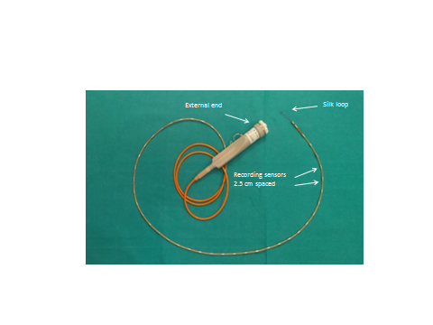

Supplementary Figure 2. Examples of propagating sequences. A) a long distance anterograde propagating sequence involving the entire colon characterized by pressure waves of low-amplitude associated with anal sphincter relaxation in one subject in color plot (right panel) and in line plot (left panel). B) a long distance anterograde propagating sequence involving the left colon characterized by pressure waves of different amplitude associated with anal sphincter relaxation in another subject in color plot (right panel) and in line plot (left panel). C) the first HAPS starting in the transverse colon and associated with relaxation of the anal sphincter, recorded one hour after the meal in another subject in color plot (upper panel) and in line plot (lower panel). D) non-propagating activity in another subject in color plot (right panel) and in line plot (left panel). In the line plot panels the channels recording the activity of the anal sphincter are visualized in red.
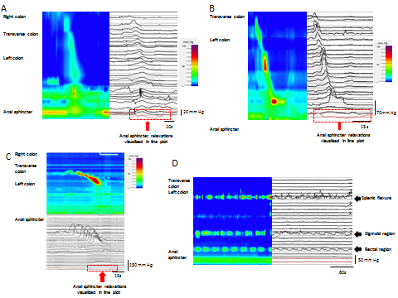

Supplementary Figure 3. Example of an “interrupted” pan-colonic pressurization associated with anal sphincter relaxation in color (right panels) and in line (left panels) plot (A) and of a pan-colonic pressurization not involving the distal five sensors in two different subjects in color (right panels) and in line (left panels) plot (B). In the line plot panels the channels recording the activity of the anal sphincter are visualized in red. Note the absence of the anal sphincter relaxation in figure 8B.

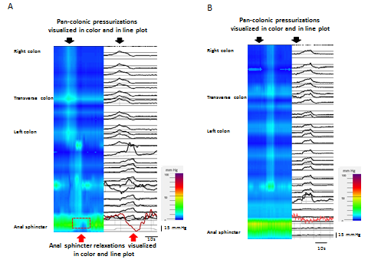

Supplementary Figure 4. Example of propagating sequences in the context of pan-colonic pressurizations. Anterograde propagating sequence of the left colon in the context of a pan-colonic pressurization in one subject in color (right panel) and in line plot (left panel) (A); anterograde propagating sequence of the left colon starting as pan-colonic pressurization and continuing as propagating sequence in another subject in color (right panel) and in line plot (left panel) (B). In the line plot panels the channels recording the activity of the anal sphincter are visualized in red.

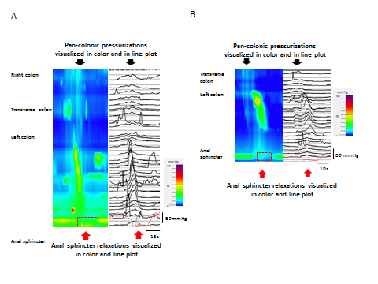

Supplementary Figure 5. Example of cyclic retrograde propagating sequences in the context of pan-colonic pressurizations during a period of two minutes in one subject in color (upper panel) and in line plot (lower panel). In the line plot panels the channels recording the activity of the anal sphincter are visualized in red.

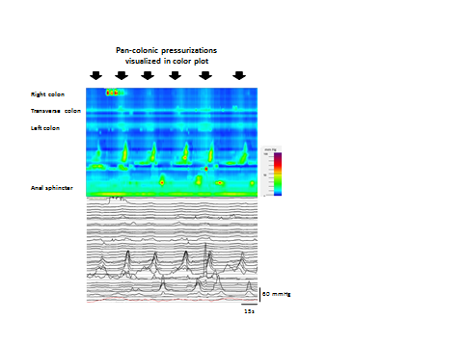

Supplementary Figure 6. VAS score for the sensations of feeling of abdominal gas, desire to evacuate gas, desire to defecate, urgency to defecate and abdominal discomfort/pain reported by the patients during the period they were awake (two hours before the meal and until the end of the recording).

