Supplementary Table 1. Surveillance protocol at 10 institutions

Institution | Chromoendoscopy | Random biopsy (The number of biopsies) | Intended interval
1 | Panchromoendoscopy | None | 1 year
2 | Only targeted lesion | Each segment (6-12) | 1 year
3 | Only targeted lesion | Each segment (6) | 1 year
4 | Only targeted lesion | S, R (2-4) | 1 year
5 | Inflamed area | Each segment (12) | 1-2 years
6 | Only targeted lesion | None | 1 year
7 | Panchromoendoscopy | S, R (2) | 1 year
8 | Only targeted lesion | None | 1-2 years
9 | Only targeted lesion | None, Each segment only for past dysplasia | 1-3 years
10 | S, R | Each segment (12) | 1 year
R: rectum, S: sigmoid colon

Although data on the interval from the previous SC could not be fully obtained, from the obtained data, the real-life average surveillance colonoscopy interval was calculated to be 17.8±10.2 months (n=55), and the average interval before cancer and neoplasia diagnosis was 13.0±5.8 months (n=45) and 14.3±8.1 months (n=100), respectively.

Supplementary Table 2. Reasons for not undergoing surveillance colonoscopy in the non-SC group
Reason for not undergoing surveillance
Within 8 years after UC onset | 46 (22.3%)
Low compliance to surveillance colonoscopy | 75 (36.4%)
UC exacerbation | 75 (36.4%)
Unknown | 10 (4.9%)
Total | 206
UC: ulcerative colitis

Supplementary Table 3. Indications for colonoscopy or surgery in the non-SC group
Indication for colonoscopy or surgery | UC duration < 8 years | UC duration ≥ 8 years
Symptomatic
Symptoms indistinguishable from UC flare | 17 | 81
Stenotic symptoms | 1 | 19
Others
Inflammation assessment | 5 | 36
Referral after medical check-up (FOBT, CT) | 5 | 7
Concurrent diagnosis of UC and neoplasia | 9 | 0
Neoplasia detection at postoperative histopathology | 8 | 7
Unknown | 1 | 10
Total | 46 | 160
CS; colonoscopy, CT; computed tomography, FOBT; fecal occult blood test, UC; ulcerative colitis

Supplementary Figure 1. Overall survival stratified based on Mayo endoscopic sub-score and surveillance colonoscopy and non-surveillance colonoscopy groups
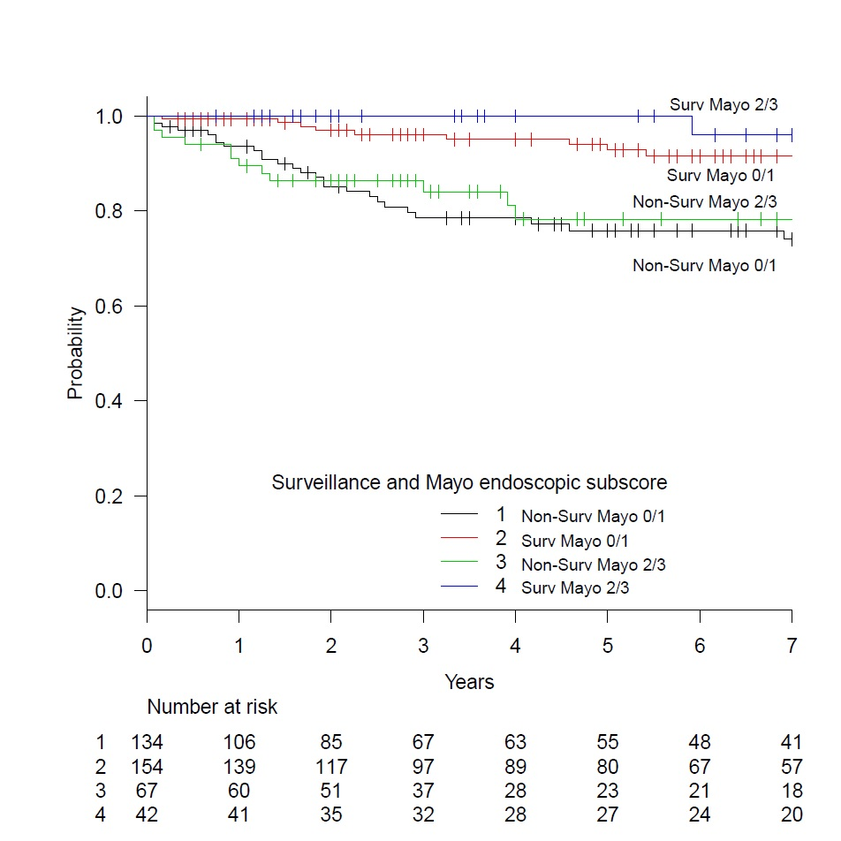Pairwise comparisons using log-rank test (P value adjustment method: holm)
1 2 3
2 0.00039 - -
3 1.00000 0.00477 -
4 0.02216 1.00000 0.02757

The severity of inflammation did not appear to influence the overall survival, whereas the surveillance group showed significantly better survival than the non-surveillance group stratified based on the severity of inflammation.

Supplementary Figure 2. Overall survival of the non-surveillance colonoscopy group stratified based on reasons for not undergoing surveillance compared to that of the surveillance colonoscopy group.
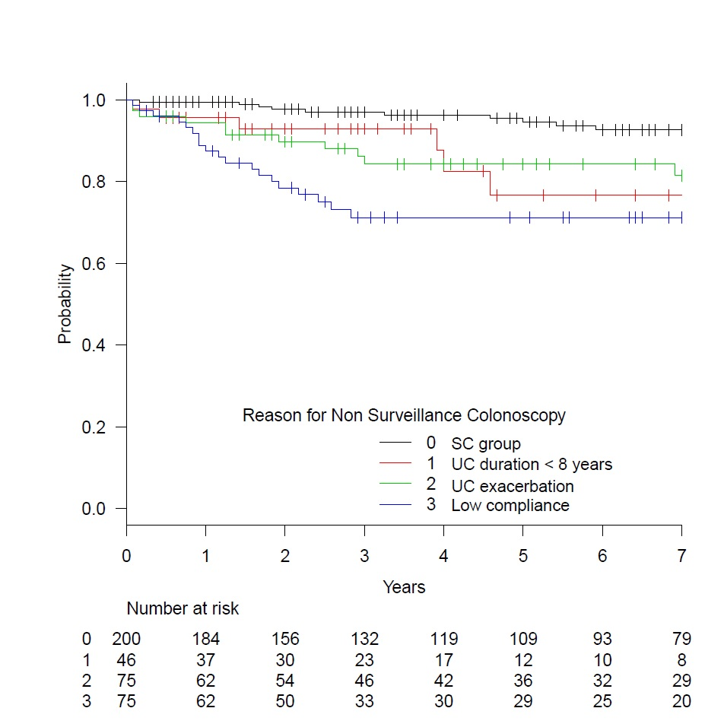
Pairwise comparisons using log-rank test (P value adjustment method: holm)
0 1 2
1 0.002 - -
2 0.038 0.770 -
3 0.0000021 0.770 0.281

All three groups in the non-surveillance group showed statistically worse overall survival than those in the surveillance group. Those with low compliance to surveillance endoscopy showed slightly lower survival but without statistical significance.
Supplementary Figure 3. Overall survival of the non-surveillance colonoscopy group stratified based on colonoscopy indication compared with that of the surveillance colonoscopy group.
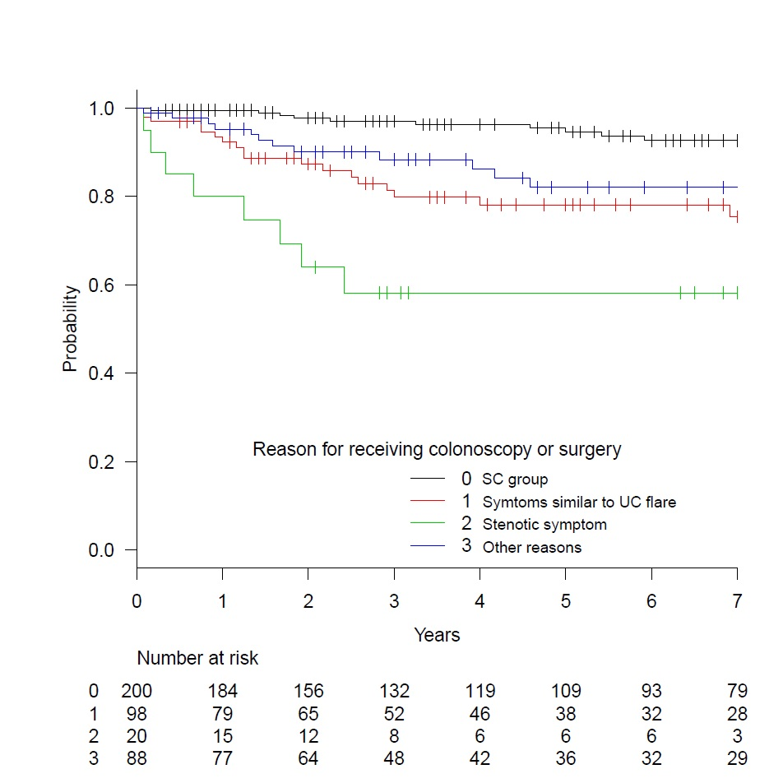
Pairwise comparisons using log-rank test (P value adjustment method: holm)
0 1 2
1 0.00042 - -
2 2.2e-11 0.01700 -
3 0.00498 0.61800 0.00233
All three groups in the non-surveillance group showed statistically worse overall survival than those in the surveillance group. Of these, those with stenotic symptoms showed statistically worse survival than the other two groups in the non-surveillance group.

