Supporting Documents
Earlier Normalization of Serum Alanine Aminotransferase Levels during Antiviral Treatment is Independently Associated with Lower Risk of Hepatocellular Carcinoma in Patients with Chronic Hepatitis B
Jonggi Choi, MD, PhD; Gi-Ae Kim, MD, PhD; Seungbong Han, PhD;
and Young-Suk Lim, MD, PhD
Table of Contents
- Supplementary Table 1. Time-dependent Cox regression analysis for the risk of hepatocellular carcinoma according to the timing of ALT normalization in CHB patients with and without cirrhosis.

- Supplementary Table 2. Time-dependent Cox regression analysis for the risk of hepatocellular carcinoma by the timing of ALT normalization according to the type of antiviral drug.

- Supplementary Table 3. Time-dependent Cox regression analysis for the risk of hepatocellular carcinoma according to the timing of ALT normalization based on presence of fatty liver.
- Supplementary Table 4. Factors associated with early (<6 months) ALT normalization as compared to late (7-24 months) ALT normalization among 3438 patients who achieved ALT normalization at 2-year of treatment.
- Supplementary Table 5. Factors associated with no ALT normalization as reference to ALT normalization among 3054 patients who achieved VR at 2-year of treatment.
- Supplementary Figure 1. Cumulative rates of achievement of surrogate markers during treatment with entecavir or tenofovir disoproxil fumarate in patients with chronic hepatitis B.
(A) ALT normalization
(B) Virological response
(C) HBeAg seroclearance in HBeAg-positive patients
ALT, alanine aminotransferase; HBeAg, hepatitis B e antigen
- Supplementary Figure 2. Risk of HCC by the timing of ALT normalization in CHB patients with and without cirrhosis by 2-year landmark analysis.
(A) Cirrhosis subcohort (n=1811)
(B) Non-cirrhosis subcohort (n=2431)
- Supplementary Figure 3. Risk of HCC by the timing of ALT normalization by 2-year landmark analysis in ETV and TDF subcohorts.
(A) Entecavir subcohorts (n=2803)
(B) Tenofovir subcohorts (n=1349)
- Supplementary Figure 4. Risk of Death or transplantation according to on-treatment ALT normalization in patients with CHB
(A) One-year landmark analysis
(B) Two-year landmark analysis
Supplementary Table 1. Time-dependent Cox regression analysis for the risk of hepatocellular carcinoma according to the timing of ALT normalization in CHB patients with and without cirrhosis.
Timing of ALT normalization during treatment | Entire population  (n=4152) |  | Patients  with cirrhosis  (n=1811) |  | Patients  without cirrhosis  (n=2431)
 | AHR*  (95% CI) | P-Value | AHR†  (95% CI) | P-Value | AHR†  (95% CI) | P-Value
At ≤6 months | 1.00 |  | 1.00 |  | 1.00
At 6‒12 months | 1.40  (1.05–1.87) | 0.02 | 1.44  (1.06–1.96) | 0.004 | 1.11  (0.50-2.46) | 0.65
At 12‒24 months | 1.74  (1.29–2.35) | <0.001 | 1.49  (1.07–2.07) | 0.003 | 4.00  (1.98-8.07) | <0.001
At >24 months | 2.45  (1.89–3.17) | <0.001 | 2.22  (1.68–2.94) | <0.001 | 3.98  (2.08-7.64) | <0.001
*Adjusted for age, sex, hepatitis B virus DNA levels, albumin levels, platelet counts, cirrhosis, diabetes, and fatty liver at baseline.
†Adjusted for age, sex, hepatitis B virus DNA levels, albumin levels, platelet counts, diabetes, and fatty liver at baseline.

Supplementary Table 2. Time-dependent Cox regression analysis for the risk of hepatocellular carcinoma by the timing of ALT normalization according to the type of antiviral drug.
Timing of ALT normalization during treatment | Entire population  (n=4152) |  | Patients  Treated with ETV  (n=2803) |  | Patients  Treated with TDF  (n=1349)
 | AHR*  (95% CI) | P-Value | AHR*  (95% CI) | P-Value | AHR*  (95% CI) | P-Value
At ≤6 months | 1.00 |  | 1.00 |  | 1.00
At 6‒12 months | 1.40  (1.05–1.87) | 0.02 | 1.46  (1.07-1.99) | 0.02 | 0.97  (0.43-2.22) | 0.95
At 12‒24 months | 1.74  (1.29–2.35) | <0.001 | 1.83  (1.32-2.53) | <0.001 | 1.45  (0.67-3.14) | 0.35
At >24 months | 2.45  (1.89–3.17) | <0.001 | 2.62  (1.98-6.45) | <0.001 | 2.12  (1.08-4.17) | 0.03
*Adjusted for age, sex, hepatitis B virus DNA levels, albumin levels, platelet counts, cirrhosis, diabetes, and fatty liver at baseline.
AHR: adjusted hazard ratio, CI: confidence interval, ETV: Entecavir, TDF: Tenofovir disoproxil fumarate

Supplementary Table 3. Time-dependent Cox regression analysis for the risk of hepatocellular carcinoma according to the timing of ALT normalization based on presence of fatty liver.
Timing of ALT normalization during treatment | Entire population at 2-year landmark analysis  (n=4152) |  | Patients  Without fatty liver  (n=3066) |  | Patients  With fatty liver  (n=1047)
 | AHR*  (95% CI) | P-Value | AHR‡  (95% CI) | P-Value | AHR‡  (95% CI) | P-Value
At ≤6 months | 1.00 |  | 1.00 |  | 1.00
At 6‒12 months | 1.40  (1.05–1.87) | 0.02 | 1.48  (1.08–2.04) | 0.02 | 1.05  (0.54-2.05) | 0.89
At 12‒24 months | 1.74  (1.29–2.35) | <0.001 | 1.58  (1.11–2.24) | 0.01 | 2.03  (1.15-3.59) | 0.014
At >24 months | 2.45  (1.89–3.17) | <0.001 | 2.58  (1.93–3.45) | <0.001 | 2.21  (1.23-3.98) | 0.008
*Adjusted for age, sex, hepatitis B virus DNA levels, albumin levels, platelet counts, diabetes, and fatty liver at baseline.

Supplementary Table 4. Factors associated with early (<6 months) ALT normalization as compared to late (7-24 months) ALT normalization among 3438 patients who achieved ALT normalization at 2-year of treatment.
Variables | Univariate analysis |  | Multivariable analysis
 | HR (95% CI) | P-Value | AHR (95% CI) | P-Value
Age, years | 0.99 (0.99-1.00) | 0.06
Sex, male | 1.12 (0.97-1.30) | 0.12 | 1.16 (1.00-1.35) | 0.044
Cirrhosis, present | 0.82 (0.71-0.94) | 0.006 | 0.87 (0.73-1.03) | 0.10
HBV DNA, per 1 log₁₀ IU/mL increase | 0.95 (0.91-0.99) | 0.02 | 0.94 (0.89-0.98) | 0.006
HBeAg positivity | 0.89 (0.77-1.02) | 0.10 | 0.88 (0.76-1.03) | 0.12
Albumin, g/dL | 1.00 (0.88-1.13) | 0.99 | 0.86 (0.75-0.99) | 0.33
Total bilirubin, mg/dL | 1.03 (0.99-1.06) | 0.12
Prothrombin time, INR | 0.90 (0.64-1.26) | 0.54
Platelets, ×1000/mm³ | 0.99 (0.99-1.00) | <0.001
Diabetes | 1.00 (0.74-1.36) | 0.99
Fatty liver | 0.91 (0.79-1.06) | 0.24 | 0.84 (0.72-0.98) | 0.03
Treatment with TDF | 1.15 (0.99-1.33) | 0.06 | 1.26 (1.08-1.47) | 0.003

Supplementary Table 5. Factors associated with no ALT normalization as reference to ALT normalization among 3054 patients who achieved VR at 2-year of treatment.
Variables | Univariate analysis |  | Multivariable analysis
 | HR (95% CI) | P-Value | AHR (95% CI) | P-Value
Age, years | 1.03 (1.02-1.04) | <0.001 | 1.01 (1.00-1.02) | 0.03
Sex, male | 0.59 (0.47-0.72) | <0.001 | 0.58 (0.46-0.72) | <0.001
Cirrhosis, present | 1.98 (1.60-2.44) | <0.001 | 1.74 (1.35-2.25) | <0.001
HBV DNA, per 1 log₁₀ IU/mL increase | 0.79 (0.73-0.84) | <0.001 | 0.80 (0.74-0.86) | <0.001
HBeAg positivity | 0.77 (0.62-0.94) | 0.01 | 1.04 (0.83-1.30) | 0.73
Albumin, g/dL | 1.10 (0.90-1.33) | 0.35 | 1.24 (0.97-1.59) | 0.09
Total bilirubin, mg/dL | 0.89 (0.81-0.97) | 0.009 | 0.84 (0.75-0.94) | 0.03
Prothrombin time, INR | 1.10 (0.67-1.81) | 0.70
Platelets, ×1000/mm³ | 0.99 (0.99-1.00) | <0.001
Diabetes | 1.39 (0.92-2.11) | 0.12 | 1.37 (0.88-2.11) | 0.16
Fatty liver | 1.08 (0.85-1.37) | 0.53 | 1.39 (1.09-1.78) | 0.009
Treatment with ETV | 1.25 (1.01-1.54) | 0.04 | 1.22 (0.97-1.56) | 0.08

Supplementary Figure 1. Cumulative rates of achievement of surrogate markers during treatment with entecavir or tenofovir disoproxil fumarate in patients with chronic hepatitis B.

A. ALT normalization
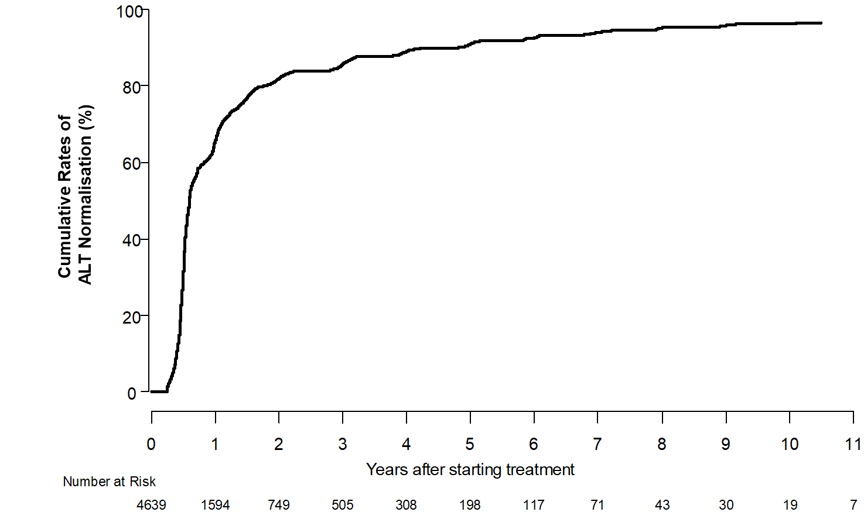

ALT, alanine aminotransferase; HBeAg, hepatitis B e antigen

B. Virological response

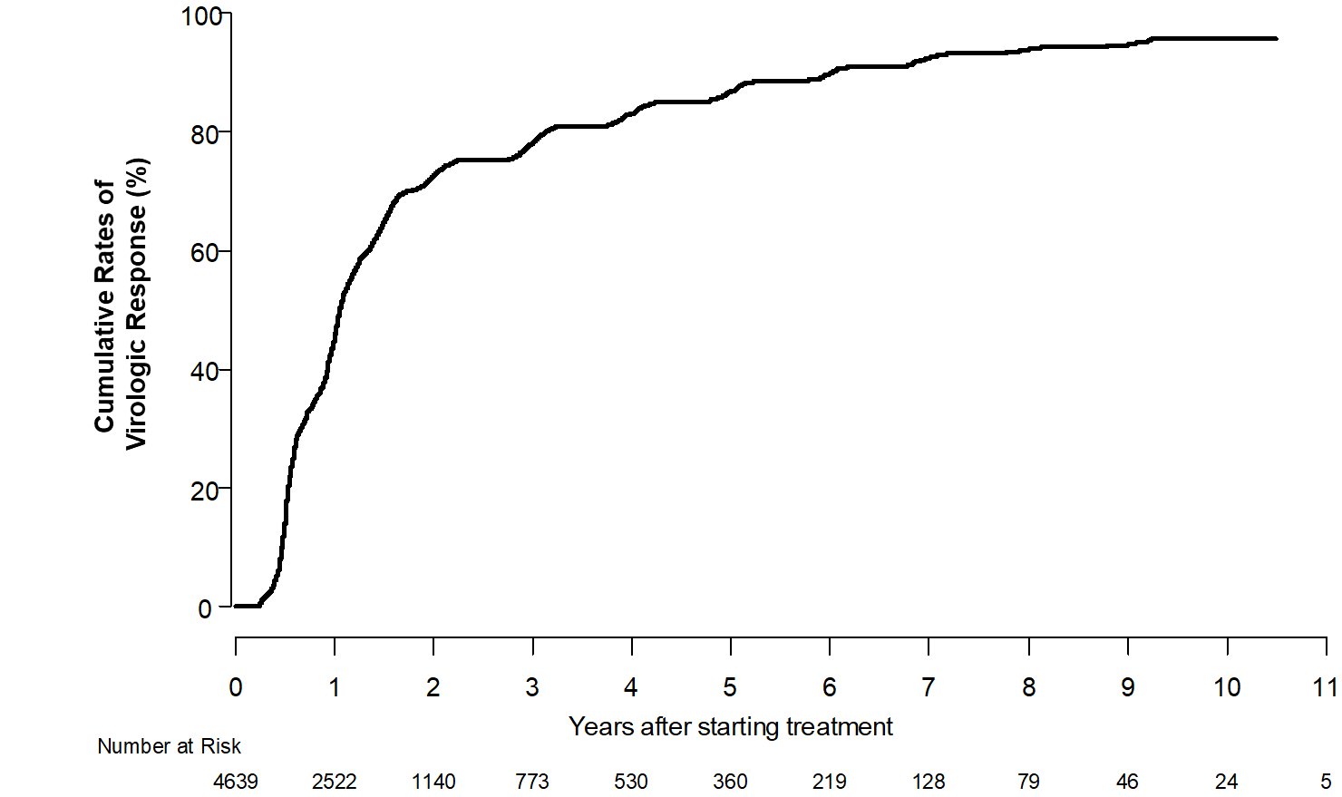

C. HBeAg seroclearance in HBeAg-positive patients

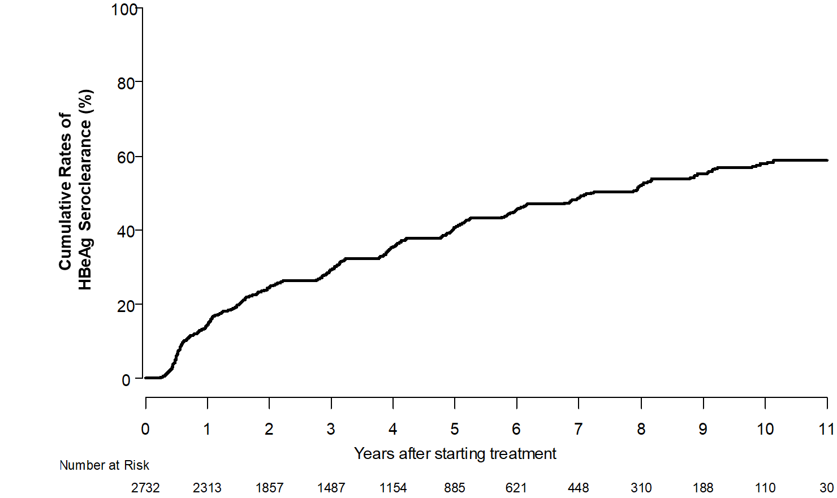

Supplementary Figure 2. Risk of HCC by the timing of ALT normalization in CHB patients with and without cirrhosis by 2-year landmark analysis.

A. Cirrhosis subcohort (n=1811)
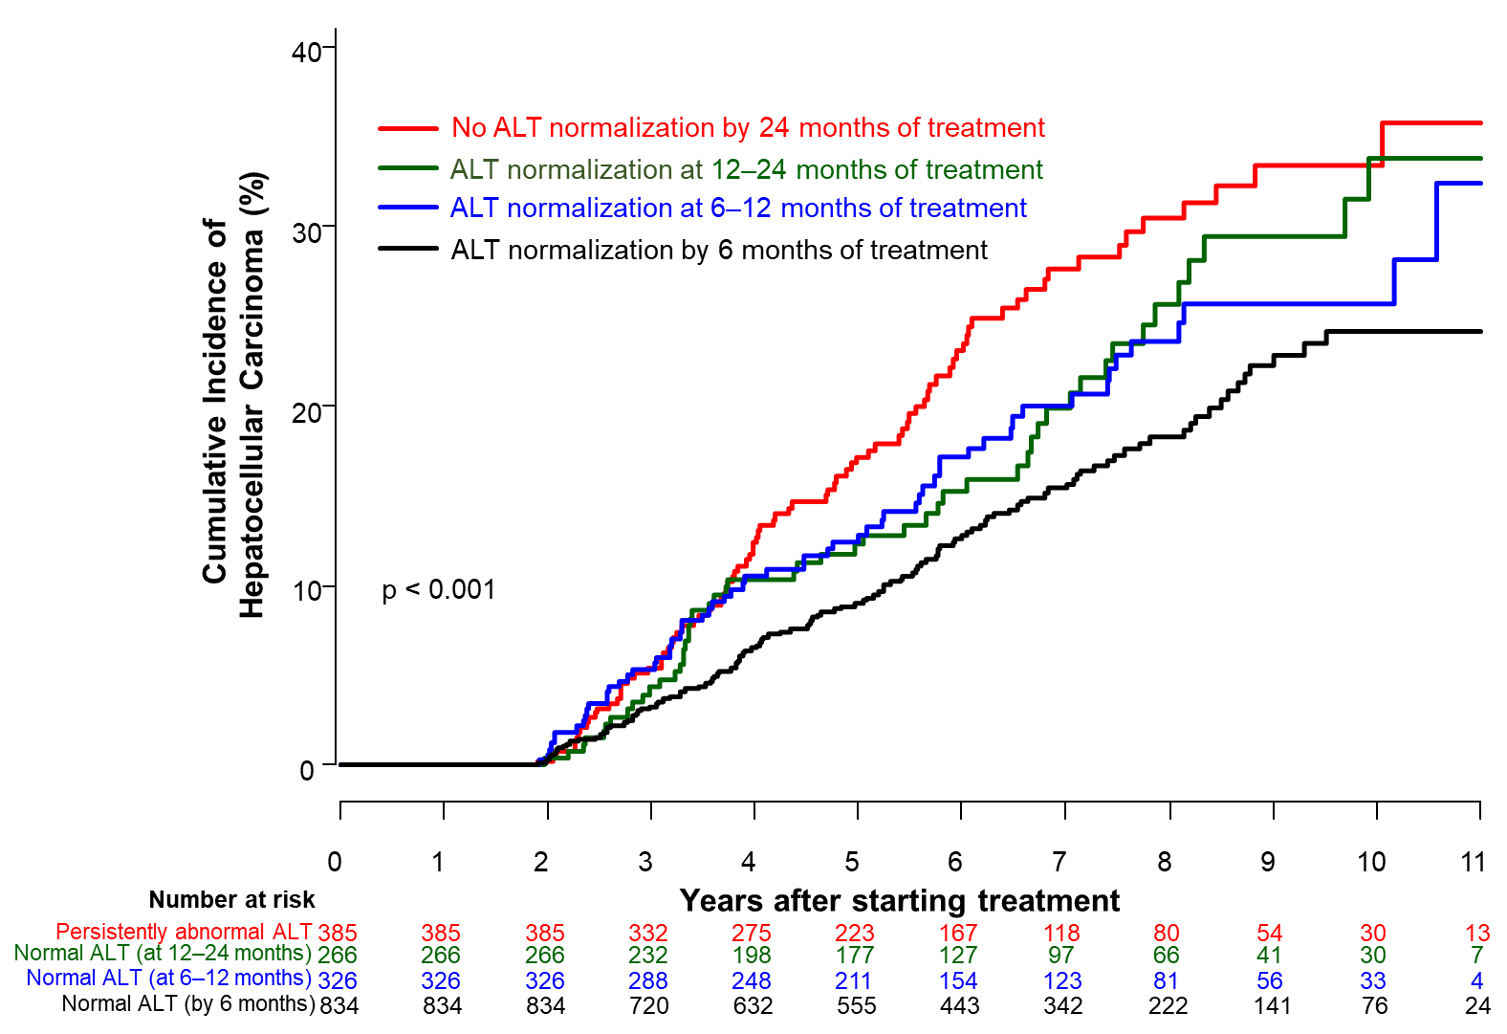

B. Non-cirrhosis subcohort (n=2431)
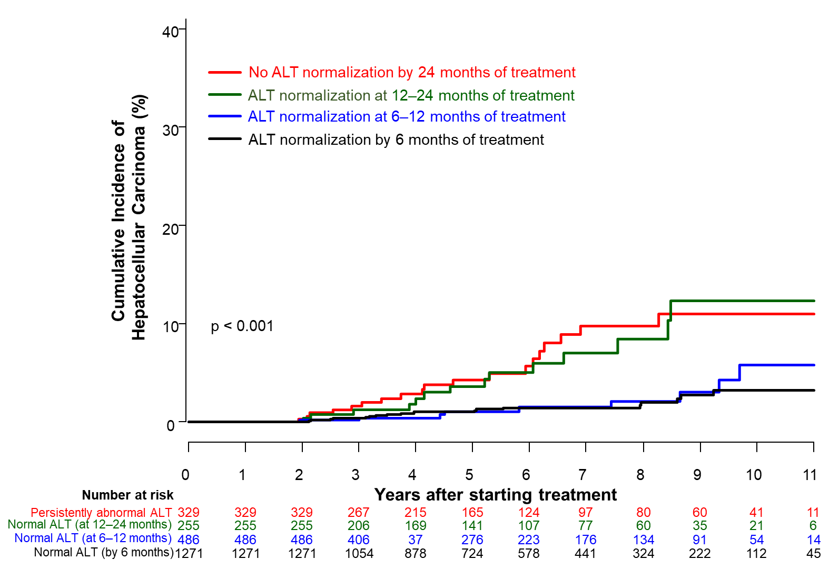

Supplementary Figure 3. Risk of HCC by the timing of ALT normalization by 2-year landmark analysis in ETV and TDF subgroups.

(A) Entecavir subcohorts (n=2803)
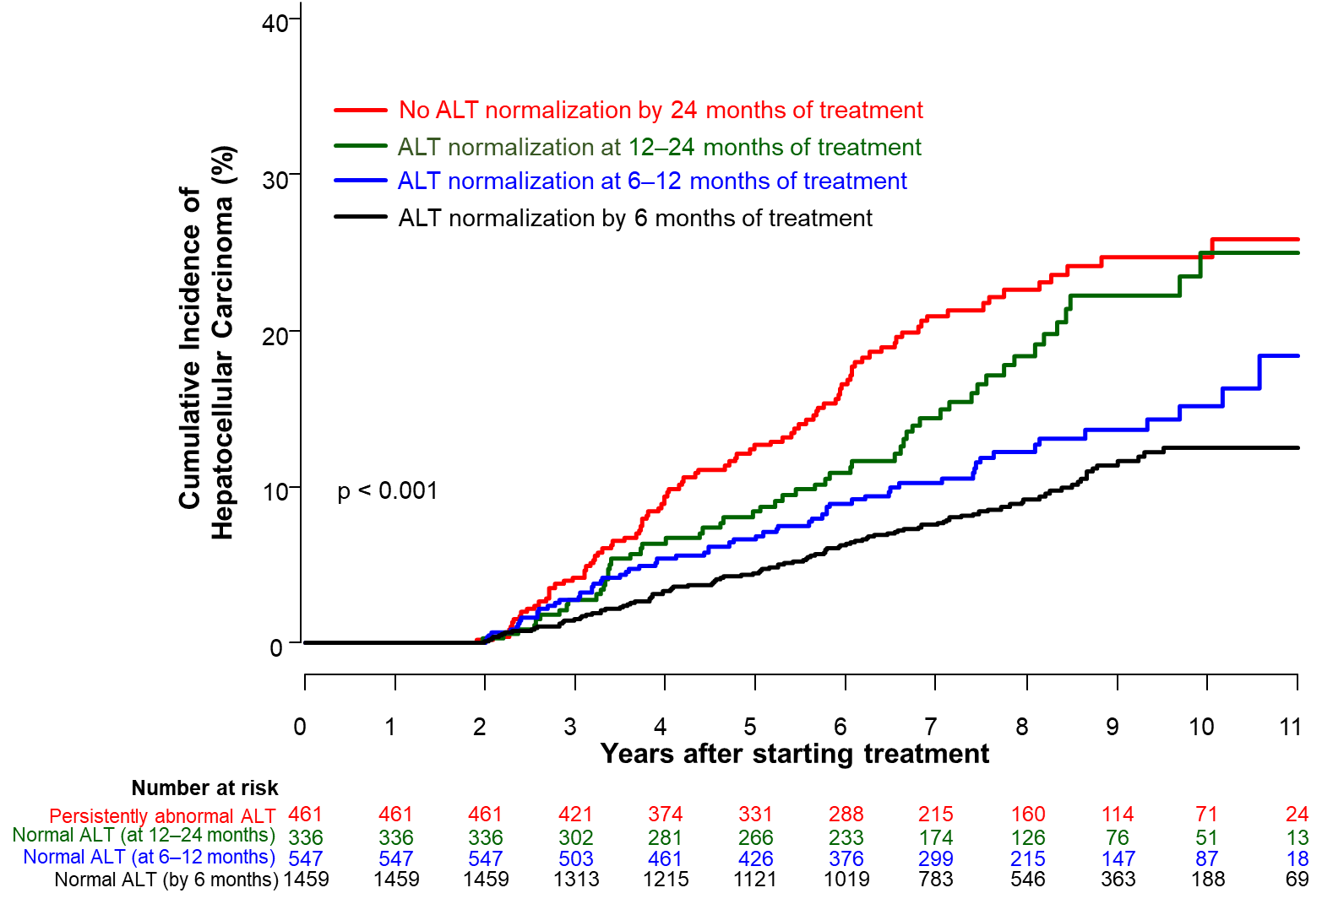

(B) Tenofovir subcohorts (n=1349)
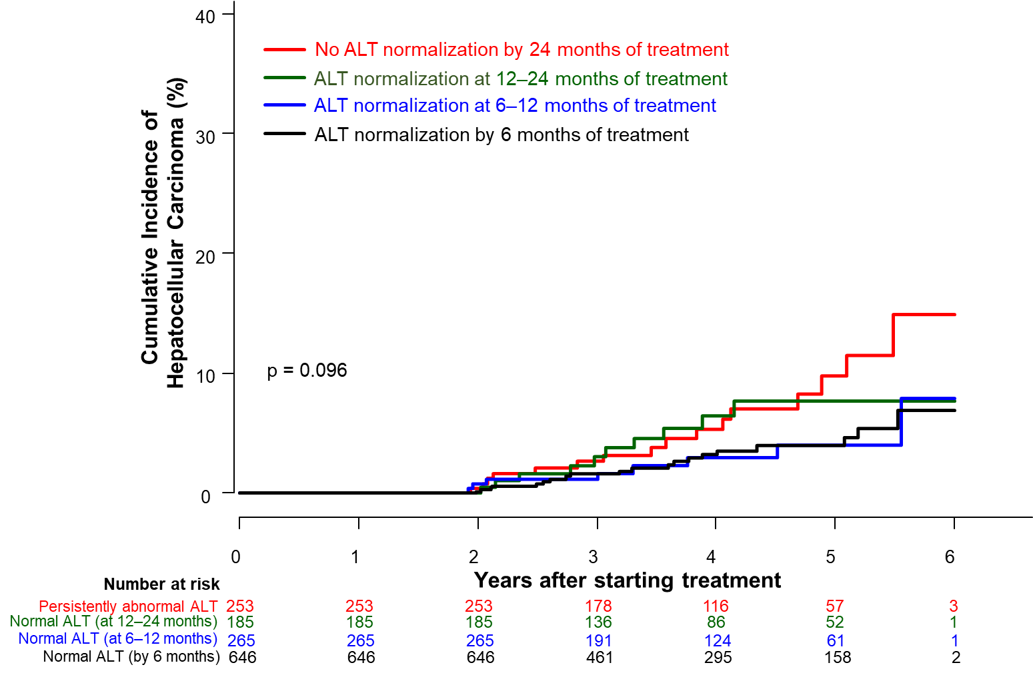
Supplementary Figure 4. Risk of Death or transplantation according to on-treatment ALT normalization in patients with CHB.

A. One-year landmark analysis

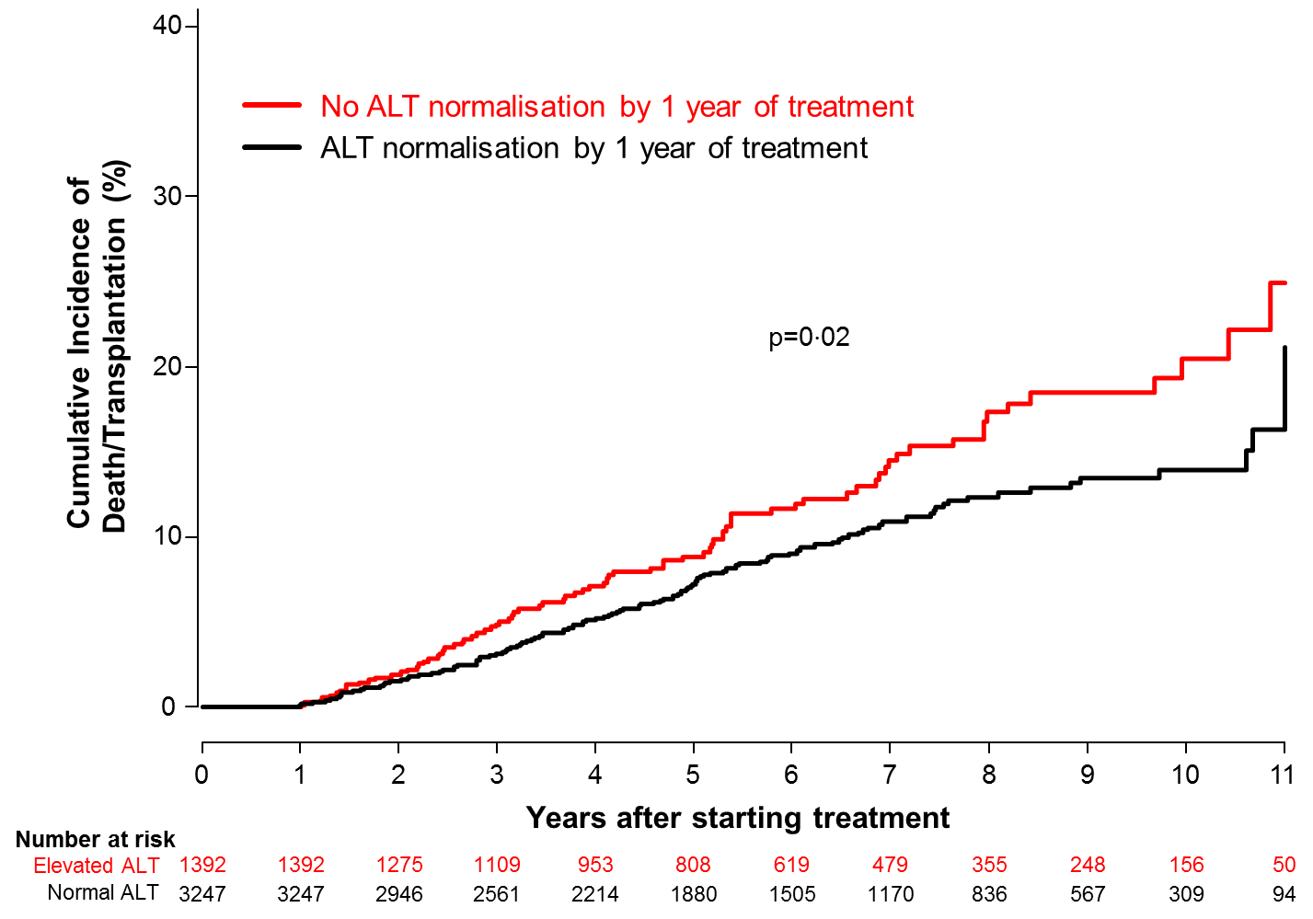

B. Two-year landmark analysis

