Figure S1 : Forest plot evaluating association between PPI use and Alzheimer’s dementia, data presented as HR
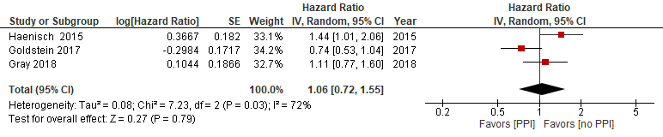

Figure S2 : Forest plot evaluating association between PPI use and Alzheimer’s dementia, data presented as OR
