Supplementary Figure S3: Child-to-adult incidence rate ratio of celiac disease in the 21st century
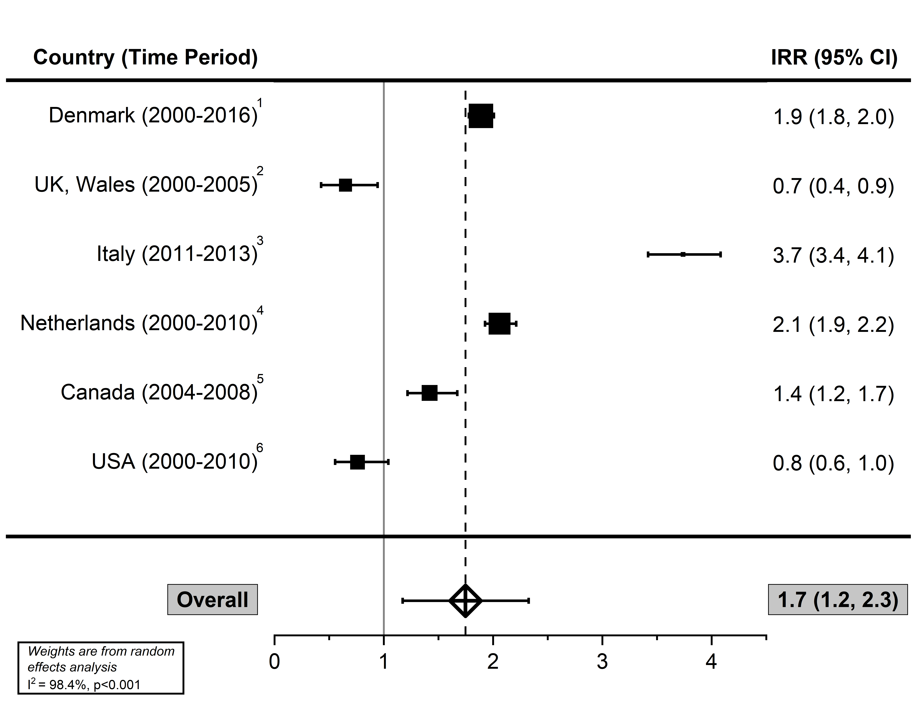
Supplementary Table S4: Sensitivity analyses of pooled incidence among children and adults*
Category | Studies | Pooled Incidence (95% CI) | I²
Children | 19 | 18.6 (14.4, 22.8) | 99.6% (p < 0.001)
Adults | 12 | 14.5 (9.6, 19.5) | 99.9% (p < 0.001)
*meta-analyses pooled estimates that included overlapping data due to similar geographic region and/or time periods

References
- Grode L, Bech BH, Jensen TM, et al. Prevalence, incidence, and autoimmune comorbidities of celiac disease: a nation-wide, population-based study in Denmark from 1977 to 2016. Eur J Gastroenterol Hepatol. 2018;30(1):83-91.
- Hurley JJ, Lee B, Turner JK, Beale A, Jenkins HR, Swift GL. Incidence and presentation of reported coeliac disease in Cardiff and the Vale of Glamorgan: the next 10 years. Eur J Gastroenterol Hepatol. 2012;24(5):482-486.
- Zingone F, West J, Auricchio R, et al. Incidence and distribution of coeliac disease in Campania (Italy): 2011-2013. United European Gastroenterol J. 2015;3(2):182-189.
- Burger JP, Roovers EA, Drenth JP, Meijer JW, Wahab PJ. Rising incidence of celiac disease in the Netherlands; an analysis of temporal trends from 1995 to 2010. Scand J Gastroenterol. 2014;49(8):933-941.
- Stewart M, Andrews CN, Urbanski S, Beck PL, Storr M. The association of coeliac disease and microscopic colitis: a large population-based study. Aliment Pharmacol Ther. 2011;33(12):1340-1349.
- Ludvigsson JF, Rubio-Tapia A, van Dyke CT, et al. Increasing incidence of celiac disease in a North American population. Am J Gastroenterol. 2013;108(5):818-824.

