Appendix 2
COST APPENDIX: COSTS FOR DUTCH MISCAN-EAC MODEL
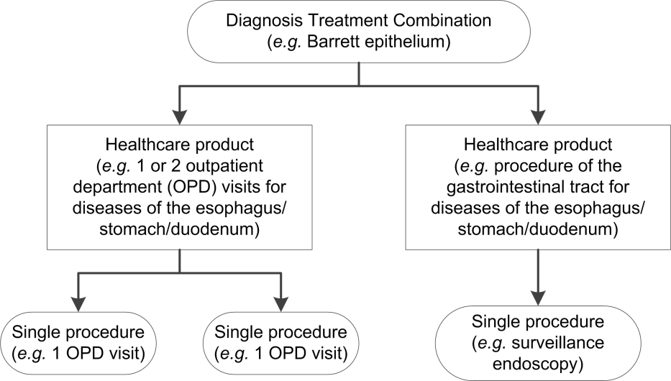
In this study we calculated the costs of surveillance and treatment of Barrett’s esophagus (BE) and esophageal adenocarcinoma (EAC) by using Diagnosis Treatment Combinations (DTC), healthcare products, and single procedures (Figure 1).
Figure 1. Diagnosis Treatment Combinations, healthcare products, and single procedures

In the Netherlands, patients are assigned a DTC by the clinician at presentation to be able to declare healthcare costs at the insurance company. In such a DTC all costs are covered that are related to a patient’s diagnosis (1). A nationwide definition is available for each individual DTC of what exact healthcare costs are included. Although patients with the same DTC have the same diagnosis, the total costs can differ for each individual, since the use of diagnostics and treatment is not always exactly the same.
Therefore, healthcare products as consumed per patient are assigned to and declared within a DTC. The costs of these products in the care of patients with BE and EAC may differ between hospitals. The mean declared costs of these products of all hospitals in The Netherlands to insurance companies are made freely available by the Dutch healthcare authority (2).
Healthcare products consist of a predefined number of single procedures. For example, if a patient with BE has been assigned the DTC ‘Barrett epithelium’, this patient could have the corresponding healthcare products ‘1 or 2 outpatient department (OPD) visits for disease of the esophagus/stomach/duodenum’ and ‘procedure of the gastrointestinal tract for diseases of the esophagus/stomach/duodenum’ to declare for his surveillance endoscopy. These may include the single procedures of either one or two OPD visits and one upper endoscopy with biopsies. Consequently, the same costs are declared for the patient with one as the patient with two OPD visits. Therefore, the number of healthcare products used will define the costs, not the number of single procedures.
Every department has its own DTCs. Consequently, if a patient is treated for EAC and multiple departments are involved (e.g. DTC ‘esophagus | cardia malignancy’ in the department of gastroenterology and DTC ‘malignancy esophagus/cardia’ for the department of oncology), this patient will be assigned more than 1 DTC for the same condition. The available healthcare products in the system that can be assigned to these DTCs are the same for every department.
Costs per BE and EAC patient
Based on the structure concerning the states as used in our simulation model, 7 treatment groups of BE and EAC patients were defined to calculate the costs per individual (Table 1): (1) a BE patient having surveillance, (2) a BE patient having endoscopic treatment with a DTC for BE, (3) a BE patient having endoscopic treatment with a DTC for EAC, (4) an EAC patient treated according to the CROSS regimen, (5) an EAC patient treated with definitive chemoradiation therapy, (6) an EAC patient treated with induction chemotherapy and if indicated esophagectomy afterwards, and (7) an EAC patient who was treated with palliative therapy. Groups 1 up to 3 were considered to contain patients in the premalignant stage, groups 4 up to 7 in the malignant stage.
To calculate the costs per treatment group, first the number of healthcare products per patient per treatment group should be collected, and secondly the costs per healthcare product.
The mean number of healthcare products as consumed per representative patient for each group was calculated, based on data from our own institution. Data concerning these patients were retracted from our electronic patient files by using BusinessObjects (SAP AG, Germany). The following consecutive steps were followed in order to collect these data. First, for each group a representative single procedure was selected, that was highly likely to be used by every patient in this group (e.g. an upper endoscopy for every BE patient having surveillance). All patients at our institution who had this procedure in a certain time period were identified, e.g. July 2013 up to June 2017 for BE patients having surveillance. The allocated time period varied between patient types, to be able to exclude periods in which study protocols of clinical trials at our institution may have influenced clinical practice and, consequently, the declaration of healthcare products. Next, only the patients in whom this procedure was linked to the relevant DTC were selected (e.g. only the patients with the DTC Barrett epithelium who have had an upper endoscopy). Within the electronic patient files all selected patients were reviewed to confirm their eligibility for that specific treatment group. Finally, all the healthcare products as used within this DTC for these patients were collected.

Table 1. Search strategy as used by business intelligence to convert single procedures to healthcare products.
Group | Procedure code* | DTC code** | 1st year filter
- Surveillance | 339141L  NOT 334390G | 303 | July 2013, 2014, 2015, 2016, June 2017
- Endoscopic treatment | 334390G | 303 | July 2013, 2014,  June 2015
- Endoscopic treament | 334390G | 307, 904, 102, 319 | July 2013, 2014,  June 2015
- EAC CROSS regimen | 390791 (23x)  339966A (5x) | 307, 904, 102, 319 | July 2011, 2012,  June 2013
- EAC definitive chemoradiation | 390791 (28x)  339966A (6x) | 307, 904, 102, 319 | July 2011, 2012,  June 2013
- EAC induction chemotherapy | 339966A  NOT 390791 | 307, 904, 102, 319 | July 2011, 2012,  June 2013
- EAC palliative phase | 339966B | 307, 904, 102, 319 | July 2011, 2012,  June 2013
*339141L surveillance endoscopy, 334390G RFA, 339966A chemotherapy for malignancy without metastasis, 339966B chemotherapy for malignancy with metastasis, 390791 radiotherapy
**303 Barrett epithelium (gastroenterology), 307 esophagus | cardia malignancy (gastroenterology), 904 malignancy esophagus/cardia (oncology), 102 gastroenterological tumors (radiotherapy), 319 malignant neoplasms esophagus | cardia (surgery)
Once patients were identified, we collected all their healthcare products as assigned to their DTC without restriction in time period. The completeness of these healthcare products was checked in the electronic patient file for each patient included. Consequently, all healthcare products within a certain DTC of all patients of a certain group at our institution were collected.
These healthcare products were then multiplied by their most recently reported (mostly 2017) mean costs per healthcare product as made available by the Dutch healthcare authority. This strategy provided the mean costs per patient per treatment group. If the mean costs of a healthcare product were not reported, we derived them from the costs of other healthcare products that were available. Per treatment group, some additional assumptions had to be made to get to final estimates (Table 2). For example, for all patients included in group 2, who were treated according to the CROSS regimen, we assumed 49% had recurrence at a certain point in time. For this proportion the costs of group 7 (EAC palliative phase) were added to the costs of a patient of group 4.
For treatment group 7, EAC palliative phase, an additional dataset was used to increase the number of patients the mean costs could be based on. They could not all be identified by using the strategy as reported in Table 1, since they had not all had palliative chemotherapy. All patients with EAC in the palliative phase who received a stent in a certain year were identified by a specialist nurse during clinical practice for another clinical study.
Also, for admission to the intensive care unit (ICU) it was necessary to include extra costs, since healthcare products do not cover the costs of admission to the ICU. Therefore, we used the costs per day of admission to the ICU of 2017 as provided by the financial department of our institution for all treatment groups that included esophagectomy, since in most hospitals a short admission to the ICU post-surgery standard of care. These costs were estimated to be € 2,442 per day.
Touch-ups, complications of endoscopic eradication therapy (EET), esophagectomy
Apart from the main treatment groups, we isolated three additional subgroups: touch-up, complications of EET, and esophagectomy. The costs of these options were derived from the previously collected costs, and the type and number of healthcare products used were based on the literature and expert opinion. The rates of these subgroups are also based on expert opinion and the literature, and they were checked for the individual patients as selected by our search strategy. It was not possible to use the same strategy as for the main treatment groups, because of the expected small amount of touch-ups, complications, and single surgeries occurring in our reviewed patients in the selected time period.
For touch-ups after the initial two-year treatment period of EET, the costs of the healthcare products were used that belonged to a single RFA, together with the costs of group 1 to account for an upper endoscopy after the touch-up and a potential OPD visit.
Complications of EET included in the model are perforation, bleeding, and stricture. The costs of the healthcare product of a complicated upper endoscopy of the esophagus and gastroduodenal tract with a maximum of two days of admission to the ward were used. For both perforation and bleeding we assumed only a single set of these procedures to be necessary, for a stricture we assumed this set of procedures occurred on average 2.5 per stricture (3-5).
Besides the previously defined treatment groups, some patients received only esophagectomy. Two groups of patients may have used this treatment: persistent HGD after EET, and a proportion of patients with T1b EAC. The costs of two years after the esophagectomy of patients from treatment group 4 ‘EAC CROSS regimen’ were used. The patients having persistent HGD after EET are modelled separately, the proportion of patients with T1b EAC who are treated with only esophagectomy instead of also with chemoradiation according to the CROSS regimen are included in the calculation of the costs per stage, as explained in the next paragraph.
This strategy provided the costs per treatment group as declared by the hospitals to insurance companies in the Netherlands (Figure 2).
Malignant stage
Since in our model EAC diagnosis was implemented per stage and not per treatment group, an extra transformation was performed to the costs as retrieved by the previously mentioned methods. To be able to calculate the proportion of each treatment group per EAC stage, data concerning the proportions of treatment groups with EAC stage from 2015 from the Dutch cancer registry (Integraal Kankercentrum Nederland (IKNL)) were used. For each stage 1, 2, 3, and 4 patients, the proportion of treatment groups were calculated (Table 3). By combining costs per treatment group and the proportions of treatment groups per stage, the costs per stage were calculated as used in the model.
We have also used these data to calculate the proportion of patients of group 7 who had palliative therapy (Figure 2). In case they had a combination, the proportion of what therapy was used could be obtained.
Limitations of the search strategy
Although patients with EAC have diagnostic work-ups, those costs were not included separately in the calculation. In the dataset as composed according to our search strategy the number of healthcare products of an individual patient with and without diagnostic procedures were compared. There were no differences. Therefore, these costs are likely to be incorporated in these healthcare products.
Out of the data concerning stage and treatment from the Dutch healthcare registry (IKNL) 12% of patients did not meet any of the inclusion criteria of any treatment group. Those patients were excluded from the analysis, since they were not treated according to an established schedule as set by experts according to the literature. Out of all patients, 3.7% had an undefined stage. Those patients were also not included in the analysis.

Table 2. Assumptions per treatment group in collecting number of healthcare products.
Treatment group | Assumptions
- Surveillance | The costs of the mean number of OPD visits per patient in the time period of four years were added to the costs of a surveillance endoscopy.
- Endoscopic treatment BE  - Endoscopic treatment EAC | The initial EET was assumed to be finished after two years. Therefore, healthcare products that were declared within two years after the first endoscopic treatment session (RFA and if applicable EMR) were included in the calculation of the costs.  Patients with complications were excluded from this calculation, because costs of complications were calculated separately.  A median stay at the intensive care unit of 2 days was assumed post-surgery (6).  All T1a patients were assumed to be treated with EET, none of the T1a patients were assumed to be treated otherwise.
- EAC CROSS regimen | All healthcare products of the first two years after diagnosis were collected, since time until recurrence was assumed to be two years (7). Of all patients included in this treatment group, 49% is expected to have recurrence and the median survival is estimated to be 43 months. Consequently, for 49% of all patients in this treatment group the costs of group 7 were added, for 51% of patients a yearly OPD visit was assumed for two years after the two years of the initial treatment.  A median stay at the intensive care unit of 2 days was assumed post-surgery (6).  Patients were assumed to be in stage 1, 2, or 3 of EAC.
- EAC definitive chemoradiation | All healthcare products of the first year after diagnosis were collected, since time until recurrence was assumed to be one year (8). Of all patients included in this treatment group, 86% was expected to have recurrence and the median survival was estimated to be 22 months (9). Consequently, for 86% of all patients in this treatment group the costs of group 7 were added, for 14% of patients a yearly OPD visit was assumed for two years after the year of the initial treatment.  Patients were assumed to be in stage 1, 2, or 3 of EAC.
- EAC induction chemotherapy | For patients who have only had induction chemotherapy all healthcare products were used, in which recurrence is assumed to be included, because of the lack of a curative treatment. This group is estimated to be 28% of all patients treated with induction chemotherapy (10).  For patients who had both induction chemotherapy and esophagectomy all healthcare products of the six months after diagnosis were collected, since time until recurrence was assumed to be six months. Of all patients included in this treatment group, 60% was expected to have recurrence and the median survival was estimated to be 21 months. Consequently, for 60% the costs of group 7 were added, for 40% of patients a yearly OPD visit was assumed for one year after the year of the initial treatment.  A median stay at the intensive care unit of 2 days was assumed post-surgery (6).  Patients were assumed to be in stage 1, 2, 3, or 4 of EAC.
- EAC palliative phase | All healthcare products per patient without restriction in time were collected and assigned to be part of the following options for palliative therapy: chemotherapy, external radiotherapy, internal radiotherapy, and an endoscopic stent.  Patients were assumed to be in stage 4 of EAC.

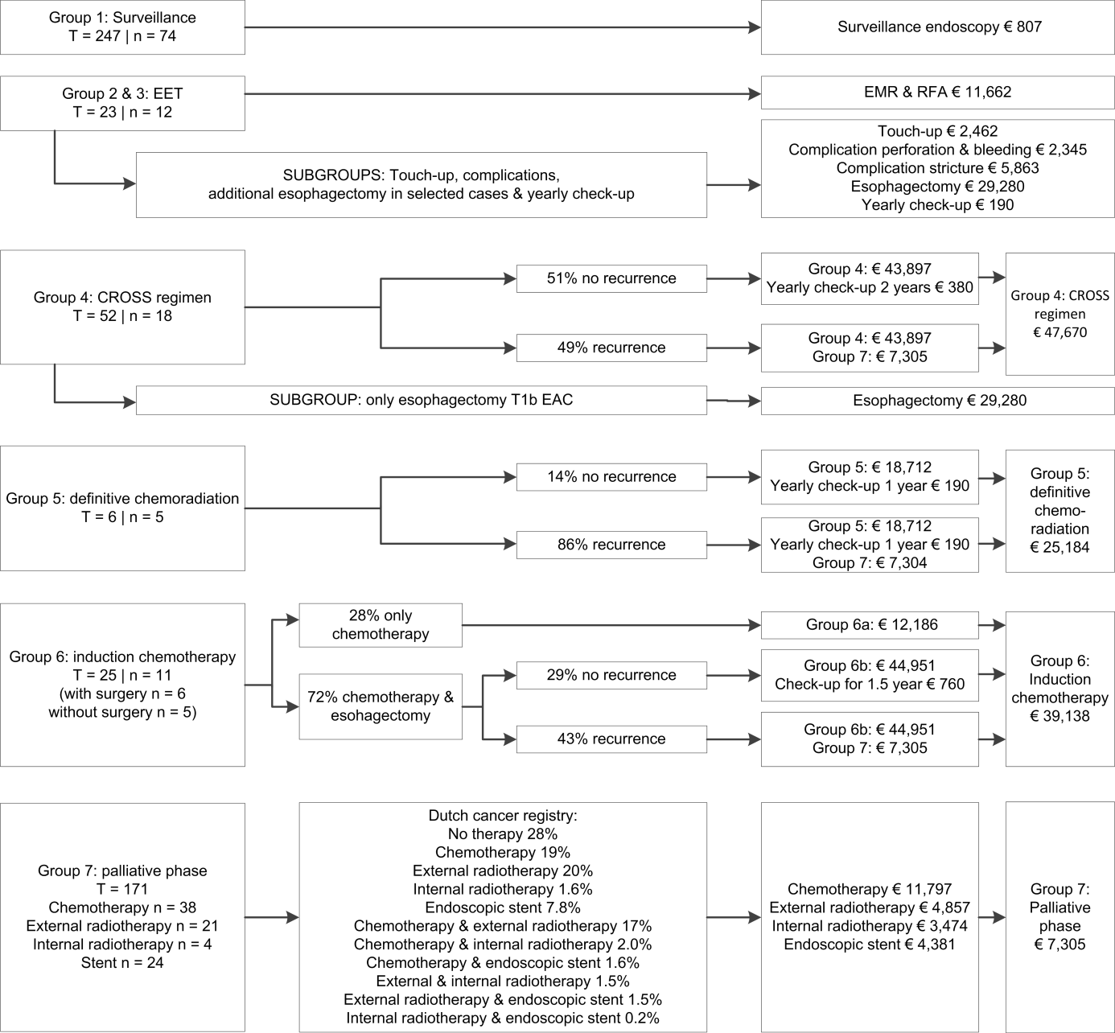

Figure 2. Mean costs per representative patient per treatment group.
EAC: esophageal adenocarcinoma, EET: endoscopic eradication therapy, EMR: endoscopic mucosal resection, n: number of patients included in calculation of costs, RFA: radiofrequency ablation, T: total number of patients identified by search strategy in EPD.

Table 3. Mean costs per stage of EAC as declared to insurance companies according to the national registry of the healthcare authorities.
 | Stage 1* |  | Stage 2 |  | Stage 3 |  | Stage 4
 | % | n | % | n | % | n | % | n
Group 2 & 3* | 18 | 19 | 0 | 0 | 0 | 0 | 0 | 0
Group 4 | 45 | 49 | 78 | 134 | 79 | 282 | 0 | 0
Only esophagectomy | 12 | 13 | 1.2 | 2 | 0 | 0 | 0 | 0
Group 5 | 22 | 24 | 20 | 35 | 20 | 72 | 0 | 0
Group 6 | 2.8 | 3 | 0.6 | 1 | 1.1 | 4 | 6.3 | 37
Group 7 | 0 | 0 | 0 | 0 | 0 | 0 | 94 | 549
Total n° patients per stage | 100% | 108 | 100% | 172 | 100% | 358 | 100% | 586
Costs per stage | € 31,602 |  | € 42,806 |  | € 43,127 |  | € 9,332
Data are converted from costs per treatment group, according to the proportion of number of patients with EAC and their treatment as registered in the Dutch cancer registry. *This only includes EAC > T1a. Costs for T1a EAC are included separately in the model.

REFERENCES
1. Folmer K, Mot E. Diagnosis and treatment combinations in Dutch hospitals. cpb Report 2003;1:52-56.
2. National Healthcare Institute of the Netherlands (Nederlandse Zorgautoriteit). DIS open data. 2014-2018 [cited 2018; Available from: http://www.opendisdata.nl/msz/zorgproduct
3. Phoa KN, van Vilsteren FG, Weusten BL, et al. Radiofrequency ablation vs endoscopic surveillance for patients with Barrett esophagus and low-grade dysplasia: a randomized clinical trial. Jama 2014;311:1209-17.
4. Shaheen NJ, Sharma P, Overholt BF, et al. Radiofrequency ablation in Barrett's esophagus with dysplasia. N Engl J Med 2009;360:2277-88.
5. Lyday WD, Corbett FS, Kuperman DA, et al. Radiofrequency ablation of Barrett's esophagus: outcomes of 429 patients from a multicenter community practice registry. Endoscopy 2010;42:272-8.
6. (DICA) DIfCA. Dutch Upper GI Cancer Audit (DUCA). 2017 [cited 2018; Available from: https://dica.nl/duca/home
7. Shapiro J, van Lanschot JJB, Hulshof M, et al. Neoadjuvant chemoradiotherapy plus surgery versus surgery alone for oesophageal or junctional cancer (CROSS): long-term results of a randomised controlled trial. Lancet Oncol 2015;16:1090-1098.
8. Versteijne E, van Laarhoven HW, van Hooft JE, et al. Definitive chemoradiation for patients with inoperable and/or unresectable esophageal cancer: locoregional recurrence pattern. Dis Esophagus 2015;28:453-9.
9. Reid TD, Davies IL, Mason J, et al. Stage for stage comparison of recurrence patterns after definitive chemoradiotherapy or surgery for oesophageal carcinoma. Clin Oncol (R Coll Radiol) 2012;24:617-24.
10. Toxopeus EL, Talman S, van der Gaast A, et al. Induction chemotherapy followed by surgery for advanced oesophageal cancer. Eur J Surg Oncol 2015;41:323-32.

