Appendix
Appendix to ‘Probiotics for celiac disease: a systematic review and meta-analysis of randomized controlled trials.’
This appendix provides supplemental information on this systematic review. It is divided into four appendices (Appendix 1 – 12).

Table of Contents
Appendix 1 | MEDLINE search strategy for article selection (from 1 Jan 1970 to 5 February 2019).
Appendix 2 | Excluded studies and reasons for exclusion.
Appendix 3 | Summary of studies evaluating the effects of probiotics in CD.
Appendix 4 | Effect of probiotics vs. placebo on GI symptoms, sub-grouped by presence of IBS diagnosis.
Appendix 5 | Effect of probiotics vs. placebo on GI symptoms, sub-grouped by GFD adherence.
Appendix 6 | Effect of probiotics vs. placebo on faecal Bifidobacterium counts, sub-grouped by geographical location.
Appendix 7 | Effect of probiotics vs. placebo on faecal Lactobacillus counts, sub-grouped by probiotic type, length of GFD adherence, and age group.
Appendix 8 | Effect of probiotics vs. placebo on faecal Lactobacillus counts, sub-grouped by geographical location.
Appendix 9 | Effect of probiotics vs. placebo on number of adverse events, sub-grouped by age group.
Appendix 10 | Effect of probiotics vs. placebo on number of adverse events, sub-grouped by GFD adherence.
Appendix 11 | Effect of probiotics vs. placebo on number of adverse events, sub-grouped by probiotic type.
Appendix 12 | Effect of probiotics vs. placebo on number of adverse events, sub-grouped by geographical location.

Appendix 1. MEDLINE search strategy for article selection (from 1 Jan 1970 to 5 February 2019).

1 | Celiac Disease/
2 | c?eliac.mp.
3 | (gluten adj2 enteropath*).mp.
4 | nontropical sprue.mp.
5 | gluten enteropathy.mp.
6 | gluten enteropathies.mp.
7 | (gluten adj2 sensitive).mp. [mp=title, abstract, original title, name of substance word, subject heading word, floating sub-heading word, keyword heading word, organism supplementary concept word, protocol supplementary concept word, rare disease supplementary concept word, unique identifier, synonyms]
8 | gluten sensitive enteropathy.mp.
9 | gluten sensitive enteropathies.mp.
10 | (Celiac adj3 sprue).mp. [mp=title, abstract, original title, name of substance word, subject heading word, floating sub-heading word, keyword heading word, organism supplementary concept word, protocol supplementary concept word, rare disease supplementary concept word, unique identifier, synonyms]
11 | (nontropical adj3 sprue).mp.
12 | exp Diet, Gluten-Free/
13 | gluten free diet.mp.
14 | Gliadin*.mp.
15 | exp Glutens/
16 | gluten*.mp.
17 | or/1-16
18 | exp Probiotics/
19 | probiotic*.mp.
20 | exp symbiosis/ or exp microbiota/ or exp GI microbiome/ or exp microbial consortia/ or exp mycobiome/
21 | microbiome.mp.
22 | bacterial microbiome.mp.
23 | microbiota.mp.
24 | mycobiome.mp.
25 | symbiosis.mp.
26 | endosymbiosis.mp.
27 | microbial consortium.mp.
28 | microflora.mp.
29 | bacterial flora.mp.
30 | intestine flora.mp.
31 | (probiotic* adj3 commensal).mp. [mp=title, abstract, original title, name of substance word, subject heading word, floating sub-heading word, keyword heading word, organism supplementary concept word, protocol supplementary concept word, rare disease supplementary concept word, unique identifier, synonyms]
32 | (probiotic* adj3 complimentary).mp. [mp=title, abstract, original title, name of substance word, subject heading word, floating sub-heading word, keyword heading word, organism supplementary concept word, protocol supplementary concept word, rare disease supplementary concept word, unique identifier, synonyms]
33 | (probiotic* adj2 commensal).mp. [mp=title, abstract, original title, name of substance word, subject heading word, floating sub-heading word, keyword heading word, organism supplementary concept word, protocol supplementary concept word, rare disease supplementary concept word, unique identifier, synonyms]
34 | (probiotic* adj2 complimentary).mp. [mp=title, abstract, original title, name of substance word, subject heading word, floating sub-heading word, keyword heading word, organism supplementary concept word, protocol supplementary concept word, rare disease supplementary concept word, unique identifier, synonyms]
35 | exp Lactobacillus/
36 | Lactobacillus.mp.
37 | exp Bifidobacterium/
38 | Bifidobacteri*.mp.
39 | Nissle Yeast.mp.
40 | exp Saccharomyces/
41 | Saccharomyces.mp.
42 | boulardii.mp.
43 | VSL$.mp.
44 | exp Streptococcus/
45 | Streptococcus.mp.
46 | or/18-45
47 | 17 and 46

Appendix 2. Excluded studies and reasons for exclusion.

Author, yr | Reason for Exclusion
Afifi 2017¹ | Study population does not include CD patients
Coqueiro 2017² | Review article. Not a study
Cristofori 2018³ | Review article. Not a study
Darby 1946⁴ | Not a randomised controlled trial and the intervention is not probiotics.
Kim 2006⁵ | Study population does not include CD patients
Klemenak 2016⁶ | Duplicate of Klemenak 2015²⁸
Martinello 2017⁷ | Not a randomised controlled trial
NCT01257620⁸ | Duplicate of Smecuol 2013¹⁷
NCT01699191⁹ | Duplicate of Smecuol 2013¹⁷
NCT02810301¹⁰ | Study population does not include CD patients
NCT03176095¹¹ | Study population does not include CD patients
NCT03403387¹² | Study population does not include CD patients
NCT03483805¹³ | Intervention is not solely probiotics
NCT03775499¹⁴ | Study intervention too short (<2 weeks)
Novik 2016¹⁵ | Not a randomised controlled trial
Pinto-Sánchez 2017¹⁶ | Not a randomized controlled trial
Pisarello 2015¹⁷ | Not a randomised controlled trial
Rall 2010¹⁸ | Not a randomised controlled trial
Respondek 2013¹⁹ | Study population does not include CD patients
Savilahti 2018²⁰ | Study population does not include CD patients
Serena 2019²¹ | Review article. Not a study
Smecuol 2012²² | Duplicate of Smecuol 2013¹⁷
Smecuol 2013 (2)²³ | Duplicate of Smecuol 2013¹⁷
Smecuol 2015²⁴ | Not a randomised controlled trial
Tavakkoli 2013²⁵ | Review article. Not a study
Tjellstrom 2016²⁶ | Not a randomised controlled trial
Uspenskaia 1991²⁷ | Probiotics in both intervention and placebo groups
Wilms 2016²⁸ | Study population does not include CD patients

References
1- Afifi L, Danesh MJ, Lee KM, et al. Dietary Behaviors in Psoriasis: Patient-Reported Outcomes from a U.S. National Survey. Dermatol Ther (Heidelb). 2017;7(2):227-242.
2- Coqueiro AY, Bonvini A, Tirapegui J, Rogero MM. Probiotics supplementation as an alternative method for celiac disease treatment. Int J Probiotics Prebiotics. 2017;12(1):23-31.
3- Cristofori F, Indrio F, Miniello V, De Angelis M, Francavilla R. Probiotics in Celiac Disease. Nutrients. 2018;10(12):1824.
4- Darby W, Jones E, Johnson H. Effect of synthetic Lactobacillus casei factor in the treatment of sprue. J Am Med Assoc. 1946;130:780-786.
5- Kim L, Hilli L, Orlowski J, Kupperman JL, Baral M, F Waters R. Efficacy of probiotics and nutrients in functional gastrointestinal disorders: a preliminary clinical trial. Dig Dis Sci. 2006;51(12):2134-2144.
6- Klemenak M, Dolinšek J, Langerholc T, Mičetić-Turk D. Administration of Bifidobacterium breve decreases the production of TNF-a and faecal fermentation index in children with celiac disease. Gastroenterology. 2016;62 (Supple(May):199.
7- Martinello F, Roman CF, Souza PA de. Effects of Probiotic Intake on Intestinal Bifidobacteria of Celiac Patients. Arq Gastroenterol. 2017;54(2):85-90
8- ClinicalTrials.gov. Clinical Trial on the Effects of Bifidobacterium Infantis in Active Celiac Disease (Celiac). Bethesda (MD): National Library of Medicine (US). https://clinicaltrials.gov/ct2/show/NCT01257620. Published 2012.
9- ClinicalTrials.gov. Probiotics for the Treatment of Irritable Bowel Syndrome in Celiac Patients (ProCel). Bethesda (MD): National Library of Medicine (US). https://clinicaltrials.gov/show/nct01699191. Published 2012.
10- ClinicalTrials.gov. Efficacy of Probiotic ES1 for the Treatment of Non-Celiac Gluten Sensitivity. Bethesda (MD): National Library of Medicine (US). https://clinicaltrials.gov/show/nct02810301. Published 2016.
11- ClinicalTrials.gov. Celiac Disease Prevention With Probiotics (CiPP). Bethesda (MD): National Library of Medicine (US). https://clinicaltrials.gov/ct2/show/NCT03176095. Published 2017.
12- ClinicalTrials.gov. Effects of GlutenShield, a Prebiotic, Probiotic, and Enzyme Supplement, on the Gut Microbiome of Adults With GI Symptoms. Bethesda (MD): National Library of Medicine (US). https://clinicaltrials.gov/show/nct03403387. Published 2018.
13- ClinicalTrials.gov. Effects of a Nutritional Solution to Improve Intestinal Permeability in Celiac Patients (Protalsafe). Bethesda (MD): National Library of Medicine (US). https://clinicaltrials.gov/ct2/show/NCT03483805. Published 2018.
14- ClinicalTrials.gov. Probiotic BL NCC 2705 and Gluten Sensitivity. Bethesda (MD): National Library of Medicine (US). https://clinicaltrials.gov/ct2/show/NCT03775499. Published 2019.
15- Novik G, Mikhailopulo K, Knirel Y, Kiseleva E. Linear low molecular weight alpha-1,6-glucan from Bifidobacterium bifidum BIM B-733D is implicated in pathogenesis of celiac disease. FEBS J. 2016;283 (Suppl:296-297.
16- Pinto-Sánchez MI, Smecuol EC, Temprano MP, et al. Bifidobacterium infantis NLS Super Strain Reduces the Expression of α-Defensin-5, a Marker of Innate Immunity, in the Mucosa of Active Celiac Disease Patients. J Clin Gastroenterol. 2017;51(9):814-817.
17- Pisarello MJL, Vintiñi EO, González SN, Pagani F, Medina MS. Decrease in lactobacilli in the intestinal microbiota of celiac children with a gluten-free diet, and selection of potentially probiotic strains. Can J Microbiol. 2015;61(1):32-37.
18- Rall B. Probiotika zeigen bei Zöliakie Benefit Probiotische Bakterien können bei Patienten mit einer gluteninduzierten Enteropathie das Krankheitsgeschehen positiv beeinflussen . Das ist das Ergebnis eines Laborversuchs , den spanische Wissenschaftler aktuell dur. Dtsch Apotheker Zeitung. 2010;150(18):72.
19- Respondek W, Traczyk I, Jarosz M, Mekus M, Tomasiuk R. Effectiveness of the gluten reduction intake, with and without priobotic, in IBS patients with positive serological test for coeliac disease. Ann Nutr Metab. 2013;63(suppl 1):2043.
20- Savilahti EM, Ilonen J, Kukkonen AK, Savilahti E, Kuitunen M. Celiac Disease by the Age of 13 Years Is Not Associated With Probiotics Administration in Infancy. J Pediatr Gastroenterol Nutr. 2018;66(6):937-940.
21- Serena G, Fasano A. Use of Probiotics to Prevent Celiac Disease and IBD in Pediatrics. Adv Exp Med Biol. 2019;1125:69-81.
22- Smecuol E, Hwang HJ, Chernavsky AC, et al. 340 Exploratory, Randomized, Double-Blind, Placebo-Controlled Trial on the Effects of Bifidobacterium Infantis in Untreated Celiac Disease. Gastroenterology. 2012;142(5):S-79.
23- Smecuol E, Hwang H, Vázquez H, et al. Bifidobacterium infantis NLS super strain reduces expression of alpha-defensin-5, a marker of innate immunity, in the mucosa of untreated celiac patients. Acta Gastroenterológica Latinoam. 2013;43(2):165.
24- Smecuol E, Pinto-Sánchez MI, Bai JC. Understanding the role of probiotics in coeliac disease. Br J Nutr. 2015;113(10):1664-1665.
25- Tavakkoli A, Green PH. Probiotic therapy for celiac disease. J Clin Gastroenterol. 2013;47(2):101-103.
26- Tjellström B, Högberg L, Stenhammar L, et al. A Role for Bacteria in Celiac Disease? Dig Dis Sci. 2016;61(7):2140-2141.
27- Uspenskaia ID. The efficacy of the use of lactic acid lactobacterin enriched with zinc in the treatment of patients with celiac disease. Vopr Pitan. 1991;(4):24-27. http://www.ncbi.nlm.nih.gov/pubmed/1792743.
28- Wilms E, Gerritsen J, Smidt H, et al. Effects of Supplementation of the Synbiotic Ecologic® 825/FOS P6 on Intestinal Barrier Function in Healthy Humans: A Randomized Controlled Trial. PLoS One. 2016;11(12):e0167775.

Appendix 3. Summary of studies evaluating the effects of probiotics in CD.
Study | Year | Country | Age category | N | Funding | Outcomes
 |  |  |  |  |  | GI | QOL | AE | TNF-α | IP | Bifido | Lacto
Francavilla⁹ | 2019 | Italy | Adults | 109 | NR | ↓ |  |  |  |  | ↑ | ↑
Harnett¹¹ | 2016 | Australia | Adults | 45 | NR
Klemenak²⁰ | 2015 | Slovenia | Children | 49 | G & I |  |  |  | ↓
Olivares¹⁹ | 2014 | Spain | Children | 36 | G
Primec²² | 2018 | Slovenia | Children | 40 | G & I
Quagliariello²¹ | 2016 | Slovenia | Children | 40 | G & I |  |  |  |  |  |  | ↑
Smecuol¹⁰ | 2013 | Argentina | Adults | 22 | G
Smecuol²⁶ | 2019 | Argentina | Adults | 12 | NR | ↓
NOTE: Study design: all RCTs; Green: Significant benefit in probiotics vs placebo; Yellow: no difference probiotic vs placebo; white: outcome not assessed. Abbreviations: Bifido = Bifidobacteria; GI = gastrointestinal symptoms; G = peer-reviewed grant; I = industry; IP = intestinal permeability; Lacto = Lactobacilli; NR = not reported; QOL= quality of life; AE = adverse events; TNF-α = change in serum TNF-α. Symbols: ↑=increase; ↓=decrease.

Appendix 4. Effect of probiotics vs. placebo on GI symptoms, sub-grouped by presence of IBS diagnosis.
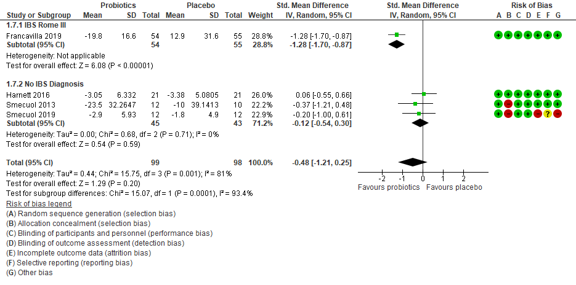

Appendix 5. Effect of probiotics vs. placebo on GI symptoms, sub-grouped by GFD adherence.

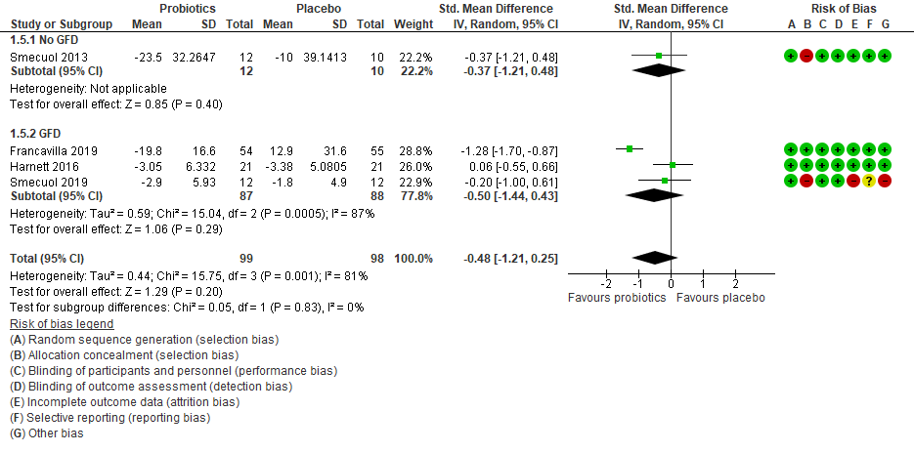

Appendix 6. Effect of probiotics vs. placebo on faecal Bifidobacterium counts, sub-grouped by geographical location.

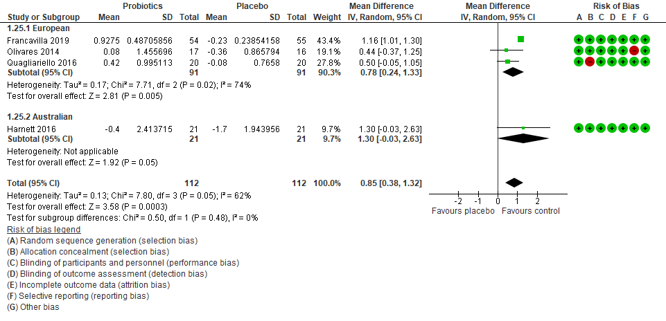

Appendix 7. Effect of probiotics vs. placebo on faecal Lactobacillus counts, sub-grouped by probiotic type, length of GFD adherence, and age group.

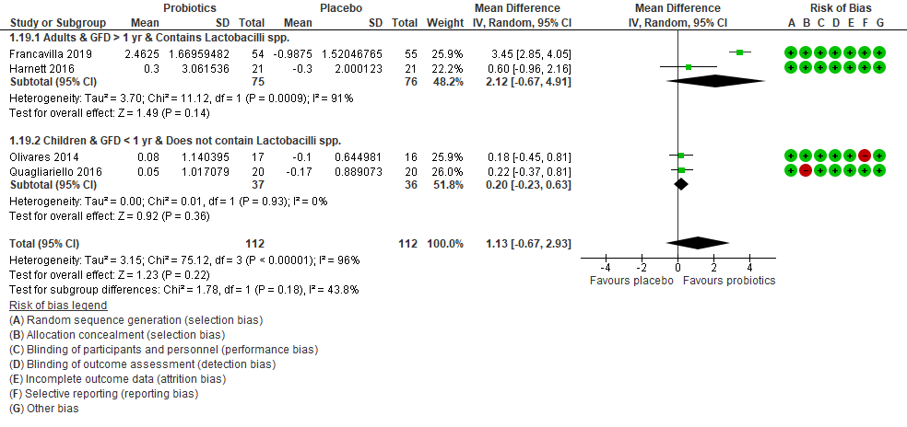

Appendix 8. Effect of probiotics vs. placebo on faecal Lactobacillus counts, sub-grouped by geographical location.

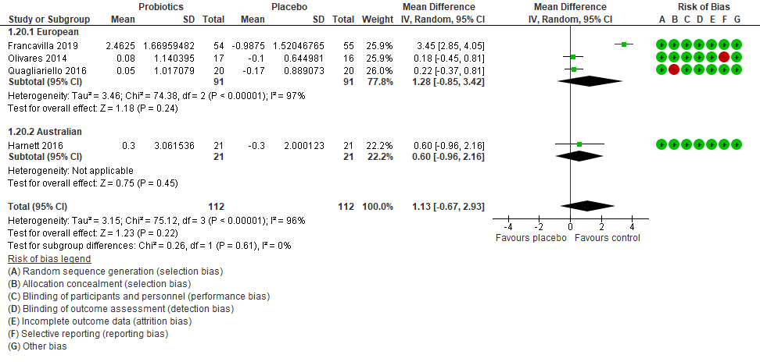

Appendix 9. Effect of probiotics vs. placebo on number of adverse events, sub-grouped by age group.

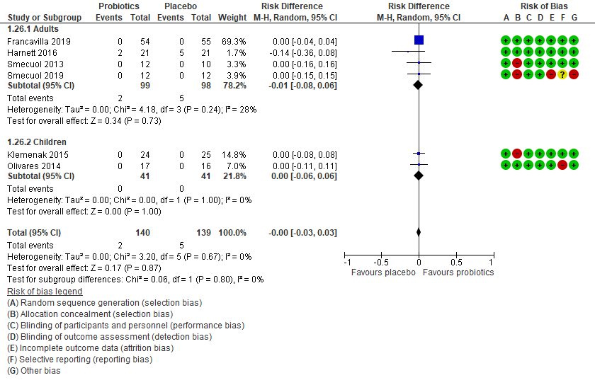

Appendix 10. Effect of probiotics vs. placebo on number of adverse events, sub-grouped by GFD adherence.

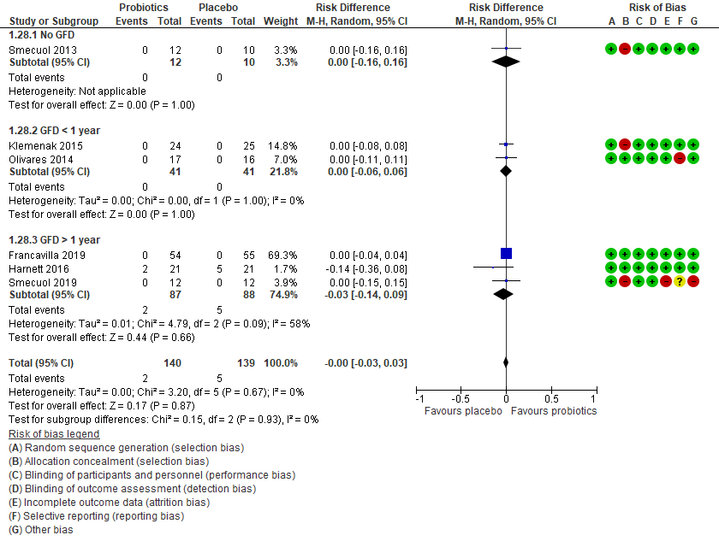

Appendix 11. Effect of probiotics vs. placebo on number of adverse events, sub-grouped by probiotic type.

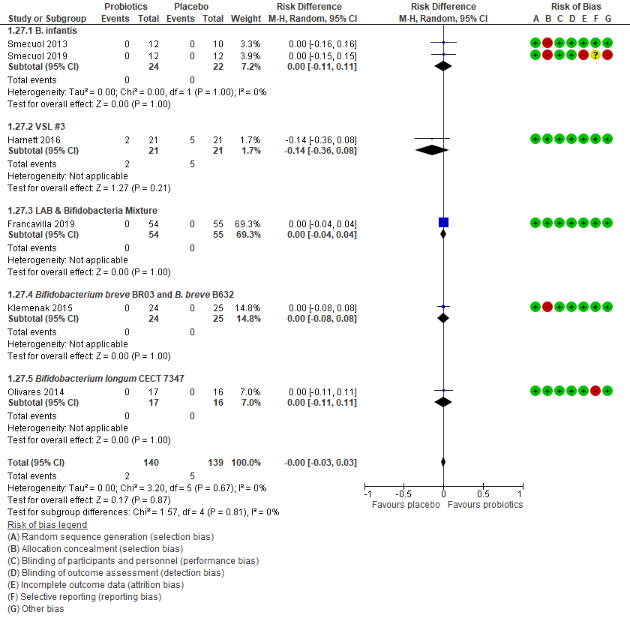

Appendix 12. Effect of probiotics vs. placebo on number of adverse events, sub-grouped by geographical location.

